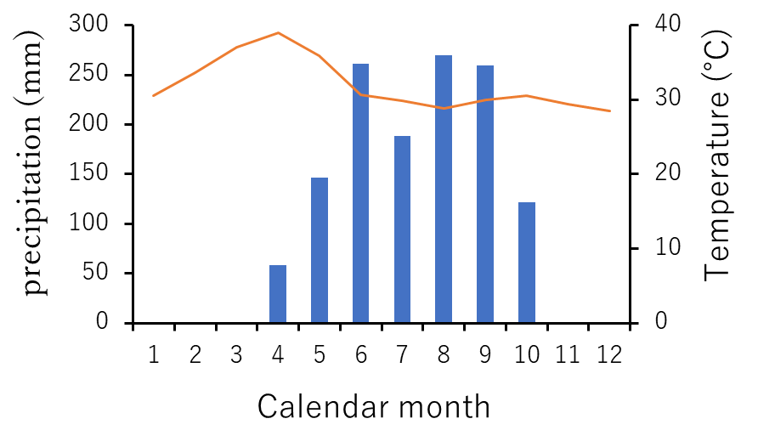
Figure S1. Average monthly temperature and precipitation on the Bago Mountains, Ottarathiri Township, Naypyitaw Union Territory, Myanmar.

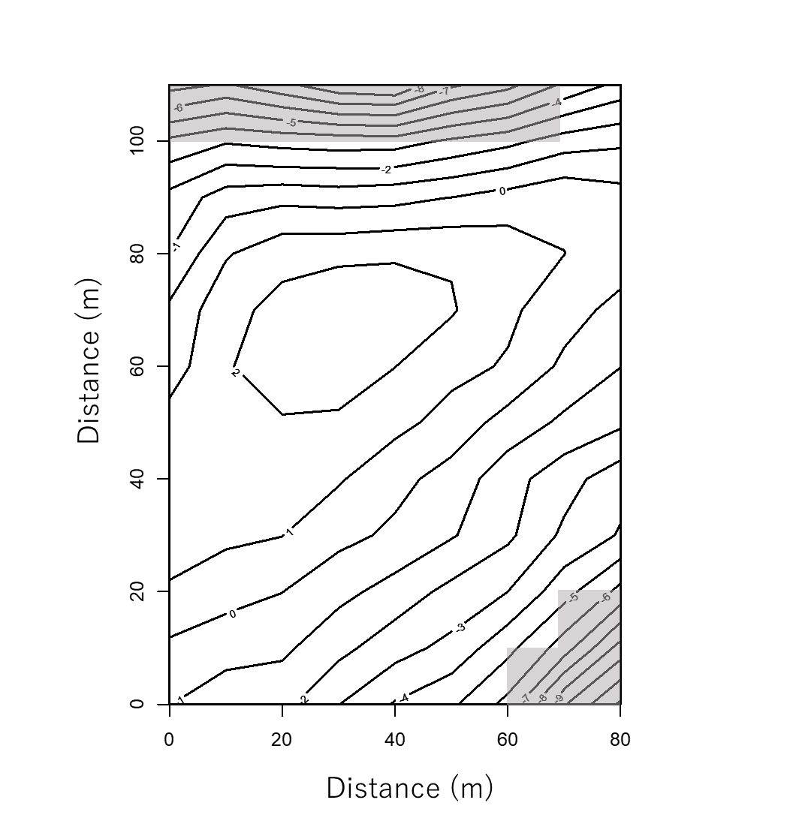

Figure S2. Distribution of steep slope quadrats (shaded areas, n = 9) and gentle slope quadrats (non-shaded areas, n = 79) in the plot in a commercial tree plantation forest on the Bago Mountains, Ottarathiri Township, Naypyitaw Union Territory, Myanmar. The contour interval is 1 m in elevation.
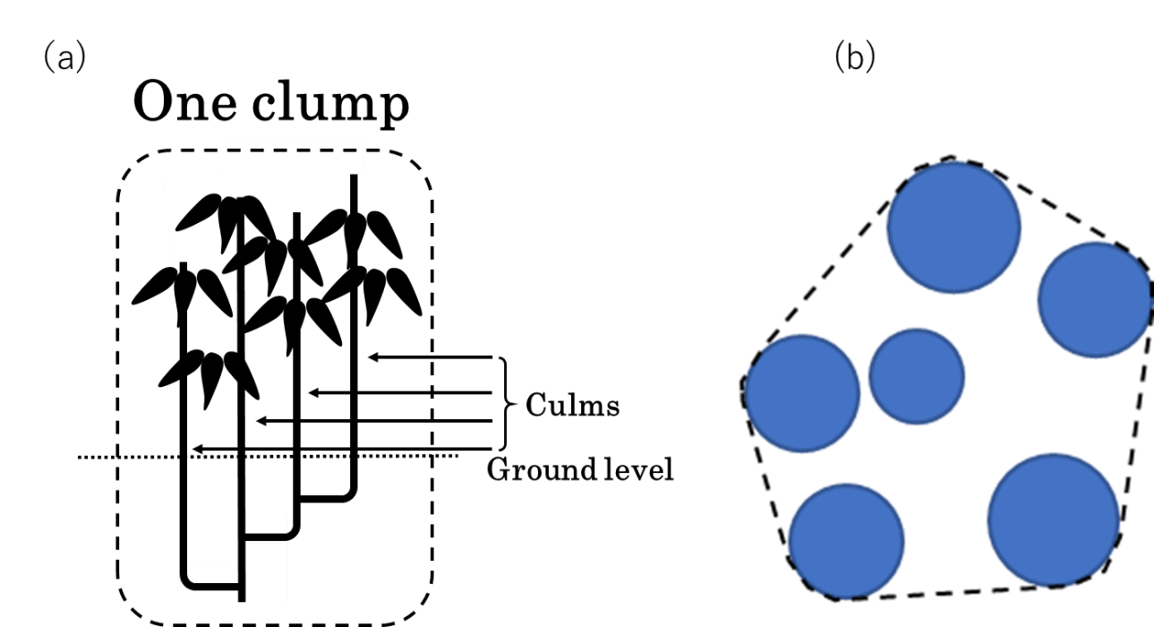
Figure S3. (a) Schematic diagram showing a bamboo plant with pachymorphic rhizomes. A clump (genet) comprising four culms is shown. (b) Transverse sectional view of a bamboo clump at breast height. A clump with six culms is shown. We measured the perimeter of the polygon formed by the culms in a clump at breast height, which is shown by the dotted line. By approximating the polygon to a circle with the same length of circumference, the perimeter of the polygon was converted into the diameter of the circle. This diameter is termed the “clump diameter”.

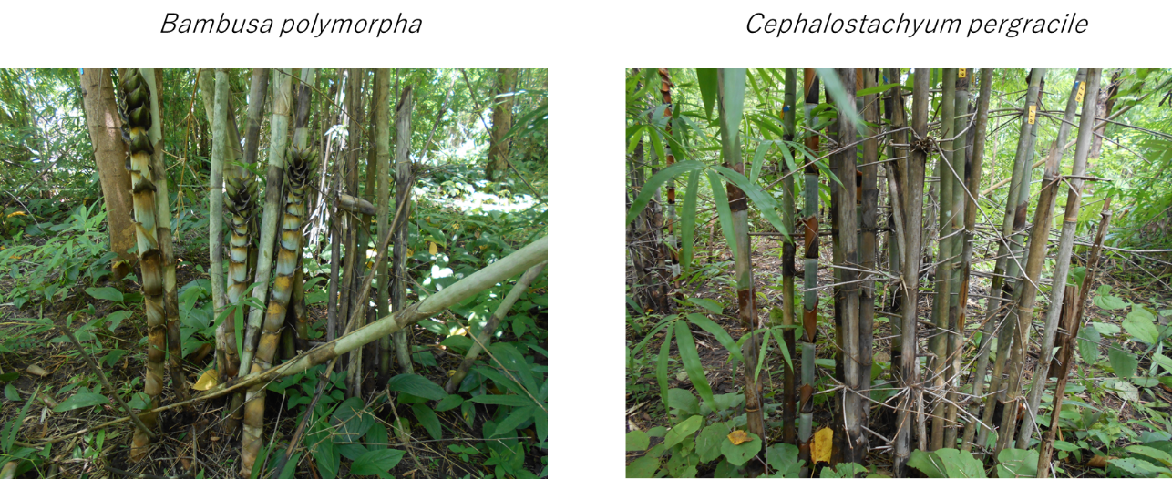
Figure S4. Photograph of Bambusa polymorpha and Cephalostachyum pergracile
on the Bago Mountains, Ottarathiri Township, Naypyitaw Union Territory, Myanmar.

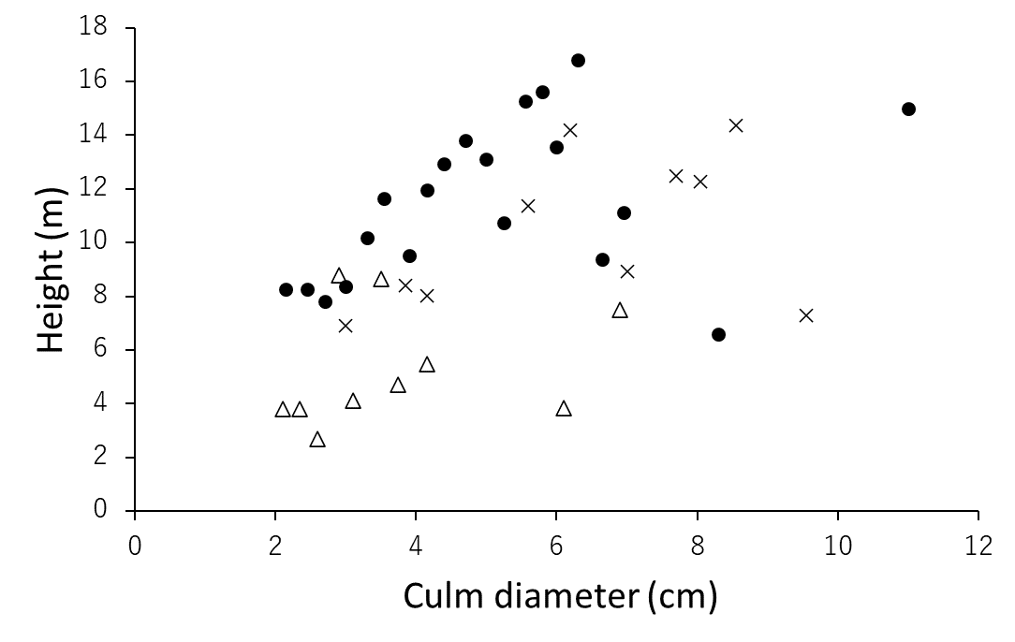
Figure S5. Relationship between height and culm diameter at breast height of Cephalostachyum pergracile, Bambusa polymorpha, and Dinochloa maclellandii in a commercial tree plantation forest on the Bago Mountains, Ottarathiri Township, Naypyitaw Union Territory, Myanmar.

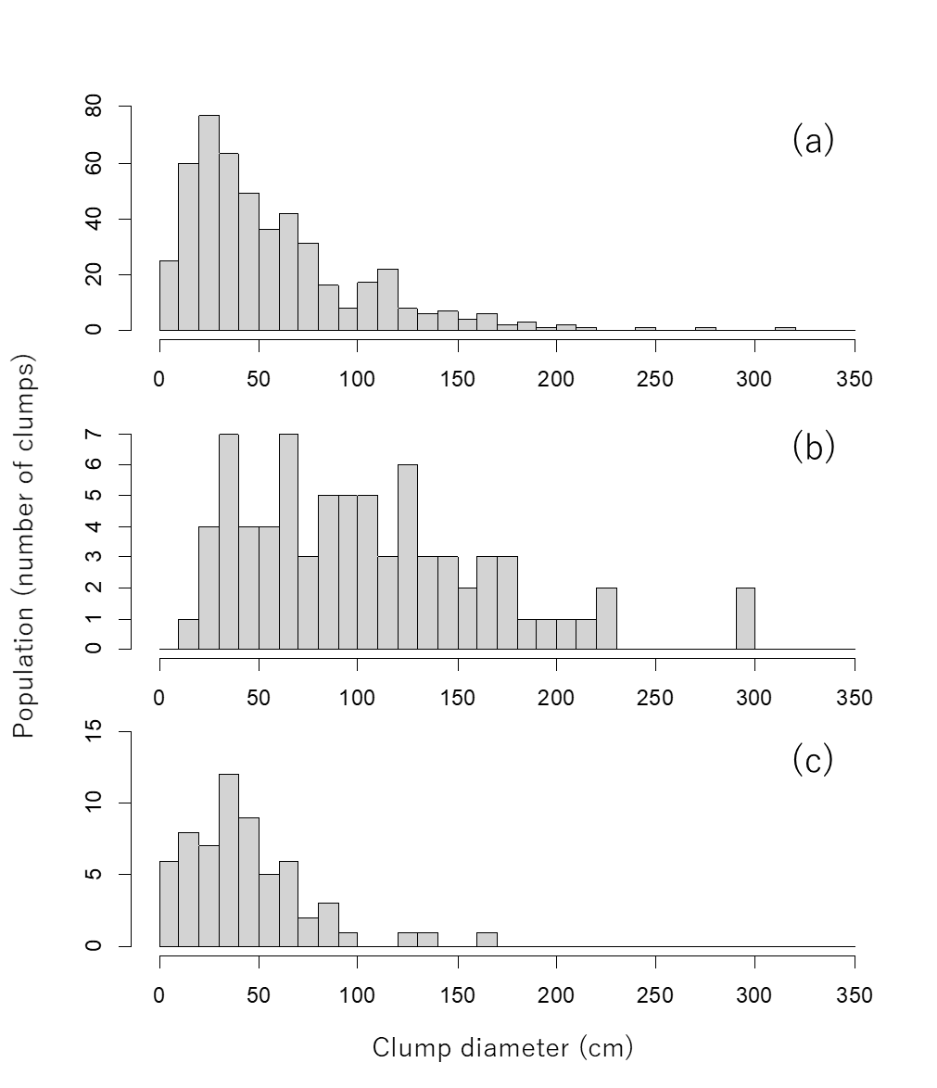
Figure S6. Frequency distribution of clump diameter for Cephalostachyum pergracile (a; n = 489); Bambusa polymorpha (b; n = 76), and Dinochloa maclellandii (c; n = 62) in a commercial tree plantation forest on the Bago Mountains, Ottarathiri Township, Naypyitaw Union Territory, Myanmar. Clump diameter was defined as the diameter of the circle fitted to the perimeter of the polygon formed by the culms of a clump (see Fig. S4b). We assumed that clumps with a clump diameter > 50 cm are large for C. pergracile and B. polymorpha, and those clumps > 20 cm for D. maclellandii. These clumps usually had a culm that attained the maximum attainable height of the species (see Fig. S5). Only large clumps were considered for the spatial analyses.

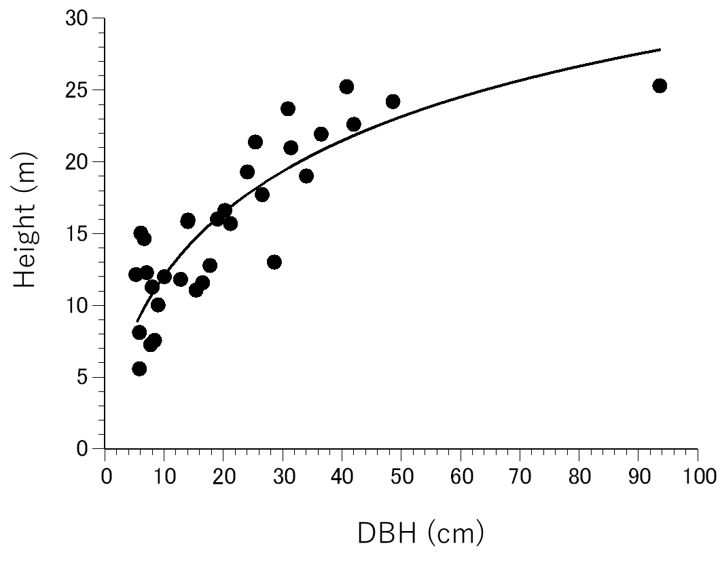
Figure S7. Relation between height and diameter at breast height (DBH) of trees in a commercial tree plantation forest on the Bago Mountains, Ottarathiri Township, Naypyitaw Union Territory, Myanmar. Only two trees in the plot attained DBH > 50 cm; we measured the height of one of these trees. A regression curve is also shown by a thick line: Y = 1/(3.73X^{0.64}) + 1/46.9, R² = 0.738.

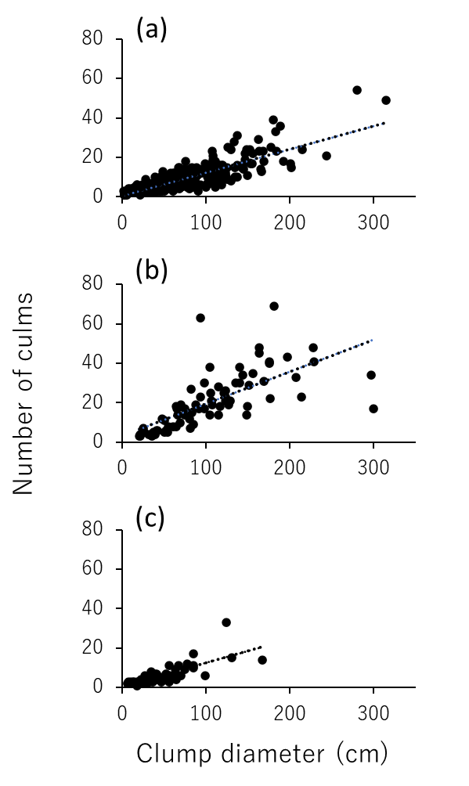
Figure S8. Relationship between number of culms in a clump and clump diameter for Cephalostachyum pergracile (a), Bambusa polymorpha (b), and Dinochloa maclellandii (c) in a commercial tree plantation forest on the Bago Mountains, Ottarathiri Township, Naypyitaw Union Territory, Myanmar. Clump diameter was defined as the diameter of the circle approximated to the perimeter of the polygon formed by the culms of a clump (see Fig. S3b). Regression lines are also shown by dotted lines; Y = 0.125X, R² = 0.72 for Cephalostachyum pergracile, Y = 0.186X, R² = 0.470 for Bambusa polymorpha, and Y = 0.129X, R² = 0.600 for Dinochloa maclellandii.

