Supplementary Information

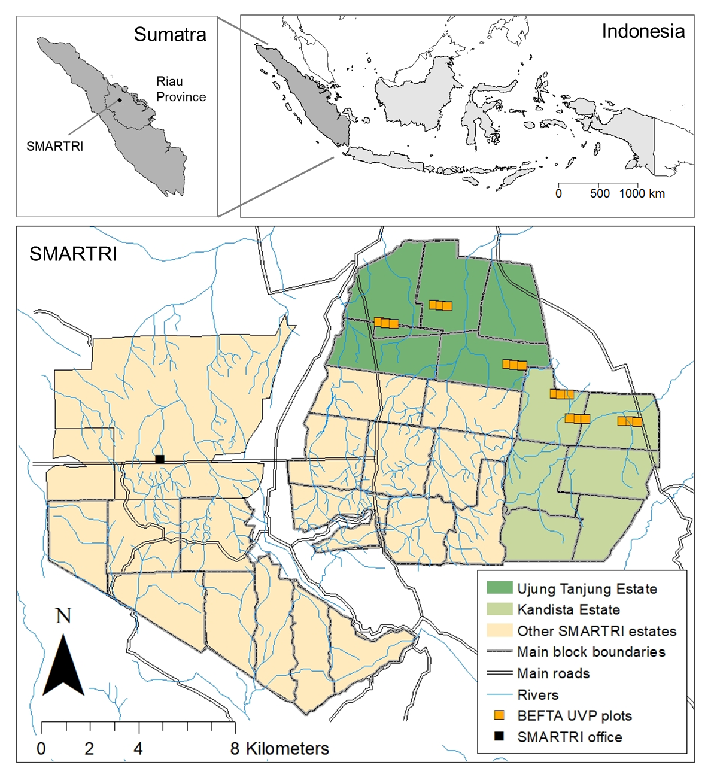
Supplementary Information 1. Maps showing the location of the BEFTA Understory Vegetation Project (BEFTA UVP) plots within mature oil palm estates receiving management advice from Sinar Mas Agro Resources and Technology Research Institute (SMARTRI), within Sumatra, and within Indonesia. Indonesia and Sumatra maps were drawn using library “maps” in R statistical package (Brownrigg, 2016; R Core Team, 2017). The SMARTRI map was constructed using ArcMap 10.5.1 GIS Software (Environmental Systems Research Institute (ESRI), 2017), with reference to maps produced by Sinar Mas. This figure is reproduced, with the permission of the authors, from Luke et al., (2019).

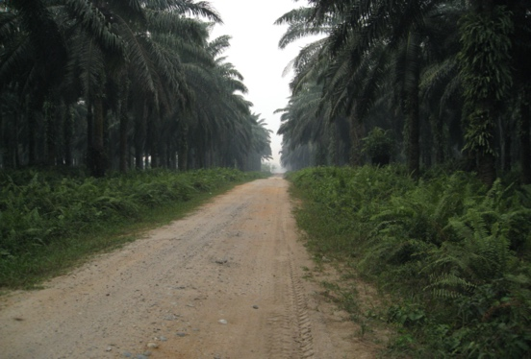
Road

‘‘Edge’’ habitat

‘‘Core’’ habitat

Drainage ditch
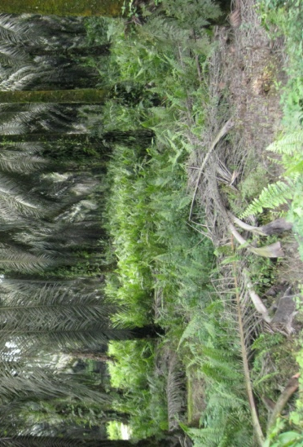

Supplementary Information 2. Schematic showing the design of the BEFTA Understory Vegetation Project. The figure represents a triplet of three plots located beside a road lined by a drainage ditch, and with roads running through the spaces between plots. Drainage ditches are common along roadsides within our study plantations. The red line along the edge of each plot, in between the road and the drainage ditch, shows the location of the Edge microhabitat transect that was surveyed in this study. Each plot has a core 50 x 50 m area, the perimeter of which served as the Core microhabitat transect surveyed in this study. This 50 x 50 m area is surrounded by a buffer region of 150 x 150 m which received the same understory management treatment. At the time of our study, each plot received the same understory management treatment, which included intermediate levels of herbicide spraying around palms and along access paths to facilitate harvesting. The triplet design is replicated six times across the SMARTRI landscape, with three triplets located in Ujung Tanjung Estate, and three triplets within Kandista Estate – see Figure S1. The photographs [credit: Julia Drewer] give an example of what the understory vegetation looked like in the Core and Edge habitats.

Supplementary Information 3:
Calculations of transect survey volume.
Edge habitat survey volume: Width (5 m) x Height (5 m) x Length (150 m) = 3750 m³
Core habitat survey volume: Width (5 m) x Height (5 m) x Length (200 m – 1.25 m) = 4969 m³

Supplementary Information 4:
Excel file of raw data, uploaded on The University of Cambridge Online Digital Depository at https://doi.org/10.17863/CAM.96818

