SUPPLEMENTARY INFORMATION
Table S1. Presence absence of species by transect
 | Pasture | Pasture | T-15 | T-15 | T-10 | T-7 | T-7 | Old | Old
Bay Wren (Cantorchilus nigricapillus) | 0 | 0 | 0 | 0 | 1 | 0 | 0 | 0 | 0
Northern Barred Woodcreeper (Dendrocolaptes sanctithomae) | 0 | 0 | 0 | 1 | 0 | 0 | 0 | 1 | 1
Blue-gray Tanager (Thraupis episcopus) | 1 | 0 | 0 | 0 | 0 | 0 | 0 | 0 | 0
Black Vulture (Coragyps atratus ) | 1 | 0 | 0 | 0 | 0 | 0 | 0 | 0 | 0
Boat-billed Flycatcher  (Megarynchus pitangua) | 1 | 1 | 1 | 1 | 1 | 0 | 0 | 0 | 0
Brown Jay  (Psilorhinus morio) | 1 | 1 | 1 | 0 | 1 | 1 | 1 | 1 | 1
Buff-throated Saltatar (Saltator maximus) | 0 | 1 | 0 | 0 | 1 | 1 | 0 | 0 | 0
Steely-vented Hummingbird (Amazilia saucerrotei) | 0 | 0 | 0 | 0 | 0 | 0 | 1 | 0 | 0
Cabanis's Wren (Cantorchilus modestus) | 1 | 1 | 1 | 1 | 1 | 1 | 1 | 1 | 1
Canada Warbler  (Cardellina canadensis) | 0 | 0 | 1 | 0 | 0 | 0 | 0 | 0 | 0
Clay-colored Thrush  (Turdis grayi) | 1 | 0 | 1 | 1 | 1 | 0 | 0 | 0 | 0
Common Pauraque  (Nyctidromus albicollis) | 0 | 0 | 0 | 0 | 1 | 0 | 0 | 1 | 0
Common Tody-Flycatcher (Todirostrum cinereum) | 1 | 0 | 0 | 0 | 0 | 0 | 0 | 0 | 0
Crested Guan  (Penelope purpurascens) | 0 | 0 | 0 | 0 | 0 | 0 | 0 | 1 | 0
Dusky-capped Flycatcher  (Myiarchus tuberculifer) | 1 | 1 | 1 | 1 | 1 | 1 | 0 | 1 | 0
Eastern Meadowlark  (Sturnella magna) | 0 | 1 | 0 | 0 | 0 | 0 | 0 | 0 | 0
Gray-crowned Yellowthroat  (Geothlypis poliocephala) | 1 | 1 | 0 | 0 | 1 | 1 | 1 | 0 | 0
Gray-headed Chachalaca  (Ortalis cinereiceps) | 0 | 0 | 0 | 0 | 1 | 0 | 0 | 0 | 0
Great Kiskadee (Pitangus sulphuratus) | 1 | 0 | 1 | 0 | 0 | 0 | 0 | 0 | 0
Great-tailed Grackle  (Quiscalus mexicanus) | 1 | 0 | 1 | 0 | 0 | 0 | 0 | 0 | 0
Hepatic Tanager  (Piranga flava) | 1 | 0 | 0 | 0 | 0 | 0 | 0 | 0 | 0
Hoffmann’s Woodpecker  (Melanerpes hoffmannii) | 1 | 1 | 1 | 0 | 1 | 1 | 0 | 0 | 1
House Wren  (Troglodytes aedon) | 1 | 1 | 1 | 1 | 1 | 0 | 1 | 0 | 0
Keel-billed Toucan  (Ramphastos sulfuratus) | 0 | 0 | 0 | 1 | 0 | 0 | 0 | 0 | 0
Laughing Falcon (Herpetotheres cachinnans) | 0 | 0 | 0 | 0 | 0 | 1 | 0 | 0 | 0
Lesson’s Motmot  (Momotus lessonii) | 0 | 0 | 1 | 1 | 1 | 1 | 0 | 1 | 1
Lesser Greenlet  (Pachysylvia decurtatus) | 0 | 0 | 0 | 0 | 0 | 1 | 0 | 0 | 0
Lesser Violetear  (Colibri cyanotus) | 0 | 0 | 1 | 0 | 0 | 0 | 0 | 0 | 0
Lineated Woodpecker  (Dryocopus lineatus) | 0 | 0 | 0 | 0 | 1 | 0 | 0 | 0 | 0
Long-tailed Manakin  (Chiroxiphia linearis) | 0 | 0 | 1 | 1 | 1 | 1 | 0 | 1 | 1
Masked Tityra  (Tityra semifasciata) | 0 | 0 | 1 | 0 | 0 | 0 | 0 | 0 | 0
Mountain Elaenia (Elaenia frantzii) | 0 | 0 | 0 | 1 | 0 | 0 | 0 | 0 | 0
Northern Emerald-Toucanet (Aulacorhynchus prasinus) | 0 | 0 | 0 | 1 | 1 | 1 | 0 | 1 | 1
Orange-billed Nightingale-Thrush (Catharus aurantiirostris) | 0 | 0 | 1 | 1 | 1 | 1 | 1 | 1 | 1
Orange-bellied Trogan (Trogon collaris aurantiiventris) | 0 | 0 | 1 | 1 | 0 | 0 | 0 | 1 | 0
Olivaceous Woodcreeper (Sittasomus griseicapillus) | 0 | 0 | 1 | 0 | 1 | 0 | 0 | 1 | 1
Ovenbird (Seiurus aurocapilla) | 0 | 0 | 1 | 0 | 1 | 0 | 0 | 1 | 0
Philadelphia Vireo  (Vireo philadelphicus) | 0 | 0 | 0 | 0 | 1 | 0 | 0 | 0 | 0
Rufous-and-white Wren (Thryophilus rufalbus) | 0 | 0 | 1 | 1 | 1 | 1 | 0 | 1 | 1
Rose-breasted Grosbeak (Pheucticus ludovicianus) | 1 | 0 | 0 | 0 | 0 | 0 | 0 | 0 | 0
Rufous-browed Peppershrike (Cyclarhis gujanensis) | 0 | 0 | 0 | 0 | 1 | 1 | 0 | 1 | 0
Red-billed Pigeon (Patagioenas flavirostris) | 1 | 0 | 1 | 1 | 1 | 1 | 1 | 0 | 1
Rufous-capped Warbler (Basileuterus rufifrons) | 1 | 0 | 1 | 1 | 1 | 1 | 1 | 1 | 1
Rufous-tailed Hummingbird (Amazilia tzacatl) | 0 | 0 | 0 | 1 | 0 | 0 | 0 | 0 | 0
Streaked-headed Woodcreeper (Lepidocolaptes souleyetii) | 0 | 1 | 1 | 1 | 0 | 0 | 0 | 1 | 0
Social Flycatcher (Myiozetetes similis) | 1 | 1 | 0 | 0 | 0 | 0 | 0 | 0 | 0
Squirrel Cuckoo (Piaya cayana) | 1 | 0 | 0 | 0 | 0 | 1 | 0 | 1 | 0
Swainson’s Hawk (Buteo swainsoni) | 1 | 0 | 1 | 0 | 0 | 0 | 0 | 0 | 0
Thicket Tinamou (Crypturellus cinnamomeus) | 0 | 0 | 1 | 1 | 1 | 0 | 0 | 0 | 0
Tropical Kingbird (Tyrannus melancholicus) | 1 | 0 | 0 | 0 | 0 | 0 | 0 | 0 | 0
Turkey Vulture (Cathartes aura) | 0 | 0 | 1 | 1 | 0 | 0 | 0 | 0 | 0
Three-wattled Bellbird (Procnias tricarunculatus) | 1 | 0 | 0 | 0 | 0 | 1 | 0 | 0 | 0
White-eared Ground-Sparrow (Melozone leucotis) | 1 | 0 | 1 | 1 | 1 | 1 | 1 | 1 | 1
White-fronted Parrot (Amazona albifrons) | 1 | 1 | 1 | 1 | 0 | 1 | 0 | 0 | 0
Wilson’s Warbler (Cardellina pusilla) | 0 | 0 | 0 | 1 | 0 | 0 | 0 | 0 | 0
Wood Thrush (Hylocichla mustelina) | 0 | 0 | 1 | 0 | 0 | 0 | 0 | 0 | 0
White-tipped Dove (Leptotila verreauxi) | 0 | 1 | 1 | 0 | 1 | 1 | 0 | 0 | 0
White-throated Magpie-Jay (Calocitta Formosa) | 1 | 0 | 0 | 0 | 0 | 0 | 0 | 0 | 0
Yellow-crowned Euphonia (Euphonia luteicapilla) | 1 | 0 | 1 | 0 | 0 | 0 | 0 | 0 | 0
Yellow Warbler (Setophaga petechia) | 1 | 0 | 0 | 0 | 0 | 0 | 0 | 0 | 0
Yellow-faced Grassquit (Tiaris olivaceus) | 1 | 0 | 0 | 0 | 1 | 1 | 1 | 0 | 0

Figure S1. Non-metric dimensional scaling of community composition by successional stage including species contributions to NMDS scores. Symbols represent NMDS scores for each site in this study. Text gives four-letter species code to show contributions to NMDS scores from individual species. AOU Dissimilarities used were calculated using the Bray-Curtis method.
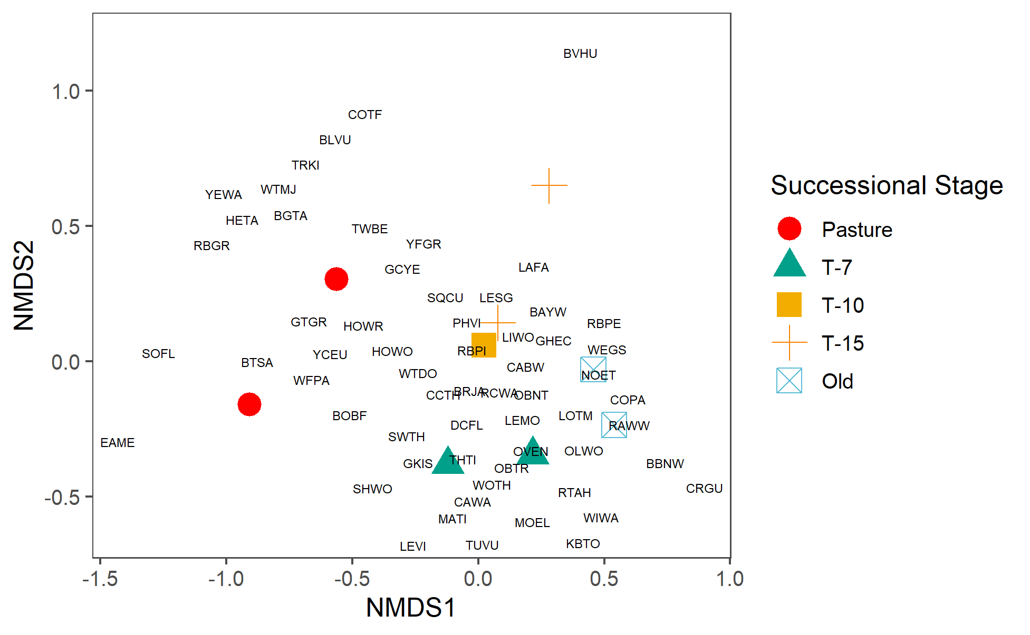

1. IUCN. The IUCN Red List of Threatened Species. Version 2022-1. In: https://www.iucnredlist.org. 2022.

