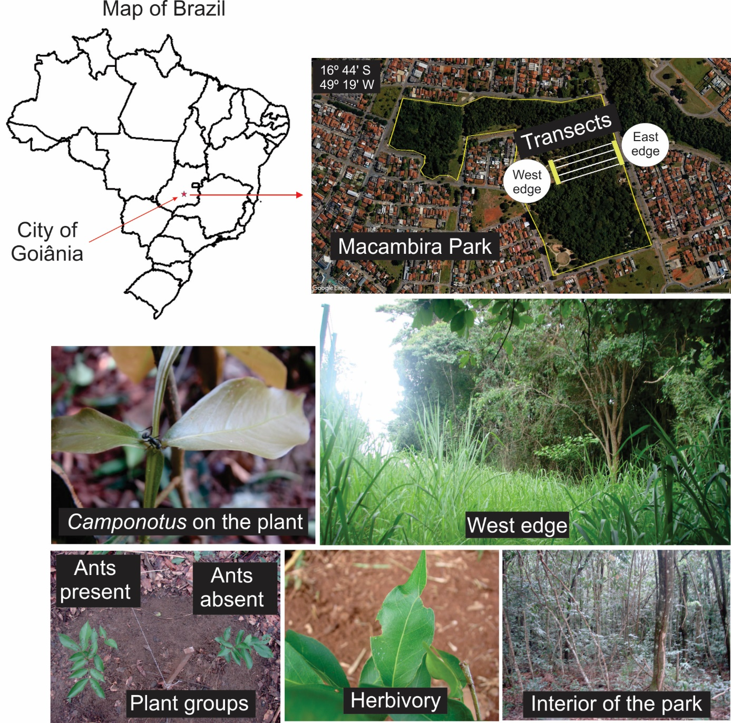
Supplementary material 1. Characteristics of the study, such as the limits of the park, the delimitation of transects and the so-called west and east edges; the ants of the genus Camponotus, which visited the study plants; the herbivory which was considered as the leaf area loss.

