Electronic Supplementary Material

Body mass determines the role of mammal species in a frugivore-large fruit interaction network in a Neotropical savanna

Larissa Gabriela Araujo Goebel^{1,2}*, Breno Dias Vitorino^{1,} Angélica Vilas Boas da Frota¹, Manoel dos Santos-Filho^{1,2}

¹ Programa de Pós-graduação stricto sensu em Ciências Ambientais, Centro de Pesquisa em Limnologia, Biodiversidade e Etnobiologia do Pantanal, Universidade do Estado de Mato Grosso, Cáceres, Mato Grosso, Brazil.
²Laboratório de Mastozoologia, Universidade do Estado de Mato Grosso, Cáceres, Mato Grosso, Brazil.

* E-mail larissagabriela_goebel@hotmail.com (corresponding author)

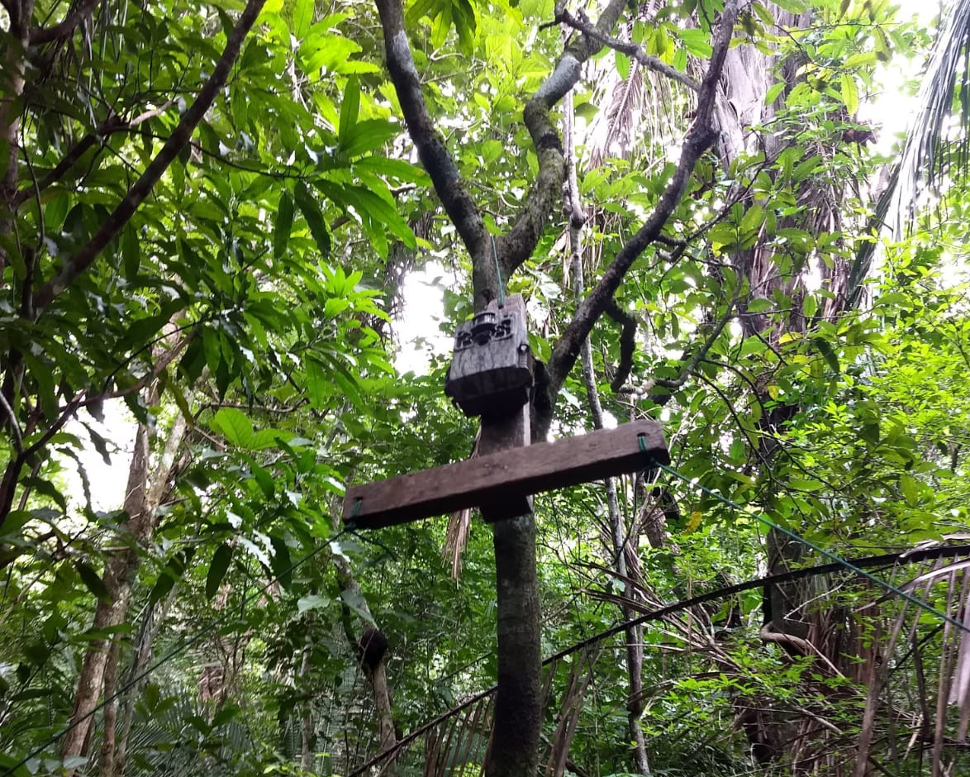
Figure S1. Wooden structure created to record frugivorous species with arboreal habits, designed for the branches with the highest fruit abundance.

Table S1. Phenology of the seven plant species sampled in the Serra das Araras Ecological Station, Brazil. The black color fills indicate the fruiting months of the species. The species were classified in ascending order according to the number of fruiting months.
Species | Jan | Feb | Mar | Apr | May | Jun | Jul | Aug | Sep | Oct | Nov | Dec | Total
Cordiera macrophylla |  |  |  |  |  |  |  |  |  |  |  |  | 2
Diospyros hispida |  |  |  |  |  |  |  |  |  |  |  |  | 2
Hymenaea courbaril |  |  |  |  |  |  |  |  |  |  |  |  | 3
Pouteria ramiflora |  |  |  |  |  |  |  |  |  |  |  |  | 3
Genipa americana |  |  |  |  |  |  |  |  |  |  |  |  | 4
Dipteryx alata |  |  |  |  |  |  |  |  |  |  |  |  | 7
Attalea speciosa |  |  |  |  |  |  |  |  |  |  |  |  | 12

Table S2. List of plant species and their respective characteristics, obtained from Matsuoka (2008), Mitja (2008), Cobra et al. (2015), Peres (2016) and Kuhlmann (2018).
Species | Fruit size (mm) | Seed size (mm) | Number of seeds per fruit
Hymenaea courbaril L. | 150 | 30 | 10
Genipa americana L. | 100 | 10 | 50
Pouteria ramiflora (Mart.) Radlk | 60 | 25 | 1
Cordiera macrophylla (K.Schum.) Kuntze | 40 | 3 | 41
Diospyros hispida A.DC. | 60 | 20 | 6
Dipteryx alata Vogel | 60 | 30 | 1
Attalea speciosa Mart. ex Spreng | 120 | 50 | 8

References

Cobra SSO, Nascimento F, Antoniazzi SA, Krause W and Silva CA (2015) Biologia reprodutiva de Cordiera macrophylla (K. Schum.) Kuntze (Rubiaceae), espécie dioica da região sudoeste do estado de Mato Grosso, Brasil. Revista Ceres. 62, 516-523.

Kuhlmann M (2018) Frutos e Sementes do Cerrado: Espécies Atrativas Para A Fauna; Ipsis Gráfica e Editora: Brasília, Brazil, pp. 1–464.

Matsuoka LG (2008) Morfo-anatomia dos ovários e dos frutos e sistemática de Alibertia e Cordiera (Rubiaceae, Gardeniae) PhD Dissertation. Universidade Federal de Goiás, Goiás.

Mitja D, Souza-Silva JCS, Melo SL, Filho HC (2008) Biometria de frutos e sementes de Babaçu, Natividade-TO. In: IX Simpósio Nacional do Cerrado e II Simpósio Internacional de Savanas Tropicais, Brasília: Embrapa Cerrados.

Peres MK (2016) Estratégias de dispersão de sementes do bioma Cerrado: Considerações ecológicas e filogenétricas. PhD Thesis. Universidade de Brasília, Brasília.

