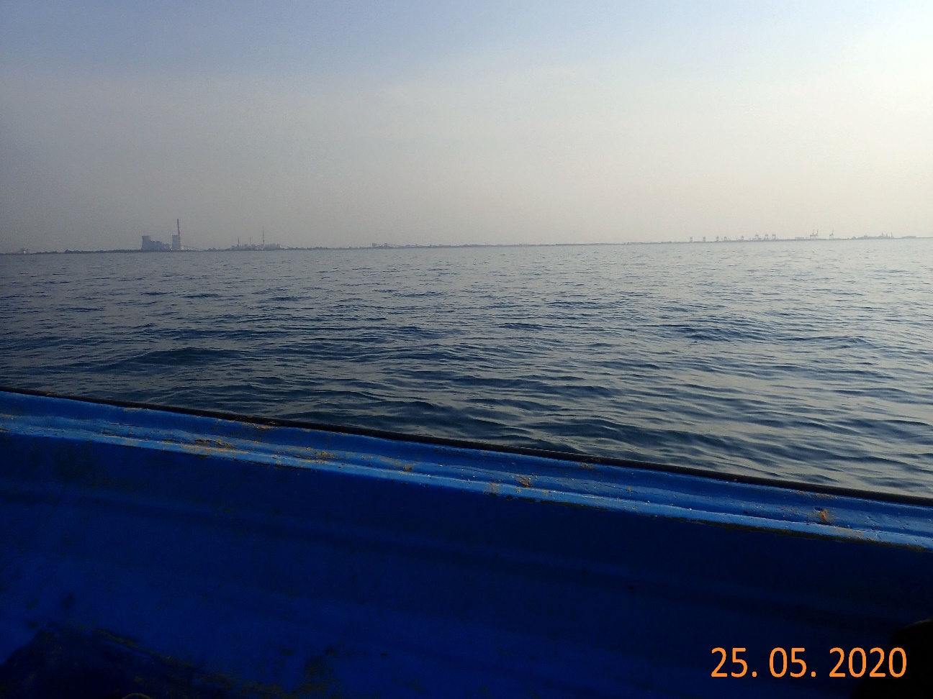
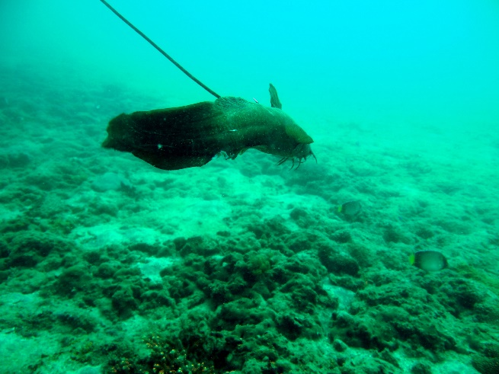
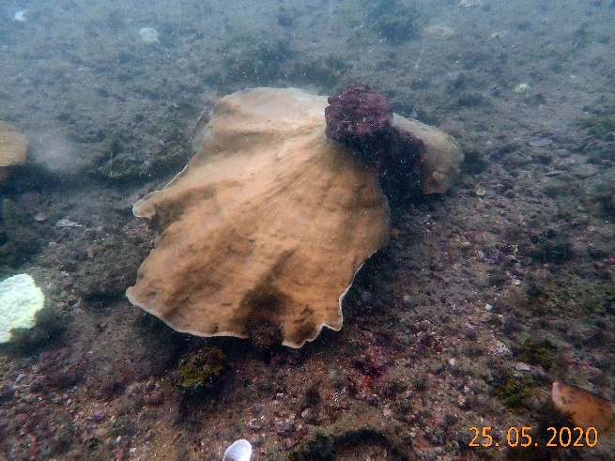
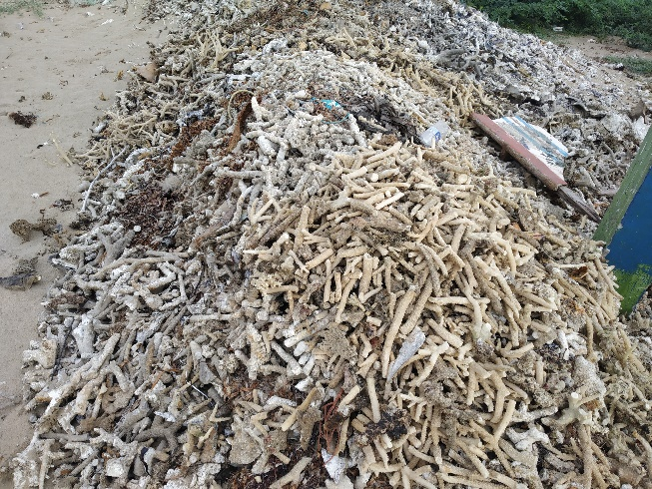
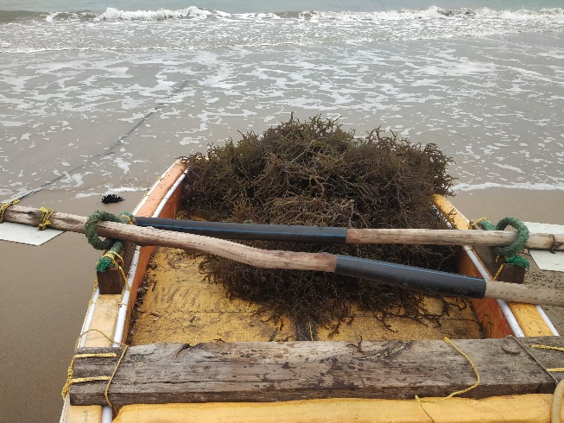
a
d
e
c
b

Supplementary Fig. 4. Human-induced threats in the mainland patch reef;
a, industries in the vicinity; b, spearfishing; c, tilted Turbinaria colony by fishing activity; d, heaped coral bycatch from bottom settling nets; e, cultivation of invasive Kappaphycus alvarezii

