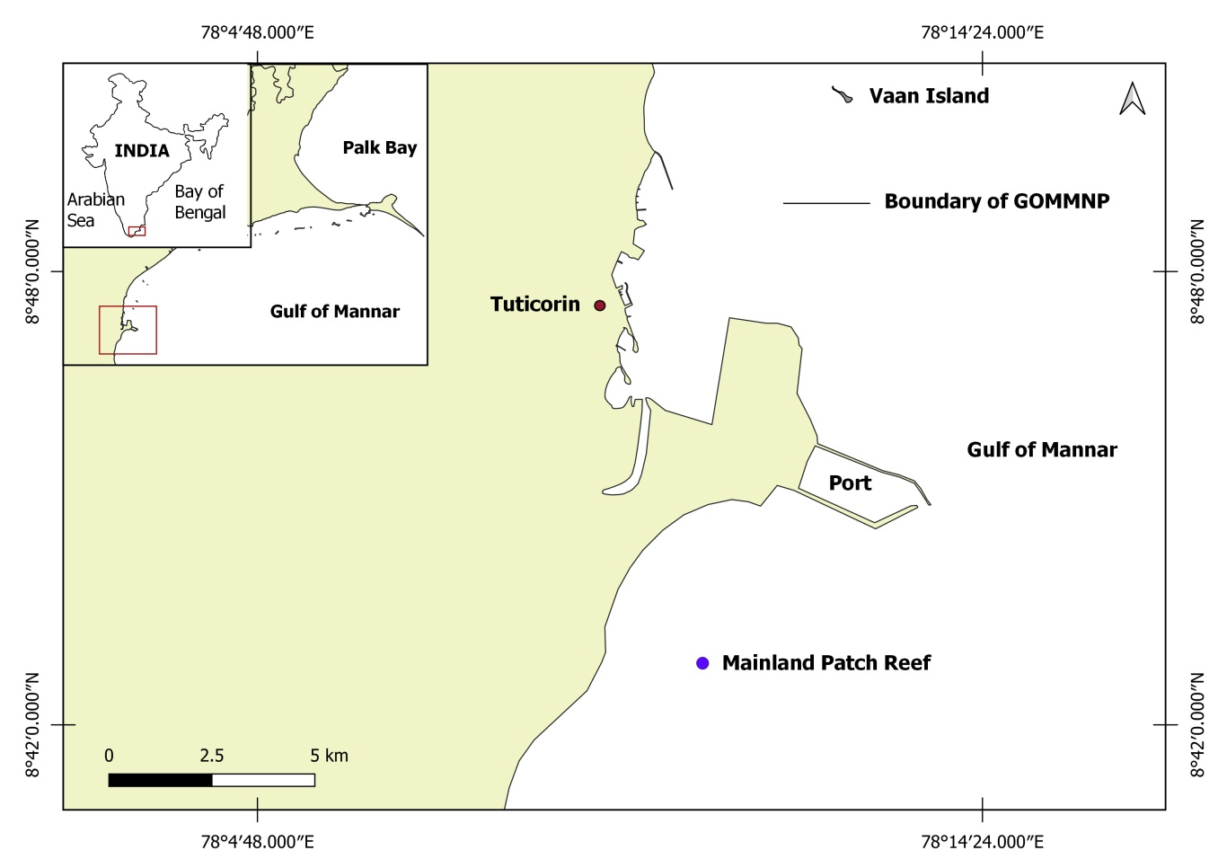

Supplementary Fig. 1. Map showing the study site (Mainland patch reef) in the Gulf of Mannar, India

