SUPPLEMENTARY INFORMATION for:
Larger insects in a colder environment? Elevational and seasonal intraspecific differences in tropical moth sizes on Mount Cameroon

Fotoula Papandreou^{1,2}, Jiří Hodeček^{1,3}, Vincent Maicher^{1,4,5}, Sylvain Delabye^{1,4,6}, Tomasz Pyrcz⁷, Robert Tropek^{1,4,*}

1 Department of Ecology, Faculty of Science, Charles University, Vinicna 7, CZ-12843 Prague, Czechia
2 Department of Forestry and Natural Environment, Faculty of Geosciences, International Hellenic University, GR-66100 Drama, Greece
3 University Center of Legal Medicine Lausanne – Geneva, Swiss Human Institute of Forensic Taphonomy, Chemin de La Vulliette 4, CH-1000, Lausanne 25, Switzerland
4 Institute of Entomology, Biology Centre, Czech Academy of Sciences, Branisovska 31, CZ-37005 Ceske Budejovice, Czechia
5 Nicholas School of the Environment, Duke University, 9 Circuit Dr., Durham, NC 27710, United States of America
6 Faculty of Science, University of South Bohemia, Branisovska 1760, CZ-37005 Ceske Budejovice, Czechia
7 Department of Evolution of Invertebrates, Institute of Zoology and Biomedical Research, Jagiellonian University, Gronostajowa 9, PL-30-387 Krakow, Poland *Corresponding author: robert.tropek@gmail.com

Supplementary Figure S1. Photos of the studied species of moths from Mount Cameroon.

Supplementary Figure S2. Elevational and seasonal patterns of forewing lengths of moths on Mount Cameroon, as analysed by GLMs (Table 1). A–M) Erebidae: Arctiinae, N–W) Erebidae: Lymantriinae, X–Y) Notodontidae, Z–AA) Lasiocampidae, AB) Sphingidae.

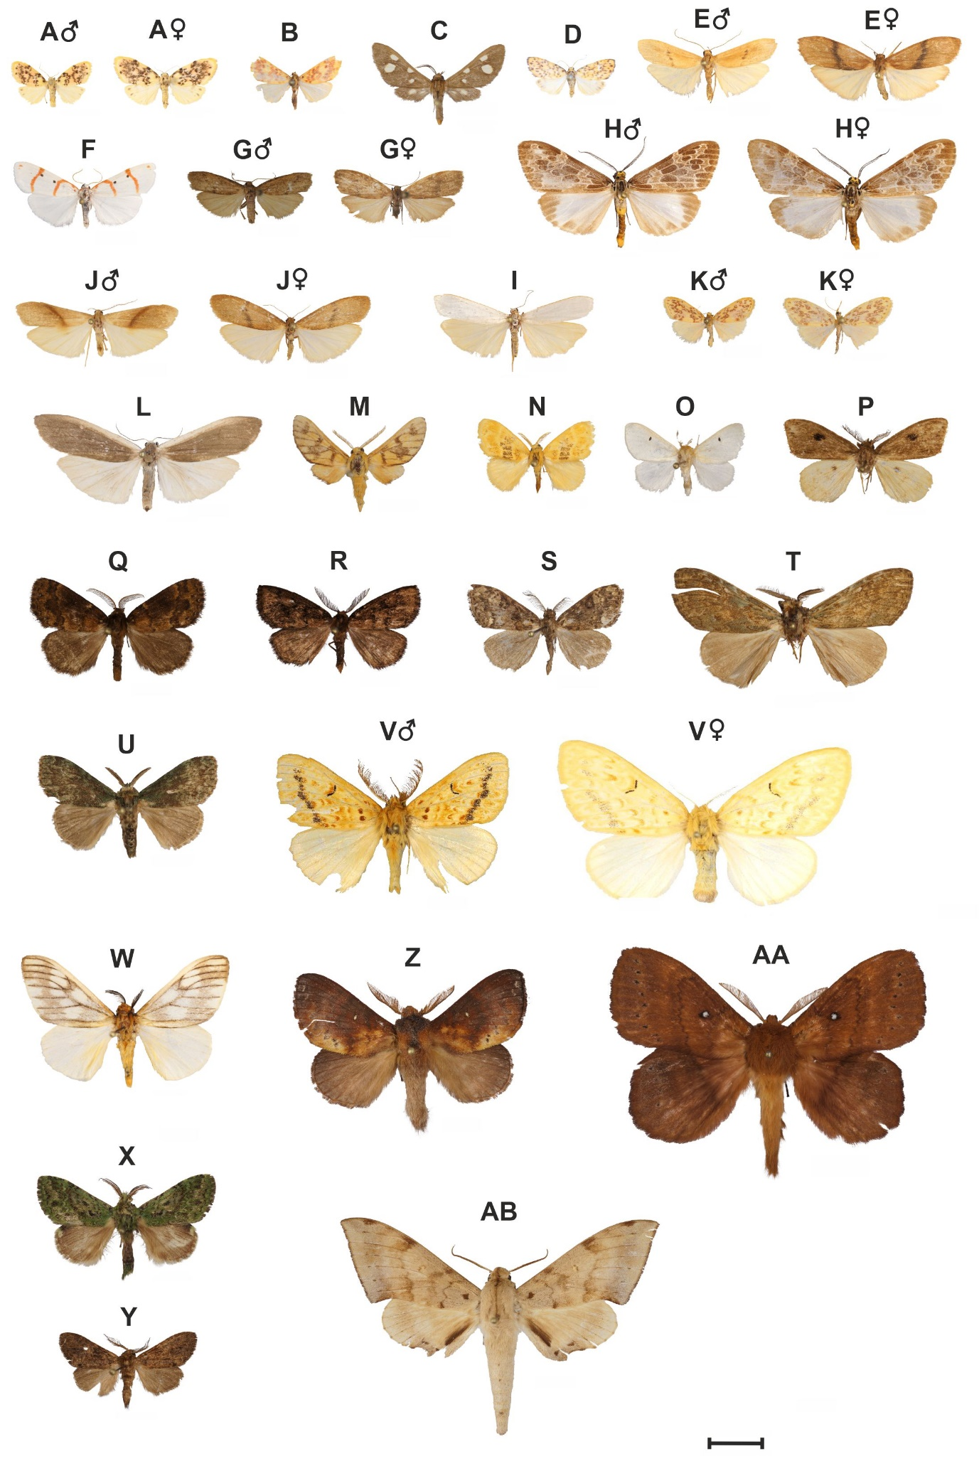
Supplementary Figure S1. Photos of the studied species of moths from Mount Cameroon. Erebidae, Arctiinae: A) Afrasura cf. numida; B) Afrasura cf. peripherica; C) Anapisa sp. “2”; D) Asura cf. craigii; E) Asythosia velutina; F) Cyana sp. “2”; G) Eilema cf. fletcheri; H) Galtara sp. “1”; I) Lamprosiella sp. “1”; J) Ligulosia costimaculata; K) Palaeugoa camerunensis; L) Phasmatilema sp. “1”; M) Rhipidarctia postrosea. Erebidae, Lymantriinae: N) Euproctis sp. “1”; O) Leucoma sp. “7”; P) Lymantriinae sp. “5”; Q) Lymantriinae sp. “54”; R) Lymantriinae sp. “55”; S) Lymantriinae sp. “58”; T) Lymantriinae sp. “65”; U) Lymantriinae sp. “75”; V) Mylantria xanthospila; W) Stracena cf. banana. Notodontidae: X) Desmeocraera sp. “1”; Y) Eurystaura sp. “1”. Lasiocampidae: Z) Mallocampa audea; AA) Mariaeia spargatana. Sphingidae: AB) Polyptychus nigriplaga. The scale bar represents 1 cm.

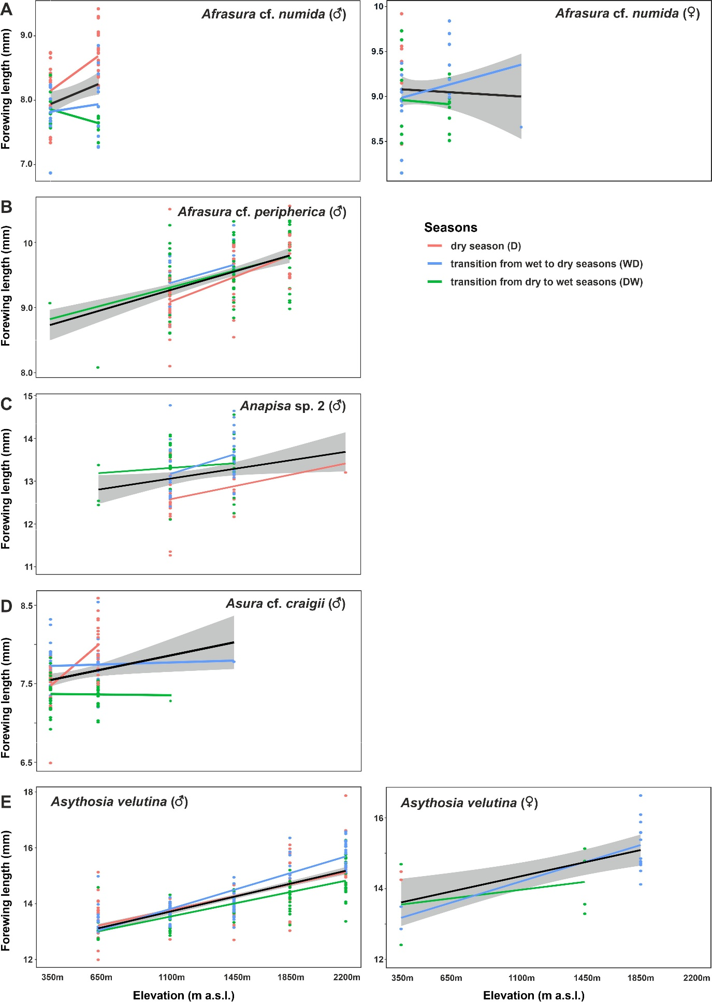
Supplementary Figure S2A–E. Elevational and seasonal patterns of forewing lengths of moths on Mount Cameroon. Erebidae: Arctiinae: A) Afrasura cf. numida (males and females), B) Afrasura cf. peripherica (males), C) Anapisa sp. "2" (males), D) Asura cf. craigii (males), and E) Asythosia velutina (males and females).
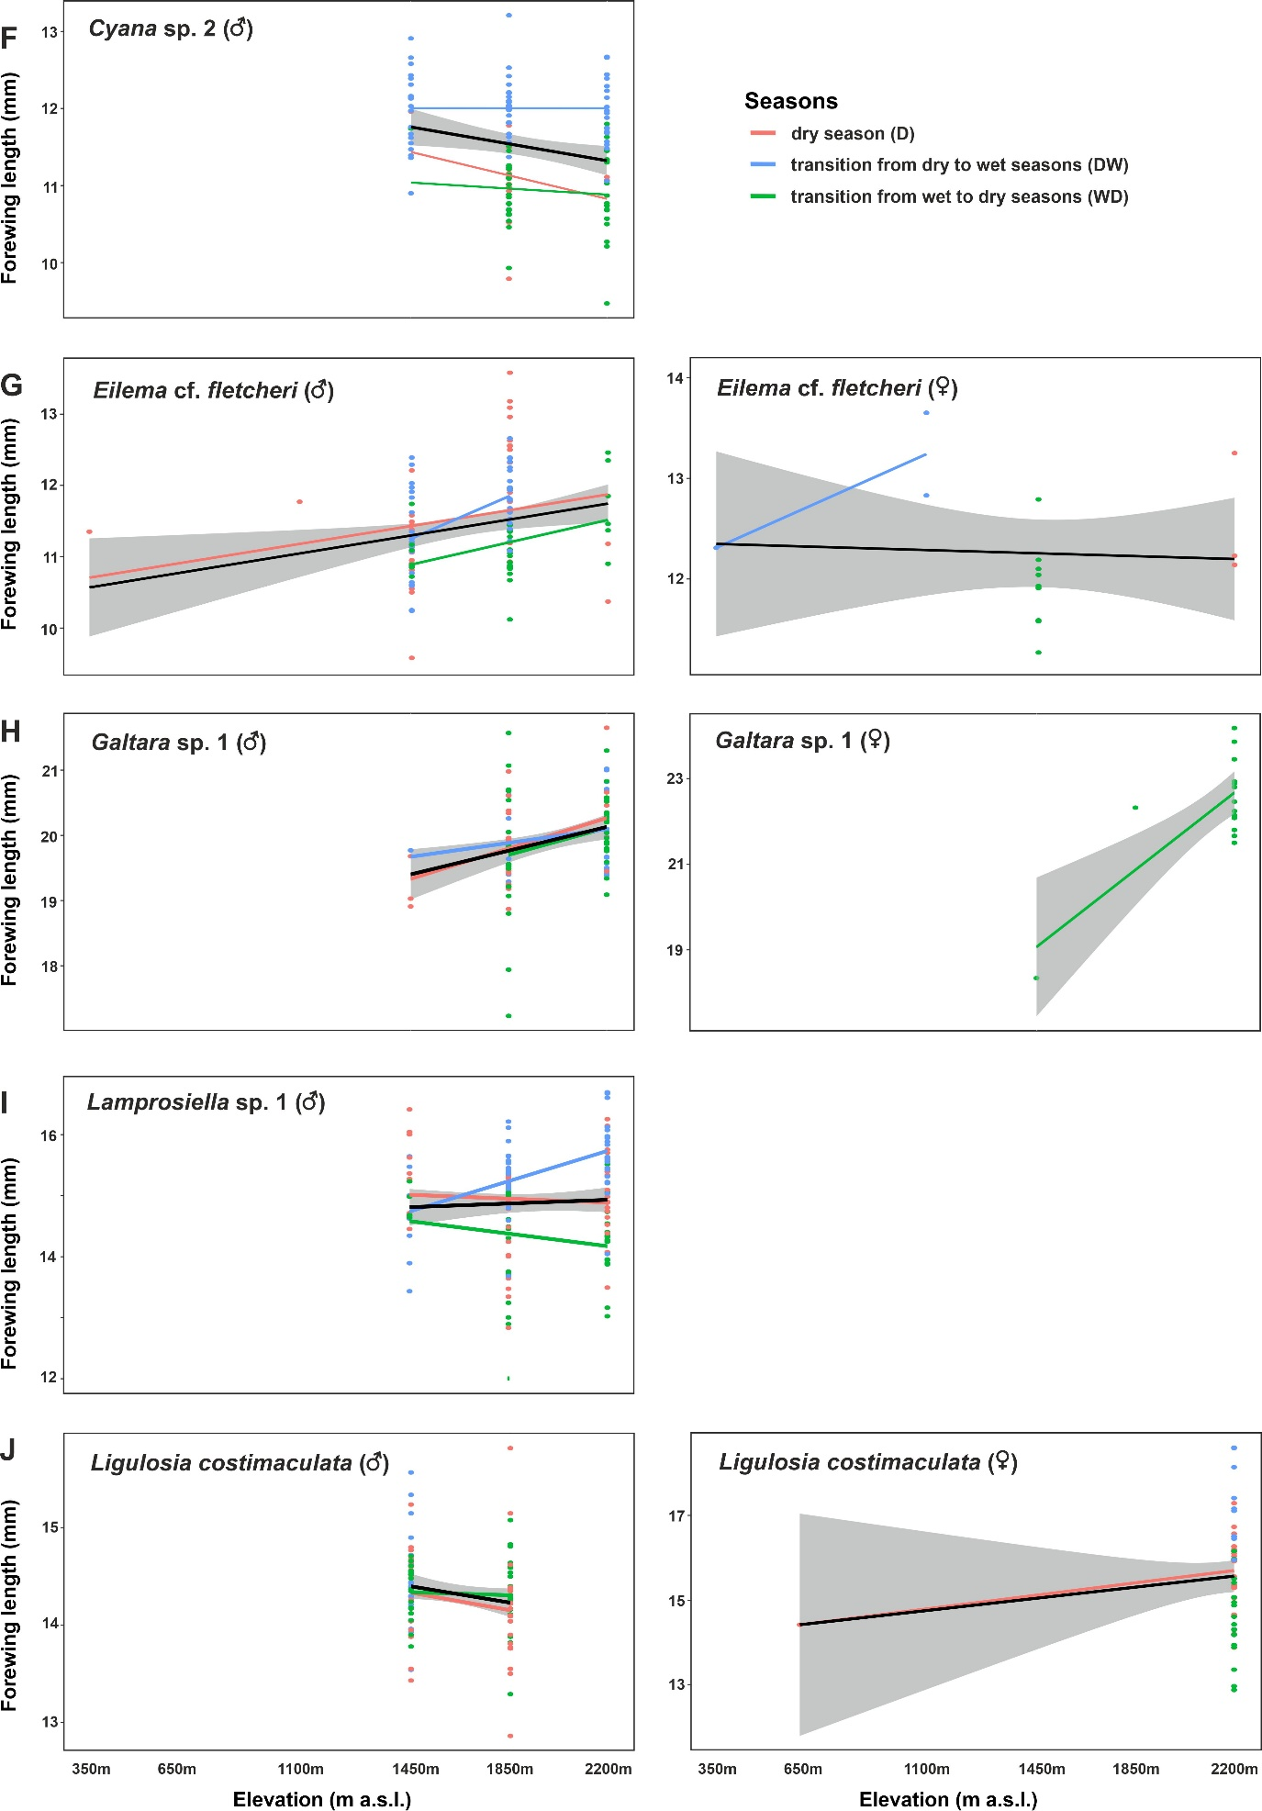
Supplementary Figure S2F–J. Elevational and seasonal patterns of forewing lengths of moths on Mount Cameroon. Erebidae: Arctiinae: F) Cyana sp. "2" (males), G) Eilema cf. fletcheri (males and females), H) Galtara sp. "1" (males and females), I) Lamprosiella sp. "1" (males), J) Ligulosia costimaculata (males and females).
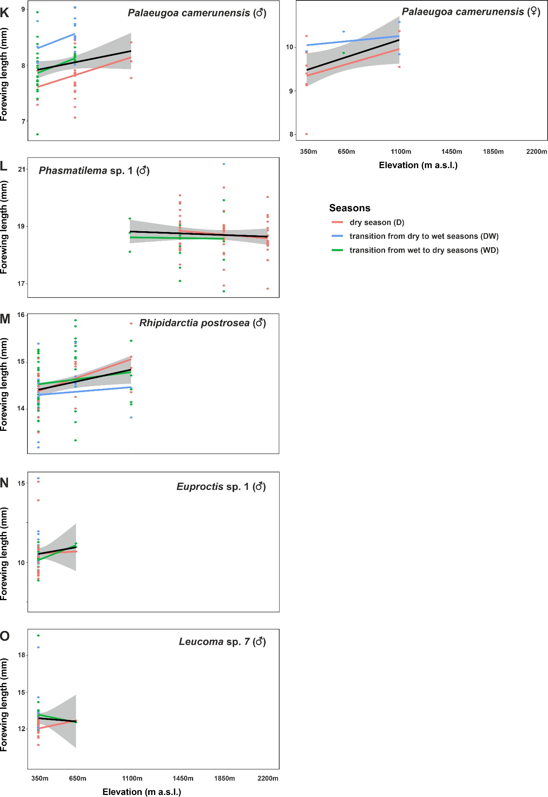
Supplementary Figure S2K–O. Elevational and seasonal patterns of forewing lengths of moths on Mount Cameroon. Erebidae: Arctiinae: K) Palaeugoa camerunensis (males and females), L) Phasmatilema sp. "1" (males), M) Phasmatilema sp. "1" (males). Erebidae: Lymantriinae: N) Euproctis sp. "1" (males), O) Leucoma sp. "7" (males).
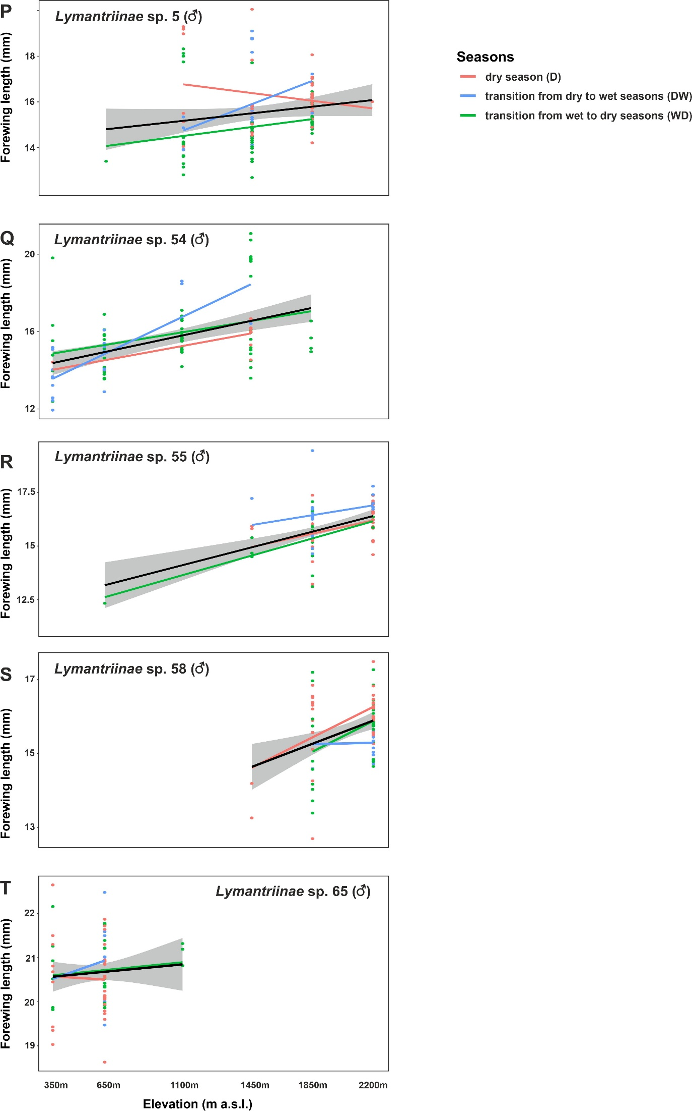
Supplementary Figure S2P–T. Elevational and seasonal patterns of forewing lengths of moths on Mount Cameroon. Erebidae: Lymantriinae: P) Lymantriinae sp. "5" (males), Q) Lymantriinae sp. "54" (males), R) Lymantriinae sp. "55" (males), S) Lymantriinae sp. "58" (males), T) Lymantriinae sp. "65" (males).
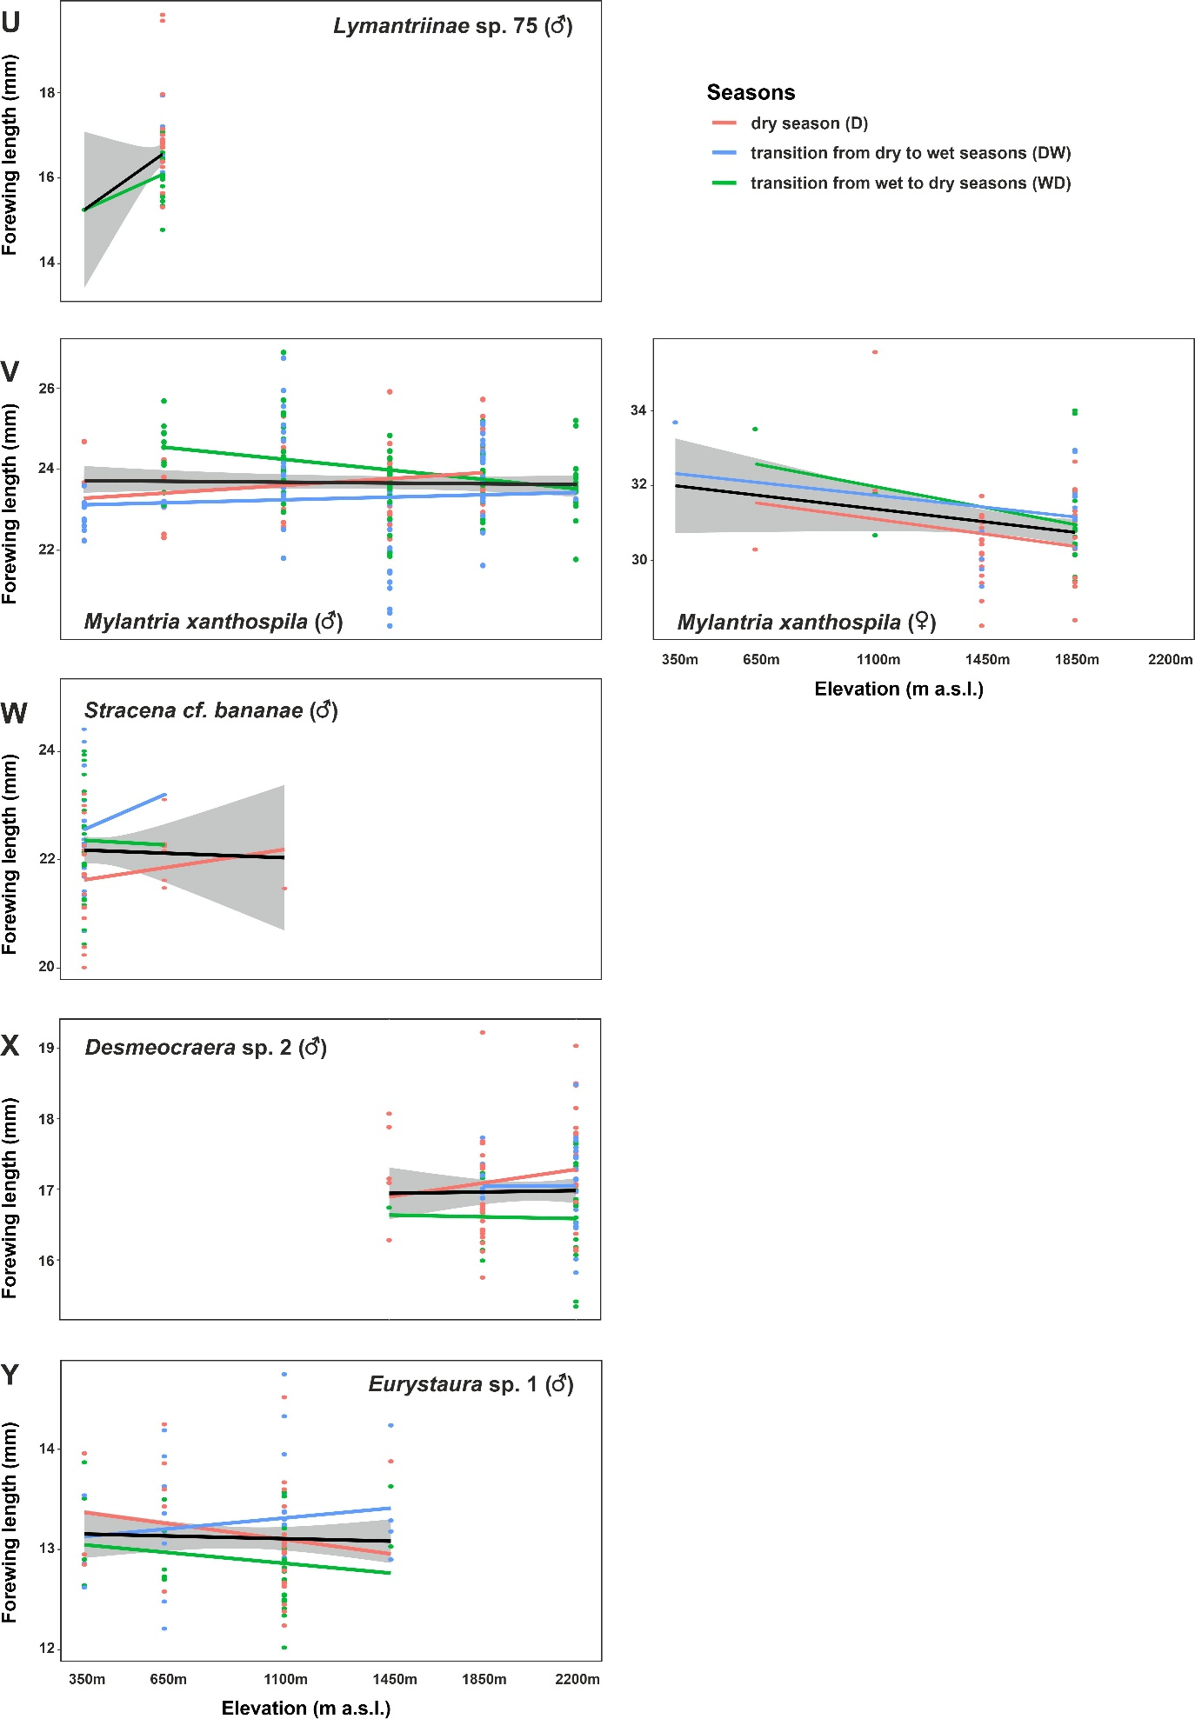
Supplementary Figure S2U–Y. Elevational and seasonal patterns of forewing lengths of moths on Mount Cameroon. Erebidae: Lymantriinae: U) Lymantriinae sp. "75" (males), V) Mylantria xanthospila (males and females), W) Stracena cf. banana (males). Notodontidae: X) Desmeocraera sp. "1" (males), Y) Eurystaura sp. "1" (males).
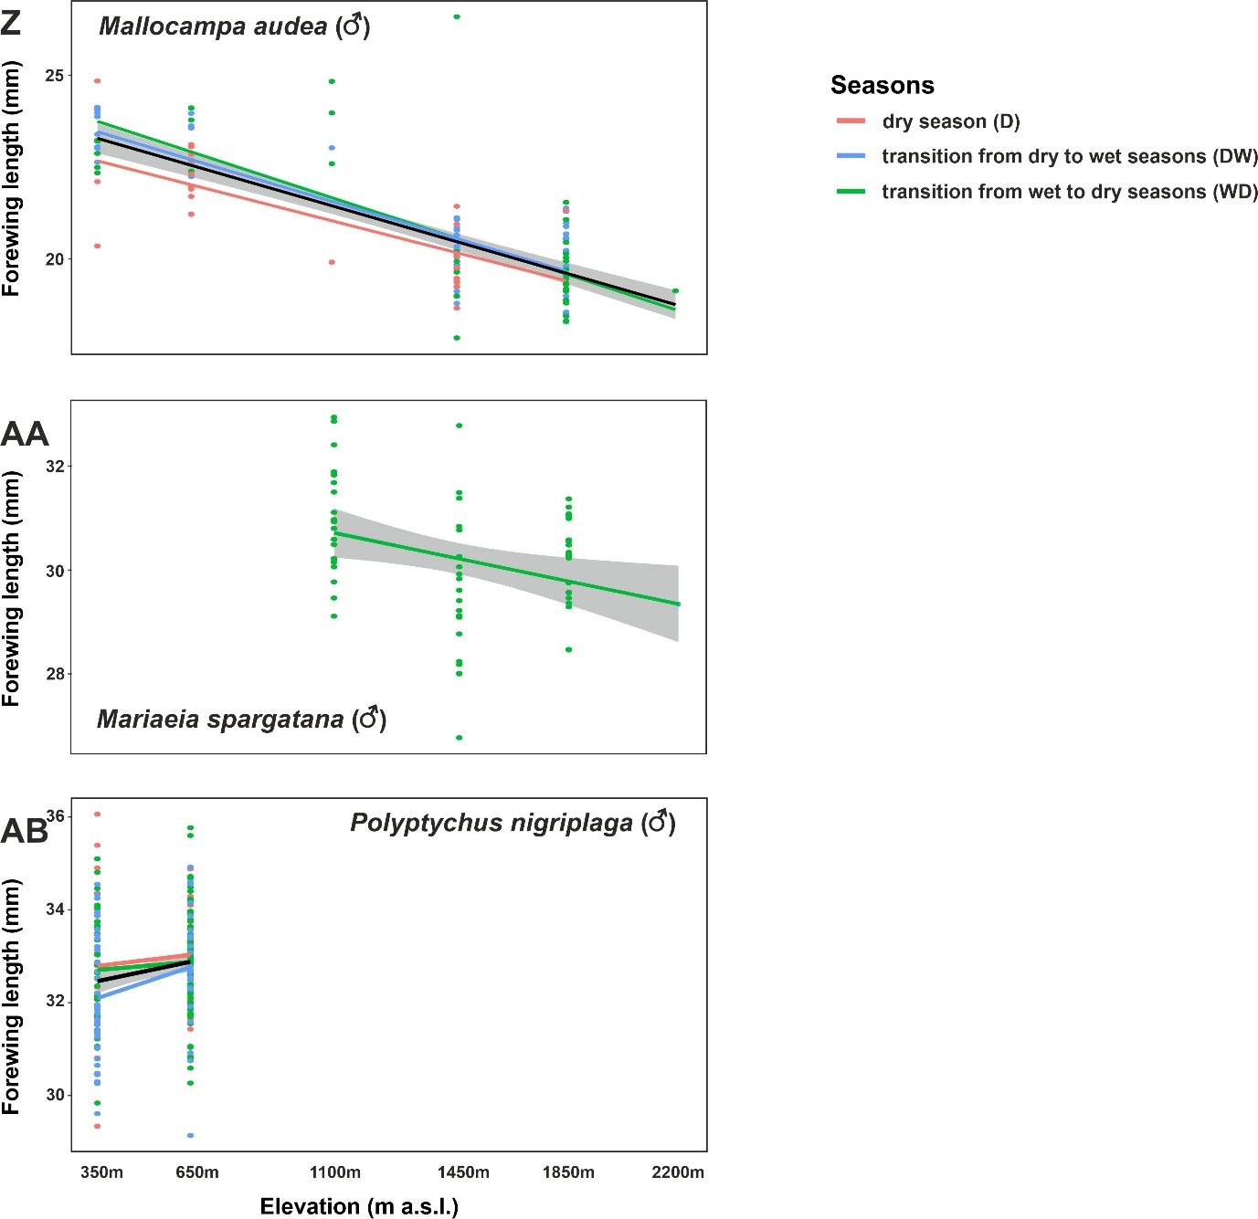
Supplementary Figure S2Z–AB. Elevational and seasonal patterns of forewing lengths of moths on Mount Cameroon. Lasiocampidae: Z) Mallocampa audea (males), AA) Mariaeia spargatana (males). Sphingidae: AB) Polyptychus nigriplaga (males).

