Supplementary materials
SUPPLEMENTARY METHODS
Detailed sample sites
Samples were collected in Santa Elena and San Luis near the town of Monteverde, Costa Rica. Sample sites for the experiment testing soil bacteria antibiotic resistance as a function of proximity to ant nest with all morphospecies were collected from the Bajo del Tigre Reserve (10.305593, -84.814384) (2 nests), Finca San Francisco de Asis (10.309129, -84.831539) (5 nests), and a private home (1 nest), all forested areas, with 8 nests total, from April 15-26, 2018. Samples for the experiment with individual morphospecies were collected from Finca San Francisco de Asís (5 nests previously sampled in 2018) and the CIEE Global Institute campus in San Luis (10.281248, -84.799229) from April 5-19, 2020 (5 nests). Samples for the experiment testing soil bacteria antibiotic resistance as a function of proximity to the fungal garden were collected from 7 nests at the Caballeriza El Rodeo in Santa Elena (10.313468, -84.828739) from October 18-November 10, 2018. Caballeriza El Rodeo is a horse-riding business that includes open areas and forest patches. The owners of these sites do not try to control leaf-cutter ant populations, so it is extremely unlikely that the ant mounds in these sites would have been exposed to toxic chemicals.
Sample plating and antibiotic treatment
Bacteria from soil samples collected at different proximities from leaf cutter ant nests were grown on agar plates and treated with antibiotics, but different experiments used slightly different conditions (Table S1). Agar types were varied to minimize the amount of time required for bacteria colonies to be visible (incubation times) and to maximize the diversity and abundance of bacteria growing on agar. Incubation times varied between samples within the same experiment, but samples from the same ant nest were grown for the same amount of time. Fungicide was applied to enriched agars (Luria-Bertani, Yeast-Malt) to prevent the growth of fungal colonies, but it was not necessary in the case of plain bacteriological agar (not enriched) because fungal colonies were not common and were easily identified and excluded by eye. Varying numbers of antibiotics were applied in different experiments based on which produced the best results in previous experiences.
Table S1. Conditions and materials used in experiments of antibiotic resistance (AR) in soil bacteria. Topsoil samples were collected from Atta cephalotes nests in Monteverde, Costa Rica and were plated on agar and treated with antibiotics in experiments to determine antibiotic resistance in relation to proximity to the ant nests (to mount or to fungal chamber inside the mount). Agar type, fungicide treatment, antibiotic treatment, measurement of antibiotic resistance, incubation period, temperature conditions, and sample sizes differed between experiments.
 | AR proximity to mount: whole sample | AR proximity to mount: individual morphospecies | AR proximity to fungal chamber
Agar | Bacteriological | Luria-Bertani | Yeast-Malt
Fungicide | None, fungi excluded visually | Nystatin 2.5mL/100mL | Nystatin 2.0mL/100mL
Treatments | Control (1X PBS) | Control (1X PBS) | Control (1X PBS)
 | Oxytetracycline (16ug/mL) | Oxytetracycline (16ug/mL) | Oxytetracycline (16ug/mL)
 | Gentamicin (16ug/mL) | Gentamicin (16ug/mL)
 | Penicillin/ Dihydrostreptomycin (32ug/mL) | Penicillin/ Dihydrostreptomycin (32ug/mL)
 | Ceftiofur (8ug/mL)
AR measurement (distance from treatment) | Distance to closest bacteria (no visible halo) | Distance to halo edge (visible halo) | Distance to closest bacteria (no visible halo)
Incubation (days) | 13±1 | 9±1 | 4±0
Temperature (℃) | 19.3±0.6 | 19.5±1.2 | 18.9±0.5
Plates | 96 | 224 | 63

Antibiotic resistance measurement
The method used to measure antibiotic resistance varied between experiments depending on whether a growth halo was visible (Figure S1), which also depended on the enrichment of the agar used in the experiment (Table S1). The bacterial halo was clearest in the experiment with individual morphospecies on each plate, which was likely due to the nutrient-enriched agar used and the relatively long incubation time. In other experiments where the bacterial halo was not clearly visible, the distance from the edge of the paper disc to the closest colony was recorded (Figure S1). In all experiments, paper filter discs were placed at equal distances from one another on the agar plate (Figure S2).
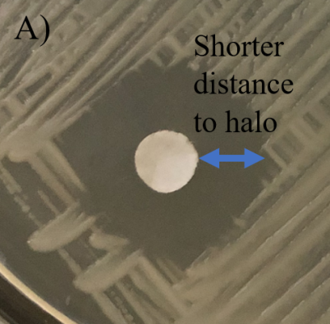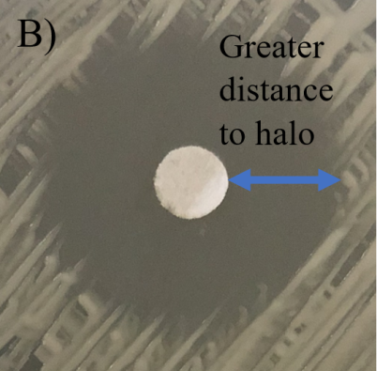
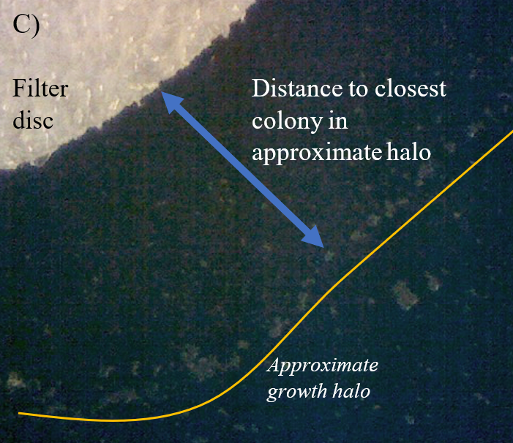
Figure S1. Bacterial growth and growth halos around paper discs soaked in antibiotic treatment or PBS buffer (control) on an agar plate. A) and B) show clear growth halos, demonstrating inhibition of bacterial growth near the filter disc. The inhibition distance from the edge of the disc to the growth halo is shorter in A) (both images are at the same scale), which suggests greater antibiotic resistance in the sample plated in A) relative to B) when comparing two discs treated with the same antibiotic, because bacteria are able to grow closer to the source of antibiotics. C) shows a close-up of the edge of filter disc and individual bacterial colonies in cases without a clear bacterial growth halo.

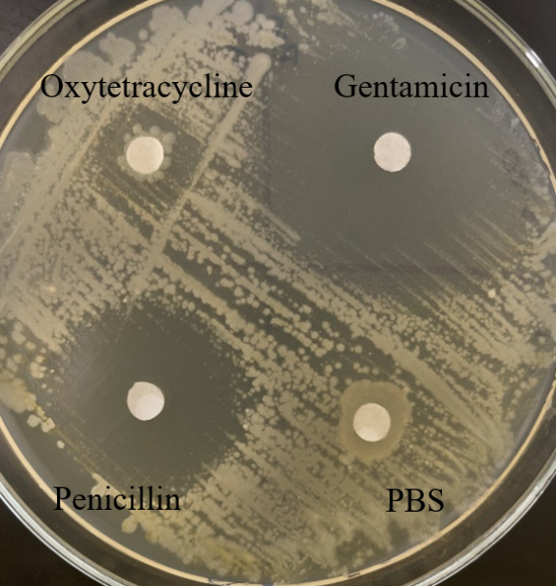
Figure S2. Equidistant placement of antibiotic-treated paper filter discs on agar plates in the experiment of antibiotic resistance in soil bacteria.

Detailed Statistical Analysis
The analysis of resistance by proximity using all morphospecies was done as follows: inhibition distance (distance from disc to closest bacteria – any morphospecies) was compared (dependent variable) between proximities to the ant nest (0, 10, 20, 50 m) and between antibiotic treatments (control and each one of the antibiotics employed) using a linear mixed model (LMM). Plate and ant nest identity (the former nested within the latter) were included as random effects in the LMM to control for the lack of independence in data points collected from each plate and nest (i.e., multiple samples/plates per colony). Proximity to nest, antibiotic treatment, and the interaction between these two factors were included as fixed effects. Data for distances of bacterial growth to disc edge were log transformed to meet assumptions of normality and constant variance of residuals. LMMs were fitted using the R package lme4. P-values were obtained using the Anova function from the R package ‘car’, which approximates p-values corresponding to type II sums of squares using the Chi-square distribution. Pairwise post hoc comparisons between means were conducted using the R package ‘emmeans’. Adjusted (i.e., least square) means and standard error were calculated in original scale using the package emmeans. All analyses were conducted in R 4.0.0 (R Core Team 2020). The analysis of samples as a function of proximity to nest was done with the same type of LMM. In this case, proximities to the fungal chamber (inside the chamber, nest mount (0 m) and 30 m), were measured with only one antibiotic and one control per plate, so no interaction term was necessary between treatment and proximity to nest.
The analysis of resistance by proximity to the nest with one morphospecies per plate was done with a Generalized Linear Mixed Model (GLMM) with Gamma distribution using the R package lme4. The reason for this is that the inhibition distance (dependent variable) was very close to this distribution and because models with this distribution fit the assumption of normality and constant variance of residuals better than others. Distances from all plates/morphospecies were combined into a single dataset because our sample size was not large enough to conduct meaningful analyses with data from only a single morphospecies. Proximity to nest, antibiotic treatment, site, and the interaction between these three factors were included as fixed effects. Plate and ant nest identity (the former nested within the latter) were included as random effects. Additionally, we included the average daily incubation temperature for each plate as a random effect to account for the relatively large variation in incubation temperature (Table S1). The variance explained by plate and nest was nearly zero after the inclusion of temperature in this GLMM model. The inclusion of temperature was not necessary in the case of the LMM models for the other experiments (i.e., did not change the results), because daily variation in incubation temperature was small (Table S1).
To evaluate whether the number of morphospecies changes with proximity to the nest, we used LMM with morphospecies richness as the dependent variable which followed a normal distribution. Richness was compared between proximities to nests (fixed effect, levels: 0, 10, 20, 50 m). The model explicitly acknowledged that samples collected from the same nest were not independent from each other (i.e., nest identity was included as a random effect in the model). This LMMs was implemented in the R package nlme. Pairwise comparisons were conducted using the package emmeans.
The similarity index in community composition (richness and abundance) between proximity to the nest (0, 10, 20, and 50 m) was calculated in a pairwise fashion for each site by the Morisita similarity index (Wolda 1981) using Past software (Hammer). The index goes from 0 to 1. An index of 1 means all morphospecies are shared in similar relative abundances between any two proximities. A hypothetical example of an index of 1 would be if the rank of morphospecies by relative abundance were the same between two proximities to the nest. An index of 0 means that 1) no morphospecies are shared or 2) if shared, they occur with very different relative abundances (e.g., morphospecies that are very rare at one proximity are very common at the other proximity).
MDS was calculated in the R package ‘vegan’ using the Bray-Curtis dissimilarity metric, which can handle species absences (i.e., zero abundance) in datasets. A Permutational Analysis of Variance was conducted with the ‘adonis’ function in vegan with 999 permutations, using the Bray-Curtis dissimilarity matrix to assess the significance of the MDS and to test for spatial dissimilarity in community composition according to proximity to the nest and site (proximity nested within site).
SUPPLEMENTARY RESULTS
Resistance due to proximity to ant nest: entire soil sample on an agar plate
Antibiotics successfully limited growth relative to the control in the experiment testing resistance by proximity to nest using the entire soil sample (LMM: Treatment term: 𝜒² = 184.4, df = 4, p <0.001; Fig S3). The patterns of inhibition by proximity across antibiotics shows that bacterial colony growth from samples closer to A. cephalotes nests was significantly more resistant to antibiotics (LMM: Proximity term: 𝜒² = 24.78, df = 3, p <0.001, Fig S4). The interaction term between treatment and proximity to the nest was also significant (LMM: 𝜒² = 21.5, df = 12, p <0.04), indicating some differences in the pattern of proximity to the nest between antibiotics. The difference is essentially the proximity from the nest mount at which resistance becomes significantly different from the level of resistance at the nest mount. An increase in inhibition distance, and therefore less resistance, is evident beyond 20 m from the nest in the case of gentamicin and oxytetracycline (Figure S4a,b), and beyond 10 m in the case of penicillin (Figure S4c), resulting in significantly larger inhibition distances at 50 m compared to those at the nest mount (approximately 30% greater on average) for all antibiotics except ceftiofur, in which the apparent increase was marginally non-significant (Figure S4d).

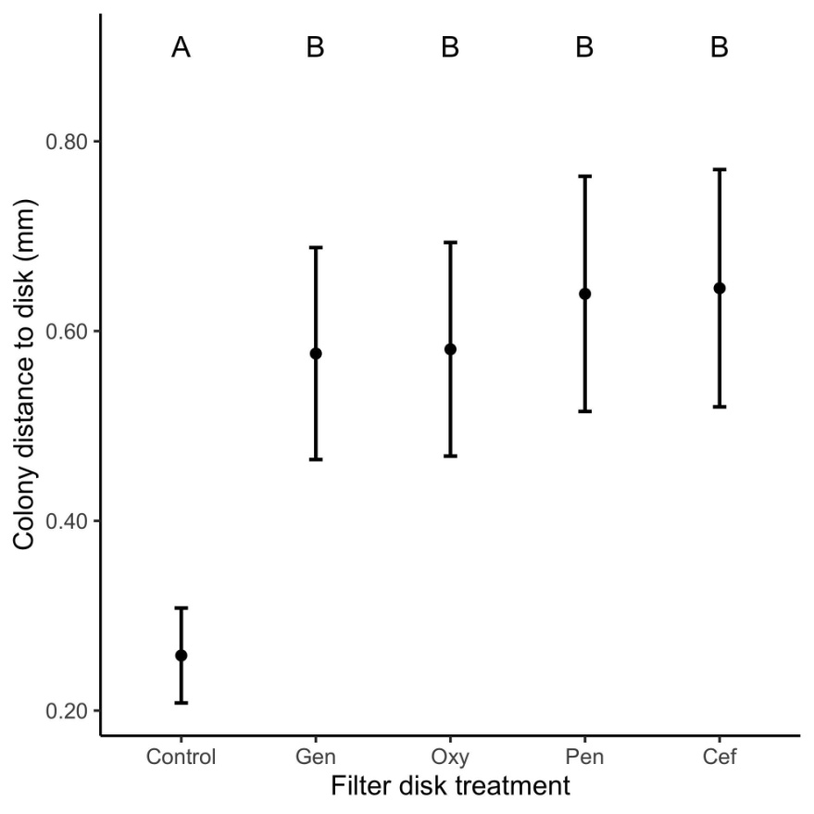
Fig S3. Antibiotic resistance in soil bacteria, measured as distance from the closest bacterial colony in an agar plate to a paper disc soaked in antibiotics. Topsoil samples collected from eight A. cephalotes nests in Monteverde, Costa Rica, were plated directly on individual agar plates (n = 96 plates) and treated with ceftiofur (Cef), gentamicin (Gen), oxytetracycline (Oxy), penicillin (Pen) and control disc with 1X PBS buffer. Each agar plate included one entire soil sample. Least square means are presented with one standard error. Different letters above means indicate significant difference in proximity to nest (Tukey posthoc pairwise comparison, p<0.05).

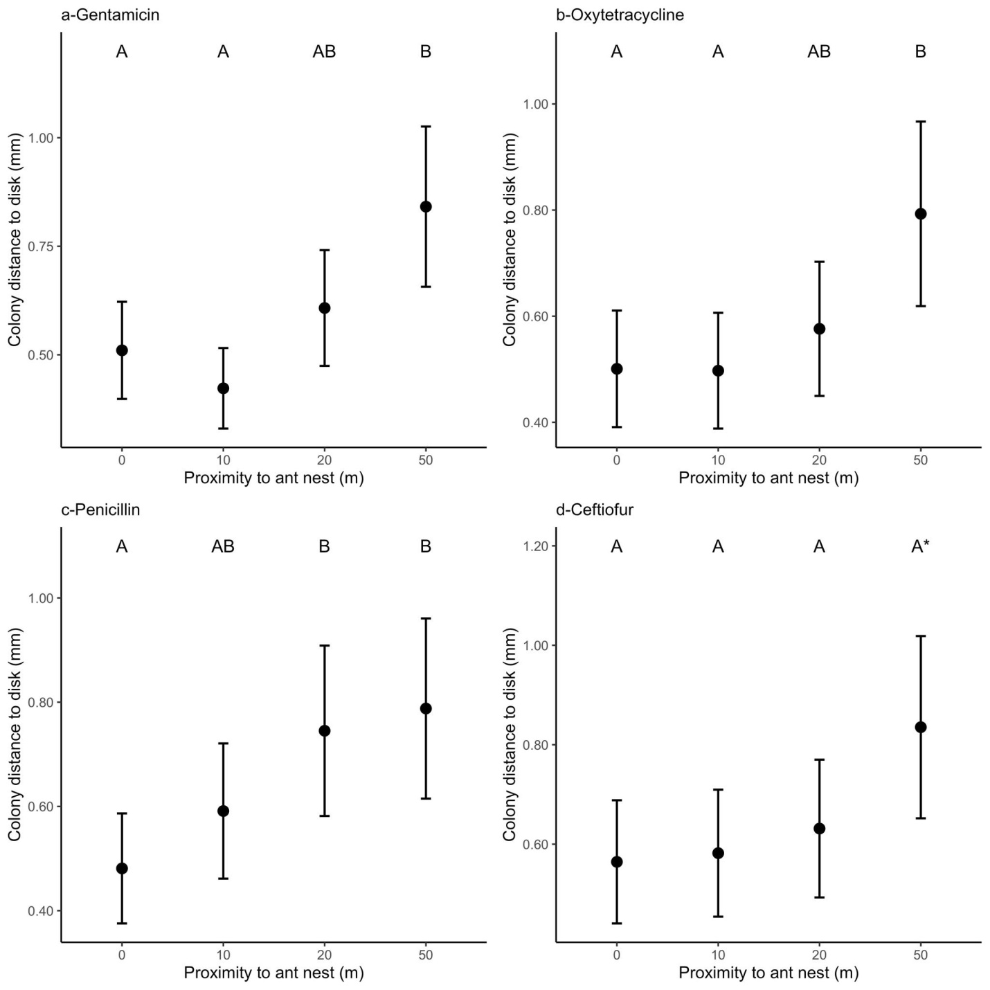
Figure S4. Antibiotic resistance in soil bacteria, measured as distance from the closest bacterial colony in an agar plate to a paper disc soaked in antibiotics, near Atta cephalotes nests. Shorter distance indicates higher resistance. Topsoil samples collected at 0 m, 10 m, 20 m, and 50 m from eight A. cephalotes nests in Monteverde, Costa Rica, were plated and treated with ceftiofur, gentamicin, oxytetracycline, penicillin, and a control disc with 1X PBS buffer (n = 96 plates). Each agar plate included one entire soil sample. Least square means are presented with one standard error. Different letters above means indicate significant difference in proximity to nest (Tukey posthoc pairwise comparison, p<0.05; *: 0.05<p⋜0.10).

Resistance due to proximity to ant nest: one morphospecies on an agar plate
Antibiotics successfully limited growth relative to the control (LMM Treatment term: 𝜒² = 299.9, df=3, p<0.001; Fig S5, S6). Bacteria exposed to oxytetracycline showed shorter distances (i.e., more resistance) relative to gentamicin and penicillin, and the difference between control and oxytetracycline was more pronounced in San Luis (Fig S5, S6).
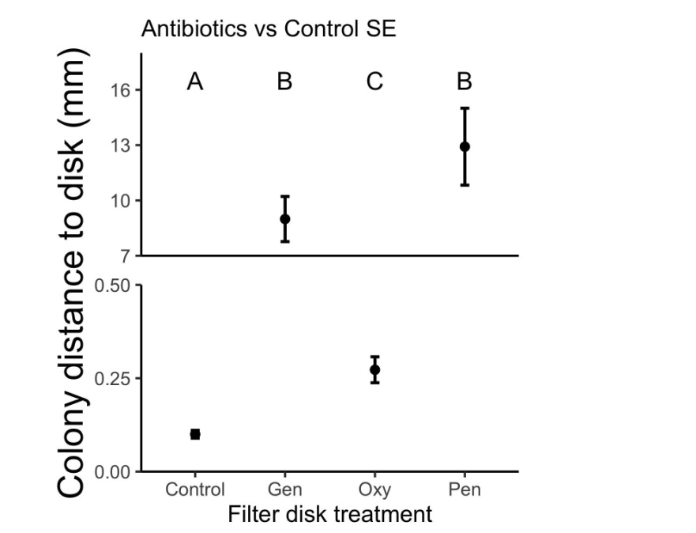
Fig S5. Antibiotic resistance in soil bacteria, measured as distance from the closest bacterial colony in an agar plate to a paper disc soaked in antibiotics. Topsoil samples collected at 0 m, 10 m, 20 m, and 50 m from five A. cephalotes nests in Santa Elena (SE) and from five nests in San Luis (SL) were plated in LB agar to maximize diversity of grown bacteria. Individual colonies of all morphospecies present on samples from all proximities to ant nests were transferred to individual plates (n = 87 plates) with LB agar and treated with gentamicin (Gen), oxytetracycline (Oxy), penicillin (Pen) and a control disc with 1X PBS buffer. Least square means are presented with one standard error. Different letters above means indicate significant differences in proximity to nest (Tukey posthoc pairwise comparison, p<0.05). The y-axis was segmented to show the difference between the control and oxytetracycline.
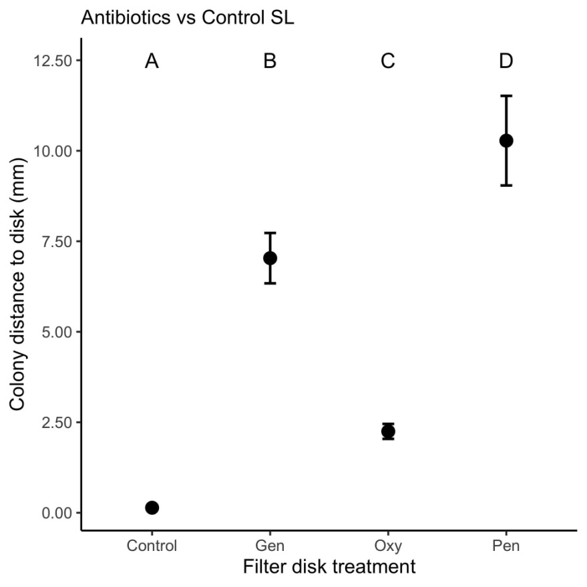
Fig S6. Antibiotic resistance in soil bacteria, measured as distance from the closest bacterial colony in an agar plate to a paper disc soaked in antibiotics. Topsoil samples collected at 0 m, 10 m, 20 m, and 50 m from five A. cephalotes nests in SE and from five nests in SL, were plated in LB agar to maximize diversity of grown bacteria. Individual colonies of all morphospecies present on samples from all proximities to ant nests were transferred to individual plates (n = 87 plates) with LB agar and treated with gentamicin (Gen), oxytetracycline (Oxy), penicillin (Pen) and control disc with 1X PBS buffer. Least square means are presented with one standard error. Different letters above means indicate significant differences in proximity to nest (Tukey posthoc pairwise comparison, p<0.05).
The patterns of inhibition by proximity across antibiotics show that bacterial colony growth was significantly more resistant to antibiotics closer to A. cephalotes nests, but this pattern was consistent only for oxytetracycline, whereas there were no significant differences in resistance by distance under penicillin or gentamicin (LMM: interaction treatment*proximity: 𝜒² = 39.7, df = 9, p <0.0001; Fig S7). Resistance to oxytetracycline was greatest in soils collected at the nest and decreased at 20 m or greater from the nest in Santa Elena (Fig S7b), and at 10 m or greater from the nest in San Luis (Fig S7e) (LMM interaction treatment*proximity*site term: 𝜒² = 27.5, df = 9, p = 0.001).

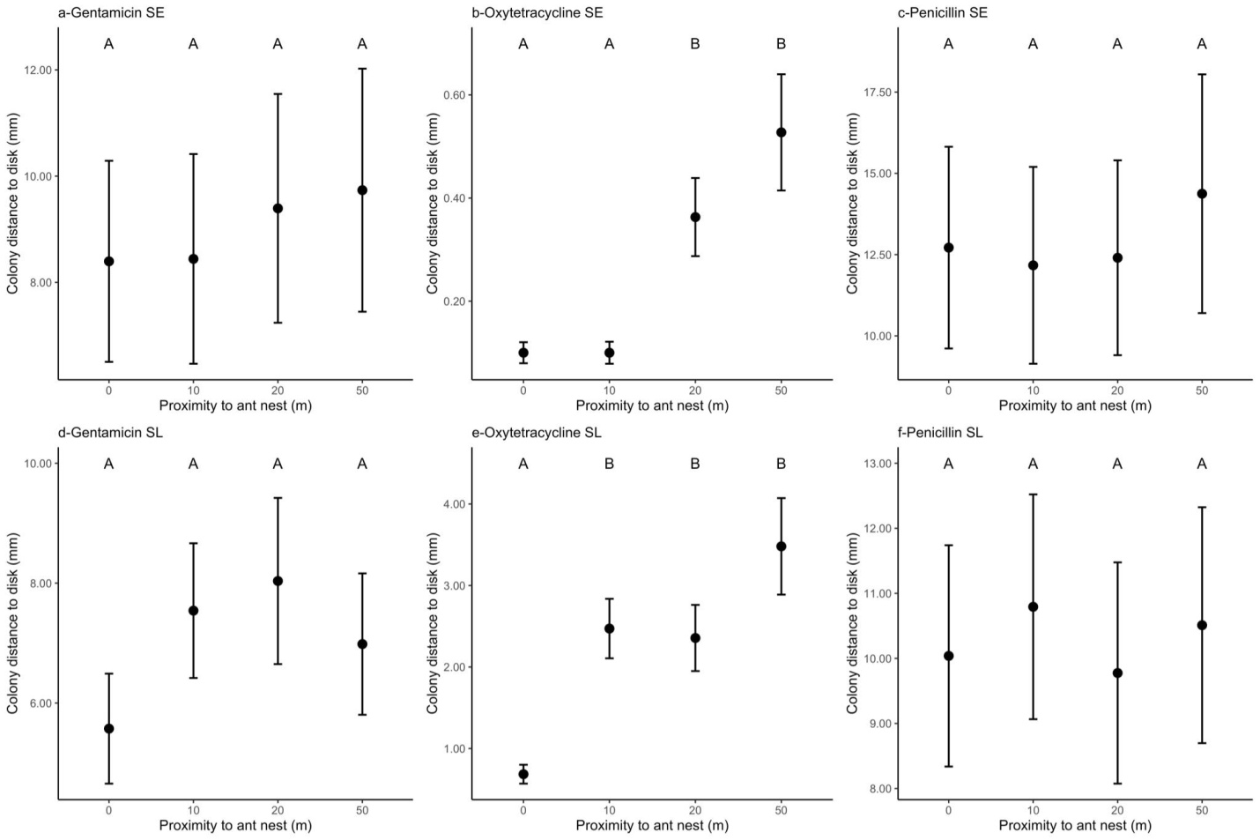
Figure S7. Antibiotic resistance in soil bacteria, measured as distance from the closest bacterial colony in an agar plate to a paper disc soaked in antibiotics near Atta cephalotes nests from two sites in Monteverde, Costa Rica: Santa Elena (SE) and San Luis (SL). Shorter distance indicates higher resistance. Topsoil samples collected at 0 m, 10 m, 20 m, and 50 m from five A. cephalotes nests in SE and from five nests in SL, were plated in LB agar to maximize diversity of grown bacteria. Individual colonies of all morphospecies present on samples from all proximities to ant nests were transferred to individual plates with LB agar and treated with gentamicin, oxytetracycline, and penicillin (n = 87 plates in SE, 137 in SL). Least square means are presented with one standard error. Different letters above means a significant difference between proximity to the nest (Tukey posthoc pairwise comparison, p<0.05).

Resistance due to proximity to fungal chamber
Inhibition distances were significantly shorter in the case of control discs compared to oxytetracycline discs (LMM Treatment term: 𝜒² =56.0, df=1, p<0.001), indicating that antibiotics successfully limited bacterial growth relative to the control (Fig S8).

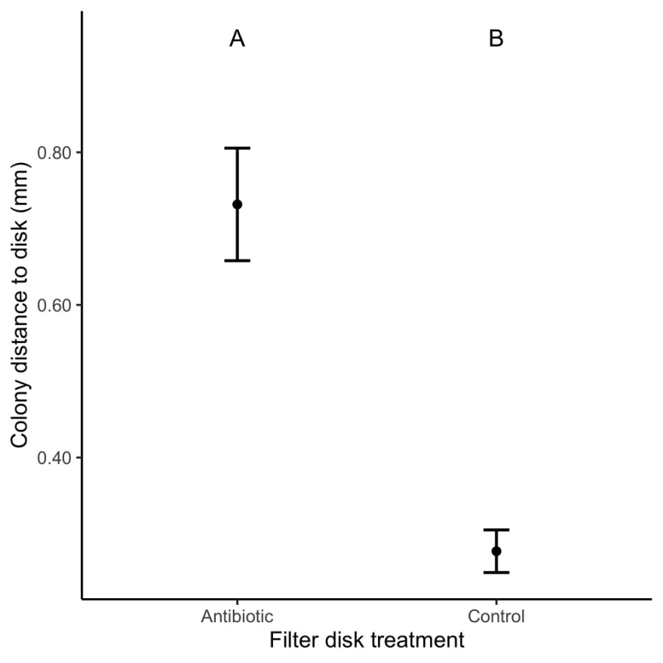
Fig S8. Antibiotic resistance to antibiotics in soil bacteria, measured as distance from the closest bacterial colony in an agar plate to a paper disc soaked in antibiotic or control (1X PBS buffer), in relation to proximity to Atta cephalotes nests in Monteverde, Costa Rica. Shorter distances indicate higher resistance to antibiotics. Topsoil samples were collected from seven A. cephalotes nests and plated on individual agar plates (n=96). Least square means are presented with one standard error. Different letters above the means indicate significant difference in proximity to nest (Tukey posthoc pairwise comparison, p<0.05).

Exploratory Study: Bacterial Community Analysis
Bacterial richness at different sites and distances from A. cephalotes nests were similar. There were no significant differences between the average number of morphospecies found at varying proximities from the nest mount (LMM proximity term: 𝜒² = 6.58, df = 3, p = 0.09) and the pattern was similar between sites (LMM proximity*site term: 𝜒²=2.02, df=3, p=0.57; Fig S9). Detailed descriptions of morphospecies are shown in Table S2.

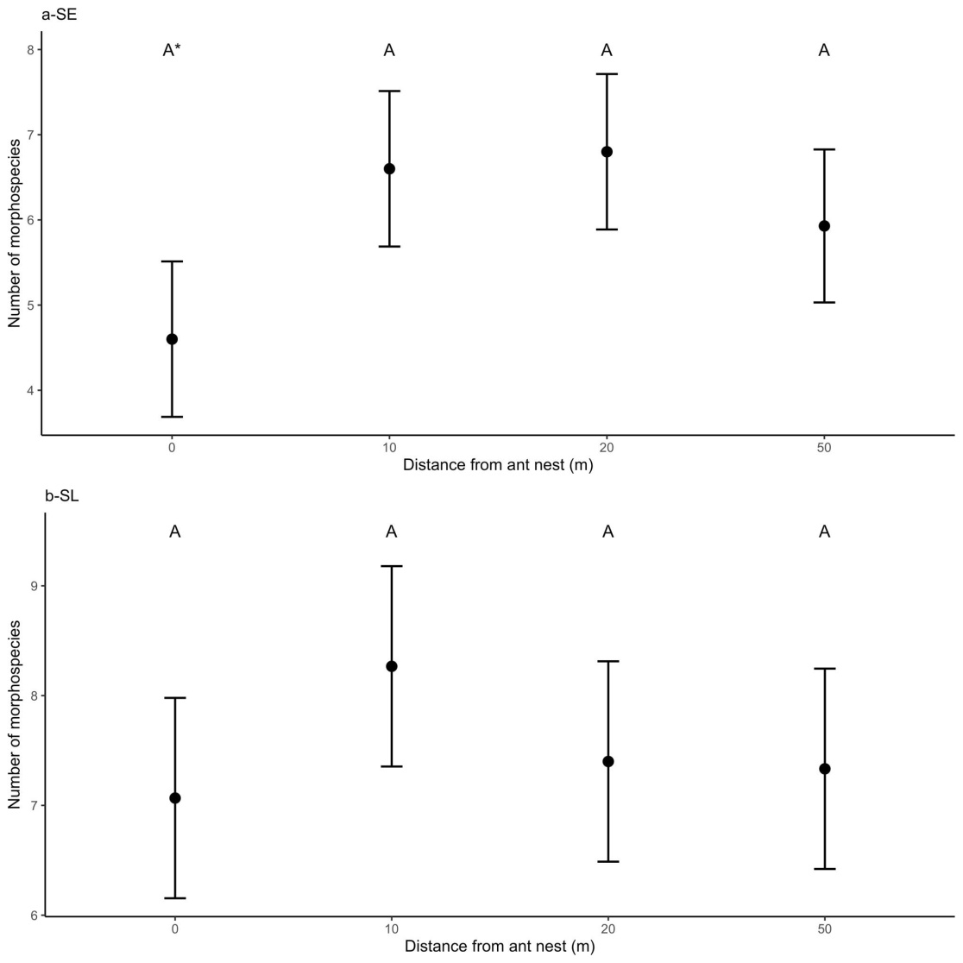
Figure S9. Mean number of bacterial morphospecies per topsoil sample according to distance from leaf cutter ant nests in Santa Elena (a) and San Luis (b), Costa Rica. Bacteria present in topsoil samples were collected at 0 m, 10 m, 20 m, and 50 m from five Atta cephalotes nests in Santa Elena and five in San Luis. Error bars represent one standard error. n = 15 samples per distance per site.*=0.05<p⋜0.10

Table S2. Morphospecies library, defined following methodologies from Benson (2001) (continued on following page) Only morphospecies that were compared in the final statistical analysis are included in this table.
Morphospecies number | 1 | 2 | 3 | 4A | 4B | 5 | 6A | 6B | 8 | 9 | 10A | 10B
Configuration | Irregular | Round | Irregular, spreading | Concentric | Concentric, L-form | L-Form | Round, irregular | Round, irregular | Round | Irregular and spreading | L-form | L-form
Colony Margin | Faded, lobate | Smooth | Lobate | Smooth | Wavy | Smooth | Smooth, lobate | Smooth, lobate | Faded | Faded | Wavy | Smooth
Colony Texture/ Consistency | Smooth | Smooth | Sticky | Smooth, varied | Smooth | Smooth | Smooth | Smooth | Smooth/ growth inside the agar | Very faint/ none | Smooth | Smooth/ like a pimple
Colony Size | Large | Small | Medium/large | Medium/ small | Medium/ small | Medium/ small | Small/ medium/ large | Small/ medium/ large | Medium/ large | Medium/ small | Small | Small
Colony Color | Cloudy white | White | Brown, transparent, “greasy” | White, cloudy white | White, cloudy white | White, cloudy white | Tan, brown | Peach | Black, dark brown | Cloudy white | Reddish, tan | Red
Grab to Transfer | Easy | Easy | Easy | Easy | Easy | Easy | Easy | Easy | Hard | Medium | Easy | Very hard
Shiny or Opaque? | Opaque | Shiny | Super shiny, jelly-like | Opaque | Shiny | Shiny | Shiny | Shiny | Opaque | Shiny | Shiny | Opaque
Elevation | Flat | Drop-like | Convex | Flat | Raised | Convex | Raised | Raised | Flat | Flat | Convex | Drop-like (hard)

Morphospecies number | 11A | 11B | 11C | 12 | 13 | 14 | 15A | 15B | 16 | 17 | 18 | 19
Configuration | Round with a border | Round with a border | Round with a border | Round | Irregular, spreading | Round | Round with scalloped margin | Round | Round, slightly irregular | Round with scalloped margin | Round | Filamentous
Colony Margin | Smooth, slightly irregular | Smooth, slightly irregular | Smooth, slightly irregular | Smooth | Irregular | Smooth, wavy, distinct white line border | Smooth, wavy | Smooth, wavy | Wavy, wrinkled | Wavy | Wavy, irregular | Branching
Colony Texture/ Consistency | Smooth | Smooth/mousse | Smooth | Smooth/ sticky | Smooth | Smooth | Smooth/mousse | Smooth/ like a pimple | Crusty/ smooth | Crusty/ smooth | Smooth | Smooth, distinct "stringy"/ growth inside agar
Colony Size | Medium/ small | Medium /small | Medium/ small | Medium/ small | Large | Small/ medium | Medium/ small | Medium/ small | Medium/ small | Medium/ small | Medium | Medium/ large
Colony Color | White | White | White | Cloudy white, "jelly-like" | White | White | Red, orange | Red | Red, tan | White | White | White
Grab to Transfer | Easy | Easy | Very hard, growth inside agar | Easy | Easy | Easy | Easy | Hard | Easy | Easy | Easy | Very hard
Shiny or Opaque? | Opaque | Shiny | Opaque | Shiny | Shiny | Opaque and wrinkled texture | Varied | Opaque | Opaque | Opaque | Opaque | Opaque
Elevation | Flat | Raised | Ingrowing into medium | Drop-like | Convex | Hilly | Convex | Drop-like | Raised | Flat | Flat | Ingrowing into medium

Morphospecies number | 20 | 22 | 23 | 25 | 26 | 27 | 28 | 29
Configuration | Round | Irregular, spreading | Distinct "train-track" like, spreading | Irregular | Wrinkled | Round with raised margin | Round with scalloped margin | Round with raised margin
Colony Margin | Smooth | Wavy, lobate, irregular | N/A | Tan irregular border | Scalloped/irregular | Smooth | White on outside | Raised, thick
Colony Texture/ Consistency | Smooth, with a distinct ring center/ growth inside agar | Smooth | Smooth | Smooth/ mousse | Smooth | Smooth/ mousse | Crusty/ smooth | Smooth
Colony Size | Small | Large | Medium/large | Large | Small/ medium | Medium | Small | Small/ medium
Colony Color | White | Bright red | White, yellowy | Cloudy white/tan | Brown | Tan/light brown with white border | White and purple | White
Grab to Transfer | Very hard | Easy | Easy | Easy | Easy | Easy | Easy | Easy
Shiny or Opaque? | Opaque | Shiny | Shiny | Shiny | Opaque | Shiny | Opaque | Shiny
Elevation | Ingrowing into medium | Raised | Drop-like | Raised | Hilly | Drop-like | Hilly | Raised

REFERENCES
Benson HJ (2001) Microbiological Applications Lab Manual, Eighth Edition, The McGraw-Hill Companies.
Hammer O PAST: Paleontological Statistics Software Package for Education and Data Analysis Palaeontologia Electronica.
R Core Team (2020) R: A language and environment for statistical computing. Vienna, Austria: R Foundation for Statistical Computing.
Wolda H (1981) Similarity indices, sample size and diversity. Oecologia 50, 296–302.

