SUPPLEMENTARY MATERIAL

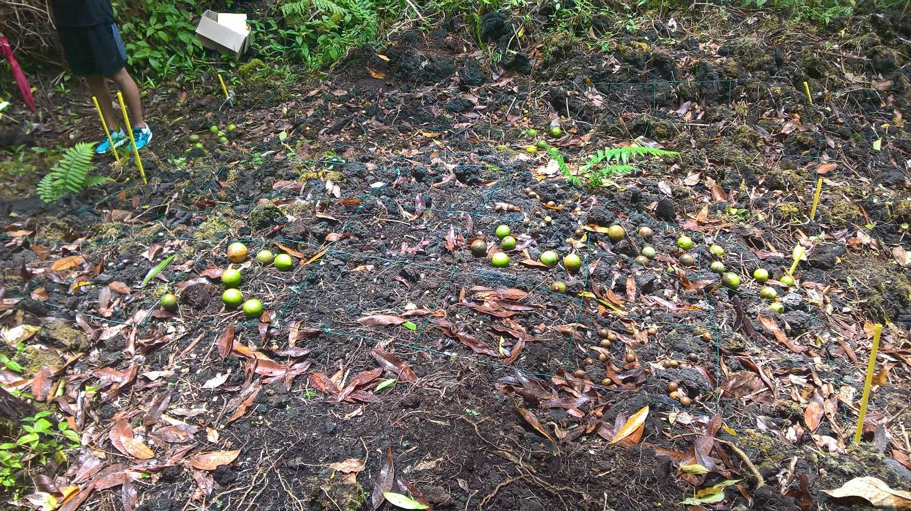App.1 View of the sowing experiment in the gap in January 2018. Black arrows and red arrows show diaspores of Labourdonnaisia calophylloides and Mimusops balata, respectively. Arrows and unfilled arrows illustrate “flesh persistence” and “hand cleaning of seeds” modalities, respectively. For more details about the seeds of focal species, please see Fig.2. Photo: F. Guilhabert.

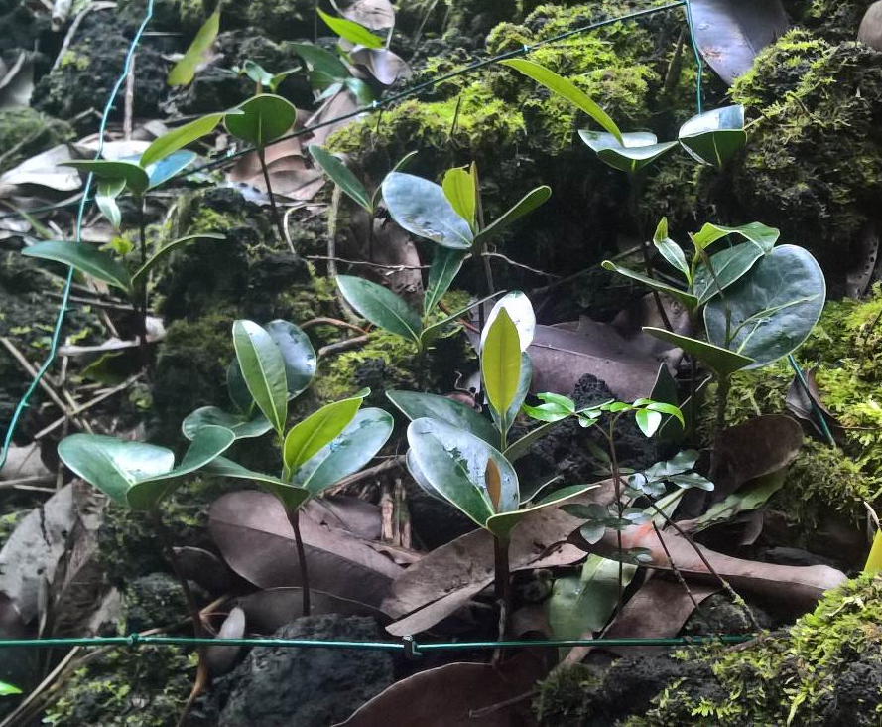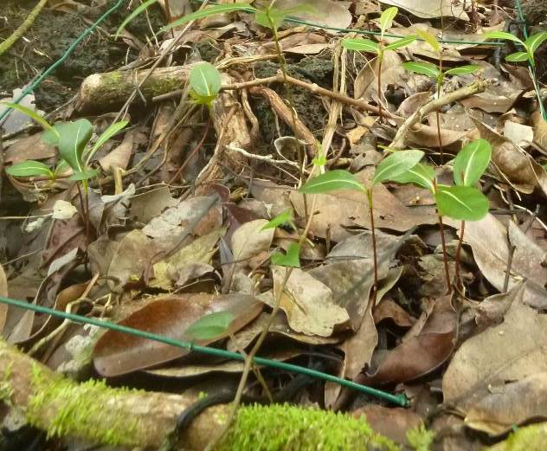
App.2 Seedlings of Mimusops balata (left, 4,5 months after sowing in January 2018) and Labourdonnaisia calophylloides (right, 6 months after sowing). Photos: F. Guilhabert & S. Albert
App.3 List of binomial GLMs (including the four variables tested and main two-way interactions) with their respective Akaike Information Criterion. The raw formula of models in R is given, except for the outcome 'recruitment' which is a two-column matrix with the first giving the number of successes (the number of established seedlings) and the second the number of failures (the number of non-established seedlings accounting for unremoved/unpredated seeds).
GLM formula in r software | AIC
recruitment ~ 1 | 1943
recruitment ~ seed_treatment + canopy_closure + date + species | 1096
recruitment ~ seed_treatment * canopy_closure + date + species | 1089
recruitment ~ seed_treatment * (canopy_closure + species) + date | 1048
recruitment ~ seed_treatment * (canopy_closure + date + species) | 1020
recruitment ~ seed_treatment * (canopy_closure + date + species) + species : canopy_closure | 1016
recruitment ~ seed_treatment * (canopy_closure + date + species) + species : canopy_closure + species : date | 1011
recruitment ~ (seed_treatment + canopy_closure + date + species)^2 | 1007
App.4 Summary of the best fitted GLM that includes four factors “seed_treatment”, “canopy closure”, “date of sowing” and “species” with the six possible two-way interactions. “MIMBAL”, Mimusops balata; “:”, interaction between two factors. Coefficients were calculated using contrasts by treatment (default in R).
Predictor | Estimate | Std.Error | z.value | P
(Intercept) | 0,225 | 0,109 | 2,070 | 0,038
seed_treatment, no | -1,697 | 0,149 | -11,370 | 6E-30
Canopy_closure, gap | -0,411 | 0,138 | -2,980 | 0,003
Date, Nov. 2019 | 0,331 | 0,139 | 2,378 | 0,017
Species, MIMBAL | 0,882 | 0,145 | 6,095 | 1E-09
seed_treatment, flesh_persistence : Canopy_closure, gap | -0,457 | 0,155 | -2,947 | 0,003
seed_treatment, flesh_persistence : Date, Nov. 2019 | 0,808 | 0,154 | 5,229 | 2E-07
seed_treatment, flesh_persistence : Species, MIMBAL | -0,918 | 0,154 | -5,967 | 2E-09
Canopy_closure, gap : Species, MIMBAL | 0,357 | 0,151 | 2,367 | 0,018
Date, Nov. 2019 : Species, MIMBAL | -0,386 | 0,150 | -2,570 | 0,010
Canopy_closure, gap : Date, Nov. 2019 | -0,384 | 0,151 | -2,540 | 0,011
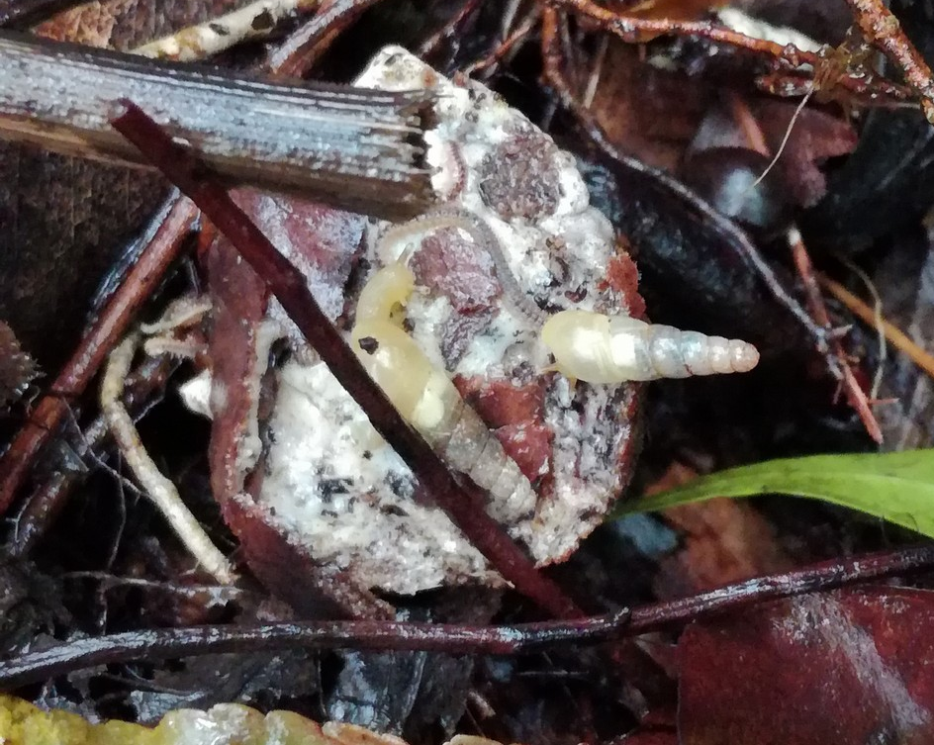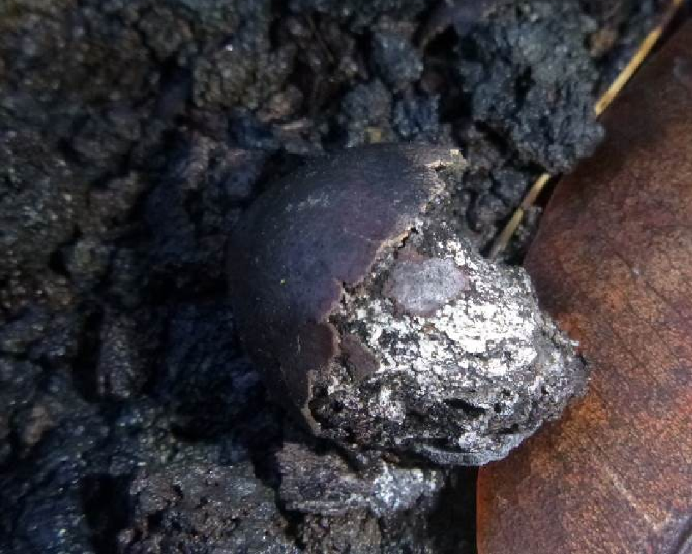
App.5 Fruit of Labourdonnaisia calophylloides with the seed trapped in the pericarp rich in latex. Left: 5 weeks after sowing; Right: 6,5 months after sowing. Photos: A. Gorissen & S.Albert
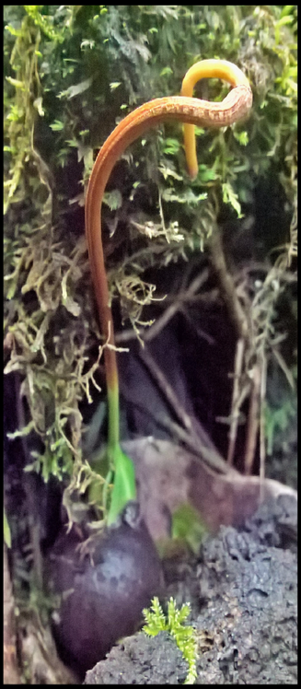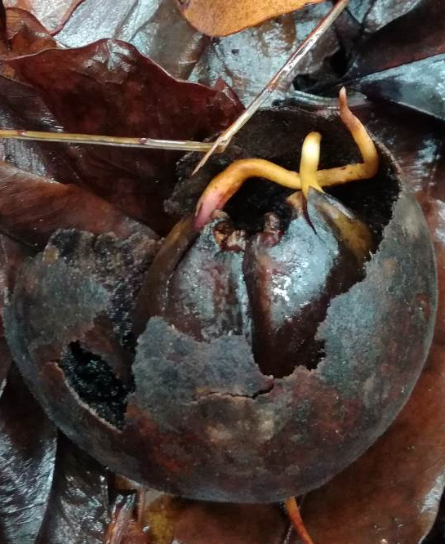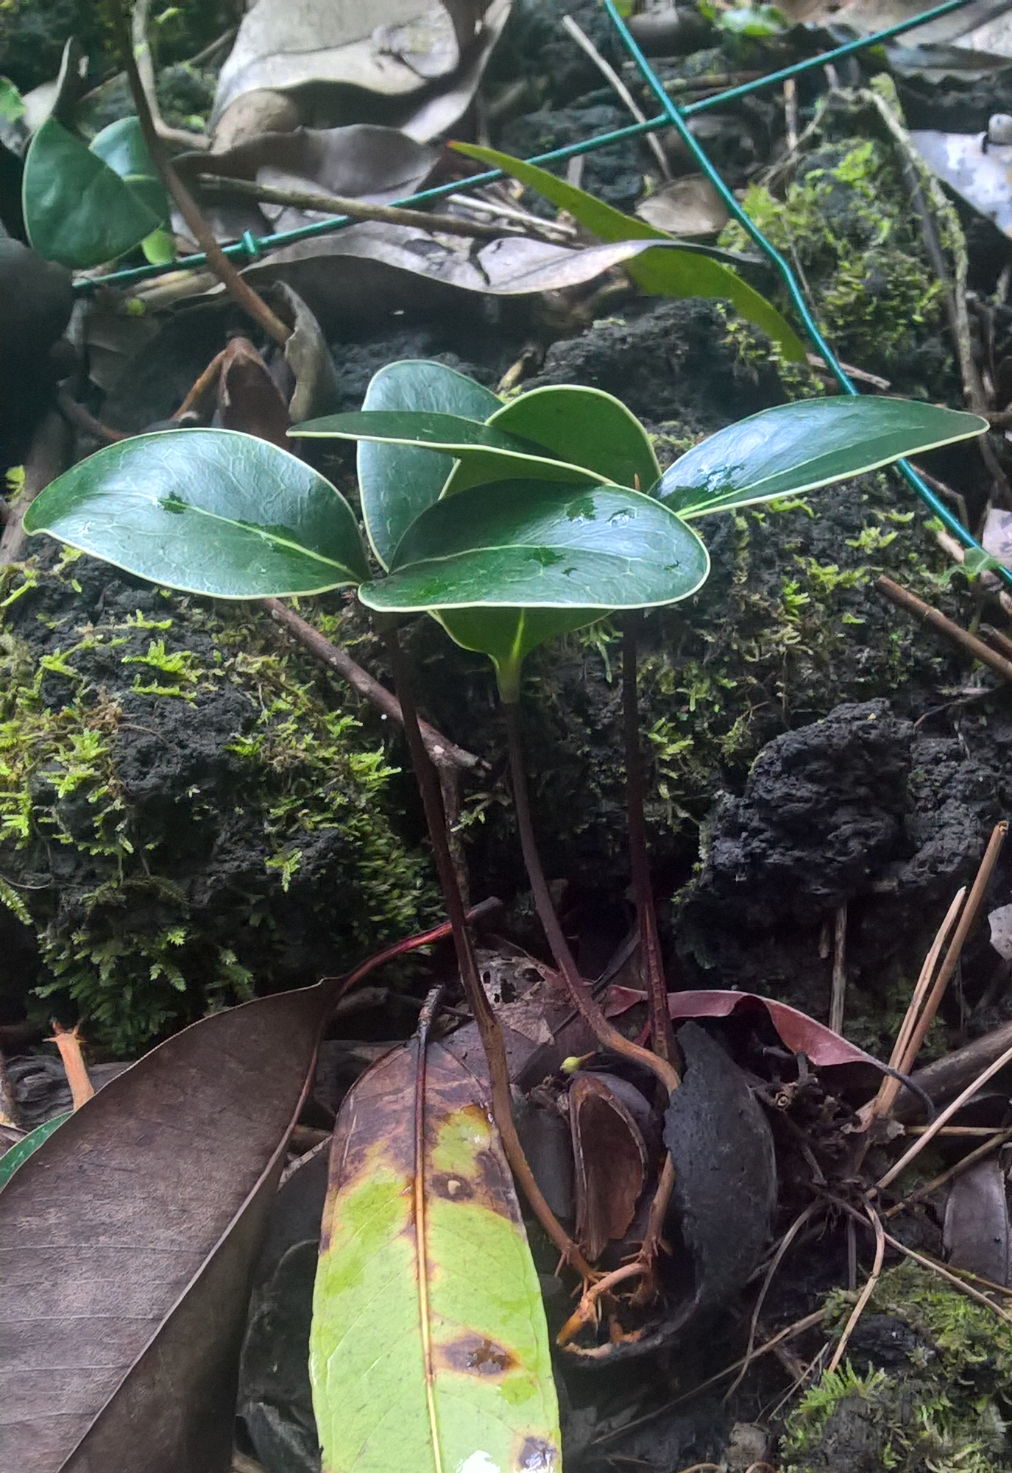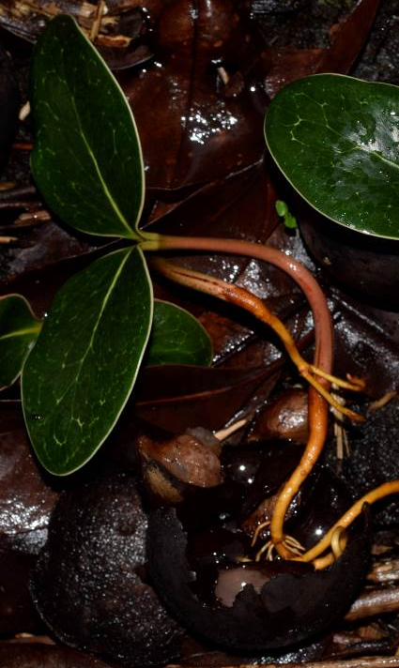
App.6 Seedling development of Labourdonnaisia calophylloides (left) and Mimusops balata (centre & right) within the pericarp. Right, roots that developed within the pericarp have remained in the air after flesh disappearance 3,5 months after sowing. Photos: F. Guilhabert & A. Gorissen
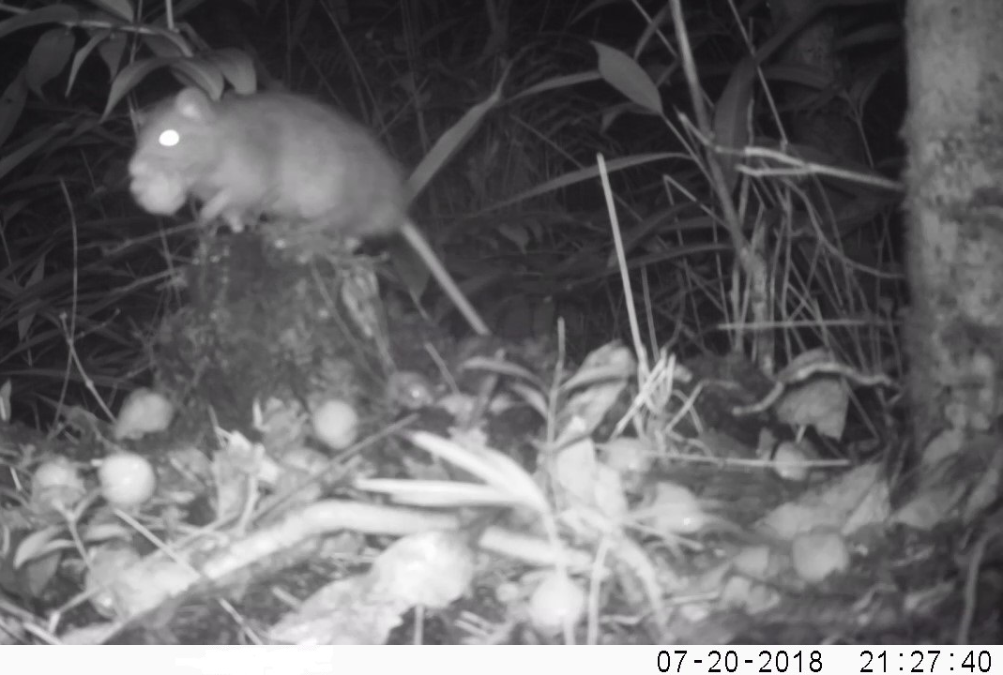
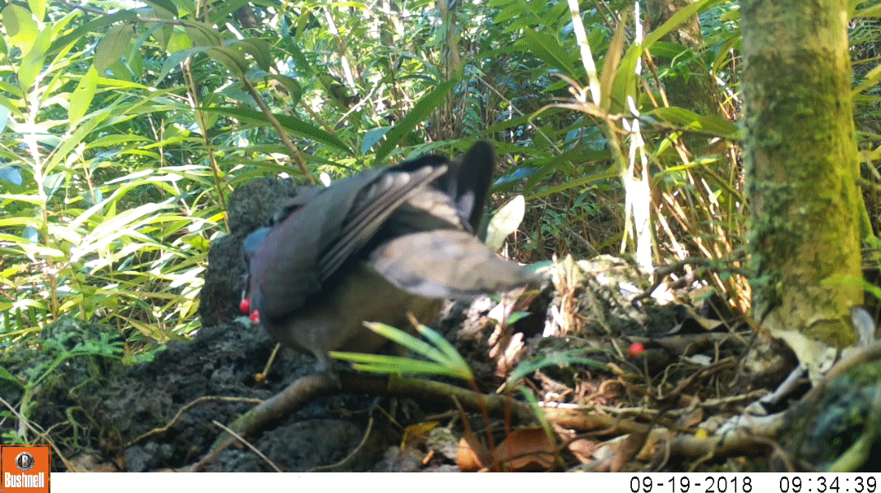
App.7 Monitoring of plant-animal interactions at Ilet Tessan. Top left, no evidence of seed predation or secondary dispersal on focal species was noted after first sowing in January 2018, in spite of the high activity of Rattus rattus in the vicinity. Between the 20th and 27th of July 2018, this species removed for example 39 out of 40 fruits of Hyophorbe indica, a large-seeded endemic and endangered palm tree. Top right, several seeds of M. balata were predated in situ after sowing in November 2019, and numerous fruits of L. calophylloides were removed from the experiment (image not shown for the latter). Bottom left, from 2018 to 2020, camera traps have also detected on the ground various vertebrates that did not interact with focal species: the native birds Saxicola tectes and Terpsiphone bourbonnensis; the introduced birds Acridotheres tristis, Nesoenas picturata (here feeding on fruits of Ardisia crenata), Pycnonotus jocosus and mammals Suncus murinus, Tenrec ecaudatus. Among invertebrates potentially involved in seed predation on oceanic islands, Geograpsus land crabs that invade certain lowland areas at Saint-Philippe have not been seen at study site. Bottom right, the giant snail Lissachatina immaculata fed largely on fruits of L. calophylloides in November 2019. Note the effective seed cleaning with the hilum clearly visible (red arrow). Photos: A. Gorissen & S. Albert.

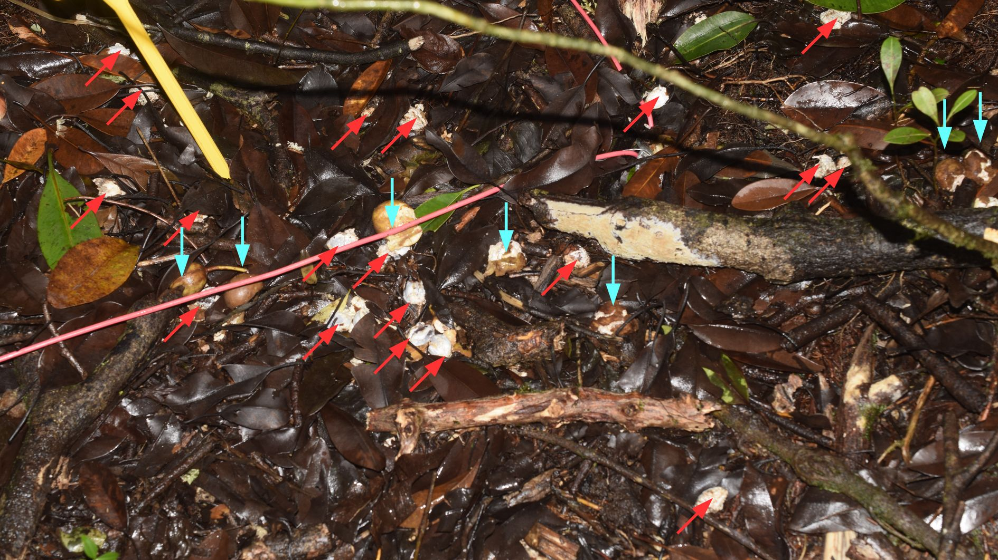
App.8 Cleaned seeds (red arrows) and whole fruits (cyan arrows) of Labourdonnaisia calophylloides on the ground in old-growth forest in January 2022. The invasive Lissachatina immaculata may have been a pervasive seed cleaner of this endemic tree in tropical rainforest on Réunion for several centuries. Photo: A. Gorissen
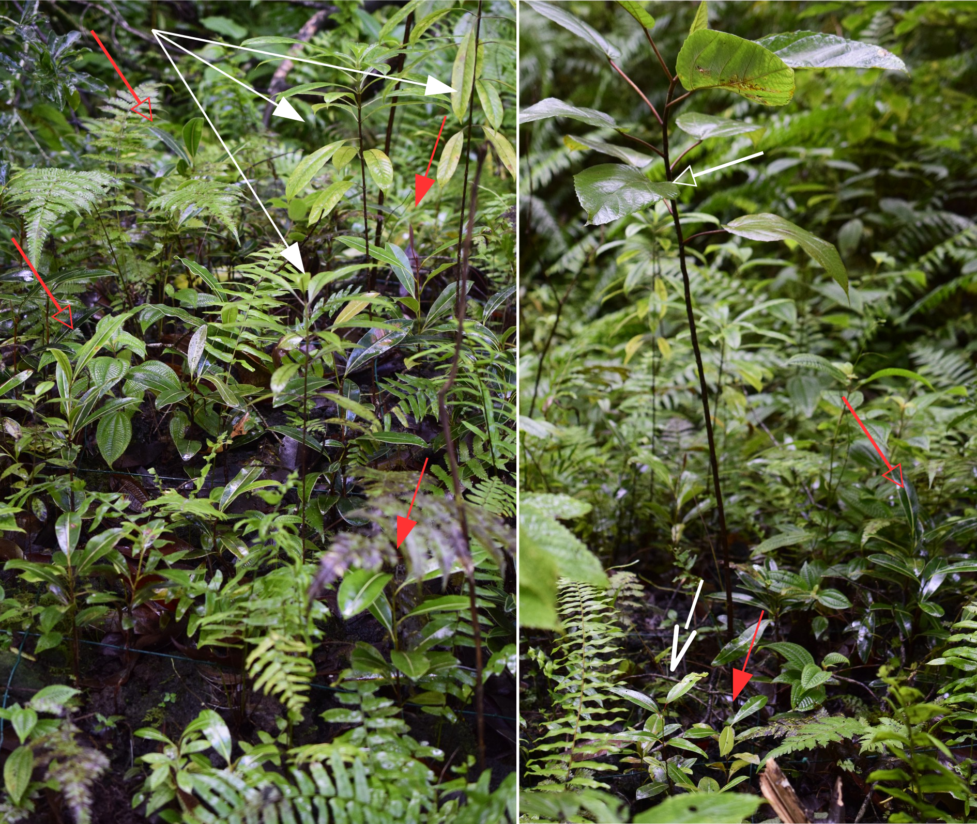
App.9 View of the experiment in the gap in July 2020, 2,5 years after sowing (for the comparison, see App.1). The largest native saplings are the result of spontaneous regeneration, Antirhea borbonica (white arrows), Ficus mauritiana (white unfilled arrow), Ocotea obtusata (white line arrow), but numerous seedlings of L. calophylloides (red arrows) and M. balata (red unfilled arrows) are visible and reach 45 cm high. Photos: A. Gorissen

