Supplementary Material for
‘Conservation management and termites: a case study from central Côte d’Ivoire (West Africa)’
Kolotchèlèma Simon Silué^{1,2,3, *}, N’golo Abdoulaye Koné^{1,2}, Souleymane Konaté¹, Roisin Yves⁴ and Judith Korb^{3, *}

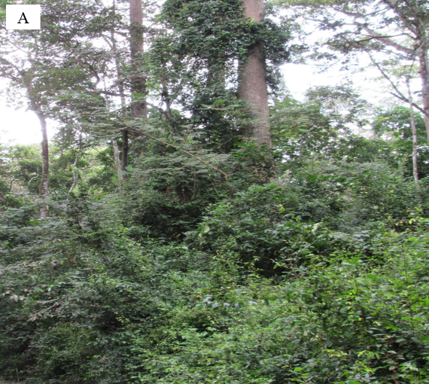
Figure S2. Photos providing (A) an overview and (B) an inside view into a forest island of the LR.

