Supplement: Is Pitcairnia halophila really a halophyte?

Fig. S1. P. halophila growing on a rocky shore near Horconcito, Panama, right above the high tide line, during the 2019 growing season. Shown are naturally occurring individuals and collected samples.

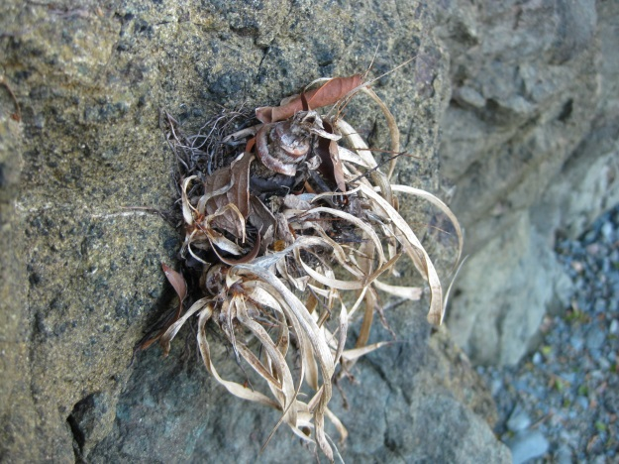
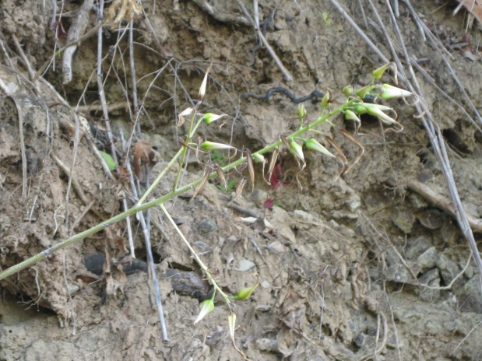
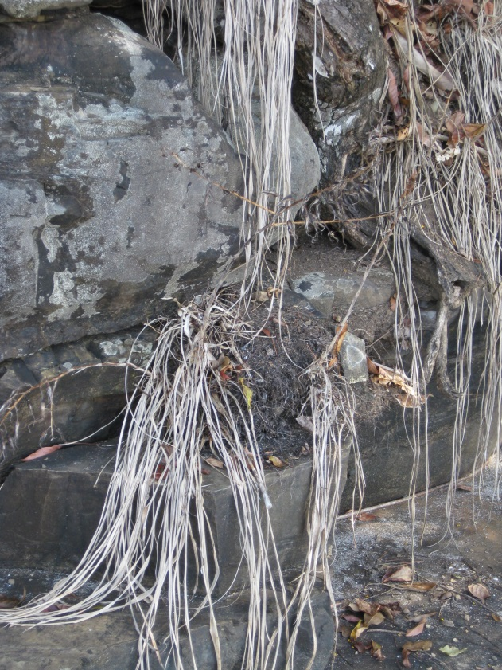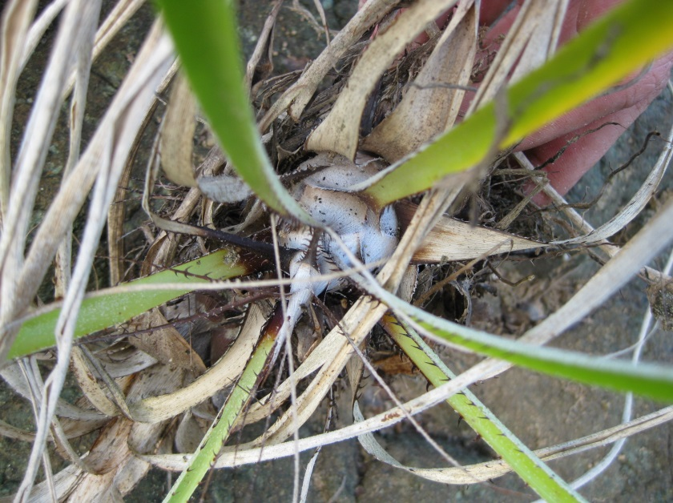

Fig. S2. Pitcairnia halophila, during the early 2020 dry season. Most seeds had already dispersed, leaves had desiccated and only the central corm persisted.

