**Overcoming the regeneration barriers of tropical dry forest: effects of water stress and herbivory on seedling performance and allocation of key tree species for restoration**

Carlos D. Cárdenas1*, Daniela Varón-García1,2, Freddy Suárez1,3,4 and Camila Pizano1.

Author for correspondence: *Carlos D. Cárdenas. Email: [carlosdcardenas1998@gmail.com](mailto:carlosdcardenas1998@gmail.com)

1 Universidad Icesi, Departamento de Ciencias Biológicas. Calle 18 # 122-135, Cali, Valle del Cauca, Colombia.

2 Department of Integrative Biology, University of South Florida, 4202 E Fowler Ave Tampa, FL 33620, USA

3 Åbo Akademi University, Faculty of Science and Engineering, Biosciences, Turku, Finland

4Turku Centre for Biotechnology, Åbo Akademi University and University of Turku, Finland

**Orcid**

Carlos Cárdenas: <https://orcid.org/0000-0001-8271-0601>

Daniela Varón: <https://orcid.org/0000-0002-2768-9931>

Freddy Suárez: <https://orcid.org/0000-0002-3556-1997>

Camila Pizano: <https://orcid.org/0000-0003-4124-1348>

**SUPLEMENT 1.**

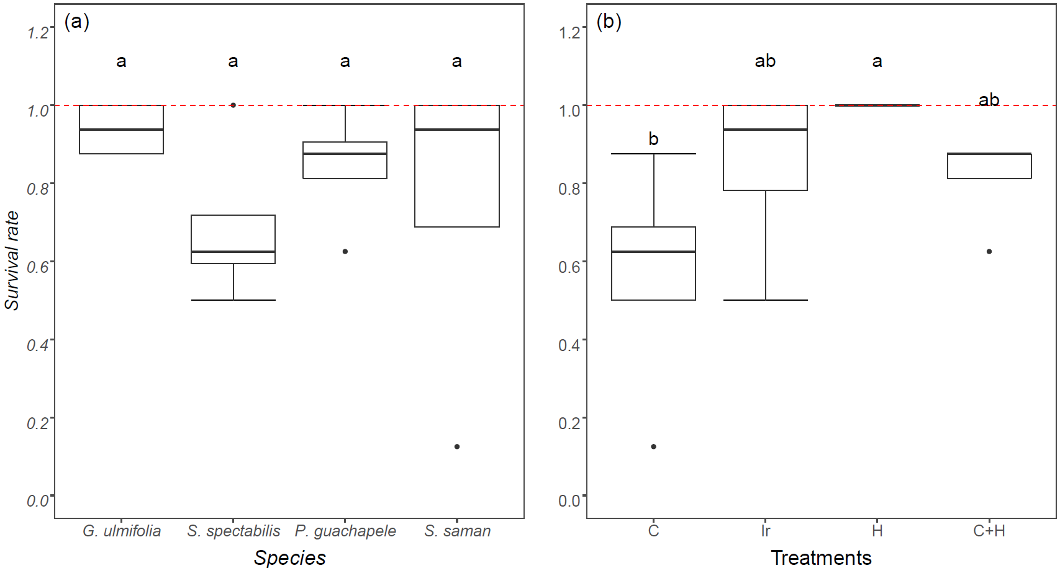

**Figure S1**. Overall survival rate of a) four plant species of tropical dry forest (*G. ulmifolia, S. spectabilis, P. guachapele,*and *S. saman*)and b) the four experimental treatments (C: control; Ir: irrigation; H: herbivory; C+H: control × herbivory). Different letters over the boxes indicate statistical differences across treatments.



**Figure S2**. a) Seedling final dry biomass, b) Root-shoot ratio and c) Water allocation to root vs shoot of four tropical dry forest species seedlings (*G. ulmifolia, S. spectabilis, P. guachapele,*and *S. saman*)combined as a response to four experimental treatments (C: control; Ir: irrigation; H: herbivory; C + H: control × herbivory). Values higher than one indicate investment in roots, while those below one suggests investment in shoot (panels b and c). Different letters over boxes indicate statistical differences across treatments.