Avifaunal feeding guilds’ response to landscape compositional heterogeneity and their drivers in forest mosaic, Uttarakhand, India
Tanveer Ahmed¹ and Afifullah Khan¹*
¹Department of wildlife sciences, Aligarh Muslim University, Aligarh, Uttar Pradesh, India (202002)
Emails: tanveerwildlife@gmail.com (TA), afifkhan@rediffmail.com (AUK)
*Corresponding author
ORCID: http://orcid.org/0000-0003-4203-0382 (TA), http:// orcid.org/0000-0003-0507-2807 (AUK)

Section 1: Spatial autocorrelation
Table S1.1: Moran’s I value of the response variables
Response variable | Moran I | z value | P value
Overall bird richness | -0.017 | -0.52 | 0.59
Insectivore richness | -0.12 | -1.13 | 0.26
Carnivore richness | 0.06 | 1.21 | 0.23
Frugivore richness | 0.01 | 0.54 | 0.59
Granivore richness | 0.02 | 0.66 | 0.51
Frugi+insectivore richness | -0.07 | -0.46 | 0.65
Nectarivore richness | 0.07 | 1.33 | 0.18
Omnivore richness | -0.03 | 0.02 | 0.99
Piscivore richness | -0.08 | -0.66 | 0.51
z value <- 2.58 - -1.65 (dispersed), -1.65- 1.65 (Random), 1.65 - >2.58 (clustered)

Section 2: Screening of landscape predictors
Table S2.1: Value of coefficient of determination (R²) of landscape variables explaining the richness of species at various scales. Bold value represent the scale of best prediction. ***Significant landscape predictors (P<0.05).
Landscape variables | 0.5 km | 0.75 km | 1 km | 1.25 km | 1.5 km | 1.75 km
Overall species richness
ED*** | 0.2646 | 0.2544 | 0.1968 | 0.1683 | 0.1267 | 0.08994
SHDI*** | 0.3878 | 0.4199 | 0.3257 | 0.2937 | 0.2492 | 0.1595
HH/AG | 0.01573 | 0.02489 | 0.02501 | 0.01662 | 0.008995 | 2.20E-07
TK*** | 0.2287 | 0.211 | 0.1344 | 0.05516 | 0.01354 | 0.002229
WB | 0.00456 | 0.01145 | 0.02052 | 0.03573 | 0.04644 | 0.04697
BR | 0.00799 | 0.01128 | 0.02234 | 0.06231 | 0.0637 | 0.04779
DRF | 0.0929 | 0.04154 | 0.02954 | 0.0238 | 0.01857 | 0.01499
MF*** | 0.2669 | 0.1569 | 0.07663 | 0.04897 | 0.03346 | 0.01938
MRF | 0.06659 | 0.07329 | 0.05456 | 0.05384 | 0.05745 | 0.03898
PL | 1.39E-05 | 0.001258 | 0.004647 | 0.004795 | 0.00132 | 0.000125
SF | 0.00114 | 0.01144 | 0.0174 | 0.01828 | 0.01274 | 0.005354
SMF*** | 0.1641 | 0.1248 | 0.1081 | 0.07769 | 0.04759 | 0.04547
SC | 0.00233 | 0.01286 | 0.01236 | 0.01454 | 0.01018 | 0.004375
Carnivore
ED | 0.104976 | 0.069696 | 0.030625 | 0.017689 | 0.011025 | 0.002601
SHDI*** | 0.111556 | 0.135424 | 0.136161 | 0.1225 | 0.142884 | 0.112225
HH/AG | 0.000784 | 0.0025 | 0.0016 | 0.0004 | 0.000004 | 0.000009
TP | 0.072361 | 0.103684 | 0.110224 | 0.066049 | 0.027556 | 0.020164
WB*** | 0.0225 | 0.049284 | 0.126025 | 0.207025 | 0.221841 | 0.223729
BR*** | 0.128164 | 0.179776 | 0.184041 | 0.221841 | 0.204304 | 0.161604
DRF | 0.020449 | 0.049284 | 0.0625 | 0.063504 | 0.077841 | 0.087025
MF | 0.044521 | 0.015876 | 0.000144 | 0.003025 | 0.010609 | 0.016129
MRF | 0.020736 | 0.0361 | 0.053824 | 0.060025 | 0.068644 | 0.024025
PL | 0.056644 | 0.020449 | 0.003844 | 0.002116 | 0.005329 | 0.011236
SF | 0.032041 | 0.066564 | 0.0729 | 0.0729 | 0.073441 | 0.0729
SMF | 0.000004 | 0.000196 | 0.001764 | 0.000064 | 0.000784 | 0.000324
SC | 0.004761 | 0.027556 | 0.026244 | 0.027889 | 0.032041 | 0.005929
Granivore
ED*** | 0.322624 | 0.304704 | 0.309136 | 0.279841 | 0.221841 | 0.161604
SHDI*** | 0.439569 | 0.541696 | 0.558009 | 0.528529 | 0.505521 | 0.419904
HH/AG*** | 0.156025 | 0.1849 | 0.194481 | 0.149769 | 0.104976 | 0.099856
TK*** | 0.138384 | 0.135424 | 0.121801 | 0.0289 | 0.019881 | 0.002401
WB | 0.015129 | 0.025281 | 0.054289 | 0.077284 | 0.086436 | 0.085264
BR*** | 0.021025 | 0.099225 | 0.2116 | 0.314721 | 0.305809 | 0.254016
DRF | 0.000025 | 0.006561 | 0.009025 | 0.01 | 0.010201 | 0.011449
MF*** | 0.096721 | 0.147456 | 0.0784 | 0.046656 | 0.028561 | 0.014161
MRF | 0.003136 | 0.000961 | 0.0001 | 0.001024 | 0.002025 | 0.0144
PL | 0.005476 | 0.009409 | 0.006561 | 0.004489 | 0.009604 | 0.015876
SF | 0.110889 | 0.081225 | 0.064009 | 0.050176 | 0.048841 | 0.064516
SMF | 0.066049 | 0.040401 | 0.032761 | 0.030625 | 0.021609 | 0.021316
SC*** | 0.070225 | 0.098596 | 0.112896 | 0.130321 | 0.125316 | 0.168921
Insectivore
ED*** | 0.147456 | 0.148996 | 0.096721 | 0.084681 | 0.062001 | 0.045796
SHDI*** | 0.229441 | 0.267289 | 0.192721 | 0.1764 | 0.134689 | 0.069169
HH/AG | 0.0004 | 0.002304 | 0.007225 | 0.008649 | 0.007921 | 0.000289
TK*** | 0.258064 | 0.252004 | 0.16 | 0.085264 | 0.015376 | 0.001225
WB | 0.012544 | 0.017424 | 0.025281 | 0.030976 | 0.035344 | 0.035721
BR | 0.000784 | 0.000169 | 0.000025 | 0.005329 | 0.008281 | 0.0049
DRF*** | 0.143641 | 0.090601 | 0.076729 | 0.068121 | 0.059049 | 0.0529
MF*** | 0.237169 | 0.09 | 0.037636 | 0.021025 | 0.013924 | 0.007056
MRF | 0.093025 | 0.091809 | 0.078961 | 0.083521 | 0.086436 | 0.064516
PL | 0.000121 | 0.003844 | 0.001936 | 0.000529 | 0.000064 | 0.000049
SF | 0.0036 | 0.026896 | 0.044521 | 0.049729 | 0.037249 | 0.023409
SMF*** | 0.190096 | 0.1521 | 0.130321 | 0.080089 | 0.043681 | 0.047089
SC | 0.046656 | 0.000361 | 0 | 0.000225 | 0.000225 | 0.002916
Frugi+Insectivore
ED*** | 0.407044 | 0.388129 | 0.401956 | 0.375769 | 0.3136 | 0.229441
SHDI*** | 0.459684 | 0.444889 | 0.413449 | 0.3844 | 0.262144 | 0.142129
HH/AG*** | 0.162409 | 0.1444 | 0.135424 | 0.086436 | 0.047961 | 0.007921
TP | 0.082369 | 0.051529 | 0.012544 | 0.002601 | 0.030976 | 0.052441
WB | 0.010404 | 0.009216 | 0.017689 | 0.033856 | 0.042025 | 0.043264
BR | 0.000841 | 0.0016 | 0.000784 | 0.015376 | 0.006241 | 0.0009
DRF*** | 0.170569 | 0.119716 | 0.086436 | 0.071824 | 0.055225 | 0.051076
MF*** | 0.285156 | 0.113569 | 0.053361 | 0.023409 | 0.006561 | 0.000004
MRF | 0.018225 | 0.018225 | 0.011664 | 0.007396 | 0.0064 | 0.003969
PL | 0.007056 | 0.008649 | 0.030276 | 0.031329 | 0.037636 | 0.034596
SF | 0.004356 | 0.009409 | 0.028561 | 0.034969 | 0.022801 | 0.020164
SMF*** | 0.192721 | 0.209764 | 0.218089 | 0.1849 | 0.142884 | 0.133956
SC | 0.0025 | 0.030625 | 0.044521 | 0.059049 | 0.026569 | 0.013225
Nectarivore
ED*** | 0.163216 | 0.165649 | 0.209764 | 0.217156 | 0.208849 | 0.173056
SHDI*** | 0.290521 | 0.251001 | 0.219024 | 0.222784 | 0.187489 | 0.139129
HH/AG*** | 0.179776 | 0.170569 | 0.110889 | 0.0729 | 0.049284 | 0.031329
TK | 0.026244 | 0.007569 | 0.000009 | 0.004225 | 0.023409 | 0.038025
WB | 0.027225 | 0.027889 | 0.024649 | 0.027225 | 0.036864 | 0.036864
BR | 0.001681 | 0.042025 | 0.017424 | 0.002116 | 0.001681 | 0.002916
DRF | 0.033856 | 0.0441 | 0.053824 | 0.055696 | 0.058081 | 0.059049
MF | 0.054756 | 0.027889 | 0.026896 | 0.034596 | 0.025281 | 0.009025
MRF | 0.018225 | 0.005776 | 0.001764 | 0.001089 | 0.000961 | 0.002209
PL | 0.009025 | 0.0001 | 0.001521 | 0.003481 | 0.000784 | 0.000196
SF | 0.026569 | 0.060516 | 0.070225 | 0.081225 | 0.099856 | 0.112896
SMF | 0.002304 | 0.003364 | 0.006724 | 0.005929 | 0.000576 | 0.002116
SC*** | 0.116281 | 0.1521 | 0.154449 | 0.148225 | 0.127449 | 0.110889
Omnivore
ED | 0.069169 | 0.031684 | 0.031329 | 0.017689 | 0.012321 | 0.008836
SHDI*** | 0.239121 | 0.190096 | 0.184041 | 0.156025 | 0.190969 | 0.146689
HH/AG*** | 0.217156 | 0.266256 | 0.25 | 0.215296 | 0.173056 | 0.150544
TK | 0.007396 | 0.01 | 0.008464 | 0.004225 | 0.006084 | 0.000256
WB*** | 0.020449 | 0.045796 | 0.076176 | 0.126025 | 0.138384 | 0.139129
BR*** | 0.004489 | 0.027889 | 0.073441 | 0.1024 | 0.124609 | 0.127449
DRF | 0.001089 | 0.0004 | 0.000004 | 0 | 0.000729 | 0.001521
MF | 0.032041 | 0.003844 | 0.0004 | 0.006241 | 0.016129 | 0.025281
MRF | 0.006724 | 0.010201 | 0.011881 | 0.015625 | 0.017956 | 0.059049
PL | 0.055225 | 0.0784 | 0.029929 | 0.016384 | 0.022201 | 0.031329
SF | 0.052441 | 0.072361 | 0.059049 | 0.043681 | 0.055225 | 0.0625
SMF | 0.003969 | 0.000064 | 0.000256 | 0.001156 | 0.001089 | 0.000121
SC*** | 0.104976 | 0.117649 | 0.107584 | 0.110224 | 0.171396 | 0.175561
Piscivore
ED | 0.087025 | 0.084681 | 0.067081 | 0.046656 | 0.038416 | 0.037249
SHDI | 0.0784 | 0.065536 | 0.033489 | 0.024025 | 0.015376 | 0.003721
HH/AG | 0.037636 | 0.04 | 0.030625 | 0.033124 | 0.044944 | 0.075076
TK | 0.022201 | 0.032041 | 0.0256 | 0.0256 | 0.027225 | 0.028561
WB*** | 0.109561 | 0.120409 | 0.059049 | 0.051984 | 0.044944 | 0.042436
BR | 0.0784 | 0.080089 | 0.053824 | 0.043264 | 0.0289 | 0.024964
DRF | 0.021609 | 0.003721 | 0.000144 | 0.000036 | 0.001681 | 0.001936
MF | 0.108241 | 0.068644 | 0.035344 | 0.016641 | 0.008464 | 0.006889
MRF | 0.097969 | 0.098596 | 0.051076 | 0.051076 | 0.059536 | 0.051984
PL | 0.000576 | 0.006241 | 0.000196 | 0 | 0.0004 | 0.000729
SF | 0 | 0.001024 | 0.0036 | 0.001681 | 0.000064 | 0
SMF | 0.0676 | 0.083521 | 0.073441 | 0.057121 | 0.042025 | 0.049729
SC | 0.024336 | 0.0324 | 0.0324 | 0.026244 | 0.026244 | 0.044944
Frugivore
ED | 0.049284 | 0.030976 | 0.006561 | 0.000784 | 0.001156 | 0.008649
SHDI | 0.004624 | 0.01 | 0.002304 | 0.000256 | 0.001681 | 0.0081
HH/AG | 0.000625 | 0.000004 | 0.000441 | 0.002116 | 0.001089 | 0.008836
TK | 0.029584 | 0.039204 | 0.0225 | 0.003721 | 0.0004 | 0.003721
WB*** | 0.177241 | 0.188356 | 0.209764 | 0.173889 | 0.167281 | 0.170569
BR | 0.005041 | 0.005776 | 0.000961 | 0.000121 | 0.003249 | 0.006561
DRF | 0.069169 | 0.020736 | 0.003969 | 0.000729 | 0.000144 | 0.000529
MF | 0.070225 | 0.043681 | 0.010404 | 0.004356 | 0.003481 | 0.001764
MRF | 0.014161 | 0.005329 | 0.0000 | 0.003249 | 0.006561 | 0.033856
PL | 0.004761 | 0.000324 | 0.043264 | 0.055225 | 0.055696 | 0.069696
SF | 0.011025 | 0.0144 | 0.011881 | 0.008281 | 0.002704 | 0.003481
SMF | 0.0169 | 0.006889 | 0.001296 | 0.000484 | 0.007744 | 0.0196
SC | 0.004225 | 0.000009 | 0.001225 | 0.002601 | 0.001936 | 0.000324

ED=Edge Density, SHDI=Shannon diversity, HH/AG= Human habitation with agriculture, BR= Barren land, DR= Dry Riverine, MF= Mixed forest, PL=Plantation, MRF= Moist riverine forest, SF=Sal forest, SMF= Sal mixed forest, SC=Scrubland, TP=Teak plantation, WB=Water body

Section 3: Multi-collinearity among explanatory variables
Table 3.1 Correlation value between various landscape predictors of overall species richness
 | ED | SHDI | TK | MF | SMF
ED | 1
SHDI | .796** | 1
TK | 0.265 | .441* | 1
MF | .623** | .614** | .461* | 1
SMF | .404* | .408* | -0.103 | 0.22 | 1

Table 3.2 Correlation value between various landscape predictors variable of carnivore species richness
 | BR | WB | SHDI
BR | 1
WB | .562** | 1
SHDI | .537** | .712** | 1

Table 3.3 Correlation between various landscape predictors variable of granivore species richness
 | ED | SHDI | HH/AG | TK | BR | MF
ED
SHDI | .614**
HH/AG | 0.135 | .520**
TK | -0.093 | .410* | -0.108
BR | 0.123 | .413* | 0.114 | 0.135
MF | .579** | .557** | -0.136 | 0.361 | 0.296
SC | 0.185 | 0.31 | .555** | -0.205 | 0.237 | -0.241
Table 3.4 Correlation value between various landscape predictors variable of insectivore species richness
Landscape variables | ED | SHDI | TK | DRF | MF
ED
SHDI | .824**
TK | 0.175 | .441*
DRF | 0.068 | -0.12 | -0.129
MF | .563** | .614** | .461* | -0.1
SMF | .497** | .408* | -0.103 | -0.296 | 0.22

Table 3.5 Correlation value between various landscape predictors variable of Frugi+insectivore species richness
Landscape variables | ED | SHDI | HH/AG | DRF | MF
ED
SHDI | .804**
HH/AG | 0.234 | 0.329
DRF | 0.076 | -0.138 | -0.268
MF | .623** | .696** | -0.169 | -0.1
SMF | .404* | .390* | 0.08 | -0.296 | 0.22

Table 3.6 Correlation value between various landscape predictors variable of nectarivore species richness
 | ED | SHDI | SIEI | HH/AG
ED
SHDI | .672**
SIEI | .684** | .957**
HH/AG | 0.284 | 0.329 | .383*
SC | 0.304 | 0.226 | 0.192 | .492**

Table 3.7 Correlation value between various landscape predictors variable of omnivore species richness
 | SHDI | HH/AG | WB | BR
SHDI
HH/AG | 0.359
WB | .371* | 0.286
BR | 0.127 | 0.09 | .571**
SC | 0.126 | .594** | 0.16 | 0.236
ED=Edge Density, SHDI=Shannon diversity, HH/AG= Human habitation with agriculture, BR= Barren land, DR= Dry Riverine, MF= Mixed forest, PL=Plantation, MRF= Moist riverine forest, SF=Sal forest, SMF= Sal mixed forest, SC=Scrubland, TP=Teak plantation, WB=Water body.
***Significant correlation between landscape predictors (P<0.05),

Section 4: Birds in the study area
Table S4.1: Birds and their feeding guild recorded at various sampling sites in Ramnagar FD, Uttarakhand
Order | Families | Row Labels | Feeding Guild
Accipitriformes | Accipitridae | Short-toed Snake-eagle | carnivore
Accipitriformes | Accipitridae | Tawny Eagle | carnivore
Accipitriformes | Accipitridae | Black-winged Kite | carnivore
Accipitriformes | Accipitridae | Steppe Eagle | carnivore
Accipitriformes | Accipitridae | Lesser Fish Eagle | carnivore
Accipitriformes | Accipitridae | Mountain Hawk-eagle | carnivore
Accipitriformes | Accipitridae | Oriental Honey-buzzard | carnivore
Accipitriformes | Accipitridae | Pariah Kite | carnivore
Accipitriformes | Accipitridae | Indian Spotted eagle | carnivore
Accipitriformes | Accipitridae | Eurasian Sparrowhawk | carnivore
Accipitriformes | Accipitridae | Shikra | carnivore
Accipitriformes | Accipitridae | Crested Serpent-eagle | carnivore
Accipitriformes | Accipitridae | Changeable Hawk-eagle | carnivore
Passeriformes | Aegithinidae | Common Iora | Insectivore
Coraciiformes | Alcedinidae | Stork-billed Kingfisher | piscivore
Coraciiformes | Alcedinidae | Common Kingfisher | piscivore
Coraciiformes | Alcedinidae | Crested Kingfisher | piscivore
Coraciiformes | Alcedinidae | Pied kingfisher | piscivore
Coraciiformes | Alcedinidae | White-throated Kingfisher | piscivore
Pelecaniformes | Ardeidae | Cattle Egret | carnivore
Pelecaniformes | Ardeidae | Indian Pond heron | carnivore
Pelecaniformes | Ardeidae | Little Egret | carnivore
Bucerotiformes | Bucerotidae | Great Hornbill | frugivore
Bucerotiformes | Bucerotidae | Pied Hornbill | frugivore
Bucerotiformes | Bucerotidae | Indian Grey Hornbill | frugivore
Charadriiformes | Burhinidae | Indian Thick-Knee | granivore
Passeriformes | Campephagidae | Black-winged Cuckooshrike | Insectivore
Passeriformes | Campephagidae | Rosy Minivet | Insectivore
Passeriformes | Campephagidae | Long-tailed Minivet | Insectivore
Passeriformes | Campephagidae | Small Minivet | Insectivore
Passeriformes | Campephagidae | Bar-winged Flycatcher-shrike | Insectivore
Passeriformes | Campephagidae | Scarlet Minivet | Insectivore
Caprimulgiformes | Caprimulgidae | Indian Nightjar | Insectivore
Passeriformes | Certhiidae | Bar-tailed Treecreeper | Insectivore
Charadriiformes | Charadriidae | River Lapwing | insectivore
Charadriiformes | Charadriidae | Little ringed Plover | Insectivore
Charadriiformes | Charadriidae | Red-wattled Lapwing | Insectivore
Passeriformes | Chloropseidae | Orange-bellied Leafbird | omnivore
Passeriformes | Cisticolidae | Zitting Cisticola | Insectivore
Passeriformes | Cisticolidae | Striated Prinia | Insectivore
Passeriformes | Cisticolidae | Ashy Prinia | Insectivore
Passeriformes | Cisticolidae | Indian Tailorbird | Insectivore
Passeriformes | Cisticolidae | Grey-breasted Prinia | Insectivore
Passeriformes | Cisticolidae | Jungle Prinia | Insectivore
Passeriformes | Cittidae | Grey-bellied Tesia | Insectivore
Passeriformes | Cittidae | Chestnut-crowned Bush Warbler | Insectivore
Passeriformes | Cittidae | Abberant Bush Warbler | Insectivore
Columbiformes | Columbidae | Wedge-tailed Green Pigeon | frugivore
Columbiformes | Columbidae | Laughing Dove | granivore
Columbiformes | Columbidae | Emerald Dove | granivore
Columbiformes | Columbidae | Yellow-footed Green Pigeon | frugivore
Columbiformes | Columbidae | Oriental Turtle Dove | granivore
Columbiformes | Columbidae | Collared Dove | granivore
Columbiformes | Columbidae | Rock Pigeon | granivore
Columbiformes | Columbidae | Spotted Dove | granivore
Coraciiformes | Coraciidae | Indian Roller | Insectivore
Passeriformes | Corvidae | Black-headed Jay | omnivore
Passeriformes | Corvidae | Common Green Magpie | carnivore
Passeriformes | Corvidae | Red-billed Blue Magpie | omnivore
Passeriformes | Corvidae | Roufus Treepie | omnivore
Passeriformes | Corvidae | Grey Treepie | omnivore
Passeriformes | Corvidae | Jungle Crow | omnivore
Cuculiformes | Cuculidae | Grey-bellied Cuckoo | Insectivore
Cuculiformes | Cuculidae | Eurasian Cuckoo | Insectivore
Cuculiformes | Cuculidae | Green-billed Malkoha | omnivore
Cuculiformes | Cuculidae | Indian Cuckoo | Insectivore
Cuculiformes | Cuculidae | Dollar Bird | Insectivore
Cuculiformes | Cuculidae | Common Hawk Cuckoo | Insectivore
Cuculiformes | Cuculidae | Asian Koel | omnivore
Cuculiformes | Cuculidae | Greater Coucal | omnivore
Passeriformes | Dicaeidae | Pale-billed Flowerpecker | frugivore
Passeriformes | Dicaeidae | Thick-billed Flowerpecker | frugivore
Passeriformes | Dicuridae | Bronze Drongo | Insectivore
Passeriformes | Dicuridae | Ashy Drongo | Insectivore
Passeriformes | Dicuridae | Lesser Racquet-tailed Drongo | Insectivore
Passeriformes | Dicuridae | White-bellied Drongo | Insectivore
Passeriformes | Dicuridae | Crow-billed Drongo | Insectivore
Passeriformes | Dicuridae | Spangled Drongo | Insectivore
Passeriformes | Dicuridae | Greater Racquet-tailed Drongo | Insectivore
Passeriformes | Dicuridae | Black Drongo | Insectivore
Passeriformes | Emberizidae | chestnut-eared bunting | granivore
Passeriformes | Emberizidae | Crested bunting | Insectivore
Passeriformes | Emberizidae | White-capped Bunting | Insectivore
Passeriformes | Estrildidae | White-rumped Munia | Insectivore
Passeriformes | Estrildidae | Scaly-breasted Munia | granivore
Passeriformes | Fringillidae | Yellow-brested Greenfinch | Insectivore
Passeriformes | Fringillidae | Common Rosefinch | Herbivore
Caprimulgiformes | Hemiprocnidae | Crested Treeswift | Insectivore
Passeriformes | Hirundinidae | Wire-tailed swallow | Insectivore
Passeriformes | Hirundinidae | Barn Swallow | Insectivore
Passeriformes | Hirundinidae | Red-rumped Swallow | Insectivore
Passeriformes | Hirundinidae | Plain Martin | Insectivore
Passeriformes | Laniidae | Long-tailed Shrike | Insectivore
Piciformes | Megalaimidae | Great Barbet | frugivore
Piciformes | Megalaimidae | Blue-throated Barbet | frugivore
Piciformes | Megalaimidae | Copper-smith Barbet | frugivore
Piciformes | Megalaimidae | Lineated Barbet | frugivore
Passeriformes | Meropidae | Blue-bearded bee-eater | Insectivore
Passeriformes | Meropidae | Chestnut-headed Bee-eater | Insectivore
Passeriformes | Meropidae | Green Bee-eater | Insectivore
Passeriformes | Monarchidae | Black-naped Monarch | Insectivore
Passeriformes | Monarchidae | Paradise Flycatcher | Insectivore
Passeriformes | Motacillidae | Tawny Pipit | Insectivore
Passeriformes | Motacillidae | Yellow Wagtail | Insectivore
Passeriformes | Motacillidae | Long-billed Pipit | Insectivore
Passeriformes | Motacillidae | Olive-backed Pipit | Insectivore
Passeriformes | Motacillidae | Paddyfield Pipit | Insectivore
Passeriformes | Motacillidae | White Wagtail | Insectivore
Passeriformes | Motacillidae | White-browed Wagtail | Insectivore
Passeriformes | Motacillidae | Grey wagtail | Insectivore
Passeriformes | Muscicapidae | Blue-capped Rock Thrush | Insectivore
Passeriformes | Muscicapidae | Rufous-bellied Niltava | Insectivore
Passeriformes | Muscicapidae | Tickell's Blue flycatcher | Insectivore
Passeriformes | Muscicapidae | Rufous-gorgeted Flycatcher | Insectivore
Passeriformes | Muscicapidae | Spotted forktail | Insectivore
Passeriformes | Muscicapidae | Rock Chat | Insectivore
Passeriformes | Muscicapidae | Small Niltava | Insectivore
Passeriformes | Muscicapidae | Common Stonechat | Insectivore
Passeriformes | Muscicapidae | Ultramarine Flycatcher | Insectivore
Passeriformes | Muscicapidae | Black Redstart | Insectivore
Passeriformes | Muscicapidae | White-rumped Shama | Insectivore
Passeriformes | Muscicapidae | Plumbeous Redstart | Insectivore
Passeriformes | Muscicapidae | Slaty blue Flycatcher | Insectivore
Passeriformes | Muscicapidae | Blue-throated Blue Flycatcher | Insectivore
Passeriformes | Muscicapidae | Golden-fronted Leafbird | omnivore
Passeriformes | Muscicapidae | White-capped Water Redstart | Insectivore
Passeriformes | Muscicapidae | Little Pied flycatcher | Insectivore
Passeriformes | Muscicapidae | Pied Bushchat | Insectivore
Passeriformes | Muscicapidae | Virditer Flycatcher | Insectivore
Passeriformes | Muscicapidae | Asian Brown Flycatcher | Insectivore
Passeriformes | Muscicapidae | Indian Robin | Insectivore
Passeriformes | Muscicapidae | Grey Bushchat | Insectivore
Passeriformes | Muscicapidae | Oriental Magpie Robin | Insectivore
Passeriformes | Nectariniidae | Fire-tailed Sunbird | Nectivore
Passeriformes | Nectariniidae | Crimson Sunbird | Nectivore
Passeriformes | Nectariniidae | Purple Sunbird | Nectivore
Passeriformes | Nectarniidae | Green-tailed Sunbird | Nectivore
Passeriformes | Oriolidae | Golden Oriole | omnivore
Passeriformes | Oriolidae | Maroon Oriole | Insectivore
Passeriformes | Oriolidae | Black-hooded Oriole | Insectivore
Passeriformes | Paridae | Black-lored Tit | Insectivore
Passeriformes | paridae | Great Tit | Insectivore
Passeriformes | Passeridae | House Sparrow | omnivore
Passeriformes | Passeridae | Chesnut-shouldered Petronia | granivore
Passeriformes | Pellorneidae | Puff-throated Babbler | Insectivore
Galliformes | Phasianidae | Jungle Bush Quail | granivore
Galliformes | Phasianidae | Black Francolin | granivore
Galliformes | Phasianidae | Grey Francolin | granivore
Galliformes | Phasianidae | Kalij Pheasant | granivore
Galliformes | Phasianidae | Indian Peafowl | omnivore
Galliformes | Phasianidae | Red Junglefowl | granivore
Passeriformes | Phylloscopidae | Grey-sided Bush Warbler | Insectivore
Passeriformes | Phylloscopidae | Tickle's Leaf Warbler | Insectivore
Passeriformes | Phylloscopidae | Lemon-rumped Warbler | Insectivore
Passeriformes | Phylloscopidae | Blyth's Leaf warbler | Insectivore
Passeriformes | Phylloscopidae | Whistler's Warbler | Insectivore
Passeriformes | Phylloscopidae | Dusky Warbler | Insectivore
Passeriformes | Phylloscopidae | Sulphur-bellied Warbler | Insectivore
Passeriformes | Phylloscopidae | Greenish Warbler | Insectivore
Passeriformes | Phylloscopidae | Grey-hooded Warbler | Insectivore
Passeriformes | Phylloscopidae | Hume's Leaf Warbler | Insectivore
Piciformes | Picidae | Speckled Piculet | Insectivore
Piciformes | Picidae | Rufous woodpecker | Insectivore
Piciformes | Picidae | Scaly-bellied Woodpecker | Insectivore
Piciformes | Picidae | Great Slaty woodpecker | Insectivore
Piciformes | Picidae | Lesser Goldenback | Insectivore
Piciformes | Picidae | Grey-headed Woodpecker | Insectivore
Piciformes | Picidae | Lesser Yellownape | Insectivore
Piciformes | Picidae | Greater Yellownape | Insectivore
Piciformes | Picidae | Greater Goldenback | Insectivore
Piciformes | Picidae | Himalayan Goldenback | Insectivore
Piciformes | Picidae | Grey-capped Pygmy Woodpecker | Insectivore
Piciformes | Picidae | Brown headed pygmy woodpecker | Insectivore
Piciformes | Picidae | Streaked-throated Woodpecker | Insectivore
Piciformes | Picidae | Fulvous-brested Woodpecker | Insectivore
Psittaciformes | Psittaculidae | Red-breasted Parakeet | frugivore
Psittaciformes | Psittaculidae | Alexandrine Parakeet | frugivore
Psittaciformes | Psittaculidae | Slaty-headed Parakeet | frugivore
Psittaciformes | Psittaculidae | Plum-headed Parakeet | frugivore
Psittaciformes | Psittaculidae | Rose-ringed Parakeet | frugivore
Passeriformes | Pycnonotiadae | Black-crested Bulbul | frugivore+Insectivore
Passeriformes | Pycnonotiadae | Ashy Bulbul | frugivore+Insectivore
Passeriformes | Pycnonotiadae | Black Bulbul | frugivore+Insectivore
Passeriformes | Pycnonotiadae | Red-whiskered Bulbul | frugivore+Insectivore
Passeriformes | Pycnonotiadae | Red-vented Bulbul | frugivore+Insectivore
Passeriformes | Pycnonotiadae | Himalayan Bulbul | omnivore
gruiformes | Rallidae | White-breasted Waterhen | carnivore
gruiformes | rallidae | Common Moorhen | omnivore
Charadriiformes | Recurvirostridae | Black-winged stilt | carnivore
Passeriformes | Rhipiduridae | White-throated Fantail | Insectivore
Passeriformes | Sittidae | Velvet-fronted Nuthatch | Insectivore
Passeriformes | Sittidae | Chestnut-bellied Nuthatch | Insectivore
Passeriformes | Stenostiridae | Yellow-bellied Fantail | Insectivore
Passeriformes | Stenostiridae | Grey-headed Canary Flycatcher | Insectivore
Strigiformes | Strigidae | Asian-barred Owlet | carnivore
Strigiformes | Strigidae | Spotted owlet | carnivore
Strigiformes | Strigidae | Tawny fish owl | carnivore
Strigiformes | Strigidae | Brown Wood Owl | carnivore
Strigiformes | Strigidae | Spot-bellied Eagle Owl | carnivore
Strigiformes | Strigidae | Jungle Owlet | carnivore
Strigiformes | Strigidae | Asian Barred Owlet | carnivore
Passeriformes | Sturnidae | Brahminy Starling | omnivore
Passeriformes | Sturnidae | Asian Pied Starling | omnivore
Passeriformes | Sturnidae | Spot-winged Starling | omnivore
Passeriformes | Sturnidae | Chestnut-tailed Starling | omnivore
Passeriformes | Sturnidae | Jungle Myna | omnivore
Passeriformes | Sturnidae | Common Myna | omnivore
Passeriformes | Sylviidae | Common Chiffchaff | Insectivore
Passeriformes | Sylviidae | Blyth's Reed Wabler | Insectivore
Passeriformes | Sylviidae | Lesser Whitethroat | Insectivore
Passeriformes | Tichodromadidae | Wall creeper | Insectivore
Passeriformes | Timaliidae | White-bellied Erpornis | Insectivore
Passeriformes | Timaliidae | Rusty-cheeked Scimitar Babbler | Insectivore
Passeriformes | Timaliidae | Black-chinned Yuhina | Insectivore
Passeriformes | Timaliidae | Whiskered Yuhina | Insectivore
Passeriformes | Timaliidae | Striated Laughingthrush | Insectivore
Passeriformes | Timaliidae | Chestnut-crowned Laughingthrush | Insectivore
Passeriformes | Timaliidae | Streaked Laughingthrush | Insectivore
Passeriformes | Timaliidae | Red-billed Leiothrix | Insectivore
Passeriformes | Timaliidae | White-throated Laughingthrush | Insectivore
Passeriformes | Timaliidae | Black-chinned Babbler | Insectivore
Passeriformes | Timaliidae | White-crested Laughingthrush | Insectivore
Passeriformes | Timaliidae | Jungle Babbler | Insectivore
Passeriformes | Turdidae | Tickle's Thrush | Insectivore
Passeriformes | Turdidae | Grey-winged Blackbird | Insectivore
Passeriformes | Turdidae | Orange-headed Thrush | Insectivore
Passeriformes | Turdidae | Black-throated Thrush | Insectivore
Passeriformes | Turdidae | Blue-whistling Thrush | Insectivore
Bucerotiformes | Upupidae | Hoopoe | Insectivore
Passeriformes | Vangidae | Common Woodshrike | Insectivore
Passeriformes | Zosteropidae | Oriental White-eye | Insectivore

Section 5: Generalized Linear Regression Models of species richness
Table S5.1: Most parsimonious model (<2AICc) predicting the richness of overall species and various feeding guild
Guild | Landscape variables | df | logLik | AICc | Δ AICc | wt.
Bird species richness | TK+SMF+SHDI | 4 | -118 | 245 | 0 | 0.463
 | TK+MF+SMF+SHDI | 5 | -118 | 248 | 2.7 | 0.122
Carnivore richness | WB+BR | 3 | -52 | 112 | 0 | 0.32
 | BR | 2 | -54 | 112 | 0.3 | 0.28
 | WB | 2 | -54 | 112 | 0.73 | 0.22
 | BR+SHDI | 3 | -53 | 113 | 1.25 | 0.17
Granivore richness | HH/AG+TK+BR+ED | 6 | -51 | 118 | 0 | 0.19
 | HH/AG+TK+BR | 5 | -53 | 119 | 0.61 | 0.14
 | HH/AG+TK+BR+SC+ED | 7 | -50 | 119 | 0.71 | 0.13
 | HH/AG+TK+BR+SC | 6 | -52 | 119 | 0.77 | 0.13
 | TK+BR+SC+ED | 6 | -52 | 119 | 0.93 | 0.12
 | TK+BR+SC | 5 | -53 | 119 | 1.16 | 0.11
 | HH/AG+TK+BR+MF+SC | 7 | -50 | 120 | 1.44 | 0.09
 | TK+BR+MF+SC | 6 | -52 | 120 | 1.85 | 0.08
Insectivore richness | TK+DRF+SMF | 4 | -100 | 209 | 0 | 0.28
 | TK+SMF | 3 | -101 | 210 | 0.39 | 0.23
 | TK+DRF+SMF+ED | 5 | -99 | 210 | 0.57 | 0.21
 | TK+DRF+MF+SMF | 5 | -99 | 211 | 1.19 | 0.15
 | TK+MF+SMF | 4 | -101 | 211 | 1.55 | 0.13
Furig+insectivore richness | DRF+ED | 3 | -48 | 104 | 0 | 0.389
 | HH/AG+DRF+ED | 4 | -48 | 106 | 2.2 | 0.128
Nectarivore richness | HH/AG+ED | 4 | 24 | -39 | 0 | 0.35
 | SC+ED | 4 | 24 | -37 | 1.2 | 0.19
 | HH/AG | 3 | 22 | -37 | 1.2 | 0.19
 | ED | 3 | 22 | -37 | 1.8 | 0.14
 | HH/AG+SC+ED | 5 | 25 | -37 | 1.9 | 0.13
Omnivore richness | HH/AG+WB | 4 | -67 | 144 | 0 | 0.38
 | HH/AG+BR | 4 | -67 | 144 | 0.45 | 0.3
 | HH/AG | 3 | -69 | 145 | 1.46 | 0.18
*Piscivore richness | WB | 2 | 1.8 | 3.4 | - | -
*Frugivore richness | WB | 3 | -53 | 113 | - | -

AICc: AICc score for the model, ΔAICc: delta AICc between any model and the ‘best’ model; logLik.: log-likelihood of model; wt: weight of the model; landscape variable; HH/AG= Human habitation with agriculture, BR= Barren land, DRF= Dry Riverine, MF= Mixed forest, MRF= Moist riverine forest, SF=Sal forest, SMF= Sal mixed forest, SC=Scrubland, TK=Teak plantation, WB=Water body.
*Univariate GLM.

Section 6: Residual plots of most parsimonious model (<2AICc) predicting the richness of overall species and various feeding guild
6.1 Overall bird richness
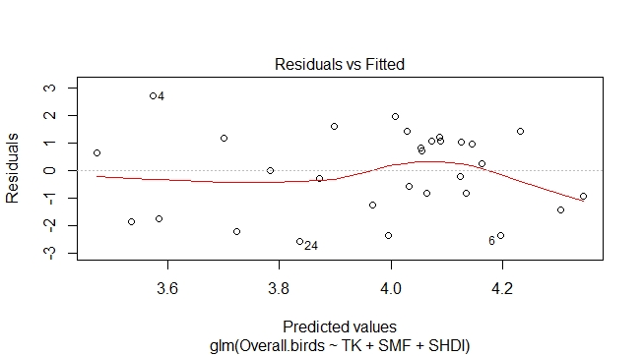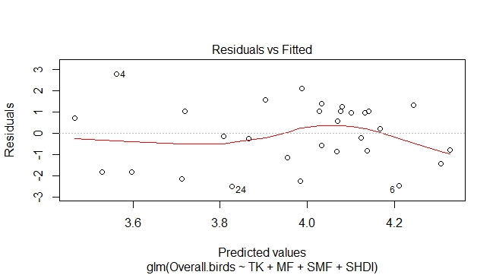

6.3 Granivore richness
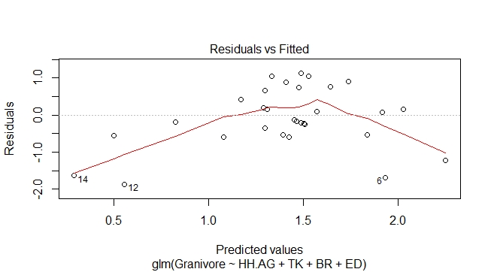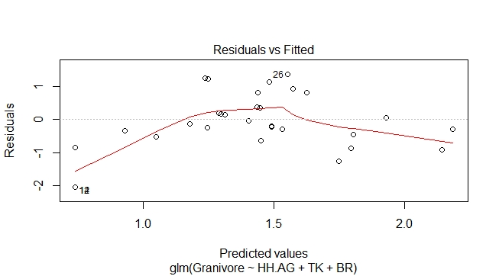

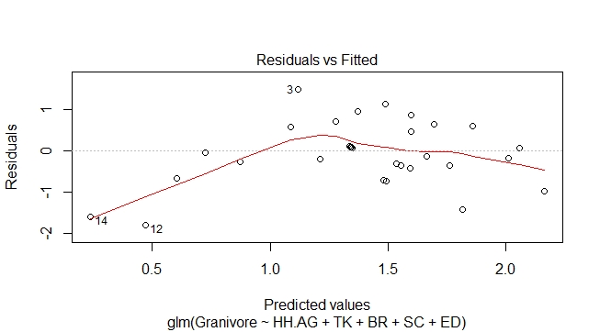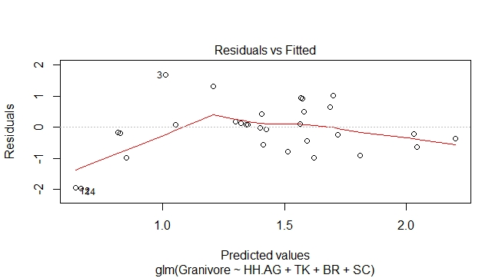
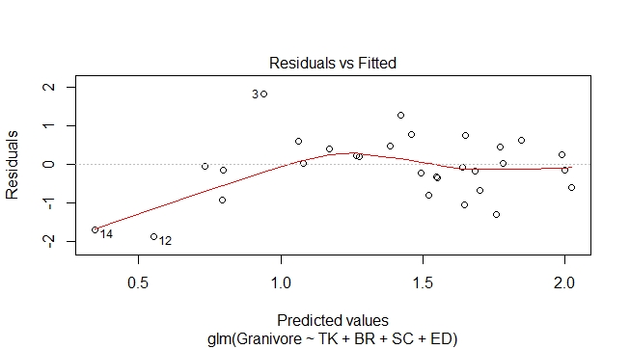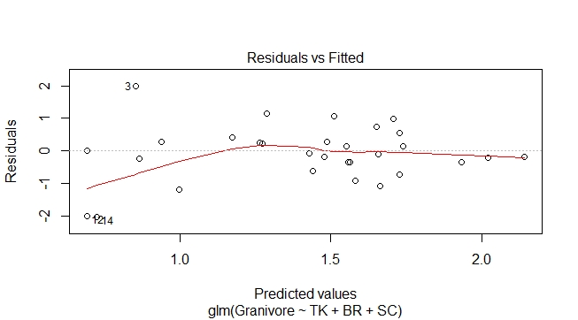

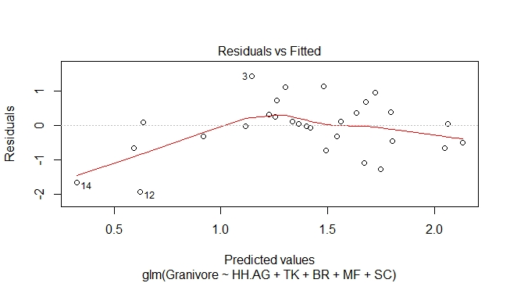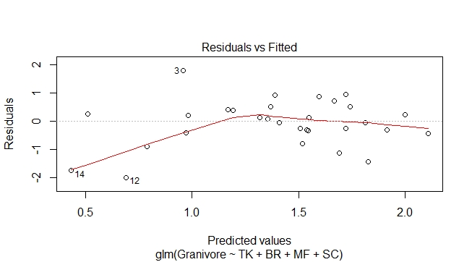
6.4: Insectivore richness
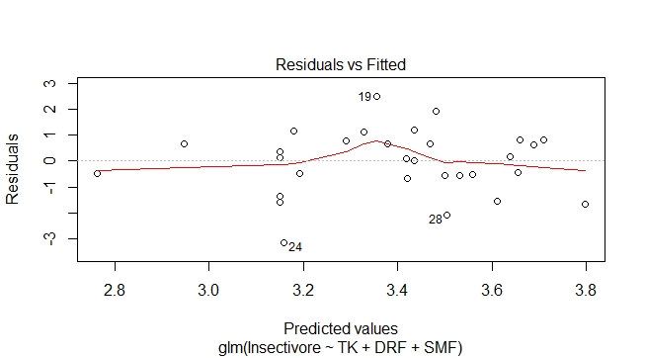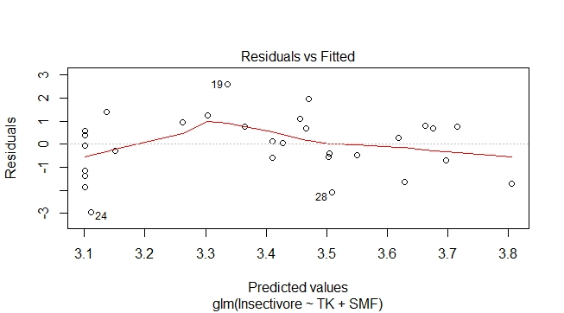
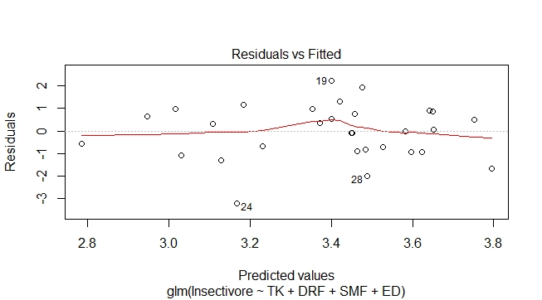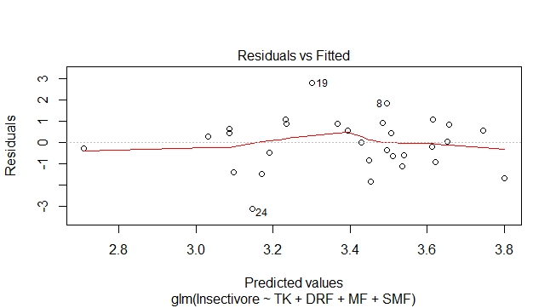
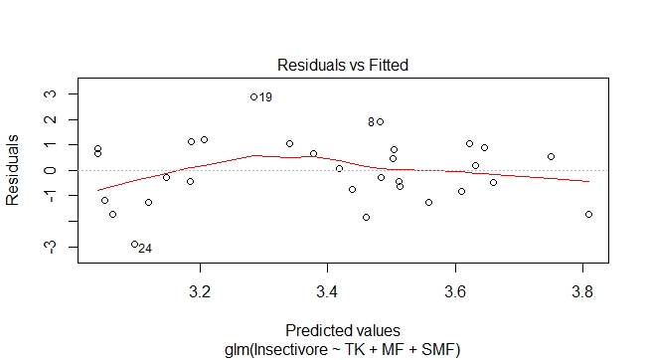
6.5 Frugi+inectivore richness
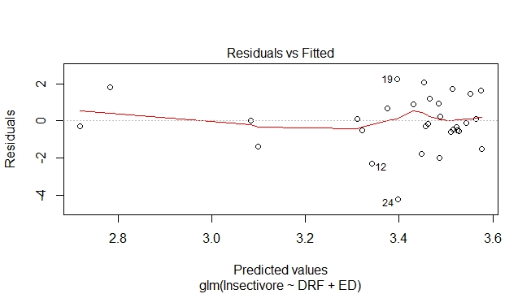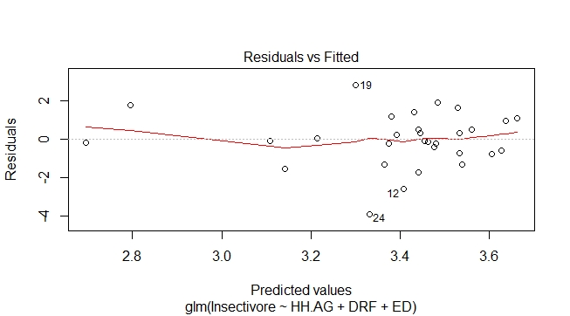
6.6 Nectarivore richness
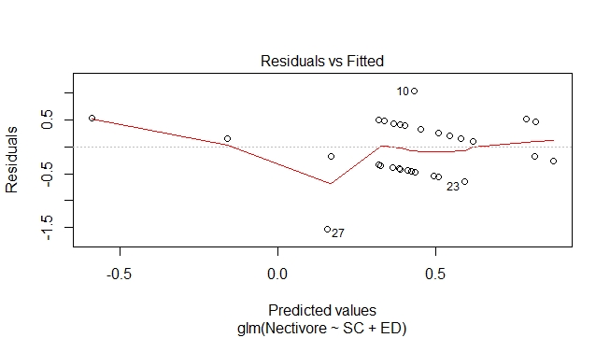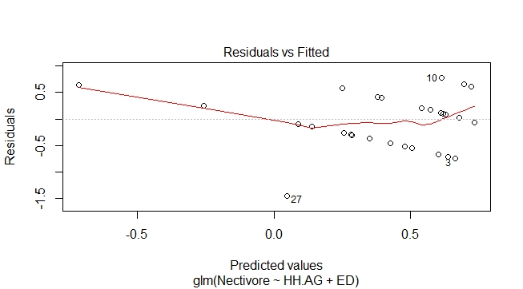
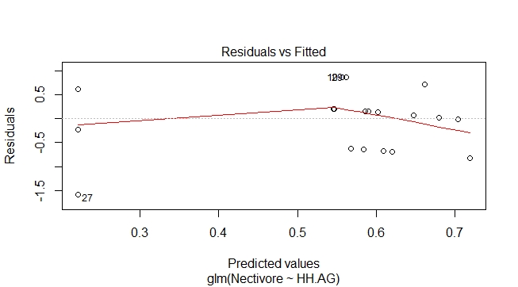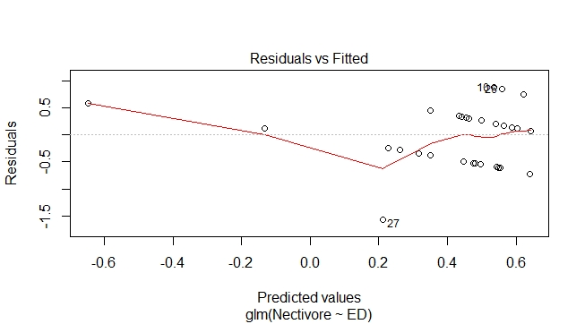
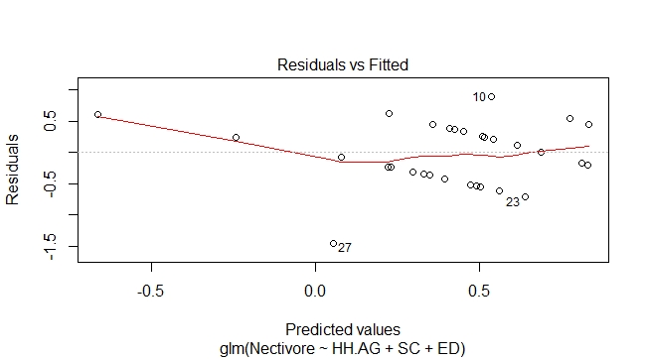

6.6 Omnivore richness
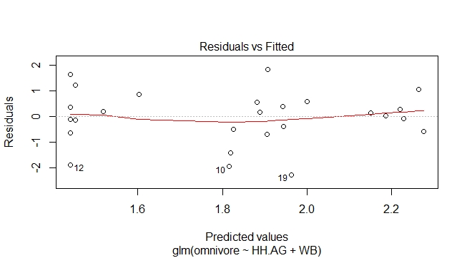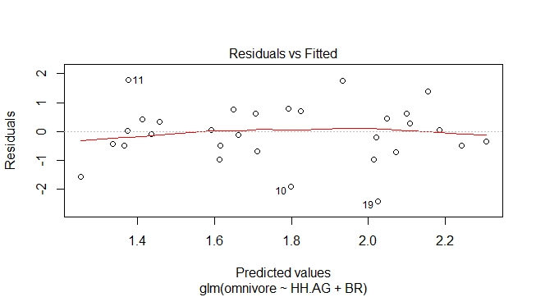
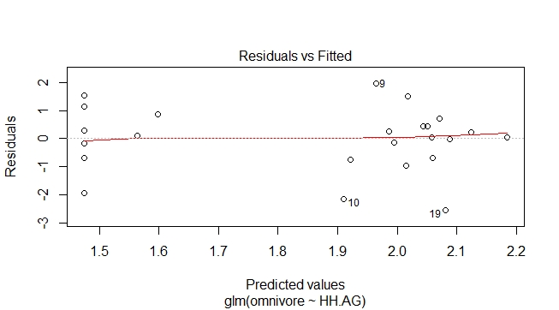

6.7 Piscivore richness
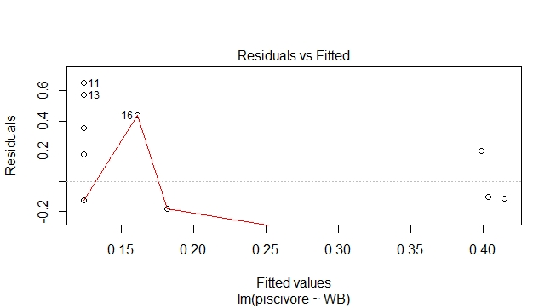

6.8 Frugivore richness
