Supplementary Information for:

Females restrict the position of domatia and suffer more herbivory than hermaphrodites in Myriocarpa longipes, a neotropical myrmecophyte

Mario A. Sandoval-Molina^{1*}, Bernardo Rafael Lugo-García¹, Alan Daniel Mendoza-Mendoza¹, Mariusz Krzysztof Janczur^{1,}
¹Research Group in Ecology and Evolutionary Biology, Department of Natural Sciences, Autonomous University of the State of Mexico, Mexico, Carretera Toluca-Tlachaloya, km 18, Cerrillo Piedras Blancas, CP 50200 Toluca, Estado de México, México.

*Mario A. Sandoval-Molina
Email: sandoval.m@hotmail.com

Figure 1. Myriocarpa longipes. Description of reproductive structures in the gynodioecious population of Los Tuxtlas, México. We did not find plants with only male inflorescences as stated by Meave and Ibarra-Manríquez (1997). Although Meave and Ibarra-Manríquez (1997) argued that male inflorescences (Figure a) are placed on the apical parts of the branches, and female inflorescences (Figure b) on inferior parts of the branches, we found male inflorescences growing separately on some branches (Figure c), and some of them growing on the same section of the branches as feminine inflorescences (Figure d, e, f).
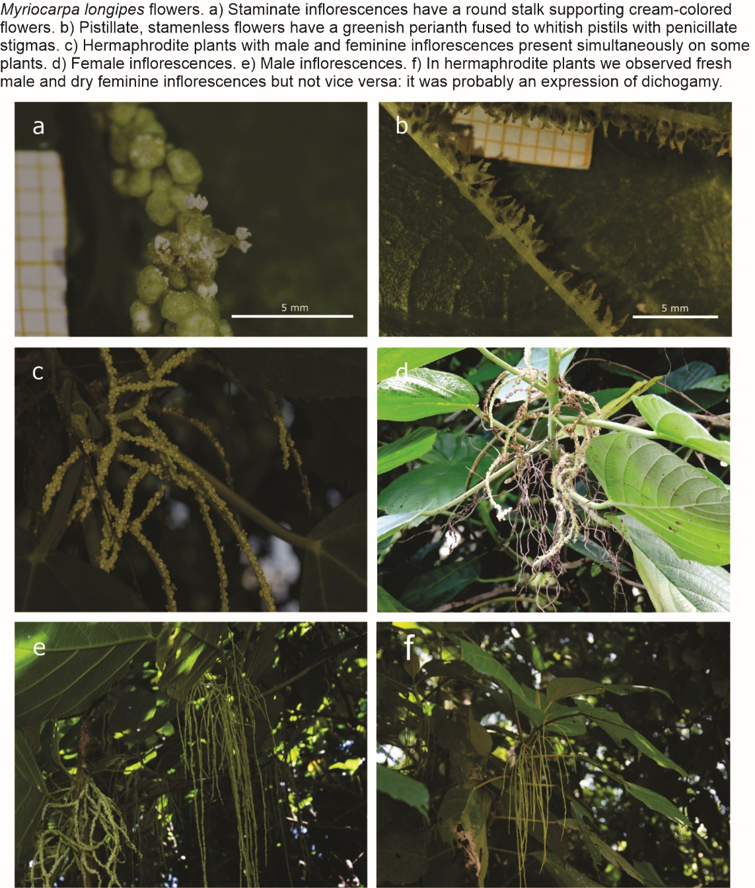

Figure 2. Measurements of the cross-sectional area and stem area surrounding of the domatium.
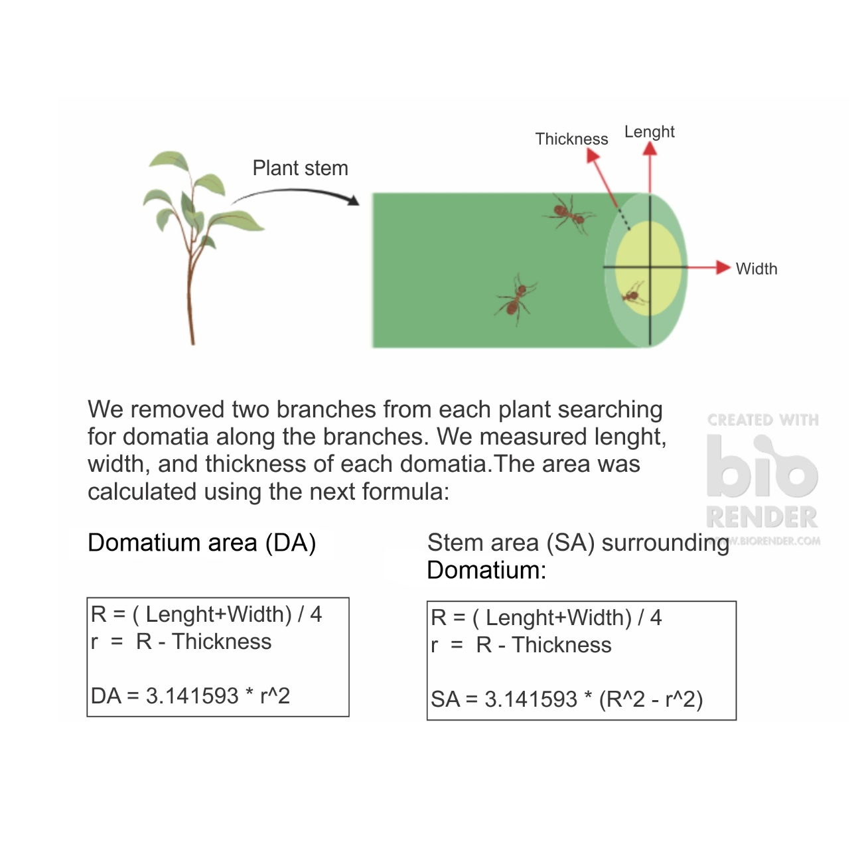

Figure 3. Comparison of leaf area between females and hermaphrodites of Myriocarpa longipes. Error lines represent confidence intervals.

Figure 4. Intersexual comparison of cross-section area of domatia regardless their position (a), cross-section area of domatia in the middle position (b), and stem area of domatia (c) of Myriocarpa longipes. Error lines represent confidence intervals.

