Palm functional trait responses to local environmental factors in the Colombian Amazon

William Trujillo Calderón^{1*}, Carlos A. Rivera-Rondón², Jorge Jácome², Néstor García², Wolf L. Eiserhardt³, Henrik Balslev³

¹Grupo Investigaciones territoriales para el uso y conservación de la biodiversidad. Fundación Reserva Natural La Palmita, Centro de Investigación. Cra 4 # 58-59, Bogotá, Colombia
²Departamento de Biología, UNESIS, Pontificia Universidad Javeriana, 110231, Bogotá, Colombia
³Department of Biology, Ecoinformatic & Biodiversity, Aarhus University, Ny Munkegade 116, DK-8000 Aarhus C., Denmark

*Corresponding author
William Trujillo
E-mail: williamtrujilloca@gmail.com

SUPPLEMENT 4

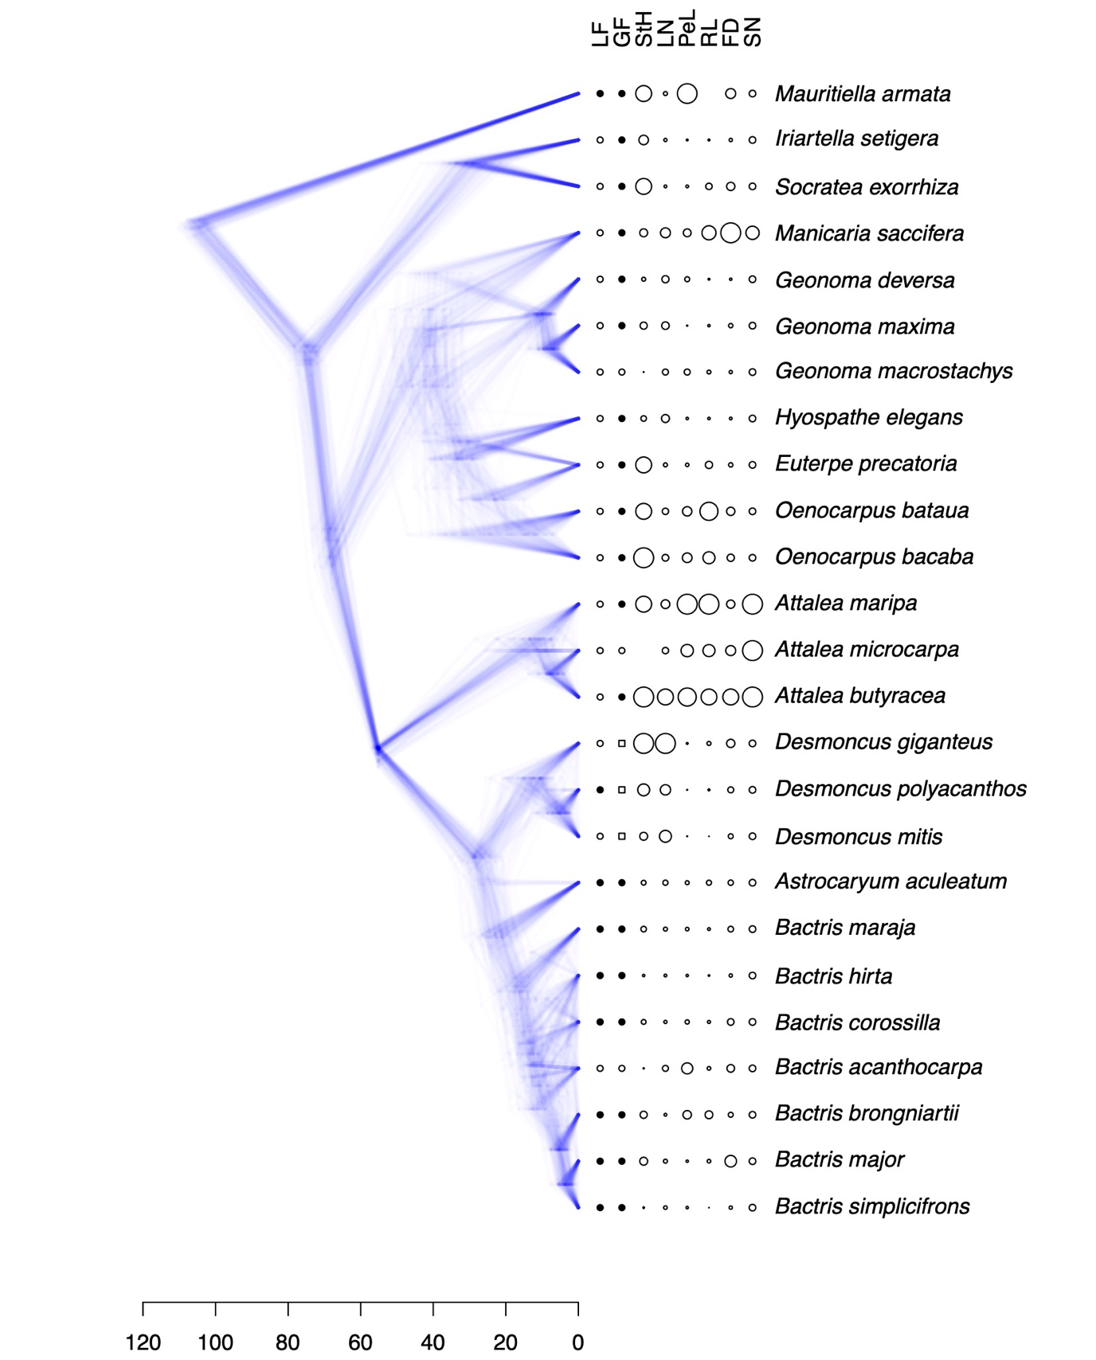

Figure 1. Distribution of trait values across the tips of a phylogeny obtained from Faurby et al. (2016). LF: lifeform ( : solitary, :cespitose); GF: growth form ( : erect, : acaulescent, : climbing); StH: maximum stem height; LN: maximum number of leaves; RL: maximum leaf rachis length; PeL: maximum petiole length; FD: maximum fruit diameter; SN: seed number. For continuous traits, circle sizes are scaled linearly between minimum and maximum trait values. The phylogeny is represented as 150 randomly sampled trees from the posterior distribution provided by Faurby et al. (2016). Scale bar in million years.

Table 1. Phylogenetic signal of the included traits (LF: lifeform; GF: growth form; StH: maximum stem height; LN: maximum number of leaves; RL: maximum leaf rachis length; PeL: maximum petiole length; FD: maximum fruit diameter; SN: seed number). For categorical traits, phylogenetic signal was calculated as the deviation of observed mean pairwise phylogenetic distance from a null distribution, which was generated by randomly reshuffling taxon names 999 times. For continuous traits, phylogenetic signal was calculated as Blomberg’s K (Blomberg & Garland 2002), compared to a null distribution generated by randomly reshuffling taxon names 999 times. All analyses were carried out for 1000 phylogenetic trees sampled from the posterior distribution of trees of Faurby et al. (2016). 95% HPD refers to the boundaries of the 95% highest posterior density interval of the values inferred across the 1000 sampled trees.

Trait | MPD Z-score  (mean [95% HPD]) | Blomberg’s K  (mean [95% HPD]) | P  (mean [95% HPD])
LF: cespitose | -2.78 [-2.91 – -2.64] | - | 0.005 [0.002 – 0.009]
GF: climbing | -2.86 [-3.05 – -2.17] | - | 0.002 [0.001 – 0.003]
GF: acaulescent | 0.37 [0.30 – 0.43] | - | 0.708 [0.678 – 0.735]
StH | - | 0.28 [0.15 – 0.43] | 0.203 [0.005 – 0.546]
LN | - | 0.35 [0.17 – 0.49] | 0.091 [0.001 – 0.335]
RL | - | 0.79 [0.53 – 1.08] | 0.009 [0.001 – 0.014]
PeL | - | 0.56 [0.40 – 0.75] | 0.007 [0.001 – 0.008]
FD | - | 0.25 [0.15 – 0.38] | 0.275 [0.054 – 0.571]
SN | - | 1.88 [1.72 – 2.02] | 0.001 [0.001 – 0.002]

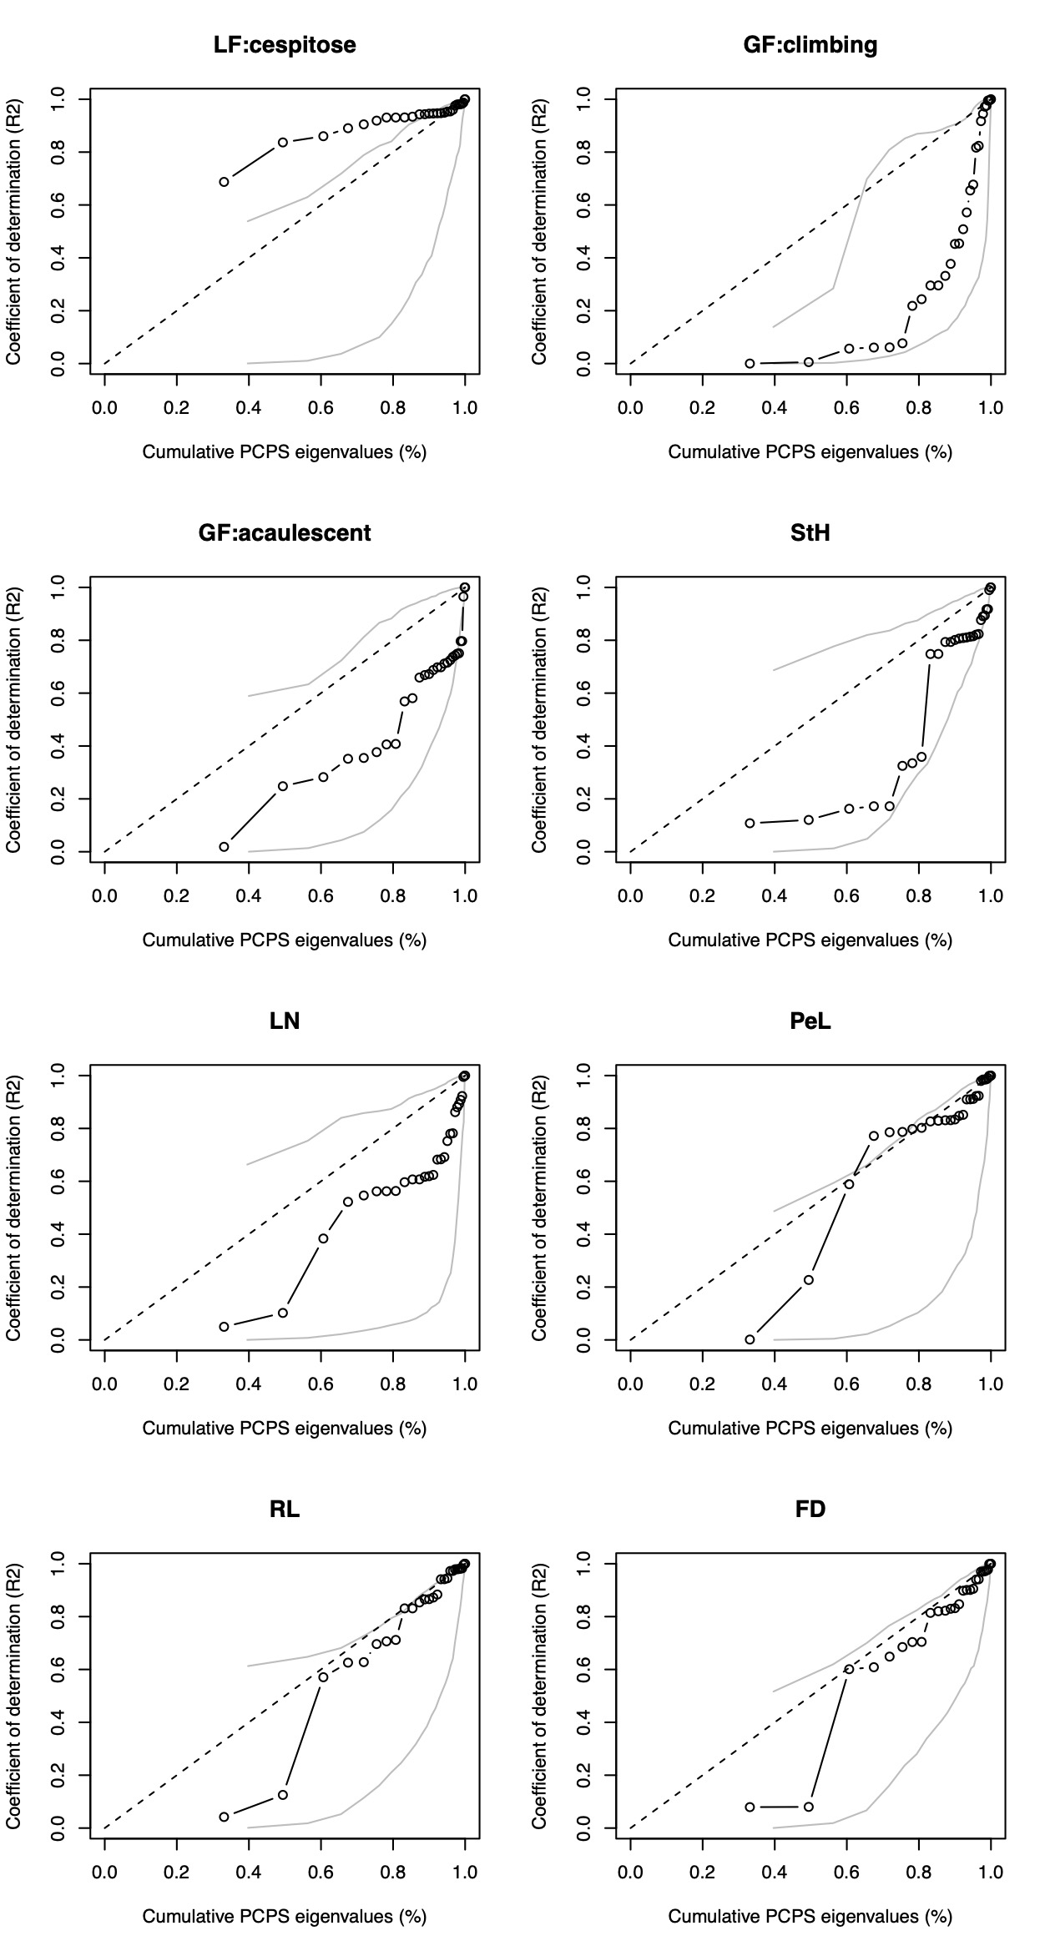
Figure 2. Metacommunity phylogenetic signal of the studied traits (LF: lifeform; GF: growth form; StH: maximum stem height; LN: maximum number of leaves; RL: maximum leaf rachis length; PeL: maximum petiole length; FD: maximum fruit diameter; SN: seed number). Circles and solid black lines show the observed R² of a model relating community averaged trait values to an increasing number of phylogenetic eigenvectors. Categorical traits were coded as 1 for the focal state (e.g. cespitose habit) and 0 otherwise. Solid grey lines show the expected values given no phylogenetic signal, obtained by randomizing species names 999 times. Only when observed values fall outside the grey lines, traits are significantly phylogenetically structured across communities. This analysis was conducted using a Maximum Clade Credibility tree calculated from 1000 trees sampled from the posterior distribution of Faurby et al. (2016).

References

Blomberg SP and T. Garland Jr. T (2002= Tempo and mode in evolution: phylogenetic inertia, adaptation and comparative methods. Journal of Evolutionary Biology 15, 899-910.
Faurby S, Eiserhardt WL, Baker WJ and Svenning J-C (2016) An all-evidence species-level supertree for the palms (Arecaceae). Molecular Phylogenetics and Evolution 100, 57–69.

