Palm functional trait responses to local environmental factors in the Colombian Amazon

William Trujillo C.^{1*}, Carlos A. Rivera-Rondón², Jorge Jácome², Néstor García², Wolf L. Eiserhardt³, Henrik Balslev³

¹Grupo Investigaciones territoriales para el uso y conservación de la biodiversidad. Fundación Reserva Natural La Palmita, Centro de Investigación. Cra 4 # 58-59, Bogotá, Colombia
²Departamento de Biología, UNESIS, Pontificia Universidad Javeriana, 110231, Bogotá, Colombia
³Department of Biology, Ecoinformatic & Biodiversity, Aarhus University, Ny Munkegade 116, DK-8000 Aarhus C., Denmark

*Corresponding author
William Trujillo
E-mail: williamtrujilloca@gmail.com

SUPLEMENT 3.

RLQ and Fourth-Corner Analysis

Methods

In addition to the CWM-RDA analysis, an analysis of RLQ and Fourth-corner corner (Dray et al. 2014) was used to evaluate the relationship of the species trait value with the environmental variables, in order to corroborate the results of the CWM-RDA. The RLQ is a multivariate technique that provides ordination values to summarize the joint structure between the R, L and Q matrices. The Fourth-corner tests the individual trait-environment relationship (Dray et al. 2014).

Results

RLQ analysis

The results of the RLQ analysis showed that species traits, environmental factors, and abundance were correlated (P <0.001). Most of the variation was captured by axis 1 of the RLQ (93%). To the positive values of this axis, the stem height (StH), the transects in floodplain forests, and the soil moisture were associated.

The traits stem height (StH) and acaulecent growth form (GFaca) were associated with axis 1. Transects in floodplain forests and soil moisture variable were associated with axis 1 positive values of the RLQ, while those on the terra firme were associated with negative values of this axis (Figure 1). The second axis of the RLQ explained considerably less variance (4%), and ordered the transects by forest type Terrace.

The species of the genera Socratea, Oenocarpus, Euterpe, manicaria and Attalea (tall palms) were associated to axis 1 positive values, while Bactris and Geonoma (mostly acaulecent and small palms), were associated with negative values of this axis; likewise, terrace forests were associated to the negative values of axis 2, associated to Mauritiella armata, the only species dioecius (figure 1).

Figure 1. Graphic ordination of the RLQ axes A) four environmental variables in 29 transects (500x5 m); B) nine functional traits of 25 Amazon palms species C) 25 species of Amazon palms D) 29 transects (500x5 m) in the Colombian Amazon.
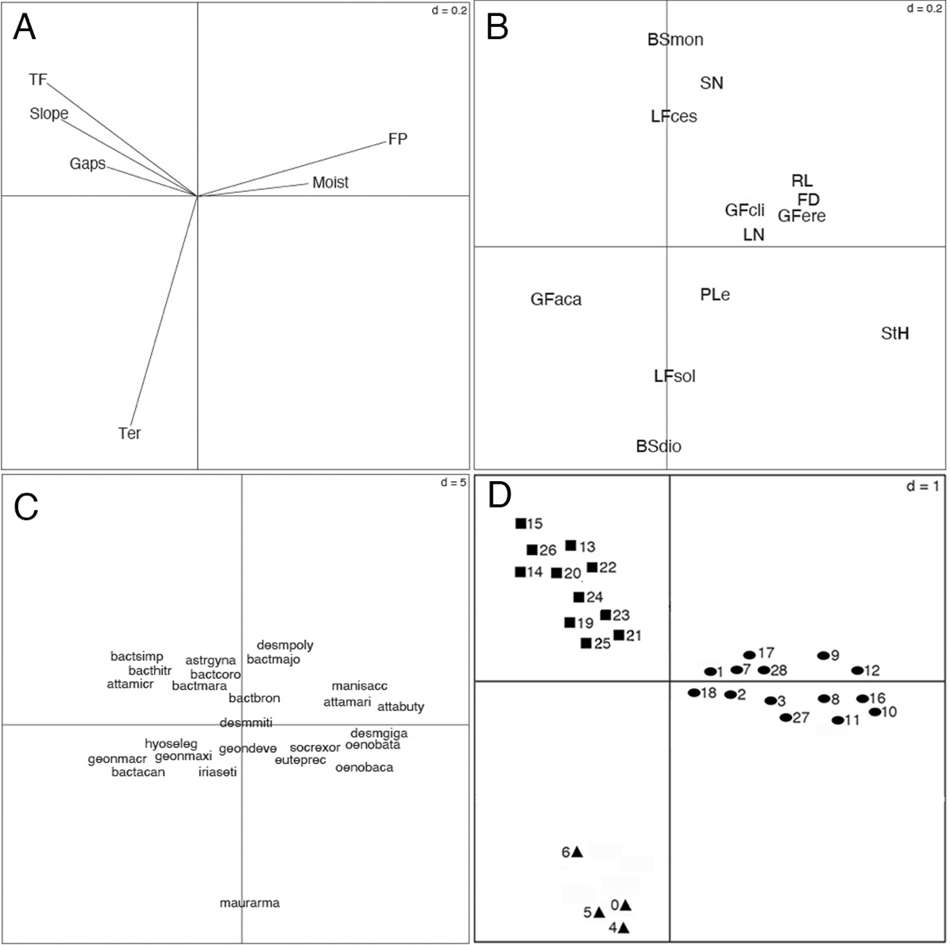
Environmental variables: gaps=presence of tree fall gaps, slope=inclination, moist=soil moisture; TF=terra firme forest, FP=floodplain forest y Ter=terrace forest. Traits: LF=lifeform (cespitose=ces, solitary=sol), GF=growth form (acaulecent=aca, erect=ere, climbing=cli), StH= stem maximum height, LN=leaves maximum number, RL= leaf rachis maximum length, PeL=petiole maximum length, FD=fruit maximum diameter, SN=seed number, BS=Breeding system (dioecious=dio, monoecious=mon). In the figure D: ellipses = floodplain forest, squares = terra firme forests, triangles = terrace forests.

Fourth-Corner analysis

Fourth-Corner analysis showed a significant positive correlation between StH and TF and slope and negative correlation with FP and moist.
The Figure 2 show the results using Model 6, which perform two separate tests using models 2 and 4 and combine the results by keeping the higher p value produced by the two permutation tests. The model 2 permutes the n samples (i.e. rows of R or L) and model 4 permutes the p species (i.e. rows of Q or columns of L). Dray et al (2004) advocate the use the Model 6, because it fixes the level of type I error.

Figure 2. Fourth-corner analysis carried out for functional traits of palm and environmental variables of forest in the Colombian Amazon. Colored squares show significant Pearson correlations (P ˂ 0.05). Red=positive correlated and blue=negative correlated.

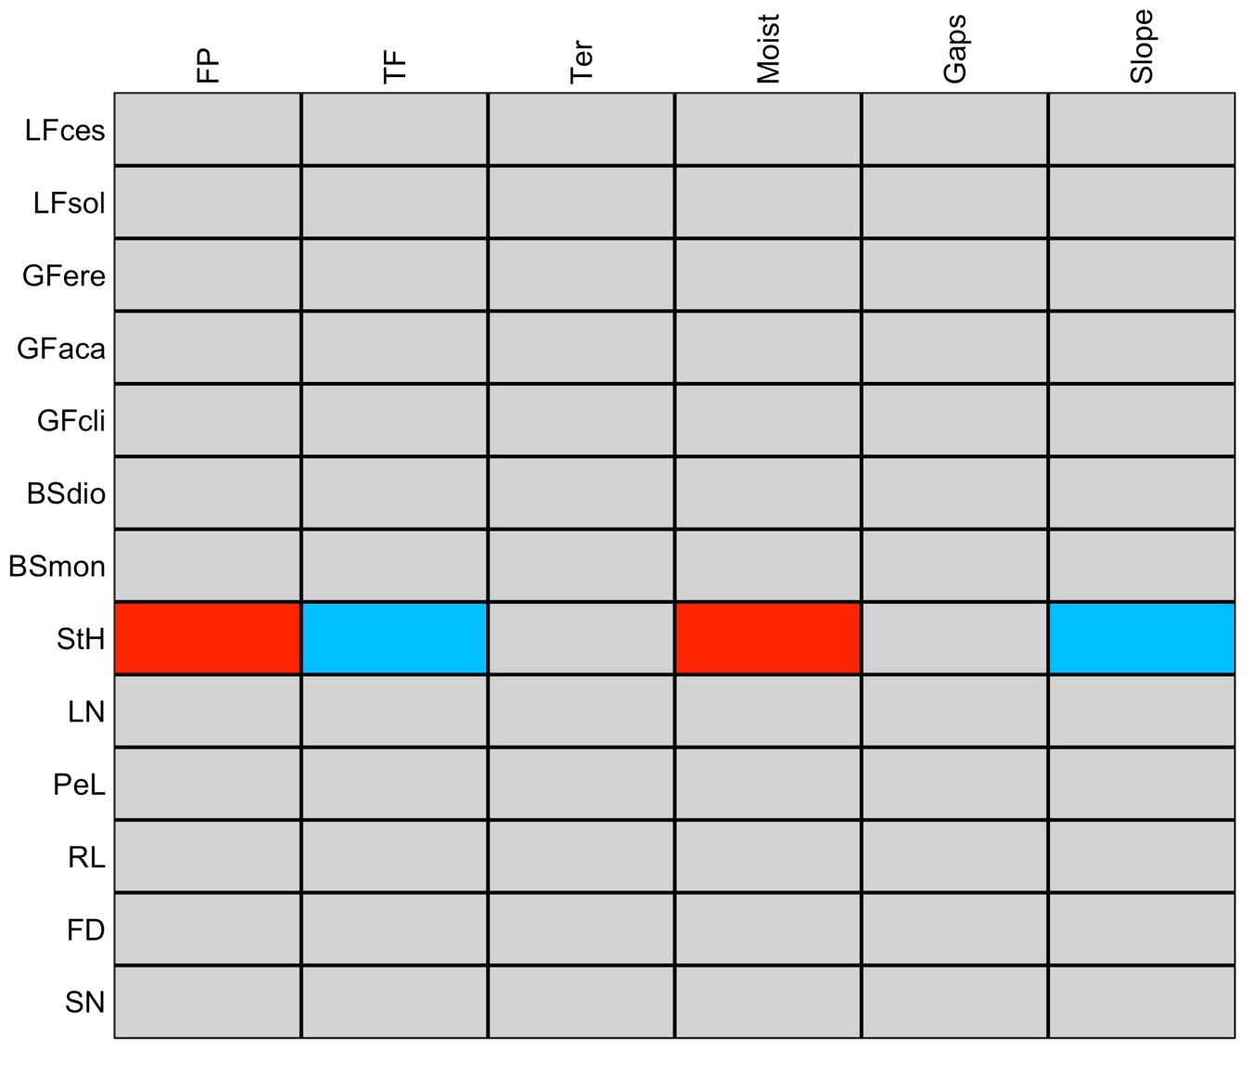
Environmental variables: gaps=presence of tree fall gaps, slope=inclination, moist=soil moisture; TF=terra firme forest, FP=floodplain forest y Ter=terrace forest. Traits: LF=lifeform (cespitose=ces, solitary=sol), GF=growth form (acaulecent=aca, erect=ere, climbing=cli), StH= stem maximum height, LN=leaves maximum number, RL= leaf rachis maximum length, PeL=petiole maximum length, FD=fruit maximum diameter, SN=seed number, BS=Breeding system (dioecious=dio, monoecious=mon).

Literature cited

Dray S, Choler P, Dolédec S, Peres-Neto P R, Thuiller W, Pavoine S and Ter Braak C J F (2014) Combining the fourth-corner and the RLQ methods for assessing trait responses to environmental variation. Ecology 95, 14–21

