Supplementary table and figures

Supplementary Table 1: Correlation matrix of forest stand attributes including C. odorata cover and environmental variables
 | Chrom  cover | Canopy  cover | Basal  area | Tree  density | Shrub  Cover | Native  richness | Herb  cover | Distance | Elev | Slope | Disturbance
Chrom. cover | 1 | -0.59 | -0.32 | -0.32 | -0.18 | 0.10 | 0.13 | -0.41 | -0.29 | -0.25 | 0.11
Canopy cover | -0.59 | 1 | 0.48 | 0.58 | -0.00 | 0.04 | -0.03 | 0.26 | 0.23 | 0.06 | -0.13
Basal area | -0.32 | 0.48 | 1 | 0.23 | 0.032 | -0.26 | 0.03 | 0.09 | -0.05 | -0.03 | -0.19
Tree density | -0.32 | 0.58 | 0.23 | 1 | -0.01 | 0.03 | 0.01 | 0.11 | 0.09 | -0.01 | -0.20
Shrub Cover | -0.19 | -0.00 | 0.032 | -0.01 | 1 | 0.00 | -0.10 | 0.03 | -0.12 | -0.08 | -0.07
Native richness | -0.10 | 0.04 | -0.26 | 0.03 | 0.00 | 1 | -0.05 | 0.01 | 0.04 | -0.01 | -0.20
Herb Cover | 0.13 | -0.03 | -0.03 | -0.01 | -0.10 | -0.05 | 1 | 0.01 | -0.08 |  | 0.04
Distance | -0.41 | 0.26 | 0.09 | 0.11 | 0.03 | 0.08 | 0.01 | 1 | 0.54 | 0.01 | -0.22
Elev | -0.29 | 0.23 | 0.03 | 0.09 | -0.12 | 0.30 | -0.08 | 0.54 | 1 | 0.49 | 0.02
Slope | -0.25 | 0.06 | -0.05 | 0.04 | -0.01 | 0.19 | -0.01 | 0.21 | 0.49 | 1 | 0.00
Disturbance | 0.11 | -0.13 | -0.19 | -0.20 | -0.07 | 0.16 | 0.04 | -0.22 | 0.02 | 0.00 | 1

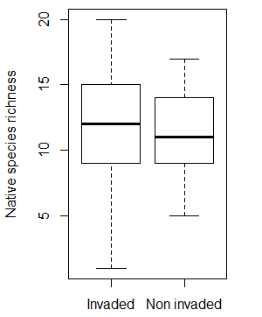
Supplementary figure 1: Comparison of native species richness in invaded and non-invaded plots.

Supplementary Figure 2: The relationship between Chromolaena cover and distance from the nearest road showing fitted line and 95% confidence interval
Supplementary Figure 3: The relationship between Chromolaena cover and slope showing fitted line and 95% confidence interval

Supplementary Figure 4: The relationship between Chromolaena cover and shrub cover showing fitted line and 95% confidence interval

