Electronic supplementary material. Johansson et al.

Table S1. Number of individuals used for wing shape analysis. FW and HW denotes front and hind wings respectively

Locality & year FW males HW males FW females HW females
Kerala 2010 15 15 15 15
Maldives 2010 9 7 10 12
Kerala 2018 35 31 33 31
Maldives 2018 12 10 51 44

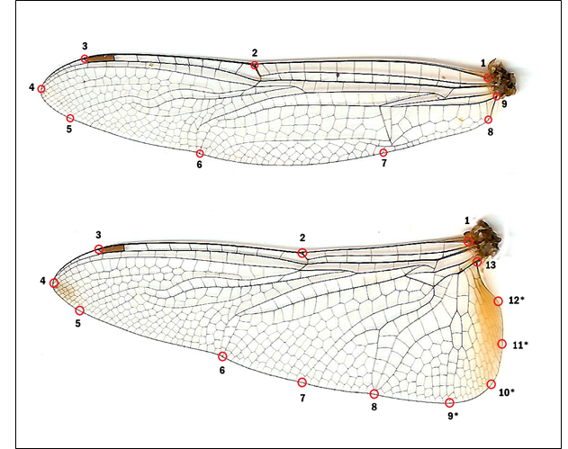

Figure S1. Front and hind wings of P. flavescens showing the landmarks used to capture wing shape. The semi-landmarks on the hind wing (9-12) are indicated with an asterisk.

Figure S2a-f. Wing shape variation between female individuals from Kerala and the Maldives sampled in 2018. Wing shape is shown as scores from the first three axes in Principal Component Analyses on the shape variables. These three axes explain 60.2% and 55.6% of the variation in wing shape for front and hind wings respectively.

