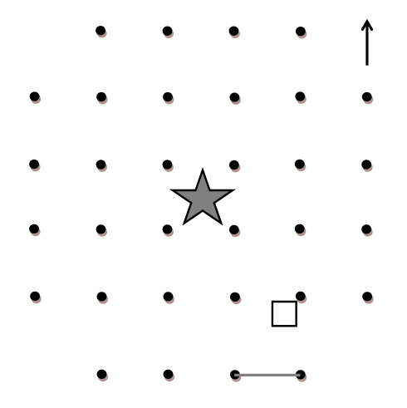
Figure S1. Graphical representation of gridded plots used to study frog and spider occupancy patterns at La Selva Biological Station. Trees were located in the center of plots (grey star), and PVC tubes (black dots) were placed at regular intervals (3 m; grey line) to generate 21 distinct plot cells (i.e., a square area between four PVC pipes). The black square indicates a hypothetical randomly selected quadrat location in the corner of a plot cell to sample leaf-litter and arthropod abundance (quadrat square not to scale). The black arrow indicates North.

