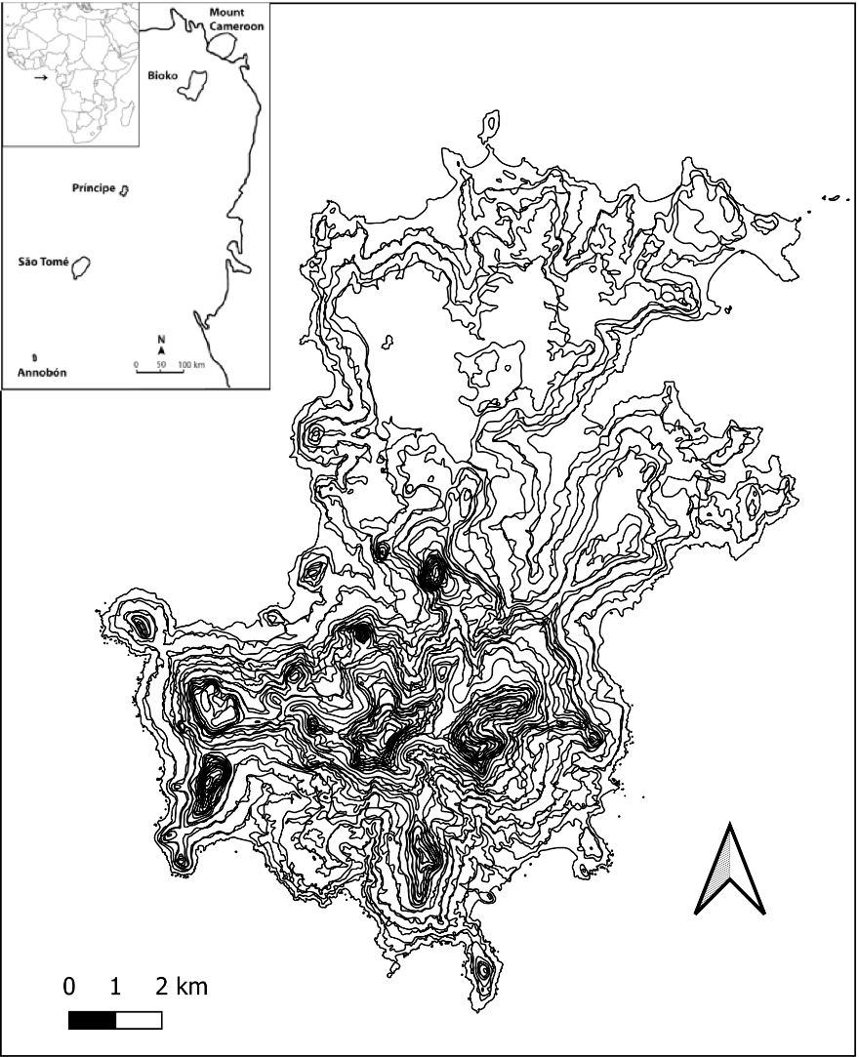
FIGURE S1. Orographic map of Príncipe and its position within the Gulf of Guinea. Due to their ruggedness many areas in the south are virtually inaccessible.

