Supplementary Material – **Diet and ecological role of a generalist frugivore across a tropical island archipelago: implications for seed dispersal and forest regeneration** – *Journal of Tropical Ecology*

Henry S. Pollock*, Evan C. Fricke, Evan M. Rehm, Martin Kastner, Nicole Suckow, Julie A. Savidge, and Haldre S. Rogers

*Corresponding author: [henry.s.pollock@gmail.com](mailto:henry.s.pollock@gmail.com). Telephone: +1 217 621 6007. ORCID iD: 0000-0002-8698-691X.

**Supplementary Table 1** Table of Såli fecal data from Saipan (2015-2016) and Guam (2017-2018) and nest contents data (2018 only) from Guam. Attached separately as: *Supplementary Table 1.xlsx.*

**Supplementary Figure 1** Frequency of occurrence of seeds of the five most common tree species found in fecal samples in a) 2017 and b) 2018.

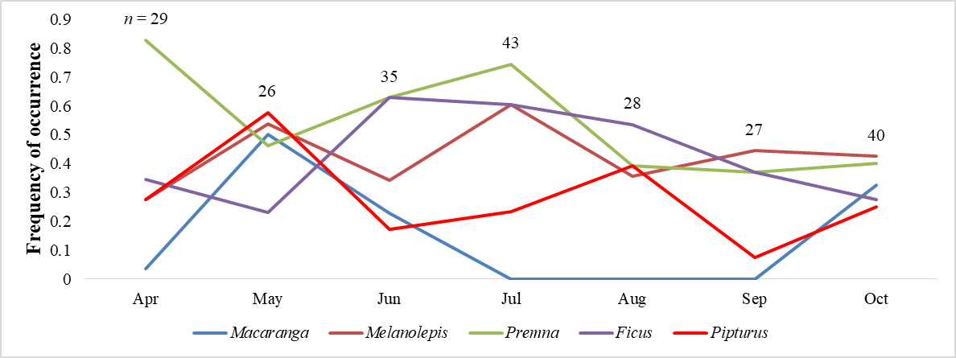

**2017**

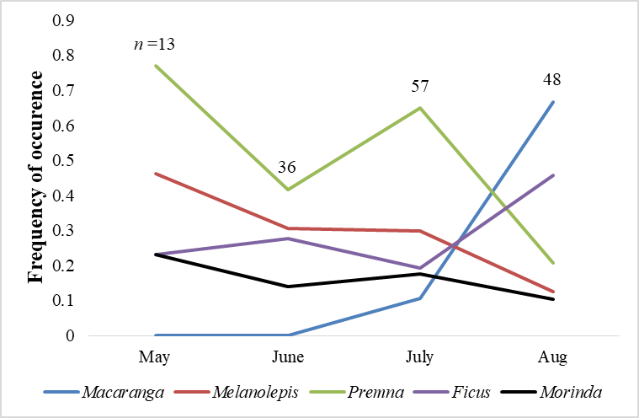

**2018**