Appendix
Figure 1: DCE example question
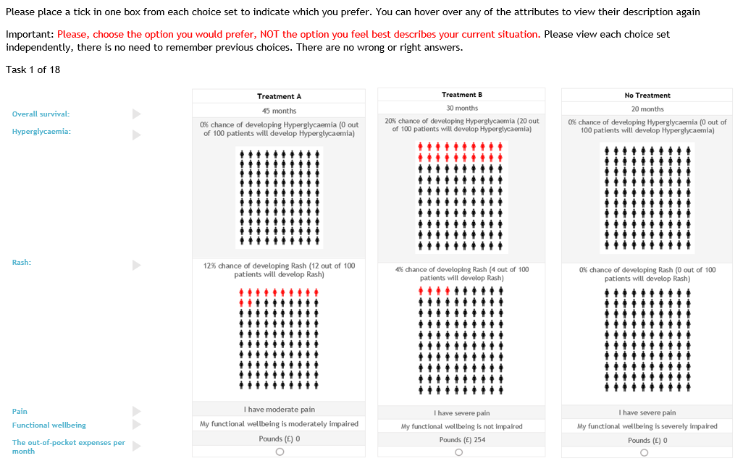

Table 1: Sociodemographic and disease specific characteristics of respondents
 | COUNTRY N (%)
 | France | Germany | Ireland | Poland | Spain | UK | Total
 | N=119(%) | N=106(%) | N=57(%) | N=79(%) | N=100(%) | N=100(%) | N=561(%)
Utilities captured by EQ-5D
(Mean, std.dev) | 0.55 (0.38) | 0.73 (0.27) | 0.68 (0.27) | 0.78 (0.22) | 0.65 (0.29) | 0.47 (0.39)
Age group
18 - 24 | 0(0) | 2(2) | 1(2) | 12(15) | 4(4) | 9(9) | 28(5)
25 - 34 | 5(4) | 20(19) | 3(5) | 19(24) | 19(19) | 25(25) | 91(16)
35 - 44 | 30(25) | 37(35) | 6(11) | 25(32) | 27(27) | 33(33) | 158(28)
45 - 54 | 32(27) | 14(13) | 18(32) | 11(14) | 27(27) | 18(18) | 120(21)
55 - 64 | 26(22) | 20(19) | 22(39) | 8(10) | 19(19) | 4(4) | 99(18)
65+ | 26(22) | 13(12) | 7(12) | 4(5) | 4(4) | 11(11) | 65(12)
University education
No | 59(50) | 46(43) | 13(23) | 16(20) | 22(22) | 31(31) | 187(33)
Yes | 59(50) | 60(57) | 41(72) | 60(76) | 76(76) | 69(69) | 365(65)
Prefer not to answer | 1(1) | 0(0) | 3(5) | 3(4) | 2(2) | 0(0) | 9(2)
Employment status
Housewife | 6(5) | 3(3) | 5(9) | 2(3) | 9(9) | 2(2) | 27(5)
Not working due to long term sickness | 12(10) | 21(20) | 8(14) | 8(10) | 22(22) | 14(14) | 85(15)
Retired | 36(30) | 13(12) | 9(16) | 5(6) | 7(7) | 10(10) | 80(14)
Unemployed | 16(13) | 6(6) | 2(4) | 3(4) | 7(7) | 8(8) | 42(7)
Working | 48(40) | 61(58) | 30(53) | 59(75) | 50(50) | 65(65) | 313(56)
Other | 1(1) | 2(2) | 3(5) | 2(3) | 5(5) | 1(1) | 14(2)
Stage of cancer
Advanced/metastatic (Stage 3-4) | 54(45) | 50(47) | 26(46) | 17(22) | 50(50) | 50(50) | 247(44)
One Site of metastasis | 16(30) | 18(36) | 10(38) | 12(71) | 34(68) | 13(26) | 103(42)
Two or more sites of metastasis | 38(70) | 32(64) | 16(62) | 5(29) | 16(32) | 37(74) | 144(58)
Early (Adjuvant/ Localized) (Stage 1 - 2) | 65(55) | 56(53) | 31(54) | 62(78) | 50(50) | 50(50) | 314(56)

Table 2 : ΕQ-5D-3L dimensions
 | France |  |  | Germany |  | Ireland |  | Poland | Spain |  | UK |  | Total
Domain | N=119(%) |  |  | N=106(%) |  | N=57(%) |  | N=79(%) | N=100(%) |  | N=100(%) |  | N=561(%)
Mobility
I have no problems in walking about |  | 73(61) | 63(59) |  | 41(72) |  | 61(77) |  |  | 56(56) |  | 50(50) |  | 344(61)
I have some problems in walking about |  | 38(32) | 41(39) |  | 16(28) |  | 17(22) |  |  | 42(42) |  | 43(43) |  | 197(35)
I am confined to bed |  | 8(7) | 2(2) |  | 0(0) |  | 1(1) |  |  | 2(2) |  | 7(7) |  | 20(4)
Self-care
I have no problems with self-care |  | 86(72) | 71(67) |  | 51(89) |  | 64(81) |  |  | 67(67) |  | 49(49) |  | 388(69)
I have some problems washing or dressing myself |  | 28(24) | 33(31) |  | 5(9) |  | 14(18) |  |  | 32(32) |  | 44(44) |  | 156(28)
I am unable to wash or dress myself |  | 5(4) | 2(2) |  | 1(2) |  | 1(1) |  |  | 1(1) |  | 7(7) |  | 17(3)
Usual activities
I have no problems with performing my usual activities |  | 58(49) | 47(44) |  | 26(46) |  | 52(66) |  |  | 43(43) |  | 37(37) |  | 263(47)
I have some problems with performing my usual activities |  | 49(41) | 56(53) |  | 28(49) |  | 25(32) |  |  | 50(50) |  | 56(56) |  | 264(47)
I am unable to perform my usual activities |  | 12(10) | 3(3) |  | 3(5) |  | 2(3) |  |  | 7(7) |  | 7(7) |  | 34(6)
Pain/discomfort
I have no pain or discomfort |  | 30(25) | 18(17) |  | 20(35) |  | 20(25) |  |  | 16(16) |  | 23(23) |  | 127(23)
I have moderate pain or discomfort |  | 75(63) | 75(71) |  | 34(60) |  | 50(63) |  |  | 75(75) |  | 59(59) |  | 368(66)
I have extreme pain or discomfort |  | 14(12) | 13(12) |  | 3(5) |  | 9(11) |  |  | 9(9) |  | 18(18) |  | 66(12)
Anxiety/depression
I am not anxious or depressed |  | 58(49) | 32(30) |  | 22(39) |  | 27(34) |  |  | 35(35) |  | 30(30) |  | 204(36)
I am moderately anxious or depressed |  | 41(34) | 63(59) |  | 30(53) |  | 40(51) |  |  | 59(59) |  | 52(52) |  | 285(51)
I am extremely anxious or depressed |  | 20(17) | 11(10) |  | 5(9) |  | 12(15) |  |  | 6(6) |  | 18(18) |  | 72(13)

Table 3: Information criteria for various number of classes including constant
Classes | LLF | Nparam | AIC | BIC
2 | -7623.87 | 19 | 15387 | 15368
3 | -7354.68 | 29 | 14921.92 | 14892.92
4 | -7211.14 | 39 | 14708.14 | 14669.14
5 | -7121.92 | 49 | 14603 | 14554
6 | -7004.56 | 59 | 14441.57 | 14382.57

Table 4: Mixed logit model with interaction terms for patient characteristics
 | Age |  |  |  | Education |  |  | Stage |  |  | Utility score
Variable | b | se | ci95 |  | b | se | ci95 | b | se | ci95 | b | se | ci95
OOP_new | -0.008 | 0.007 | -0.023,0.006 |  | -0.067*** | 0.01 | -0.087,-0.047 | -0.060*** | 0.008 | -0.075,-0.044 | 0.003 | 0.012 | -0.021,0.027
const | 0.890*** | 0.123 | 0.65,1.13 |  | 0.833*** | 0.11 | 0.617,1.049 | 0.933*** | 0.122 | 0.693,1.172 | 0.845*** | 0.112 | 0.625,1.064
OS | 0.011** | 0.004 | 0.003,0.018 |  | 0.023*** | 0.006 | 0.01,0.036 | 0.023*** | 0.005 | 0.012,0.033 | 0.002 | 0.006 | -0.01,0.015
Hyperglycaemia | -0.007*** | 0.002 | -0.011,-0.003 |  | -0.017*** | 0.003 | -0.022,-0.012 | -0.018*** | 0.002 | -0.022,-0.014 | 0.001 | 0.003 | -0.005,0.007
Rash | -0.006 | 0.003 | -0.011,0 |  | -0.011** | 0.004 | -0.019,-0.004 | -0.005 | 0.003 | -0.01,0.001 | -0.009 | 0.004 | -0.017,0
Pain_severe | -0.430*** | 0.07 | -0.568,-0.293 |  | -1.060*** | 0.102 | -1.261,-0.859 | -1.099*** | 0.079 | -1.253,-0.944 | -0.192 | 0.116 | -0.419,0.034
Pain_moderate | 0.106 | 0.056 | -0.003,0.215 |  | 0.046 | 0.073 | -0.097,0.189 | -0.043 | 0.056 | -0.153,0.067 | 0.262** | 0.088 | 0.09,0.434
FW_severe | -0.614*** | 0.075 | -0.761,-0.467 |  | -0.974*** | 0.099 | -1.168,-0.78 | -0.977*** | 0.077 | -1.128,-0.825 | -0.171 | 0.11 | -0.387,0.045
FW_moderate | -0.133** | 0.052 | -0.234,-0.032 |  | -0.151* | 0.07 | -0.289,-0.014 | -0.209*** | 0.054 | -0.315,-0.103 | 0.085 | 0.082 | -0.075,0.245
Variable*OOP | -0.069*** | 0.017 | -0.101,-0.036 |  | 0.038* | 0.015 | 0.009,0.066 | 0.047** | 0.015 | 0.018,0.076 | -0.082*** | 0.021 | -0.123,-0.041
Variable*OS | 0.027*** | 0.007 | 0.013,0.041 |  | -0.006 | 0.007 | -0.021,0.009 | 0 | 0.007 | -0.014,0.015 | 0.034*** | 0.01 | 0.015,0.053
Variable*HG | -0.011*** | 0.003 | -0.017,-0.005 |  | 0.006 | 0.003 | 0,0.012 | 0.013*** | 0.003 | 0.007,0.019 | -0.022*** | 0.004 | -0.03,-0.013
Variable*Rash | -0.005 | 0.004 | -0.013,0.004 |  | 0.005 | 0.005 | -0.004,0.014 | -0.006 | 0.004 | -0.014,0.003 | 0 | 0.006 | -0.012,0.013
Variable*Pain_severe | -0.946*** | 0.114 | -1.169,-0.723 |  | 0.349** | 0.125 | 0.103,0.594 | 0.624*** | 0.114 | 0.402,0.847 | -1.038*** | 0.168 | -1.368,-0.708
Variable*Pain_moderate | -0.123 | 0.086 | -0.291,0.045 |  | 0.01 | 0.091 | -0.168,0.188 | 0.220** | 0.084 | 0.055,0.385 | -0.374** | 0.128 | -0.625,-0.122
Variable*FW_severe | -0.547*** | 0.112 | -0.767,-0.328 |  | 0.225 | 0.12 | -0.011,0.46 | 0.320** | 0.114 | 0.096,0.545 | -1.203*** | 0.159 | -1.515,-0.892
Variable*FW_moderate | 0.015 | 0.081 | -0.144,0.173 |  | 0.015 | 0.086 | -0.153,0.183 | 0.172* | 0.079 | 0.017,0.328 | -0.367** | 0.119 | -0.6,-0.133
SD
const | 1.788*** | 0.107 | 1.579,1.997 |  | 1.410*** | 0.125 | 1.165,1.654 | 1.612*** | 0.117 | 1.383,1.842 | 1.589*** | 0.102 | 1.389,1.789
OS | 0.013* | 0.005 | 0.002,0.024 |  | 0.060*** | 0.005 | 0.051,0.07 | 0.061*** | 0.004 | 0.053,0.07 | -0.024*** | 0.007 | -0.037,-0.01
Hyperglycaemia | 0.015*** | 0.003 | 0.01,0.02 |  | 0.015*** | 0.003 | 0.009,0.021 | 0.017*** | 0.002 | 0.013,0.022 | -0.014*** | 0.003 | -0.02,-0.008
Rash | 0.002 | 0.005 | -0.008,0.011 |  | -0.003 | 0.005 | -0.012,0.006 | -0.004 | 0.004 | -0.012,0.004 | 0.006 | 0.004 | -0.002,0.014
Pain_severe | 0.805*** | 0.063 | 0.683,0.928 |  | 1.032*** | 0.068 | 0.9,1.165 | 1.072*** | 0.057 | 0.961,1.184 | 0.869*** | 0.077 | 0.718,1.021
Pain_moderate | -0.156 | 0.085 | -0.323,0.011 |  | 0.038 | 0.12 | -0.198,0.273 | 0.014 | 0.105 | -0.191,0.219 | 0.162 | 0.095 | -0.023,0.348
FW_severe | 0.889*** | 0.061 | 0.77,1.009 |  | 0.961*** | 0.059 | 0.847,1.076 | 0.963*** | 0.061 | 0.845,1.082 | 0.841*** | 0.058 | 0.727,0.955
FW_moderate | 0.029 | 0.064 | -0.097,0.154 |  | -0.049 | 0.059 | -0.165,0.068 | -0.007 | 0.06 | -0.124,0.11 | -0.002 | 0.059 | -0.117,0.114
Variable*OOP | 0.234*** | 0.016 | 0.203,0.264 |  | 0.168*** | 0.012 | 0.145,0.192 | 0.165*** | 0.015 | 0.136,0.193 | 0.266*** | 0.017 | 0.233,0.299
Variable*OS | 0.096*** | 0.006 | 0.083,0.108 |  | 0.01 | 0.006 | -0.002,0.022 | 0.008 | 0.01 | -0.011,0.028 | 0.085*** | 0.006 | 0.073,0.097
Variable*HG | 0.012** | 0.004 | 0.004,0.02 |  | -0.008 | 0.007 | -0.022,0.006 | -0.001 | 0.004 | -0.01,0.007 | 0.016*** | 0.004 | 0.009,0.023
Variable*Rash | -0.004 | 0.005 | -0.014,0.006 |  | -0.003 | 0.005 | -0.013,0.007 | -0.008 | 0.008 | -0.024,0.009 | -0.002 | 0.005 | -0.011,0.008
Variable*Pain_severe | 1.095*** | 0.115 | 0.87,1.319 |  | 0.576*** | 0.11 | 0.36,0.792 | 0.092 | 0.172 | -0.245,0.428 | 1.074*** | 0.118 | 0.843,1.305
Variable*Pain_moderate | 0.153 | 0.135 | -0.111,0.418 |  | 0.273* | 0.109 | 0.06,0.486 | 0.145 | 0.13 | -0.11,0.399 | -0.326** | 0.105 | -0.532,-0.119
Variable*FW_severe | 0.431*** | 0.102 | 0.231,0.632 |  | 0.071 | 0.145 | -0.214,0.355 | -0.033 | 0.119 | -0.266,0.2 | 0.424*** | 0.119 | 0.191,0.658
Variable*FW_moderate | -0.068 | 0.085 | -0.235,0.1 |  | 0.031 | 0.069 | -0.105,0.166 | 0.036 | 0.094 | -0.148,0.22 | 0.075 | 0.08 | -0.082,0.232
Number of observations | 26928 |  |  | 26496 |  |  |  | 26928 |  |  | 26928
chi-squared | 2683.848 |  |  | 2475.613 |  |  |  | 2482.438 |  |  | 2593.99
Model degrees of freedom | 33 |  |  | 33 |  |  |  | 33 |  |  | 33
Log likelihood | -7087.22 |  |  | -7074.47 |  |  |  | -7182.67 |  |  | -7089.46
* p<0.05 ** p<0.01 *** p<0.001

Table 5: Mean utility scores per latent class
Class | Number of patients | Mean utility (Std.dev)
Money indifferent | 216 | 0.73(0.28)
Pay anything for longer life | 89 | 0.60(0.37)
Rational decision maker | 203 | 0.56(0.33)
Treatment avoiders | 53 | 0.58(0.38)

