Supplementary appendices
1. Derivation of health state costs

The table below provides further detail of the unit costs and assumptions used to estimate health state costs in the economic model.

Table S1: Summary of unit costs and assumptions used to estimate health state costs in the economic model
Resource type | Resource component | Unit cost (GBP) | Assumptions | Source
IV drugs - hospital* | Ceftazidime 3g (per dose) | 3.38 | 42 doses in 14 days | Personal communication (Clinical  Pharmacist)ª
 | Tobramycin 481-560mg (per dose) | 16.25 | 14 doses in 14 days
 | Sodium chloride 0.9% (per dose) | 0.06 | 28 doses in 14 days
 | Heparin 50units in 5ml (per dose) | 0.44 | 42 doses in 14 days
 | Total (per IV day) | 27.82
IV drugs - homecare* | Ceftazidime 3g (per dose) | 32.88 | 42 doses in 14 days | Personal communication (Clinical  Pharmacist)ª
 | Tobramycin 481-560mg (per dose) | 48.04 | 14 doses in 14 days
 | Sodium Chloride 0.9% (per dose) | 0.64 | 28 doses in 14 days
 | Heparin 50units in 5ml (per dose) | 3.22 | 42 doses in 14 days
 | 30L WIVA waste bin (per 14-day course) | 5.99 | 1 unit
 | 1x100 Sani-cloth wipes (per 14-day course) | 24.85 | 1 unit
 | Delivery (per 14-day course) | 77.64 | 1 unit
 | Total (per IV day) | 165.36
Nebulised drugs‡ | Tobramycin solution (per year) | 1,739.56 | Tobramycin 300mg/5ml; daily dose: 600mg | BNF (1), CF Registry Report 2018 (2), personal communication (Clinical  Pharmacist,ª Consultant in Respiratory Medicine and Adult Cystic Fibrosis^{b})
 | Other aminoglycoside | 5.89 | Gentamicin 80ml/2ml; daily dose: 160mg
 | Colistin | 442.19 | Colomycin 2 million unit powder; daily dose: 2 million units
 | Promixin | 1,158.39 | Promixin 1million unit powder; daily dose: 4 million units
 | Aztreonam | 1,506.06 | Cayston 75mg powder; daily dose: 225mg
 | Colistimethate dry powder | 923.62 | Colobreathe 1.6 million units powder capsules; Daily dose: 3.32 million units
 | Tobramycin dry powder | 1,212.22 | Tobramycin 28mg powder capsules; daily dose: 224mg
 | Azithromycin | 47.51 | Azithromycin 250mg tablets; daily dose: 250mg
 | Prophylactic flucloxacillin | 4.00 | Flucloxacillin 250mg or 500mg capsules; daily dose:1g
 | Mannitol | 341.04 | Bronchitol 40mg inhalation powder capsules; daily dose: 800mg
 | DNase | 4,160.35 | Pulmozyme 2.5mg; daily dose: 2.5mg
 | Hypertonic saline | 91.33 | 6% or 7% inhalation solution; daily dose: 8ml
 | Total | 11,632.15 | -
Adherence intervention | Data transfer | N/A (CD) | Commercial value | PARI GmbH
 | Monitoring | N/A (CD) | Same costs as in the trial, conversion rate €1= £0.88756 (01/10/2019) | PARI GmbH
 | Data platform (management, maintenance, costumer support, hosting & penetration testing) | 20.60 | Costs of running the CFHealthHub plataform for 12 months divided by 5,900 patients eligible for the intervention | Farr Institute
 | Interventionists training | 21.37 | Three trainers (2 × 180.5 hours and 61 hours for developing training, delivering face-to-face and competency assessment), 30 interventionists (grade 7 physiotherapists); includes overheads for academic staff; divided by 5,900 patients eligible for the intervention; applicable only for the first year of the model | University of Sheffield (wages); PSSRU report 2021 (3) personal communication (hours and personnel involved)^{c}
 | Ongoing fidelity support | 3.62 | Includes the costs of 15 interventionists, one programme manager, one data specialist, two research assistants, one trainer and overheads for academic staff; divided by 5,900 patients eligible for the intervention
 | Initial data set-up visit | 195.00 | Includes the costs of grade 7 physiotherapists and total of 3 hours of visits per patient; applicable only for the first year of the model | PSSRU report 2021 (3); personal communication ^{c}
 | Delivery of intervention | 315.19 | Data from the intervention log from the trial, assumed the same average cost per patient for the 305 trial patients in the intervention arm | PSSRU Report 2021 (3); ACtiF trial
 | Total 1st year (annual costs) | 777.18
 | Total subsequent years (annual costs) | 560.81
Nebuliser – intervention | eTrack | N/A (CD) | Annuitised cost per patient; equipment lifetime of 5 years and discount rate of 3.5% | PARI GmbH
Nebuliser – intervention | eflow | N/A (CD)
Resource use | IV in hospital (days) | 410.75 | Assumed to reflect cost of bronchiectasis, cost per non-elective bed-day (codes DZ12C to DZ12F), weighted by FCEs and average length of stay | NHS Reference Costs 2020/2021 [(4)
 | Other hospitalisation IVs (total days) | 349.25 | Cost per non-elective excess bed-day weighted by FCEs; weighted average across all interventions
 | GP (mins) - surgery and at home | 4.23 | GP appointments of 9.22 minutes were assumed; unit cost includes direct care staff and qualification costs, and carbon emissions | PSSRU report 2021 (3)
 | Consultant hospital visits (no.) | 219.17 | Consultant-led services for respiratory medicine (service code 340) | NHS Reference Costs 2020/2021(4) (total outpatient attendances data)
 | Non-consultant hospital visits (no.) | 165.83 | Non-consultant led services for respiratory medicine (service code 340)
 | Physiotherapist (no.) | 118.88 | Total services for physiotherapy (consultant and non-consultant led, service code 650)
 | Dietician (no.) | 107.30 | Total services for dietetics (consultant and  non-consultant led, service code 654)
 | Nurse (mins) | 0.85 | Cost per working hour for band 6 community or hospital-based nurses (nurse specialist/team leader) | PSSRU Report 2021 (3)
 | Social worker (min) | 0.87 | Costs for per working hour for social worker (adult services), unit cost includes qualifications
 | Phone contact (call) | 11.47 | Based on average unit costs between GP-led and nurse-led services for telephone triage
 | Psychologist visits (no.) | 221.52 | Total services for clinical psychology (consultant and nonconsultant led, service code 656) | NHS Reference Costs 2020/2021(4) (total outpatient attendances data)
 | Occupational therapist visits (no.) | 117.66 | Total services for occupational therapy (consultant and non-consultant led, service code 651)
 | Radiographer visits (no.) | 50.20 | Total services for diagnostic imaging (consultant and non-consultant led, service code 812)
 | A&E (no.) | 170.46 | Total services for A&E (consultant and non-consultant led, service code 180)
 | Other visits (no.) | 177.09 | Assumed all interventions for total outpatient attendances, excluding paediatric (and related) items; weighted by FCEs
 | Transplant | 88,823.49 | Assumed the costs of total services for lung and heart and lung transplants (elective inpatient, elective inpatient excess bed-days and non-elective long stay, codes DZ01Z and ED01Z); weighted by FCEs | NHS Reference Costs 2020/2021 (4)
Abbreviations: A&E, accident and emergency; FCE, finished consultant episode; GP, general practitioner; N/A (CD) – data not available for being confidential commercial data; ScHARR, School of Health and Related Research.
* Unit costs presented by dose.
‡ the costs for each nebulised drug was calculated by weighting the estimated annual cost by the proportion of patients in CF registry; the lowest pack price between the NHS indicative and drug tariff prices from BNF for the correspondent dosage was used.
ª – Misbah Tahir, Clinical Pharmacists, Sheffield Teaching Hospitals NHS Foundation Trust;
^{b} – Martin Wildman, Consultant in Respiratory Medicine and Adult Cystic Fibrosis, Northern General Hospital, Sheffield Teaching Hospitals NHS Foundation Trust and Honorary Reader, School of Health and Related Research (ScHARR), University of Sheffield.
^{c} – Chin Maguire, Clinical Trials Research Unit, School of Health and Related Research (ScHARR), University of Sheffield.
2. Model validation

(a) Multistate model prevalence plots, observed versus expected, by age-category
Figures S1 to S5 show comparisons of the msm predictions against the observed data from the CF Registry (5).

Figure S1: msm prevalence plots age 30-34 years
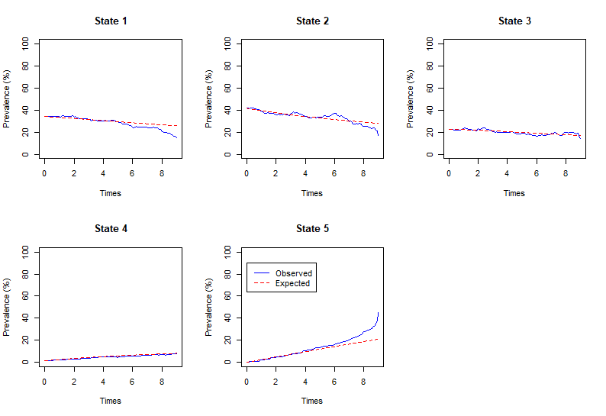
Figure S2: msm prevalence plots age 35-39 years
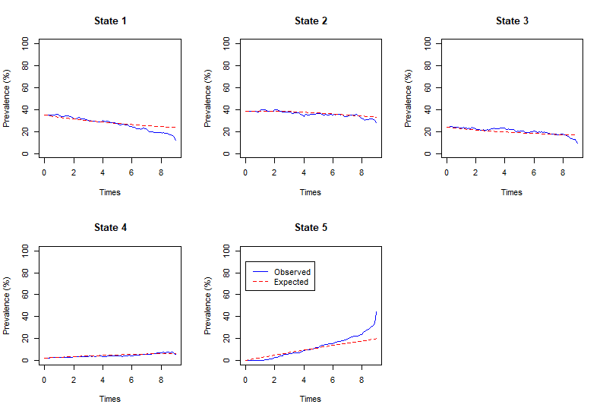
Figure S3: msm prevalence plots age 40-44 years
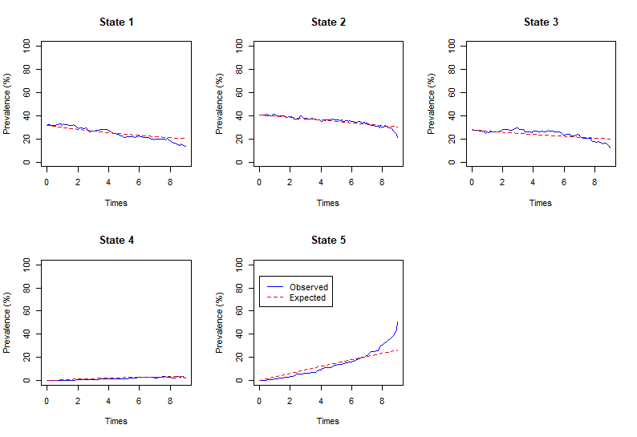
Figure S4: msm prevalence plots age 45-49 years
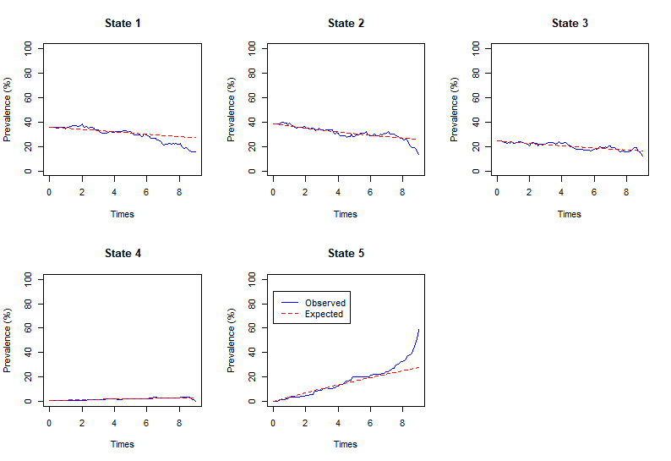

Figure S5: msm prevalence plots age 50+ years
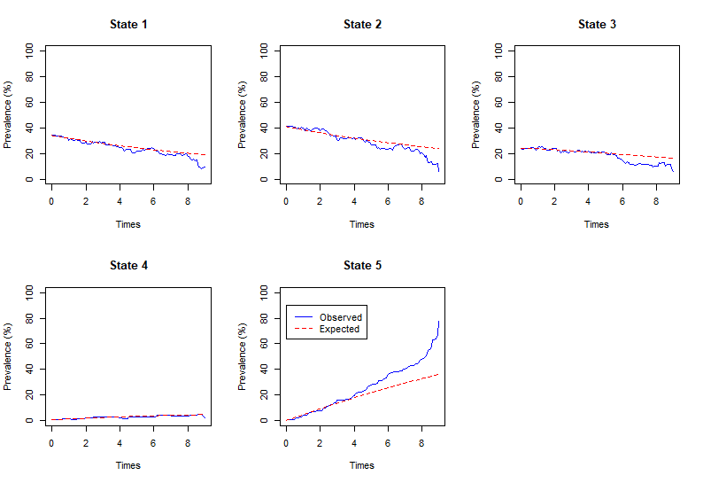

(b) Comparison of model-predicted overall survival versus spline model reported by Keogh et al
Figure S6 presents a comparison of overall survival (OS) predicted by the CFHH model versus OS predictions obtained from Keogh et al (6).

Figure S6: Modelled overall survival versus Keogh et al spline model (weighted by prevalence of covariate groupings)
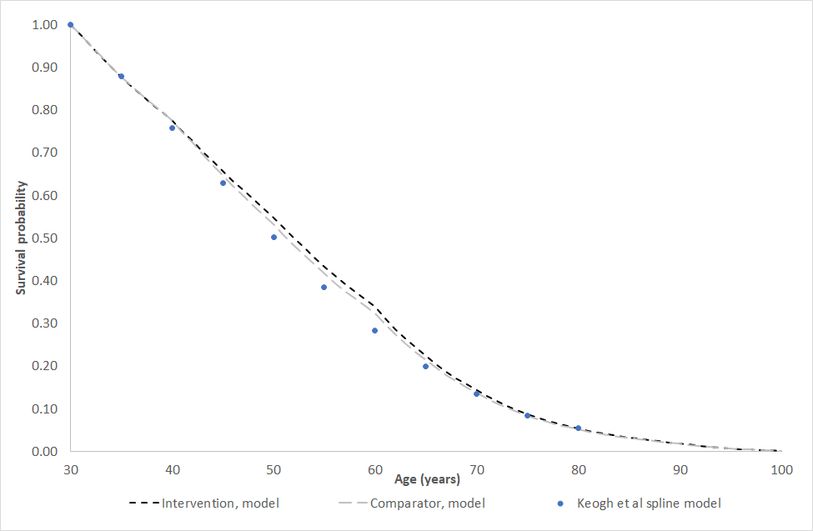

FEV₁% pred. stratum by age
Figure S7 presents a comparison of the probability of being in each of the three FEV₁% pred. groups predicted by the model compared against estimates from the CF Registry dataset.

Figure S7: FEV₁% pred. by age category, model-predicted versus CF Registry estimates
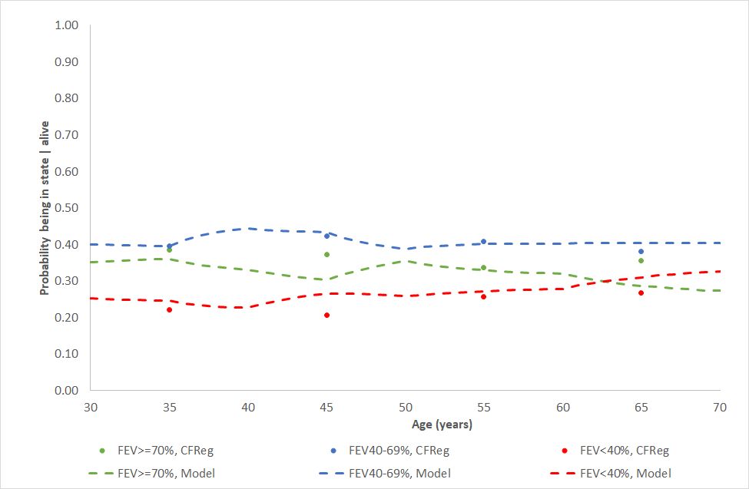

3. Cost-effectiveness acceptability curves
Figure S8: Cost-effectiveness acceptability curves – CFHH adherence intervention versus usual care
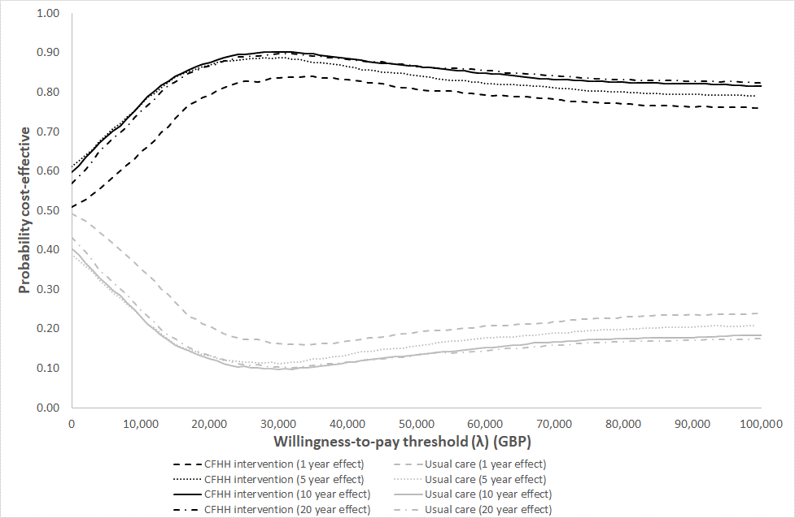

References
1. Joint Formulary Committee. British National Formulary (online). London, 2022.
2. Cystic Fibrosis Trust. UK Cystic Fibrosis Registry Annual Data Report 2018. BMJ Group and Pharmaceutical Press: London, UK, 2019.
3. Jones KC, Burns A. Unit costs of health and social care 2021. Personal Social Services Research Unit: Kent, UK, 2021.
4. NHS England. National schedule of NHS costs 2020/21. NHSE: London, UK; 2022.
5. Cystic Fibrosis Trust. CF Registry bespoke dataset (years 2006-2015; data held on file). CF Trust: London, UK; 2019.
6. Keogh RH, Szczesniak R, Taylor-Robinson D, et al. Up-to-date and projected estimates of survival for people with cystic fibrosis using baseline characteristics: A longitudinal study using UK patient registry data. Journal of Cystic Fibrosis 2018;17(2):218-27.

