Figures
Figure S1. Tornado diagram
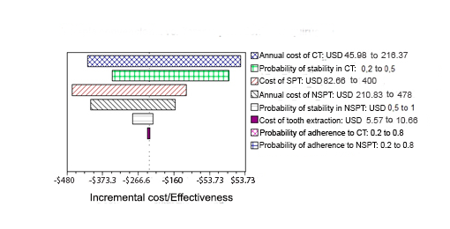

Figure S2. One-way sensitivity analysis: cost of conventional therapy (First year)
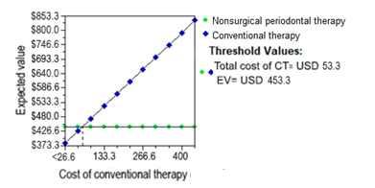

Figure S3. One-way sensitivity analysis: cost of conventional therapy (Five years)
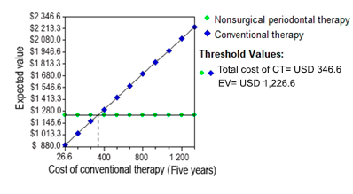

Figure S4. One-way sensitivity analysis: cost of NSPT (First year)
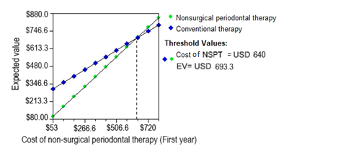

Figure S5. One-way sensitivity analysis of probability of periodontal stability: conventional therapy

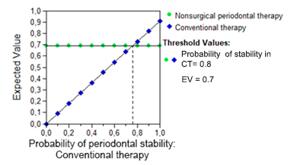
Figure S6. One-way sensitivity analysis of probability of periodontal stability: NSPT
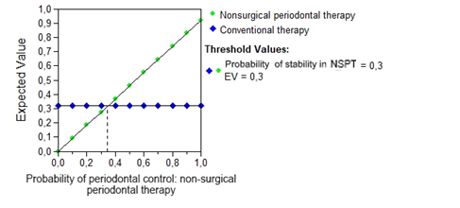

Figure S7. Monte Carlo simulation: cost of NSPT
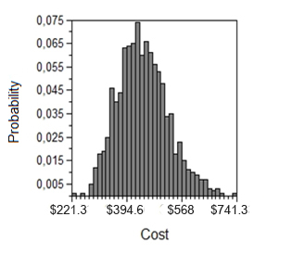

Figure S8. Monte Carlo simulation: cost of conventional therapy cost.
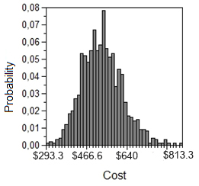
Figure S9. Monte Carlo simulation: NSPT effectiveness
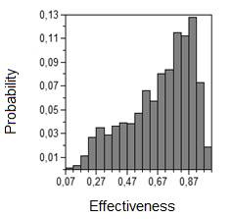

Figure S10. Monte Carlo simulation: CT effectiveness

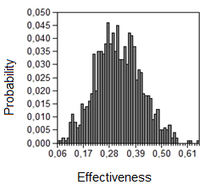

Tables
Table S1. Characteristics of expert panel members
Nº | Sex | City | Experience (years) | Institution
1 | Female | Bogotá | 3 | Health Promotion Entities
2 | Female | Santa Marta | 11 | Independent Dental Clinic/  Private Dentist Practice
3 | Male | Bogotá | 25 | Independent Dental Clinic/  Private Dentist Practice
4 | Female | Bogotá | 5 | Independent Dental Clinic/  Private Dentist Practice
5 | Male | Medellín | 18 | Independent Dental Clinic/  Private Dentist Practice
6 | Male | Cali | 39 | Independent Dental Clinic/  Private Dentist Practice
7 | Female | Armenia | 20 | P Independent Dental Clinic/  Private Dentist Practice
8 | Male | Bogotá | 19 | Independent Dental Clinic/  Private Dentist Practice
9 | Female | Cali | 3 | Independent Dental Clinic/  Private Dentist Practice
10 | Female | Bogotá | 5 | Health Promotion Entities
11 | Female | Bogotá | 7 | Health Promotion Entities
12 | Male | Valledupar | 3 | Health Promotion Entities
13 | Male | Bogotá | 4 | ADRES
14 | Male | Bogotá | 7 | Prepaid medicine; Health Promotion Entities
15 | Male | Bogotá | 18 | Independent Dental Clinic/  Private Dentist Practice; Health Promotion Entities
ADRES: Administrator of Resources of the General System of Social Security in Health

Table S2. Expert panel information
 | Mean | Min | Max
Dental consultation by dentist | USD 5,19 | USD 2,80 | USD 6,03
Periodontal consultation by periodontist | USD 6,53 | USD 4,13 | USD 13,33
Oral Hygiene Instructions and dental plaque control | USD 2,63 | USD 1,41 | USD 4,13
Scaling and root planing (Per Quadrant) | USD 22,48 | USD 10,89 | USD 40,27
Supragingival scaling (Per Quadrant) | USD 16,49 | USD 3,79 | USD 40,27
Scaling with root planing and modified Widman flap (Per quadrant) | USD 37,97 | USD 8,00 | USD 66,67
Gingivoplasty ( Per Sextant) | USD 30,67 | USD 6,67 | USD 93,33
Simple Tooth Extraction – Single rooted tooth (Per Tooth) | USD 5,28 | USD 3,67 | USD 8,00
Simple Tooth Extraction - Multirooted tooth (Per Tooth) | USD 7,13 | USD 4,41 | USD 10,67
Gum grafting (Per Tooth) | USD 37,61 | USD 12,21 | USD 93,33
Gingivectomy (Per Tooth) | USD 34,65 | USD 3,38 | USD 101,33
Periodontal session-duration | 60 minutes
Number of sessions in the first year | 4
Number of sessions from year 2 to onwards | 2
Describe your treatment plan for a patient with the following characteristics: A. Probing depth ≤ 4 mm, CAL 1-2 B. Probing depth ≤ 5 mm, CAL 3-4 mm C. Probing depth 6-7 mm, CAL ≤ 5mm | A and B. Periodontal evaluation, with medicine monitoring, plaque control, education and instruction in oral hygiene and scaling and root planing. C. The same previous activities plus scaling with root planing and modified Widman flap
During the first year, sessions should be planned according to the following patient's characteristics:  A. Probing depth ≤ 4 mm, CAL 1-2  B. Probing depth ≤ 5 mm, CAL 3-4 mm  C. Probing depth 6-7 mm, CAL ≤ 5mm | A. Every 6 months
 | B and C. Every 3 months
After the second year, sessions should be planned according to the following patient’s characteristics:  A. Probing depth ≤ 4 mm, CAL 1-2  B. Probing depth ≤ 5 mm, CAL 3-4 mm  C. Probing depth 6-7 mm, CAL ≤ 5mm | Every 6 months
In the case of periodontally stabilized/controlled patients, how would this change? | The sessions take place every six months and last 30 minutes each.
In the case of periodontally worsening patients, how would this change? | The sessions are now held every three months and are longer.

Search strategies
Table S3. PUBMED and Epistemonikos: January 15, 2020
Intervention/Exposition | ( ( ("periodontal therapy" OR "supragingival" OR (dental* AND scaling*) OR OR "root planning" OR (mechanical* AND debridement*) OR "periodontal debridement" OR "dental prophylaxis" OR "dental cleaning" OR "dental cleaning procedure" OR "periodontal cleaning" OR "periodontal prophylaxis" OR "teeth cleaning" OR " " OR "tooth cleaning" OR "tooth prophylaxis" OR "supragingival" OR (non surgical* AND periodontal*and therapy*) OR "non-surgical periodontal therapy" OR (periodontal* AND curettage*) OR "subgingival curettage" OR (periodontal* AND treatment*) OR "supragingival" OR "periodontal intervention" OR "periodontal maintenance")))) AND ( ("patient compliance" OR complia* OR complier* OR noncompli* )))
Population | "periodontitis"

Table S4. EMBASE: January 15, 2020
#2 | Population | (periodontitis* OR (chronic* AND periodontitis)
#1 | Intervention/Exposition | ('periodontal therapy' OR 'dental scaling' OR 'root planing' OR 'root planning' OR (mechanical* AND debridement*) OR 'periodontal debridement' OR 'dental prophylaxis' OR 'dental cleaning' OR 'dental cleaning procedure' OR 'periodontal cleaning' OR 'periodontal prophylaxis' OR 'teeth cleaning' OR ' ' OR 'tooth cleaning' OR 'tooth prophylaxis' OR 'supragingival' OR (non AND surgical* AND periodontal*and AND therapy*) OR 'non-surgical periodontal therapy' OR (periodontal* AND curettage*) OR 'subgingival curettage' OR (periodontal* AND treatment*) OR 'periodontal intervention' OR 'periodontal maintenance') AND ( ('patient compliance' OR complia* OR complier* OR noncompli* )))

Tabla S5. LILACS: January 15, 2020
Population | (tw: ("periodontitis" OR "periodontitis cronica"))
Intervention/Exposition | (tw: ("tratamiento periodontal" OR "raspaje y alisado radicular" OR "supragingival" OR "profilaxis dental" OR "detartraje" OR "curetaje" )) AND (“adherencia” OR “cumplimiento”)

Table S6. Cost-effectiveness report for one and five years.
 | Dominance | Strategy | Cost | Incr Cost | Eff | Incr Eff | ICER | NMB
1 years |  | NSPT | USD 443 |  | 0.69 |  |  | USD -443
 | Dominated | SC | USD 530 | USD 87 | 0.32 | -0.37 | -234 | USD -530
5 years |  | NSPT | USD 12,358 |  | 0.69 |  |  | USD -1,236
 | Dominated | SC | USD 16,356 | USD 400 | 0.32 | -0.37 | -1074 | USD -1,636

Incr Cost: Incremental Cost; Eff: Effectiveness; Incr Eff: Incremental effectiveness; ICER: incremental cost-effectiveness ratio; NMB: Net Monetary Benefits; NSPT: NSPT; SC: SC/Conventional therapy * Dominance Report: The strategy "SC" is dominated by " NSPT ".

Table S7. Discount rate. Costs in US dollars 2019
 | 0 | 3,5 | 5 | 7 | 12
SC | USD 1,236 | USD 1,176 | USD 1,152 | USD 1,121 | USD 1,048
NSPT | USD 1,636 | USD 1,535 | USD 1,494 | USD 1,441 | USD 1,318
Incremental cost | USD -400 | USD -359 | USD -342 | USD -320 | USD -270
NSPT: NSPT; SC: SC/Conventional therapy

Table S8. Monte Carlo Summary Text Report (1 year)
Attribute name | Statistic | Strategy | Value | Statistic index | Strategy index | Attribute index
Cost | Mean | NSPT | USD 442 | 0 | 1 | 1
Cost | Std Deviation | NSPT | USD 81 | 1 | 1 | 1
Cost | Minimum | NSPT | USD 396 | 2 | 1 | 1
Cost | 2.5% | NSPT | USD 396 | 3 | 1 | 1
Cost | 10% | NSPT | USD 396 | 4 | 1 | 1
Cost | Median | NSPT | USD 396 | 5 | 1 | 1
Cost | 90% | NSPT | USD 584 | 6 | 1 | 1
Cost | 97.5% | NSPT | USD 584 | 7 | 1 | 1
Cost | Maximum | NSPT | USD 584 | 8 | 1 | 1
Cost | Sum | NSPT | USD 4,422,749 | 9 | 1 | 1
Cost | Size (n) | NSPT | 10,000 | 10 | 1 | 1
Cost | Variance | NSPT | USD 24,315,485 | 11 | 1 | 1
Cost | Variance/Size | NSPT | USD 2,432 | 12 | 1 | 1
Cost | SQRT[Variance/Size] | NSPT | USD 0.8 | 13 | 1 | 1
Cost | Mean | SC | USD 535 | 0 | 2 | 1
Cost | Std Deviation | SC | USD 279 | 1 | 2 | 1
Cost | Minimum | SC | USD 148 | 2 | 2 | 1
Cost | 2.5% | SC | USD 148 | 3 | 2 | 1
Cost | 10% | SC | USD 148 | 4 | 2 | 1
Cost | Median | SC | USD 736 | 5 | 2 | 1
Cost | 90% | SC | USD 736 | 6 | 2 | 1
Cost | 97.5% | SC | USD 736 | 7 | 2 | 1
Cost | Maximum | SC | USD 736 | 8 | 2 | 1
Cost | Sum | SC | USD 5,348,244 | 9 | 2 | 1
Cost | Size (n) | SC | USD 3 | 10 | 2 | 1
Cost | Variance | SC | USD 291,941,027 | 11 | 2 | 1
Cost | Variance/Size | SC | USD 29,194 | 12 | 2 | 1
Cost | SQRT[Variance/Size] | SC | USD 3 | 13 | 2 | 1
Eff | Mean | NSPT | 0.6961 | 0 | 1 | 2
Eff | Std Deviation | NSPT | 0.4599 | 1 | 1 | 2
Eff | Minimum | NSPT | 0 | 2 | 1 | 2
Eff | 2.5% | NSPT | 0 | 3 | 1 | 2
Eff | 10% | NSPT | 0 | 4 | 1 | 2
Eff | Median | NSPT | 1 | 5 | 1 | 2
Eff | 90% | NSPT | 1 | 6 | 1 | 2
Eff | 97.5% | NSPT | 1 | 7 | 1 | 2
Eff | Maximum | NSPT | 1 | 8 | 1 | 2
Eff | Sum | NSPT | 6,961 | 9 | 1 | 2
Eff | Size (n) | NSPT | 10,000 | 10 | 1 | 2
Eff | Variance | NSPT | 0.2115 | 11 | 1 | 2
Eff | Variance/Size | NSPT | 0.00002 | 12 | 1 | 2
Eff | SQRT[Variance/Size] | NSPT | 0.005 | 13 | 1 | 2
Eff | Mean | SC | 0.3098 | 0 | 2 | 2
Eff | Std Deviation | SC | 0.4624 | 1 | 2 | 2
Eff | Minimum | SC | 0 | 2 | 2 | 2
Eff | 2.5% | SC | 0 | 3 | 2 | 2
Eff | 10% | SC | 0 | 4 | 2 | 2
Eff | Median | SC | 0 | 5 | 2 | 2
Eff | 90% | SC | 1 | 6 | 2 | 2
Eff | 97.5% | SC | 1 | 7 | 2 | 2
Eff | Maximum | SC | 1 | 8 | 2 | 2
Eff | Sum | SC | 3,098 | 9 | 2 | 2
Eff | Size (n) | SC | 10,000 | 10 | 2 | 2
Eff | Variance | SC | 0.2138 | 11 | 2 | 2
Eff | Variance/Size | SC | 0.00002 | 12 | 2 | 2
Eff | SQRT[Variance/Size] | SC | 0.00462 | 13 | 2 | 2
NMB | Mean | NSPT | USD -442 | 0 | 1 | 4
NMB | Std Deviation | NSPT | USD 81 | 1 | 1 | 4
NMB | Minimum | NSPT | USD -584 | 2 | 1 | 4
NMB | 2.5% | NSPT | USD -584 | 3 | 1 | 4
NMB | 10% | NSPT | USD -584 | 4 | 1 | 4
NMB | Median | NSPT | USD -396 | 5 | 1 | 4
NMB | 90% | NSPT | USD -396 | 6 | 1 | 4
NMB | 97.5% | NSPT | USD -396 | 7 | 1 | 4
NMB | Maximum | NSPT | USD -396 | 8 | 1 | 4
NMB | Sum | NSPT | USD -4,422,749 | 9 | 1 | 4
NMB | Size (n) | NSPT | 10,000 | 10 | 1 | 4
NMB | Variance | NSPT | USD 24,315,485 | 11 | 1 | 4
NMB | Variance/Size | NSPT | USD 2,432 | 12 | 1 | 4
NMB | SQRT[Variance/Size] | NSPT | USD 0.8 | 13 | 1 | 4
NMB | Mean | SC | USD -535 | 0 | 2 | 4
NMB | Std Deviation | SC | USD 279 | 1 | 2 | 4
NMB | Minimum | SC | USD -736 | 2 | 2 | 4
NMB | 2.5% | SC | USD -736 | 3 | 2 | 4
NMB | 10% | SC | USD -736 | 4 | 2 | 4
NMB | Median | SC | USD -736 | 5 | 2 | 4
NMB | 90% | SC | USD -148 | 6 | 2 | 4
NMB | 97.5% | SC | USD -148 | 7 | 2 | 4
NMB | Maximum | SC | USD -148 | 8 | 2 | 4
NMB | Sum | SC | USD -5,348,244 | 9 | 2 | 4
NMB | Size (n) | SC | 10,000 | 10 | 2 | 4
NMB | Variance | SC | USD 291,941,027 | 11 | 2 | 4
NMB | Variance/Size | SC | USD 29,194 | 12 | 2 | 4
NMB | SQRT[Variance/Size] | SC | USD 3 | 13 | 2 | 4
Eff: Effectiveness; NMB: Net Monetary Benefits; NSPT: NSPT; SC: SC/Conventional therapy
Table S9. Monte Carlo Summary Text Report (5 years)
Attribute name | Statistic | Strategy | Value (USD) | Statistic index | Strategy index | Attribute index
Cost | Mean | NSPT | USD 1,236 | 0 | 1 | 1
Cost | Std Deviation | NSPT | USD 81 | 1 | 1 | 1
Cost | Minimum | NSPT | USD 1,189 | 2 | 1 | 1
Cost | 2,5% | NSPT | USD 1,189 | 3 | 1 | 1
Cost | 10% | NSPT | USD 1,189 | 4 | 1 | 1
Cost | Median | NSPT | USD 1,189 | 5 | 1 | 1
Cost | 90% | NSPT | USD 1,376 | 6 | 1 | 1
Cost | 97,5% | NSPT | USD 1,376 | 7 | 1 | 1
Cost | Maximum | NSPT | USD 1,376 | 8 | 1 | 1
Cost | Sum | NSPT | USD 12,360,850 | 9 | 1 | 1
Cost | Size (n) | NSPT | 10,000 | 10 | 1 | 1
Cost | Variance | NSPT | USD 24,744,494 | 11 | 1 | 1
Cost | Variance/Size | NSPT | USD 2,474 | 12 | 1 | 1
Cost | SQRT[Variance/Size] | NSPT | USD 0.8 | 13 | 1 | 1
Cost | Mean | SC | USD 1,645 | 0 | 2 | 1
Cost | Std Deviation | SC | USD 655 | 1 | 2 | 1
Cost | Minimum | SC | USD 738 | 2 | 2 | 1
Cost | 2,5% | SC | USD 738 | 3 | 2 | 1
Cost | 10% | SC | USD 38 | 4 | 2 | 1
Cost | Median | SC | USD 2,119 | 5 | 2 | 1
Cost | 90% | SC | USD 2,119 | 6 | 2 | 1
Cost | 97,5% | SC | USD 2,119 | 7 | 2 | 1
Cost | Maximum | SC | USD 2,119 | 8 | 2 | 1
Cost | Sum | SC | USD 16,453,164 | 9 | 2 | 1
Cost | Size (n) | SC | 10,000 | 10 | 2 | 1
Cost | Variance | SC | USD 1,610,806,343 | 11 | 2 | 1
Cost | Variance/Size | SC | USD 161,080,63 | 12 | 2 | 1
Cost | SQRT[Variance/Size] | SC | USD 7 | 13 | 2 | 1
Eff | Mean | NSPT | 0.68 | 0 | 1 | 2
Eff | Std Deviation | NSPT | 0.46 | 1 | 1 | 2
Eff | Minimum | NSPT | 0 | 2 | 1 | 2
Eff | 2,5% | NSPT | 0 | 3 | 1 | 2
Eff | 10% | NSPT | 0 | 4 | 1 | 2
Eff | Median | NSPT | 1 | 5 | 1 | 2
Eff | 90% | NSPT | 1 | 6 | 1 | 2
Eff | 97,5% | NSPT | 1 | 7 | 1 | 2
Eff | Maximum | NSPT | 1 | 8 | 1 | 2
Eff | Sum | NSPT | 6874 | 9 | 1 | 2
Eff | Size (n) | NSPT | 10,000 | 10 | 1 | 2
Eff | Variance | NSPT | 0.21 | 11 | 1 | 2
Eff | Variance/Size | NSPT | 0 | 12 | 1 | 2
Eff | SQRT[Variance/Size] | NSPT | 0 | 13 | 1 | 2
Eff | Mean | SC | 0.31 | 0 | 2 | 2
Eff | Std Deviation | SC | 0.46 | 1 | 2 | 2
Eff | Minimum | SC | 0 | 2 | 2 | 2
Eff | 2,5% | SC | 0 | 3 | 2 | 2
Eff | 10% | SC | 0 | 4 | 2 | 2
Eff | Median | SC | 0 | 5 | 2 | 2
Eff | 90% | SC | 1 | 6 | 2 | 2
Eff | 97,5% | SC | 1 | 7 | 2 | 2
Eff | Maximum | SC | 1 | 8 | 2 | 2
Eff | Sum | SC | 3,120 | 9 | 2 | 2
Eff | Size (n) | SC | 10,000 | 10 | 2 | 2
Eff | Variance | SC | 0.21 | 11 | 2 | 2
Eff | Variance/Size | SC | 0.00002 | 12 | 2 | 2
Eff | SQRT[Variance/Size] | SC | 0.0046 | 13 | 2 | 2
NMB | Mean | NSPT | USD - 1,236 | 0 | 1 | 4
NMB | Std Deviation | NSPT | USD 81 | 1 | 1 | 4
NMB | Minimum | NSPT | USD - 1,376 | 2 | 1 | 4
NMB | 2,5% | NSPT | USD - 1,376 | 3 | 1 | 4
NMB | 10% | NSPT | USD - 1,376 | 4 | 1 | 4
NMB | Median | NSPT | USD - 1,189 | 5 | 1 | 4
NMB | 90% | NSPT | USD -1,189 | 6 | 1 | 4
NMB | 97,5% | NSPT | USD - 1,189 | 7 | 1 | 4
NMB | Maximum | NSPT | USD - 1,189 | 8 | 1 | 4
NMB | Sum | NSPT | USD - 12,360,850 | 9 | 1 | 4
NMB | Size (n) | NSPT | 10,000 | 10 | 1 | 4
NMB | Variance | NSPT | USD 24,744,494 | 11 | 1 | 4
NMB | Variance/Size | NSPT | USD 2,474 | 12 | 1 | 4
NMB | SQRT[Variance/Size] | NSPT | USD 0.8 | 13 | 1 | 4
NMB | Mean | SC | USD - 1,645 | 0 | 2 | 4
NMB | Std Deviation | SC | USD 655 | 1 | 2 | 4
NMB | Minimum | SC | USD - 2,119 | 2 | 2 | 4
NMB | 2,5% | SC | USD - 2,119 | 3 | 2 | 4
NMB | 10% | SC | USD - 2,119 | 4 | 2 | 4
NMB | Median | SC | USD - 2,119 | 5 | 2 | 4
NMB | 90% | SC | USD - 738 | 6 | 2 | 4
NMB | 97,5% | SC | USD - 738 | 7 | 2 | 4
NMB | Maximum | SC | USD - 738 | 8 | 2 | 4
NMB | Sum | SC | USD - 16,453,164 | 9 | 2 | 4
NMB | Size (n) | SC | 10,000 | 10 | 2 | 4
NMB | Variance | SC | USD 1,610,806,343 | 11 | 2 | 4
NMB | Variance/Size | SC | USD 161,080 | 12 | 2 | 4
NMB | SQRT[Variance/Size] | SC | USD 7 | 13 | 2 | 4
Eff: Effectiveness; NMB:Net Monetary Benefits; NSPT: NSPT; SC: SC/Conventional therapy

