Supplementary figure 1: illustration of the truncation/capitalisation issue (right truncation)

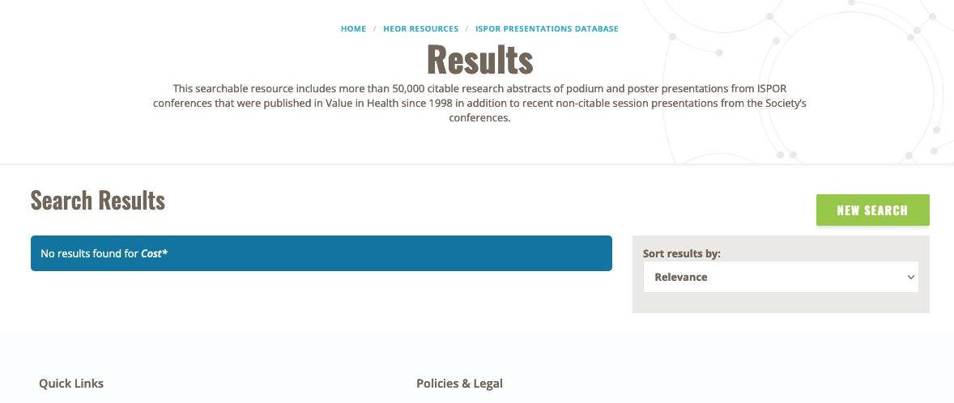

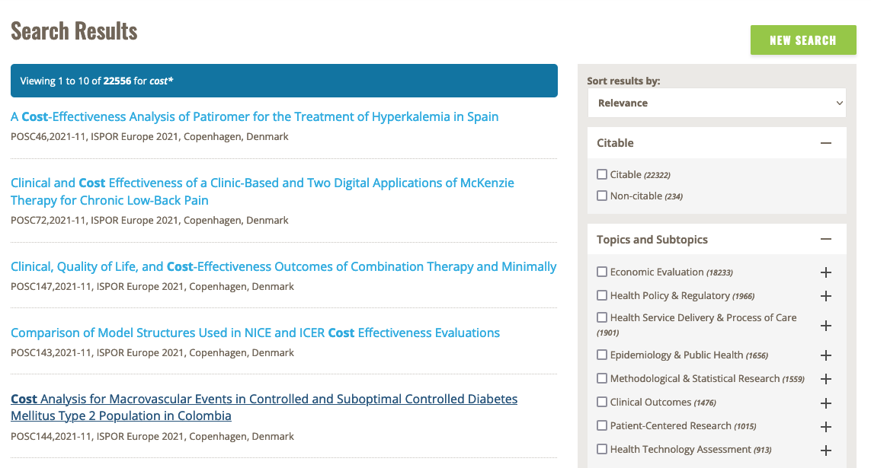

Example generated 18 October 2021. First shot, Cost is capitalised and in the second shot, it is not.

Supplementary figure 2: illustration of the truncation/capitalisation issue (left truncation)

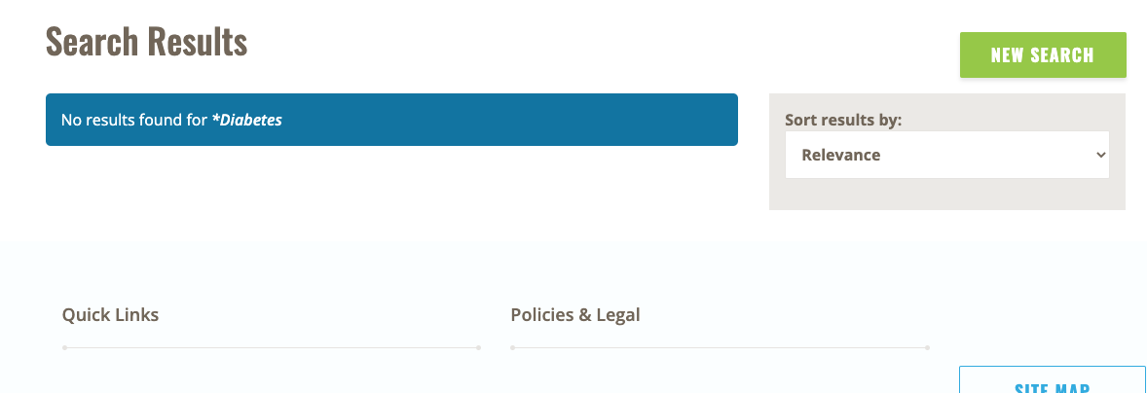

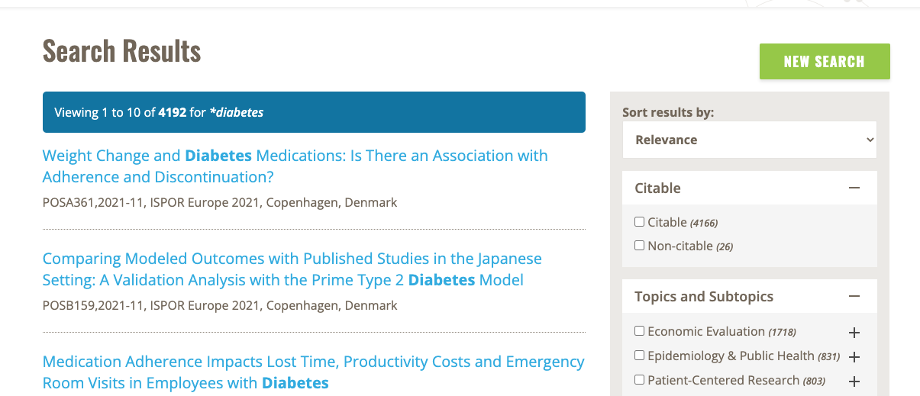

Example generated 21 October 2021. First shot, Diabetes is capitalised and in the second shot, it is not.

Supplementary figure 3: illustration of the straight-sided quotation marks issues

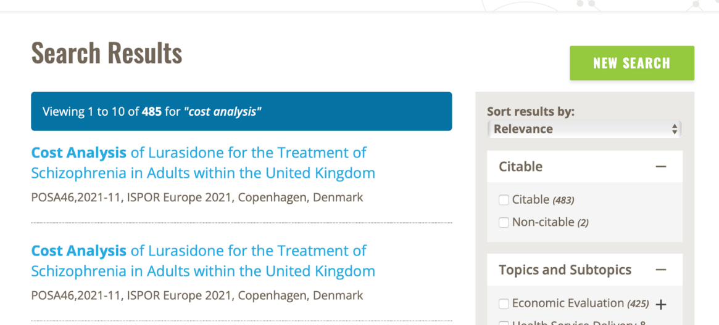

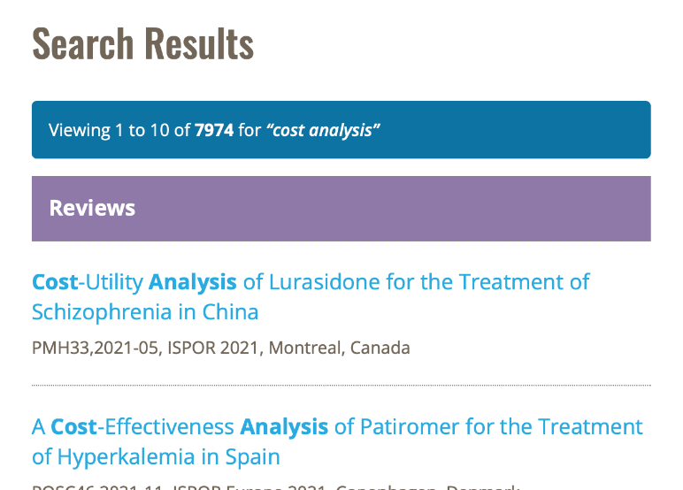

Example generated 15 October 2021. In the first shot, brackets are curly and in the second they are not.

