A review of overall survival extrapolations of immune-checkpoint inhibitors used in health technology assessments by the French Health Authorities

Supplementary files
Supplementary Materials 1

Study 2: CheckMate 017
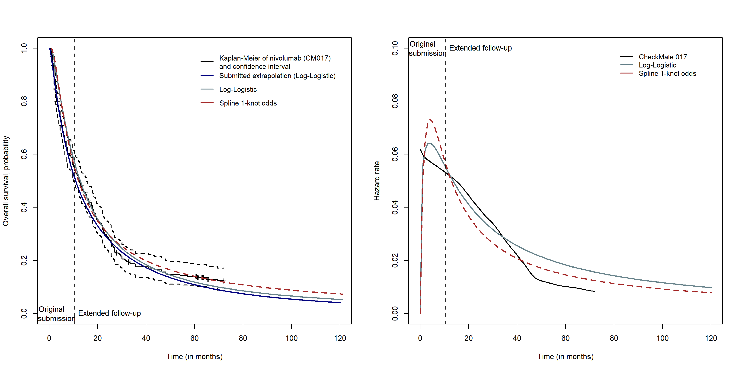
Figure S 1. Overall survival (left) and hazard rate (right) of nivolumab in CheckMate 017

Study 3: CheckMate 057
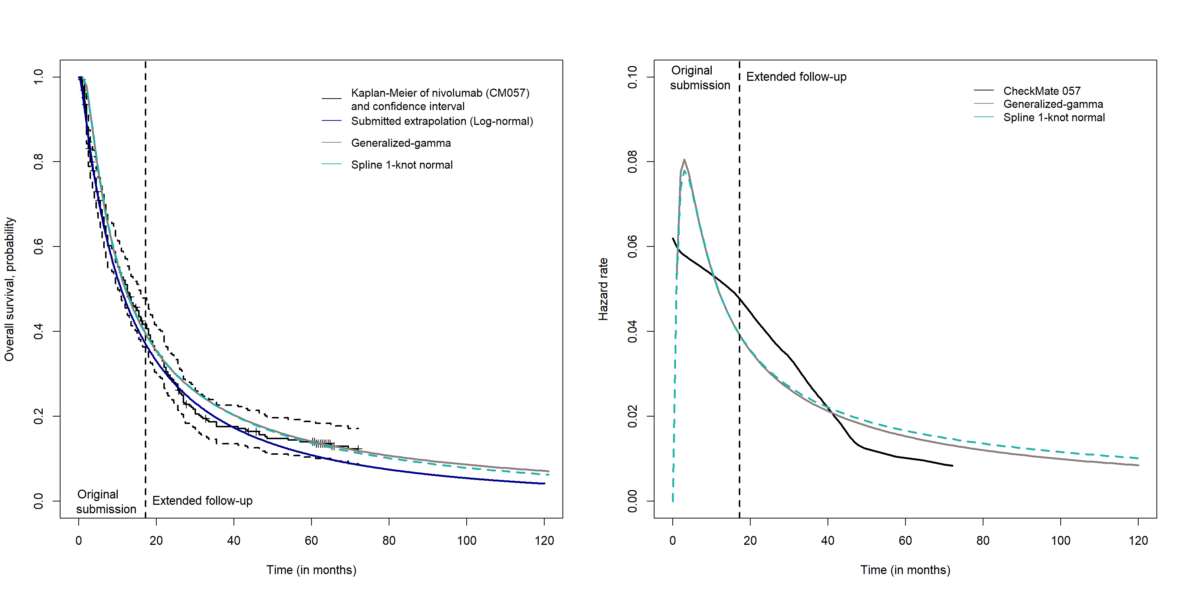
Figure S 2. Overall survival (left) and hazard rate (right) of nivolumab in CheckMate 057

Study 4: CheckMate 066
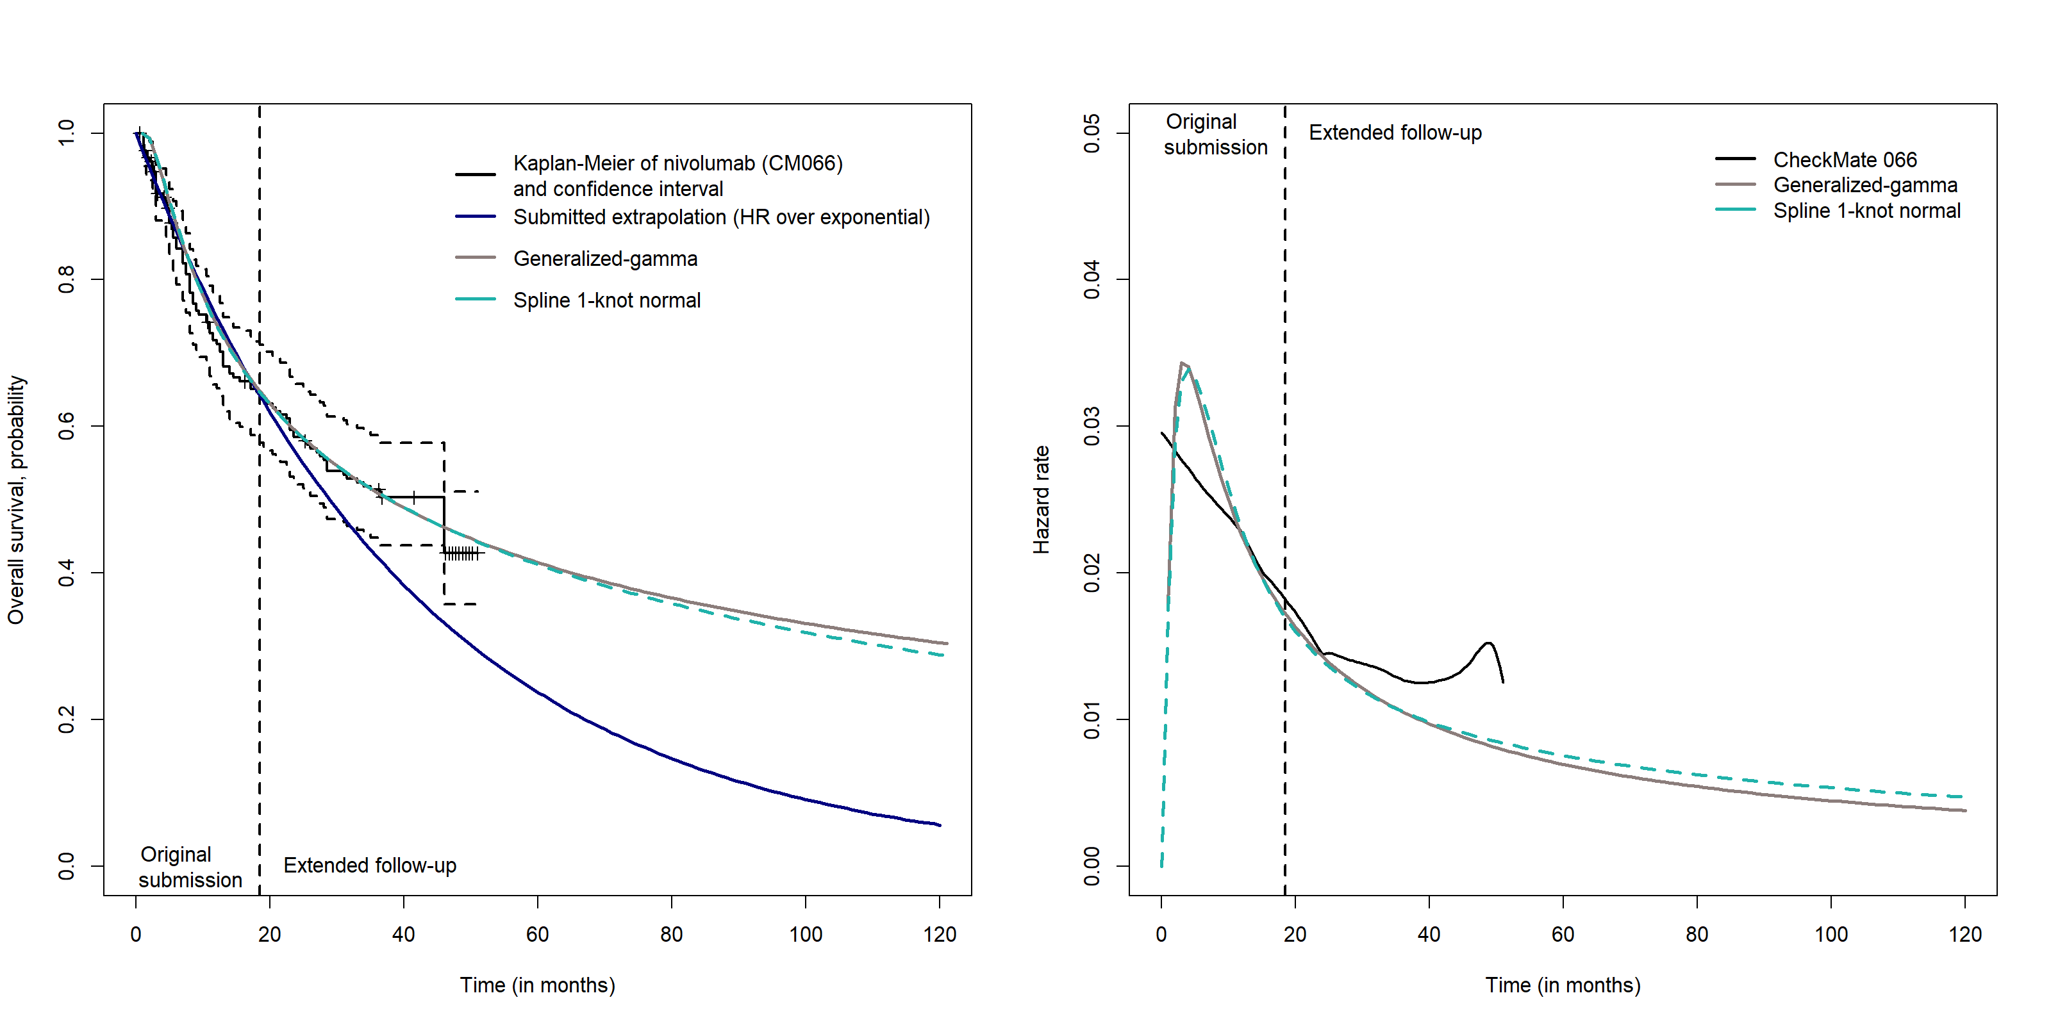
Figure S 3. Overall survival (left) and hazard rate (right) of nivolumab in CheckMate 066

Study 5: CheckMate 025
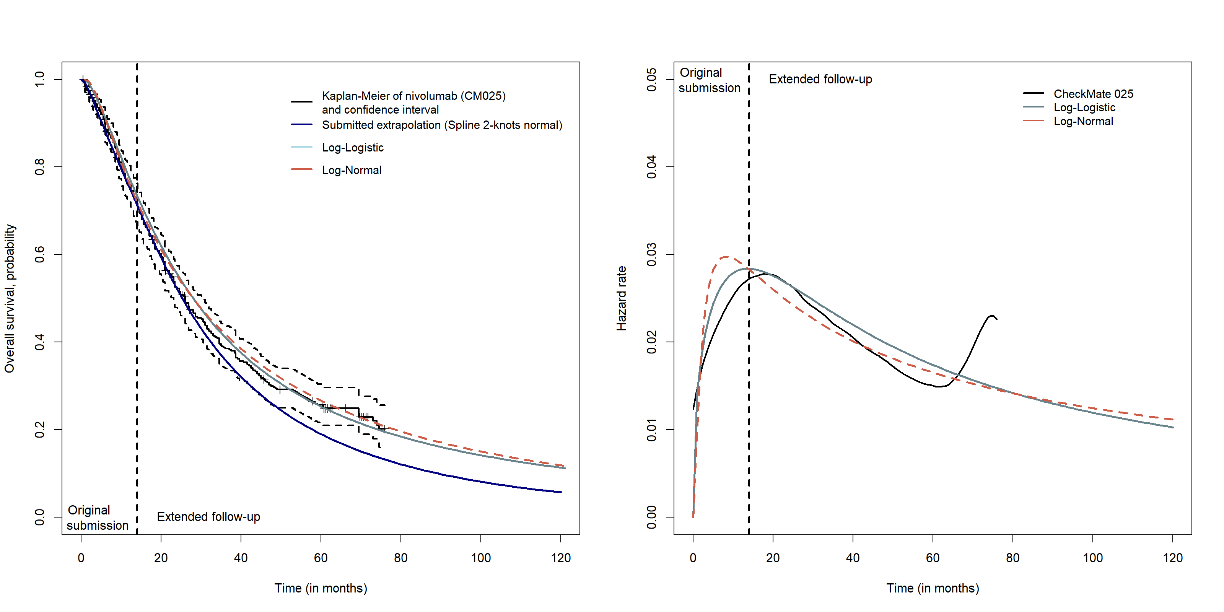
Figure S 4. Overall survival (left) and hazard rate (right) of nivolumab in CheckMate 025

Study 7: KeyNote 010
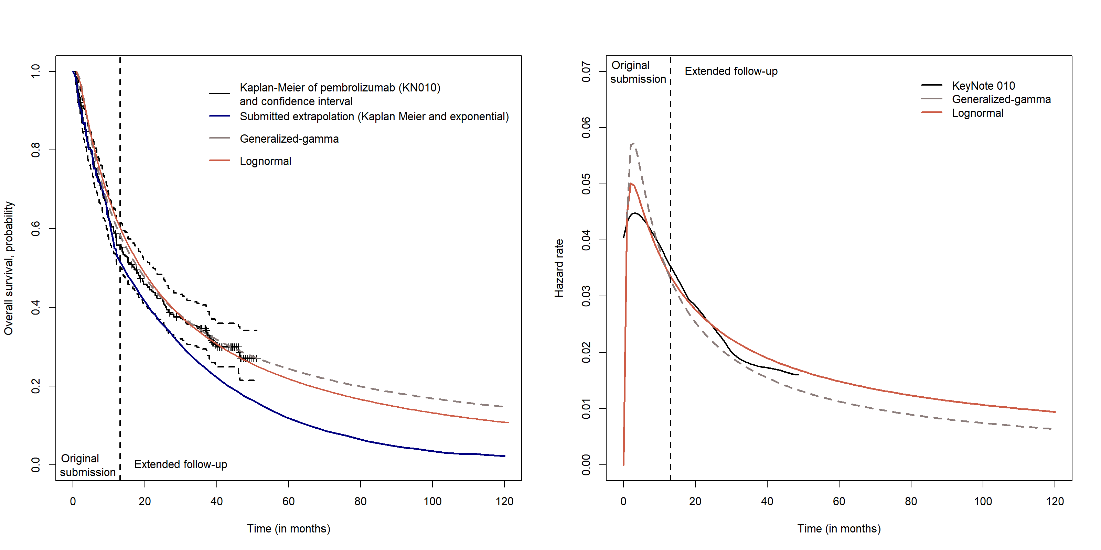
Figure S 5. Overall survival (left) and hazard rate (right) of pembrolizumab in KeyNote 010

Study 7: KeyNote 006
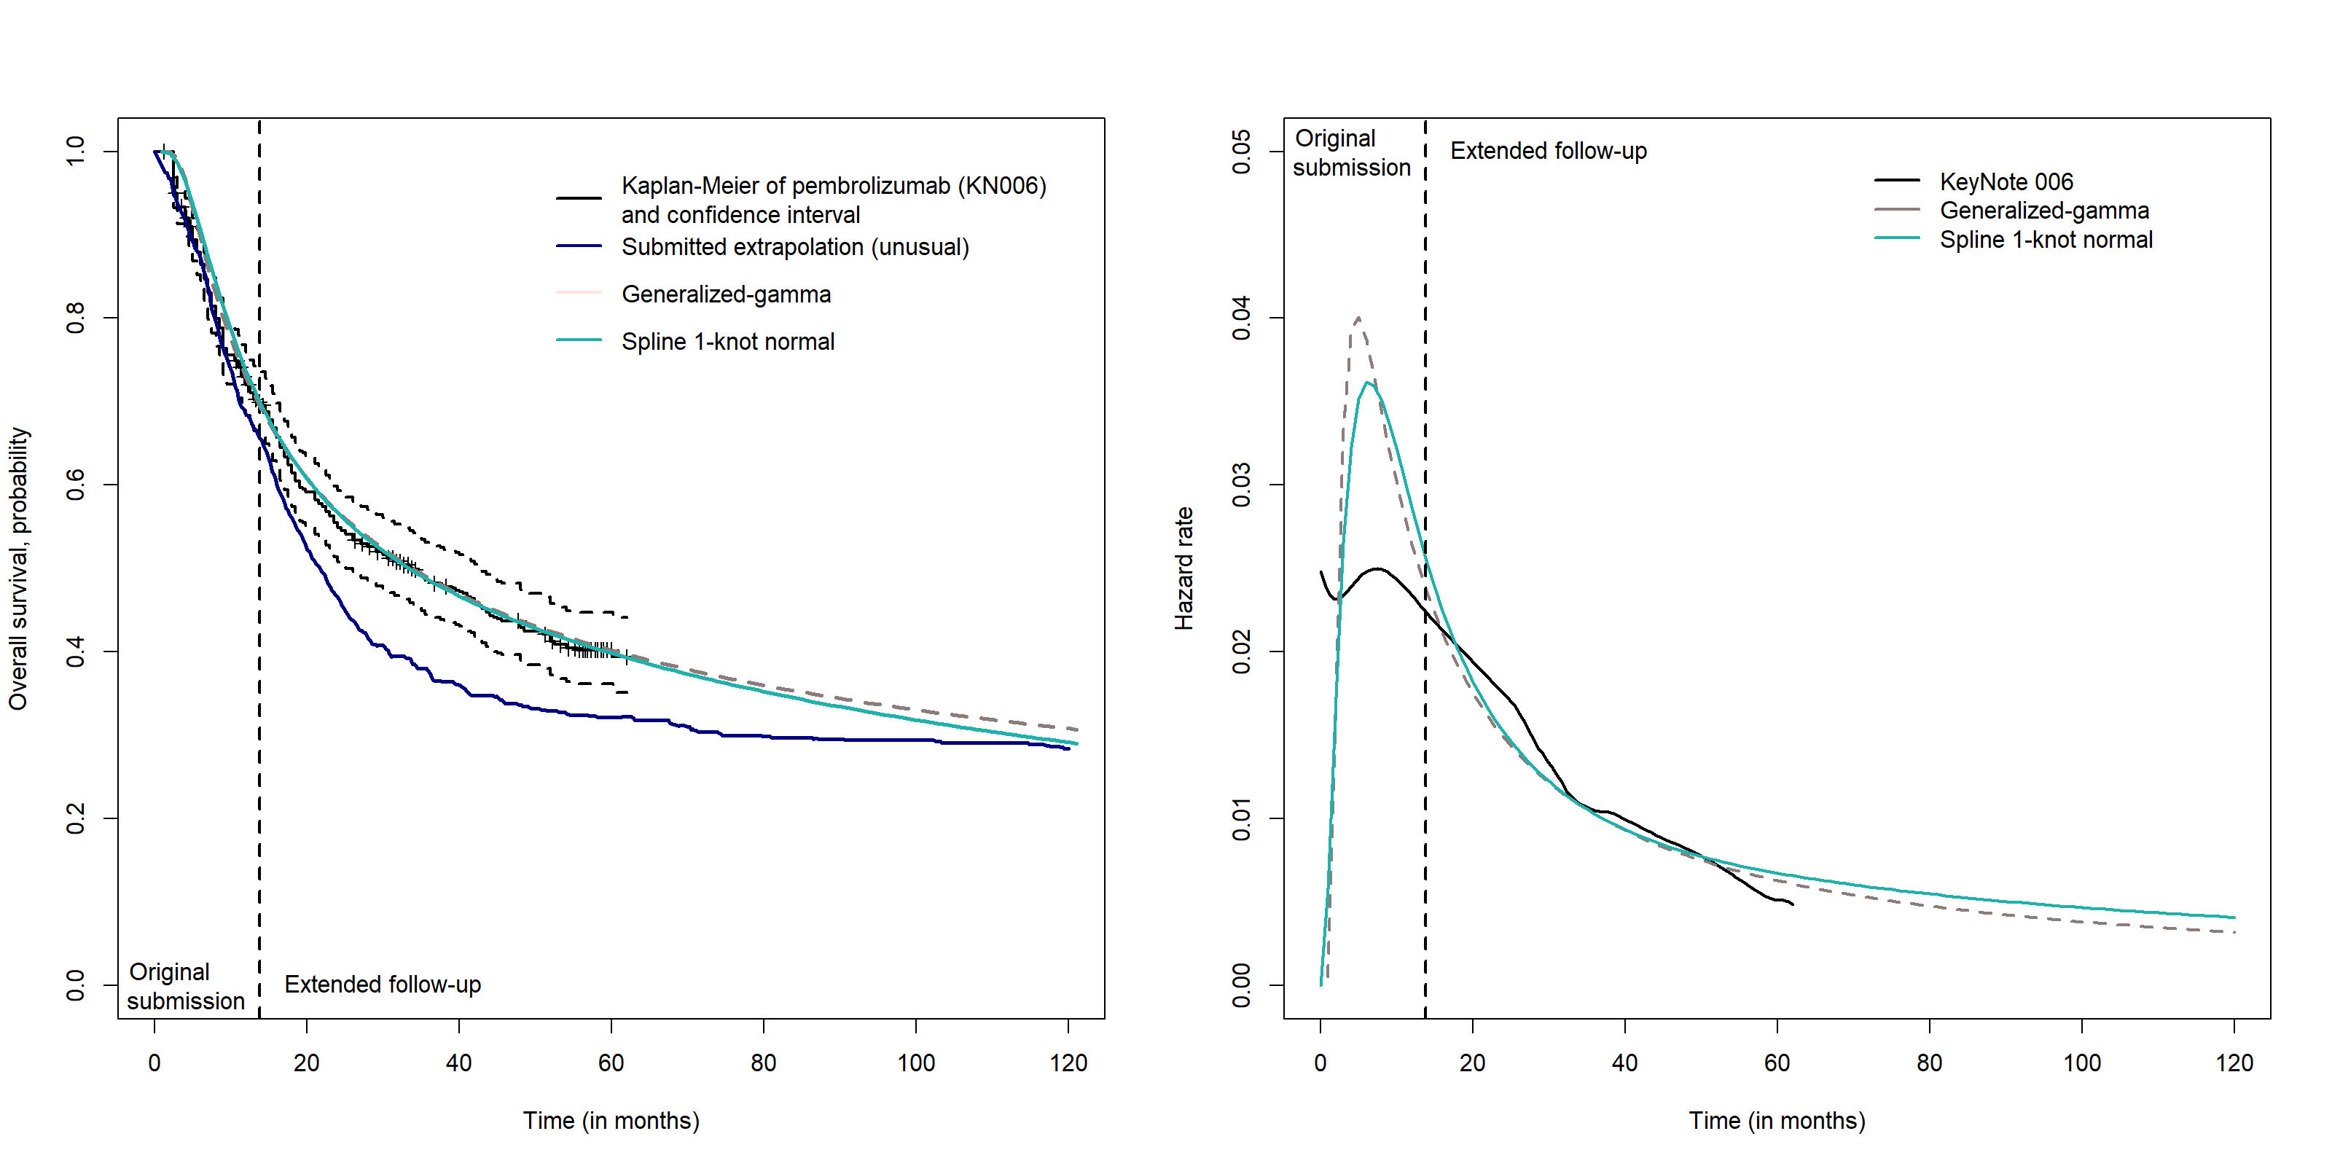
Figure S 6. Overall survival (left) and hazard rate (right) of pembrolizumab in KeyNote 006

Study 11 : KeyNote 045
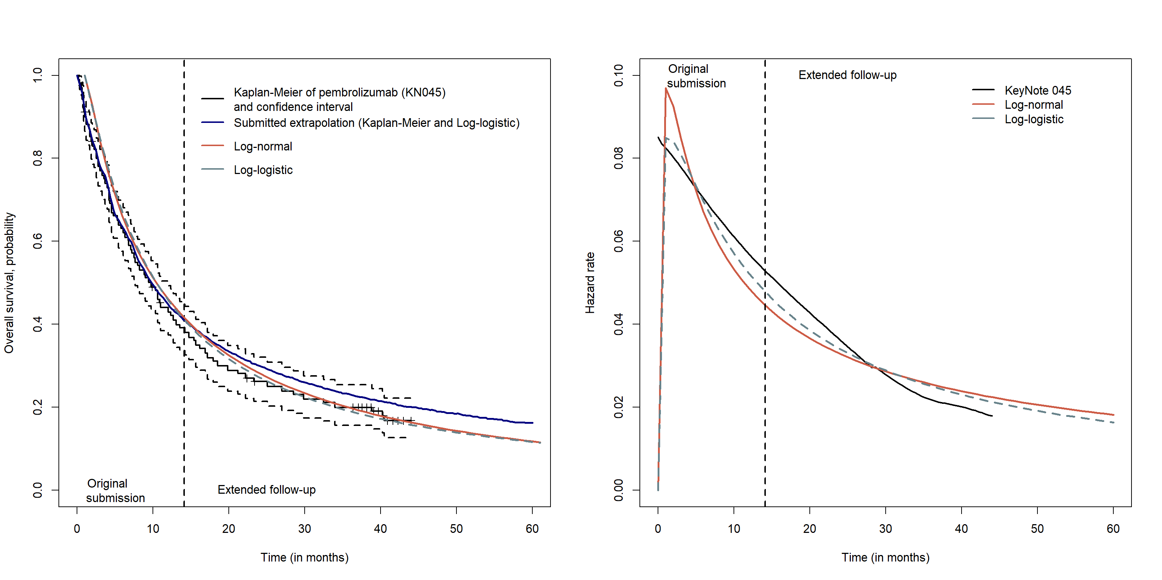
Figure S 7. Overall survival (left) and hazard rate (right) of pembrolizumab in KeyNote 045

Supplementary Materials 2
Computerized algorithm designed for extracting all the references analysed in the literature review
(atezolizumab [Title/Abstract] OR durvalumab [Title/Abstract] OR ipilimumab [Title/Abstract] OR nivolumab [Title/Abstract] OR nivolumab AND ipilimumab [Title/Abstract] OR pembrolizumab [Title/Abstract] AND aok [Title/Abstract] OR impower 150 [Title/Abstract] OR pacific [Title/Abstract] OR melbase [Title/Abstract] OR checkmate 017 [Title/Abstract] OR checkmate 025 [Title/Abstract] OR checkmate 057 [Title/Abstract] OR checkmate 066 [Title/Abstract] OR checkmate 141 [Title/Abstract] OR checkmate 214 [Title/Abstract] OR checkmate 238 [Title/Abstract] OR keynote 006 [Title/Abstract] OR keynote 010 [Title/Abstract] OR keynote 024 [Title/Abstract] OR keynote 045 [Title/Abstract] OR keynote 054 [Title/Abstract] OR keynote 189 [Title/Abstract] OR keynote 407 [Title/Abstract])

Supplementary Materials 3
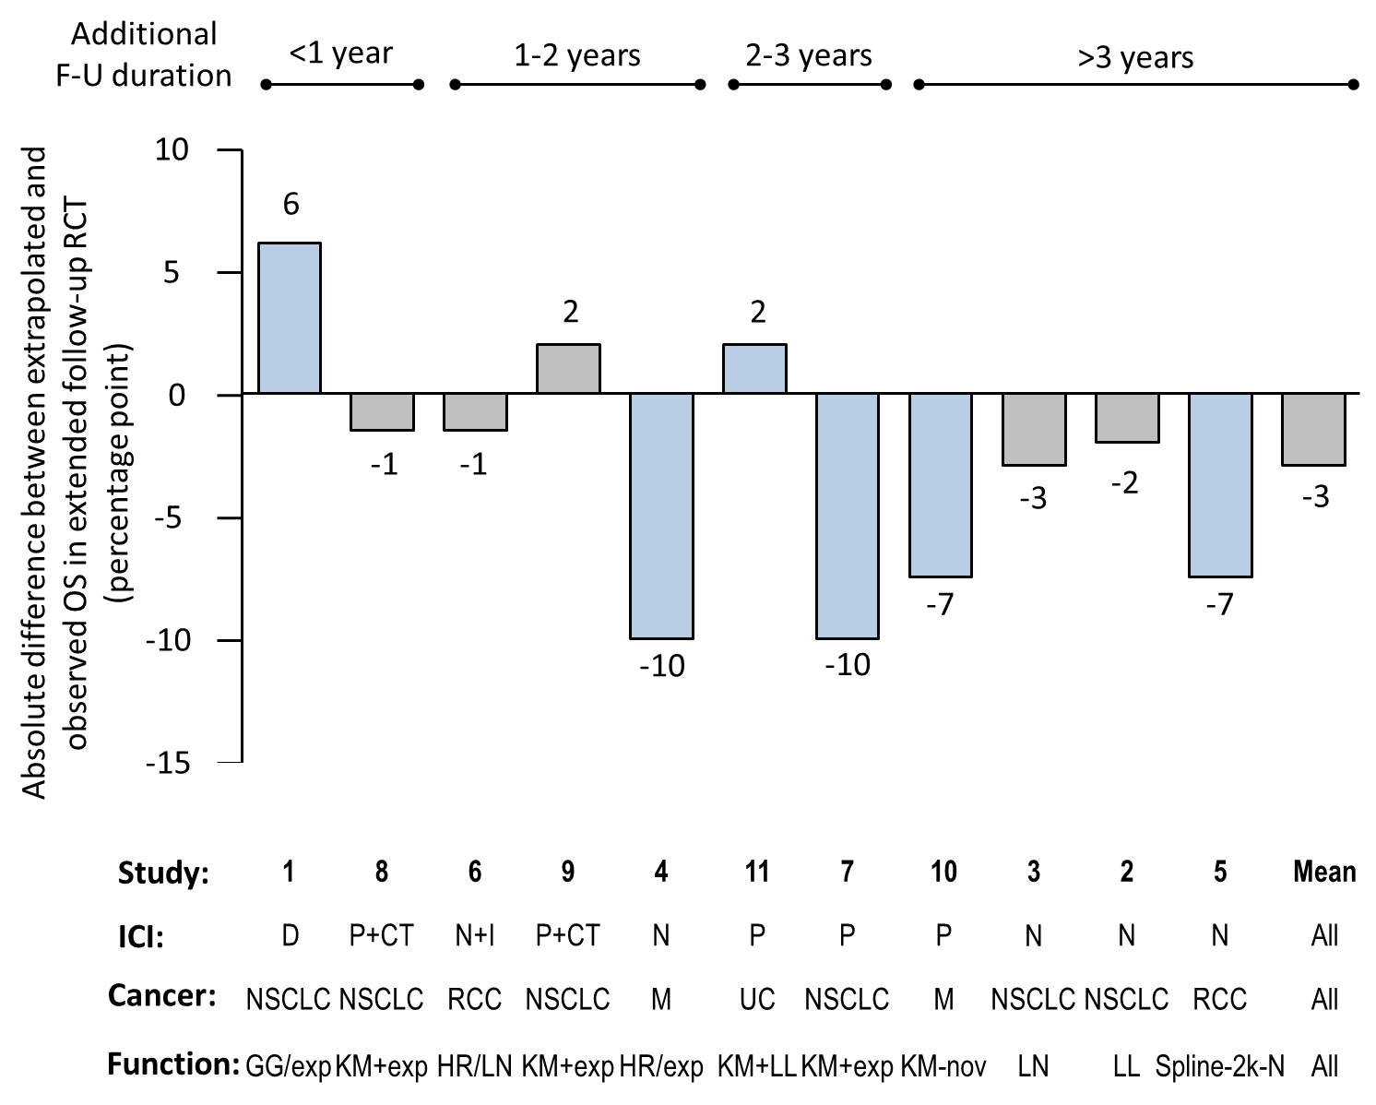
Figure S 8. Absolute percentage point difference between extrapolated and observed OS in extended follow-up of RCT

Supplementary Materials 4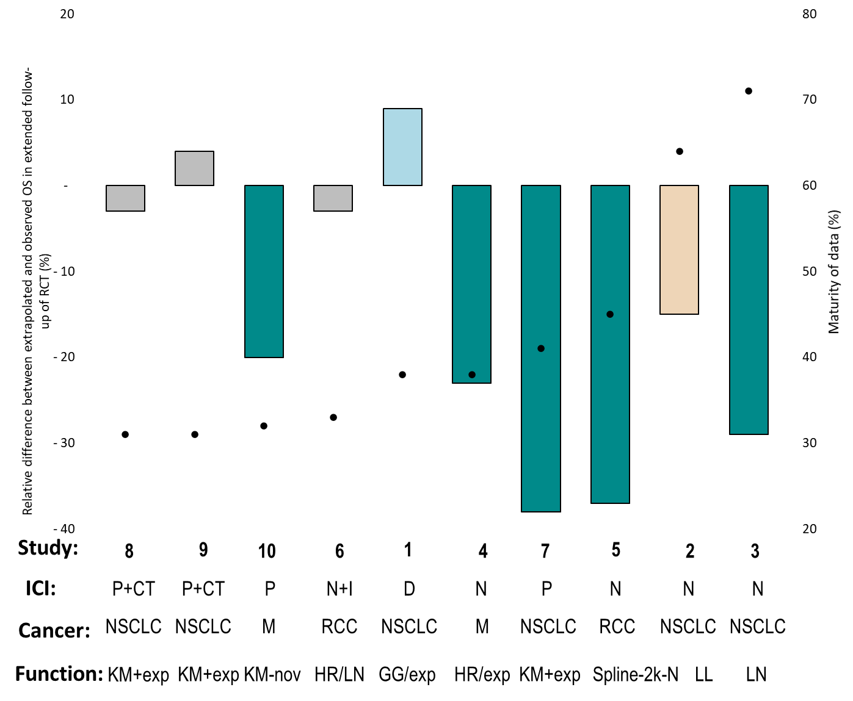
Figure S 9. Relationship between relative differences and maturity of data at the time of the submission
Maturity of data corresponds to the number of events at the time of the submission
N.B: Maturity of data was not available for KeyNote 045
Cancer type: M: melanoma; NSCLC: non-small-cell lung cancer; RCC: renal cell carcinoma; UC: urothelial carcinoma
Therapy: ICI: Immune checkpoint inhibitor; CT: chemotherapy; D: durvalumab; I: ipilimumab; N: nivolumab; P: pembrolizumab.
Extrapolation function: exp: exponential; GG: generalized gamma; HR: hazard ratio; KM: Kaplan-Meier; LL: log logistic; LN: log normal; nov: novel approach; Spline-2k-N: Spline 2-knot – normal.

