Survey for WP4 Assessment Teams and
Project Managers
Fields marked with * are mandatory.

Survey for WP4 Assessment Teams and Project Managers
This survey is aimed at EUnetHTA JA3 WP4 assessment teams (authors, co-authors, dedicated reviewers, observers) and project managers. It is a joint product of the WP4 lead and co-lead organizations (ZIN, NIPHNO and LBI-HTA) and the WP6 lead partner (IQWiG).
Answers can be provided individually, i.e. there is no need to send a combined answer per institution. Thereby please refer to the recently finished assessment mentioned in
the e-Mail notification by your project manager or the reminder by the WP6 lead partner.

I. GENERAL QUESTIONS

*1. Please indicate the EUnetHTA-project ID of the assessment to which this questionnaire refers to:
(format: PTJAxx; PTCAxx; OTJAxx or OTCAxx)

*2. Please specify the role you had in the assessment team of this project:
Author
Co-author
Dedicated Reviewer
Observer
Project Manager (PT)
Project Manager (OT)
*2.1. In how many assessments of Joint Action 3 have you so far been part of the Assessment Team?
1
- 2
- 3
- more than 3

II. EUNETHTA-PRODUCTS

Standard Operating Procedures (SOPs)

*3. Did the SOPs guide you clearly through the tasks which have been assigned to you related to your role in the assessment team?
Yes
No

3.1. Please type in your improvement suggestions for any of the following listed SOPs in the respective comment fields.
SOP title | Suggestion for improvement
All SOPs are listed in a separate row.

Please note that the full list of SOPs is not provided in this supplementary material, since the SOPs produced in EUnetHTA Joint Action 3 are internal documents only and not accessible to external stakeholders.

3
4

*4. Did the SOPs guide you clearly to the methodological guidelines and tools which were needed in each process step?
Yes
No

4.1. Please type in your improvement suggestions for any of the following listed SOPs in the respective comment fields.
SOP title | Suggestion for improvement
All SOPs are listed in a separate row.

Please note that the full list of SOPs is not provided in this supplementary material, since the SOPs produced in EUnetHTA Joint Action 3 are internal documents only and not accessible to external stakeholders.

6

*5. Did you think the provided checklists were useful in helping you keeping track of your tasks and successfully completing them?
Yes
No

5.1. Please type in your improvement suggestions for any of the following listed SOPs in the respective comment fields.
SOP title | Suggestion for improvement
All SOPs are listed in a separate row.

Please note that the full list of SOPs is not provided in this supplementary material, since the SOPs produced in EUnetHTA Joint Action 3 are internal documents only and not accessible to external stakeholders.

9

*6. Do you have any other propositions to improve the content of any SOP?
Yes
No

6.1. Please type in your improvement suggestions for any of the following listed SOPs in the respective comment fields.

SOP title | Suggestion for improvement
All SOPs are listed in a separate row.

Please note that the full list of SOPs is not provided in this supplementary material, since the SOPs produced in EUnetHTA Joint Action 3 are internal documents only and not accessible to external stakeholders.

12

*7. Did you experience any difficulties in sharing tasks among author and project manager?
Yes (please specify)
No
*7.1. Please specify your choice here:

*8. Is the distinction of your tasks and the ones of the WP4 Co-LP OT project manager clear?
Yes
No (please specify)
*8.1. Please specify your choice here:

*9. How was the attitude of the team towards following/ working with the SOPs?
Rather positive
Rather negative (please specify)

9.1. Please type in your specific observations for any of the following listed SOPs in the respective comment fields.

SOP title | Suggestion for improvement
All SOPs are listed in a separate row.

Please note that the full list of SOPs is not provided in this supplementary material, since the SOPs produced in EUnetHTA Joint Action 3 are internal documents only and not accessible to external stakeholders.

15

Templates
*10. Do you have any suggestions for improvement of any templates?
Yes
No

10.1. Please type in your improvement suggestions for any of the following listed templates in the respective comment fields.
Suggestions for improvement
Letter of Intent
Topic proposal for a EUnetHTA assessment on other technologies
Call for Collaboration
DOI & ECA-form
Project Plan
Submission Requirements for Rapid REA of Pharmaceutical Products
Submission Dossier Template
Technical Requirements for Evidence Submission: Pharmaceuticals
Assessment Report
Evidence Gaps Table Template
Plain Language Summary Template
Comment Form
Other (please specify)

Methodological Guidelines
*11. Do you have any suggestions for improvement for the Methodological Guidelines?
Yes
No

11.1. Please type in your improvement suggestions for any of the following listed Methodological Guidelines in the respective comment fields.
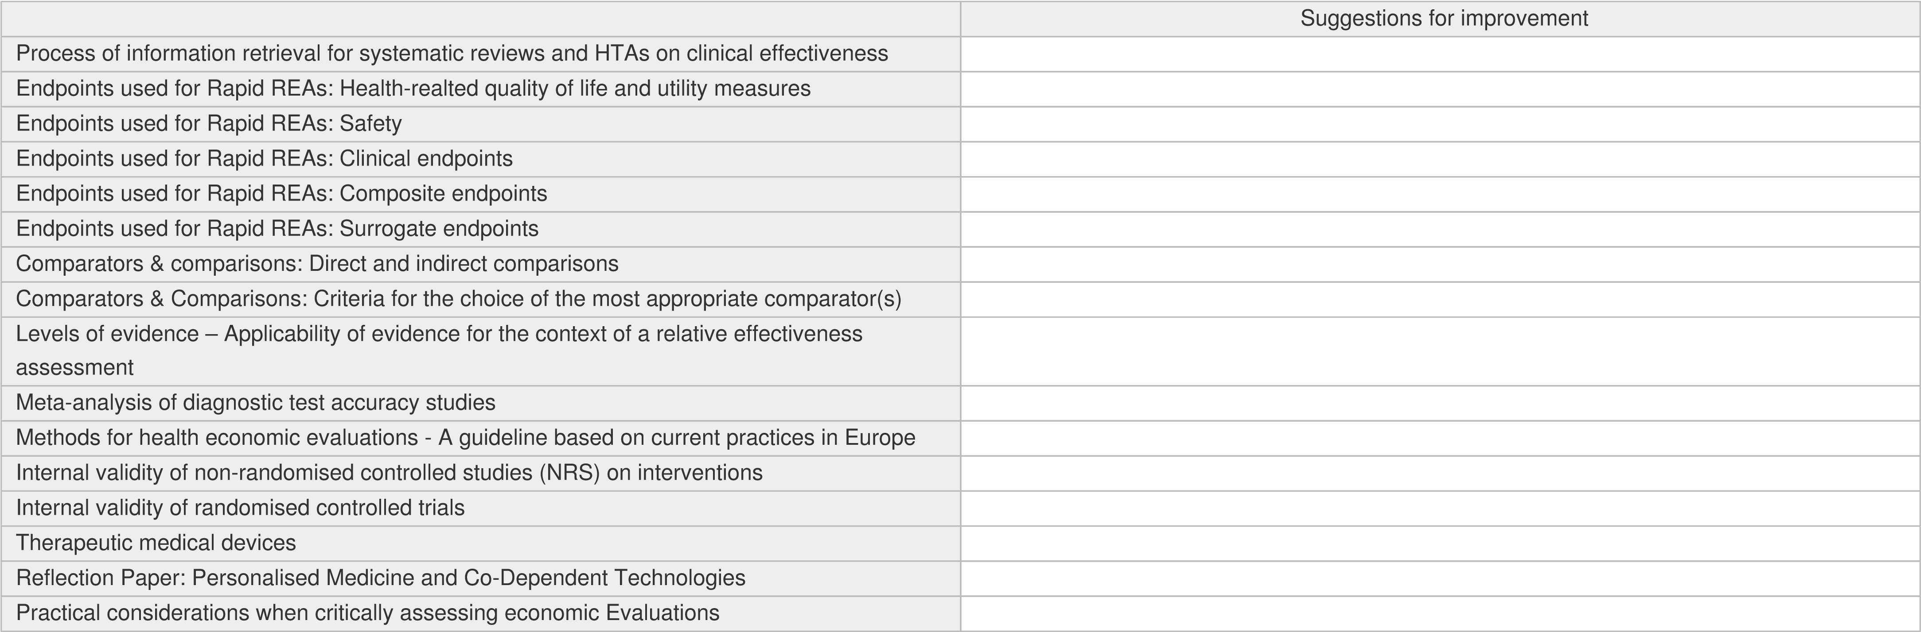

*12. Do you see the need for further Methodological Guidelines?
Yes
No
*12.1 Please specify the subject or methodological issue for which further guidance is needed.

Tools and Services

*13. Do you have any suggestions for improvement for tools and services?
(POP-database, EVIDENT-database, workoom on the intranet)
Yes
No

13.1. Please type in your improvement suggestions for any of the following listed tools and services in the respective comment fields.
Suggestions for improvement
POP-database
EVIDENT-database
Assessment-specific workroom on the EUnetHTA-intranet

HTA Core Model ®
*14. Do you have any suggestions for improvement for the domains of the HTA Core Model®?
Yes
No

14.1. Please type in your improvement suggestions for any of the following listed domains of the HTA Core Model (R) in the respective comment fields.
Suggestions for improvement
Health Problem and current use of Technology (CUR)
Description and technical chracteristics (TEC)
Safety (SAF)
Clinical effectiveness (EFF)
Costs and economic Evaluation (ECO)
Ethical Analysis (ETH)
Organisational aspects (ORG)
Patient and social apsects (SOC)
Legal aspects (LEG)

III. PROJECT AND PROCESS

Challenges in the project

*15. Did you encounter any challenges in any project phase?
Yes
Partly
No

15.1. Please type in your improvement suggestions for any of the following listed poject phases in the respective comment fields.
Please type in your improvement suggestion:
Project Start
Scoping and Developing Project Plan
Assessment Phase
Finalisation of Assessment

Timeframes
*16. Were the timeframes in the project phases that were relevant for you manageable?
Yes
Partly
No
*16.1. Please specify your choice here:

Project Management

*17. Were you satisfied with the support of your project manager?
Yes
Partly
No
*17.1. Please specify your choice here:

IV. MISCELLANEOUS

*18. Do you recognise the need for further training modules with respect to any of the products provided in the Companion Guide or a specific process (step)?
Yes (Please specify)
No
18.1. Please specify your choice here:

- How would you rate the assessment process in total?
(1 cirlce = very bad; 10 circles = excellent)

- Do you have any additional comments that have not been addressed by this questionnaire?
Please type in your comments here:

*21. Thank you very much for taking the time to fill out this survey.
It may occur that we have inquiries regarding some of your answers. In those cases it would be helpful to have your e-mail addresses available.
Your e-mail address will only be saved for the above mentioned purpose of clarifications regarding your answers. It is only available to the partners that extract the results from this Survey: WP6 Lead Partner, WP6 Co-Lead Partner, WP4 Co-Lead Partner Pharma and WP4 CoLead Partner OT). Your e-mail address will be deleted upon request (contact: euentehta@iqwig.de). I want to provide my e-mail address for potential clarifications.
I don't want to provide my e-mail address for potential clarifications.
*Please type in your work e-mail address.

