Supplementary Table 1. Search Strategies of the Scoping Reviews for HTA Frameworks and for Scientific Disciplines
Information sources | Codes | Filters
Scientific Articles regarding HTA Frameworks
PubMed | ("framework"[Title]) AND (("HTA"[Abstract] OR "health technology assessment"[Abstract]) OR ("HTA"[Title] OR "health technology assessment"[Title])) | - Article types: Journal Article  - Languages: English
Embase | 'framework':ti AND ('hta':ab,ti OR 'health technology assessment':ab,ti) | - Publication types: Article; Review
Google Scholar | allintitle: (“framework”) AND (“HTA” OR “health technology assessment”) | - Patents: not included  - Citations: included
Grey Literature regarding HTA Frameworks
European Network for Health Technology Assessment (EUnetHTA)  https://eunethta.eu | “HTA frameworks” | - Language: English  - Region: any region  - Terms appearing: anywhere in the page  - Safesearch: show most relevant results  - File type: any format  - Usage rights: not filtered by license
The Professional Society for Health Economics and Outcomes Research (ISPOR)
https://www.ispor.org
Health Technology Assessment International (HTAi)
https://htai.org
The International Network of Agencies for Health Technology Assessment (INAHTA) http://www.inahta.org
Institute for Clinical and Economic Review (ICER) https://icer-review.org
World Health Organization (WHO) https://www.who.int
National Institute for Health and Care Excellence (NICE)
https://www.nice.org.uk
Google Advance Search
Scientific Articles regarding Scientific Disciplines
PubMed | (“framework”[Title] OR “model”[Title] OR “theory”[Title] OR “guidance”) AND (“innovation”[Title] OR “identification”[Title] OR “research” [Title] OR “development”[Title] OR “implementation” [Title] OR “validation” [Title] OR “transferability” [Title] OR “generalization” [Title]) | - Text availability: Full Text  - Language: English  - Sort by Best Match
Embase | (“framework” OR “model” OR “theory” OR “guidance”) AND (“innovation” OR “identification” OR “research” OR “development” OR “implementation” OR “validation” OR “transferability” OR “generalization”) | - Search fields: Title  - Publication types: Article; Review  - Sort by Relevance
Google Scholar | allintitle: (“framework” OR “model” OR “theory” OR “guidance”) AND (“innovation” OR “identification” OR “research” OR “development” OR “implementation” OR “validation” OR “transferability” OR “generalization”) | - Citations: included  - Patents: not included  - Sort by Relevance

Supplementary Figure 1. Flow Diagram of Scanning and Identifying Eligible HTA Frameworks and Studies on 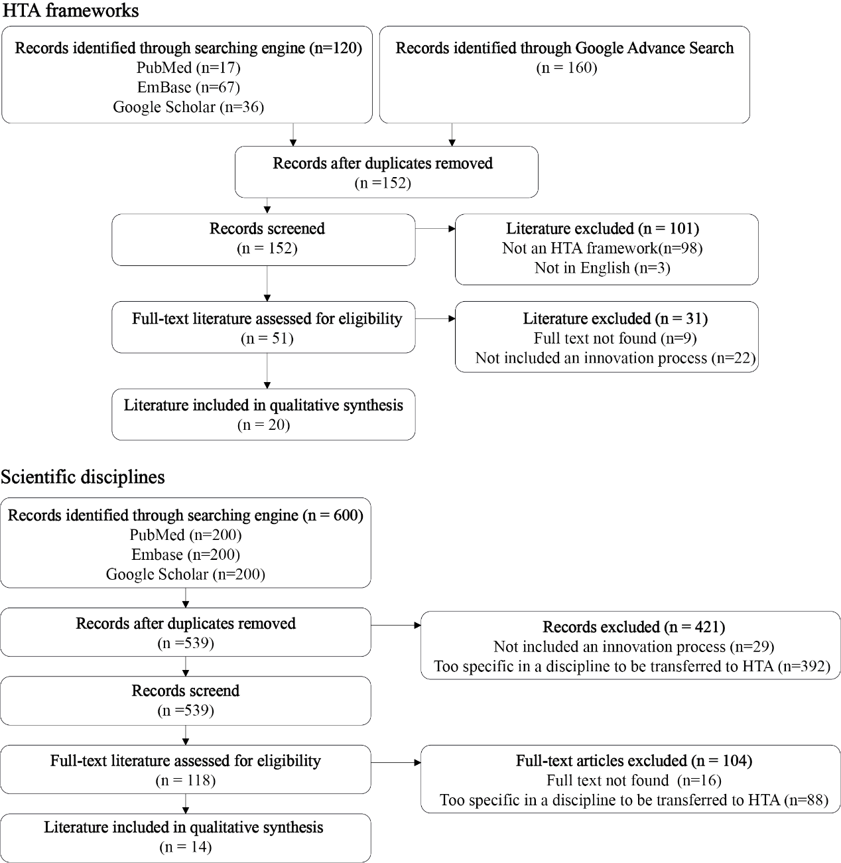

Supplementary Table 2. Study Characteristics of HTA Frameworks and Studies on Scientific Disciplines
HTA frameworks
Author | Year | Country  (corresponding author) | Source | Journal name | Name of the HTA framework?
Chan K et al. | 2020 | Canada | Scientific literature | BMJ Open | /
Ni M et al. | 2020 | The UK | Scientific literature | Expert Review of Medical Devices | The Lean and Agile Multi-dimensional Process (LAMP)
Almeida N et al. | 2019 | Canada | Scientific literature | International Journal of Technology Assessment in Health Care | /
Baran-kooiker A et al. | 2019 | Poland | Scientific literature | Acta Poloniae Pharmaceutica - Drug Research | The Evidence and Value: Impact on Decision Making Framework (EVIDEM)
Haverinen J et al. | 2019 | Finland | Scientific literature | Finnish Journal of eHealth and eWelfare | /
Brixner D et al. | 2018 | the USA | Scientific literature | Value in Health | /
Krahn M et al. | 2018 | Canada | Scientific literature | International Journal of Technology Assessment in Health Care | The Ontario Decision Framework
Palozzi G et al. | 2018 | Italy | Scientific literature | Sustainability | The Health Technology Balanced Assessment Framework (HTBA)
Angelis A et al. | 2017 | The UK | Scientific literature | Social Science & Medicine | The Advance Value Framework (AVF)
Assasi N et al. | 2016 | Canada | Scientific literature | BMC Medical Ethics | /
Abelson J et al. | 2016 | Canada | Scientific literature | International Journal of Technology Assessment in Health Care | /
Gagnon M et al. | 2015 | Canada | Scientific literature | International Journal of Technology Assessment in Health Care | /
Widrig D et al. | 2014 | Switzerland | Scientific literature | International Journal of Technology Assessment in Health Care | /
Assasi N et al. | 2013 | Canada | Grey literature (Google advanced search) | / | /
Poulin P et al. | 2013 | Canada | Scientific literature | Medical Devices: Evidence and Research | /
Goetghebeur M et al. | 2012 | Canada | Scientific literature | Medical Decision Making | The Evidence and Value: Impact on Decision Making Framework (EVIDEM)
Miot J et al. | 2012 | South Africa | Scientific literature | Cost Effectiveness and Resource Allocation | The Evidence and Value: Impact on Decision Making Framework (EVIDEM)
Tony M et al. | 2011 | Canada | Scientific literature | BMC Health Services Research | The Evidence and Value: Impact on Decision Making Framework (EVIDEM)
Goetghebeur M et al. | 2010 | Canada | Scientific literature | Cost Effectiveness and Resource Allocation | The Evidence and Value: Impact on Decision Making Framework (EVIDEM)
Veenstra D et al. | 2010 | The USA | Scientific literature | Genetics in Medicine | /
Scientific disciplines
Author | Year | Country  (Corresponding author) | Source | Journal name | Scientific discipline categorization
Hendricks S et al. | 2018 | South Africa | Scientific literature | Healthcare | Design thinking
Rapport F et al. | 2017 | Australia | Scientific literature | Journal of Evaluation in Clinical Practice | Implementation research
Neta G et al. | 2015 | The USA | Scientific literature | American Journal of Public Health | Implementation research
Roberts J et al. | 2015 | The USA | Scientific literature | Healthcare | Design thinking
Vechakul J et al. | 2015 | The USA | Scientific literature | Maternal Child Health Journal | Design thinking
Meyers D et al. | 2012 | The USA | Scientific literature | Am J Community Psychol | Implementation research
Brown T et al. | 2010 | The USA | Scientific literature | Stanford Social Innovation Review | Design thinking
Damschroder L et al. | 2009 | The USA | Scientific literature | Implementation Science | Implementation research
Liyanage C et al. | 2009 | The UK | Scientific literature | Journal of Knowledge Management | Implementation research
Majdzadeh R et al. | 2008 | Iran | Scientific literature | Journal of Continuing Education in the Health Professions | Implementation research
Kilbourne A et al. | 2007 | The USA | Scientific literature | Implementation Science | Implementation research
Graham I et al. | 2006 | Canada | Scientific literature | Journal of Continuing Education in the Health Professions | Implementation research
Newell W et al. | 2001 | The USA | Scientific literature | Issues in Integrative Studies | Interdisciplinary research
Okumus F et al. | 2001 | Turkey | Scientific literature | International Journal of Contemporary Hospitality Management | Implementation research

Supplementary Table 3. Stakeholder characteristics
Codename | Stakeholder group | Face-to-face brainstorming (n=7) | Online brainstorming (n=6) | Questionnaire (n=7)
Aca1 | Academic |  | Yes | Yes
Aca2 | Academic | Yes
Aca3 | Academic | Yes
Aca4 | Academic | Yes
Aca5 | Academic | Yes
Aca6 | Academic | Yes
Aca7 | Academic |  |  | Yes
Aca8 | Academic |  | Yes | Yes
Hta1 | HTA bodies |  | Yes | Yes
Hta2 | HTA bodies |  | Yes | Yes
Ind1 | Industry | Yes
Ind2 | Industry |  | Yes | Yes
Pat1 | patient |  | Yes | Yes
Pat2 | Patient | Yes
Aca = Academic; Hta = Representative from HTA bodies; Ind = Representative from industry; Pat = Patient.

