Supplementary File
Description: Supplementary figures and tables

Title: Medicine characteristics affecting the time to guidance publication by National Institute for Health and Care Excellence in the single technology appraisal process
Journal: International Journal of Technology Assessment in Health Care
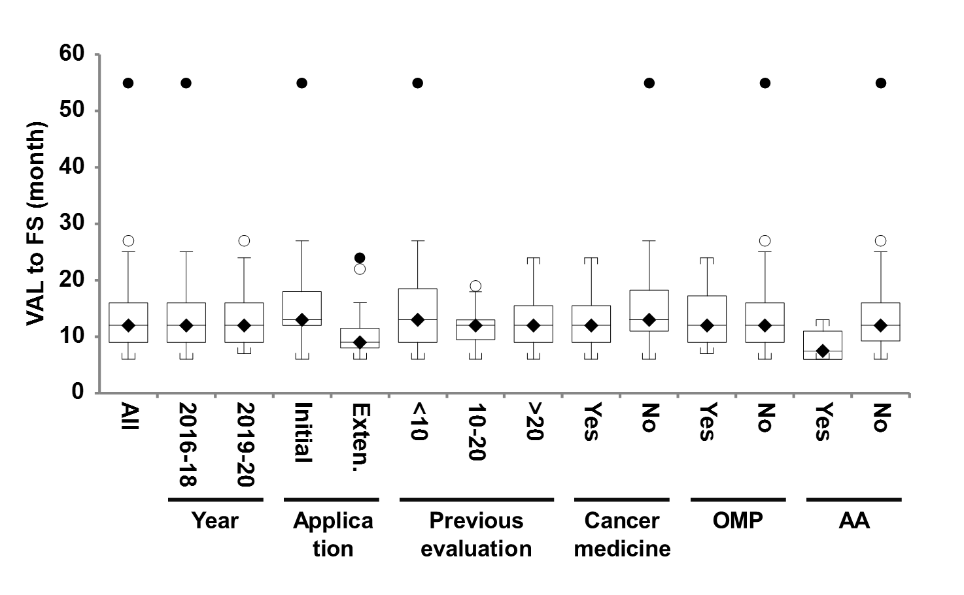
Supplementary Figure 1. Box-and-whisker plot of the VAL to FS period among apprised medicine characteristics.
The upper and lower whiskers are the upper or lower quartiles plus 1.5 times the interquartile distance. The horizontal lines that split the boxes in two represents median values, which are also expressed as the black diamonds on the boxes. The white and black circles denote outliers of 1.5 and 3 times the interquartile range, respectively. AA, accelerated assessment; FAD, final appraisal determination; MA, marketing authorization; OMP, orphan medicinal product.

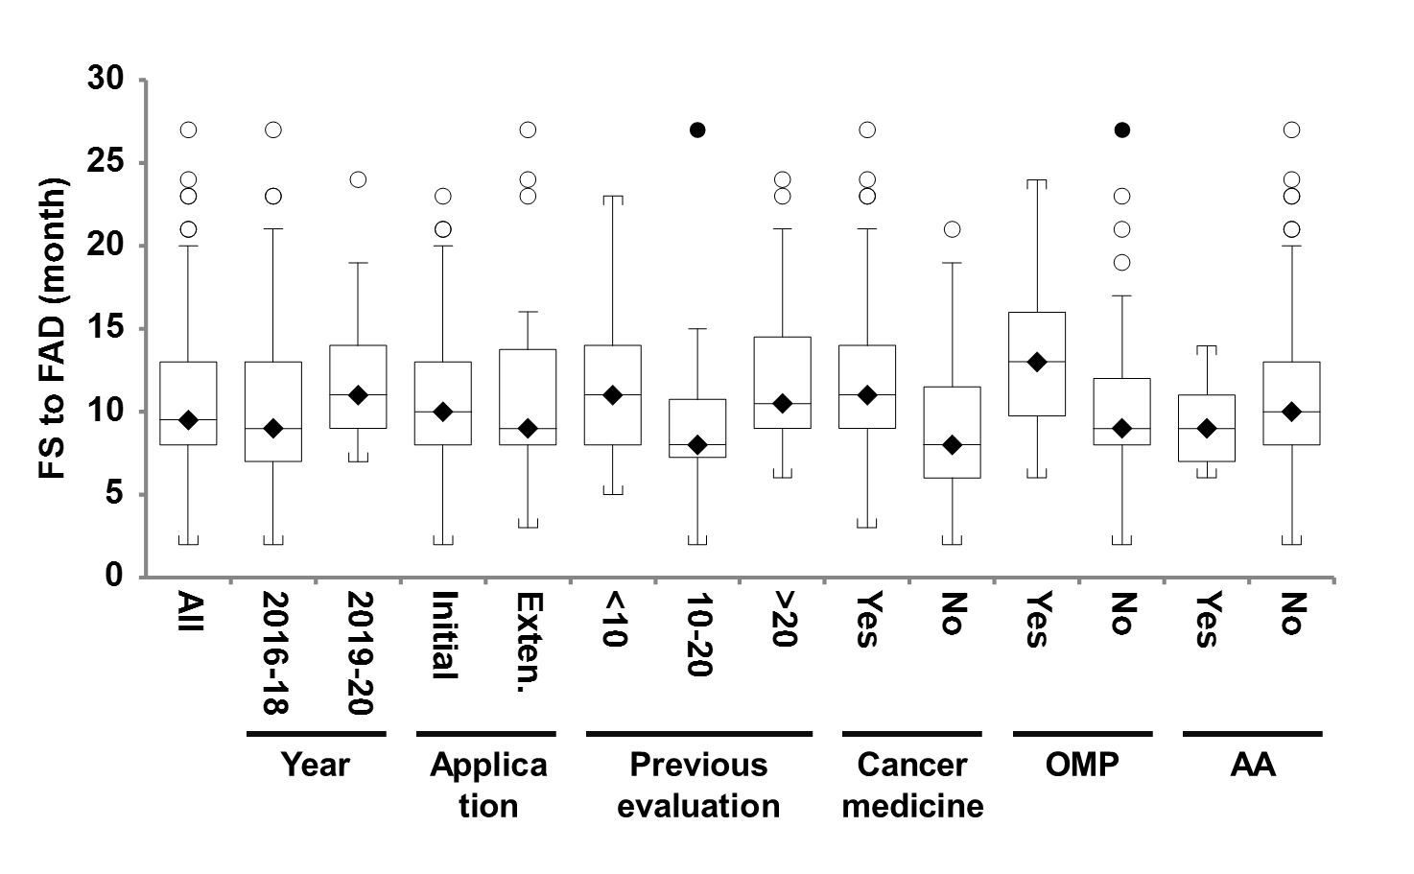
Supplementary Figure 2. Box-and-whisker plot from the FS to FAD period among apprised medicine characteristics.
The upper and lower whiskers are the upper or lower quartiles plus 1.5 times the interquartile distance. The horizontal lines that split the boxes in two represents median values, which are also expressed as the black diamonds on the boxes. The white and black circles denote outliers of 1.5 and 3 times the interquartile range, respectively. AA, accelerated assessment; FAD, final appraisal determination; MA, marketing authorization; OMP, orphan medicinal product.

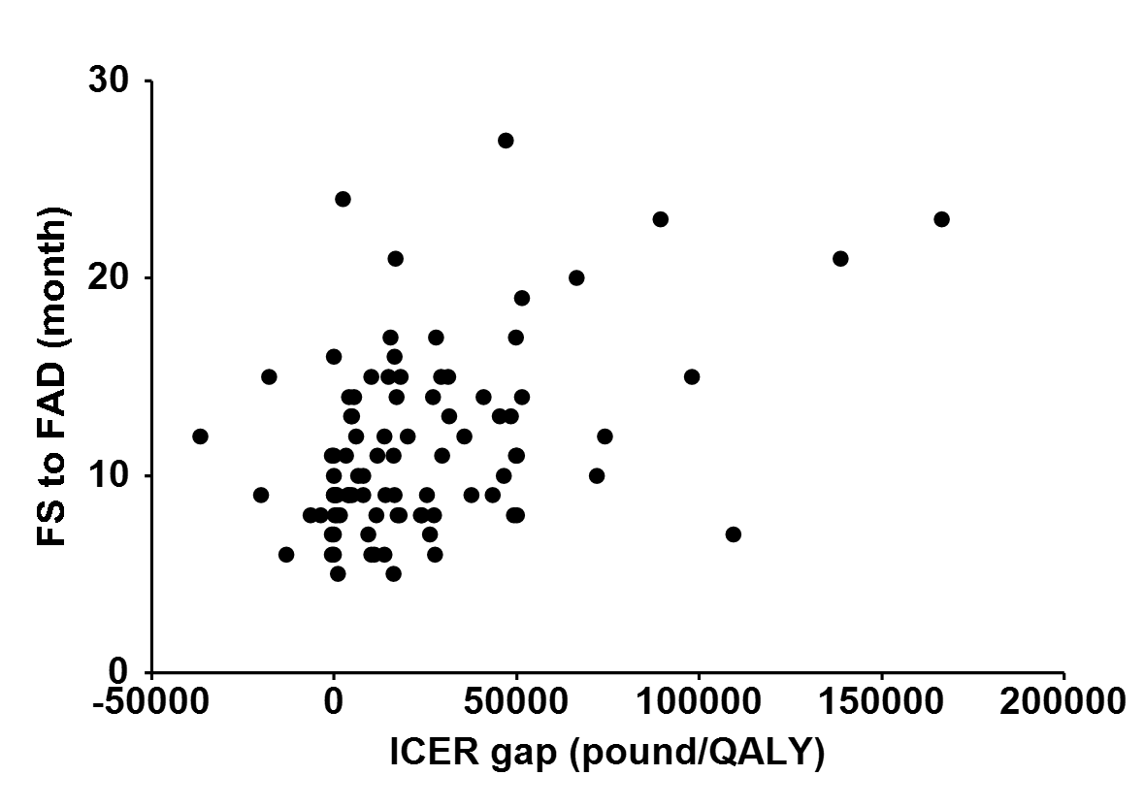
Supplementary Figure 3. Correlation of ICER gap with the FS to FAD period.
ICER gap was calculated as the ERG’s ICER minus the manufacture’s ICER for each appraisal.
Abbreviation: ERG, expert review group; FAD, final appraisal determination; FS, final scope; ICER, incremental cost-effectiveness ratio; QALY, quality-adjusted life year.

Supplementary Table 1. Multivariable analysis of appraised medicine characteristics associated with key periods (excluding one outlier).

Characteristics  (no. of appraisals) | MA to FAD |  |  | VAL to FS* |  |  | FS to FAD
 | Unstandardized coefficients  month, (95%CI) | P value |  | Unstandardized coefficients  month, (95%CI) | P value |  | Unstandardized coefficients  month, (95%CI) | P value
Completion year
2016-2018 (73) | Reference |  |  | Reference |  |  | Reference
2019-2020 (42) | 0.332 (-1.116, 1.780) | 0.650 |  | -0.705 (-3.164, 1.754) | 0.571 |  | 1.221 (-0.477, 2.920) | 0.157
Application type
Initial (68) | Reference |  |  | Reference |  |  | Reference
Extension (47) | -0.604 (-2.068, 0.859) | 0.415 |  | -5.922 (-8.479, -3.364) | < 0.001 |  | -0.053 (-1.770, 1.664) | 0.952
Previous appraisal
1 evaluation increment | -0.017 (-0.074, 0.041) | 0.566 |  | -0.007 (-0.103, 0.090) | 0.894 |  | -0.033 (-0.101, 0.035) | 0.338
Cancer medicine
No (44) | Reference |  |  | Reference |  |  | Reference
Yes (71) | -0.031 (-1.666, 1.603) | 0.970 |  | -3.830 (-6.673, -0.988) | 0.009 |  | 2.321 (0.403, 4.238) | 0.018
OMP
No (91) | Reference |  |  | Reference |  |  | Reference
Yes (24) | 2.508 (0.690, 4.327) | 0.007 |  | -0.858 (-3.880, 2.164) | 0.574 |  | 2.761 (0.628, 4.894) | 0.012
Accelerated assessment
No (110) | Reference |  |  | Reference |  |  | Reference
Yes (5) | -0.482 (-3.877, 2.913) | 0.779 |  | -7.449 (-13.093, -1.806) | 0.010 |  | -1.604 (-5.587, 2.379) | 0.426
* 108 appraisals were available, because there were some missing entries in the European Medicines Agency’s validation date. Among the 108 appraisals, the 66 were completed from 2016 to 2018, the 68 were initial application, the 67 were cancer medicines, the 24 were OMPs, and the 5 were granted accelerated assessment.
Abbreviation: CI, confidence interval; FAD, final appraisal determination; FS, final scope; MA, marketing authorization; OMP, orphan medicinal product; VAL, validation of marketing authorization application

Supplementary Table 2. Multivariable analysis of factors influencing the FS to FAD periods (including ICER gap).

Factors  (no. of appraisals) | Multivariable analysis (N=84)
 | Unstandardized coefficients  month, (95%CI) | P value
Factors regarding cost-effectiveness analyses
No. of comparators in the FS
≤ 2 (49) | Reference
> 2 (67) | -1.659 (-3.438, 0.120) | 0.067
ICER gap between the manufacture and the ERG
≤ 20,000 pound/QALY (56) | Reference
> 20,000 pound/QALY (37) | -1.491 (-0.264, 3.246) | 0.095
Factors regarding clinical trials included in cost-effectiveness analyses
Time to approval
≤ 300 days (53) | Reference
> 300 days (53) | 0.937 (-0.823, 2.697) | 0.292
Double-blinded randomized control trial
No (53) | Reference
Yes (63) | -1.878 (-3.799, 0.042) | 0.055
Comparators
Not specified in the FS (66) | Reference
Specified in the FS (50) | -1.931 (-3.953, 0.092) | 0.061
Abbreviation: ERG, evidence review group; FAD, final appraisal determination; FS, final scope; ICER; incremental cost-effectiveness ratio; QALY, quality-adjusted life year.

Supplementary Table 3. Time from validation of MA application by the EMA to approval in case of OMPs.

Time to approval, n (%) * | Median (day) | Range (day)
OMP, 20 (29) | 333 | 204-666
Non-OMP, 49 (71) | 344 | 154-1604

* Only appraisals for initial application were included.
Abbreviation: MA; marketing authorization, OMP: orphan medicinal product.

Supplementary Table 4. Clinical trial designs included in the cost-effectiveness analyses in case of OMPs.

DBRCT, n (%) * | Yes | No
OMP | 9 (8) | 16 (14)
Non-OMP | 54 (47) | 37 (32)

Comparator, n (%) * | Specified in the FS as a comparator in cost-effectiveness analyses | Not specified in the FS
OMP | 8 (7) | 17 (15)
Non-OMP | 42 (36) | 49 (42)

* Percentages may not total 100 because of rounding.
Abbreviation: DBRCT, double-blinded randomized control trial; FS, final scope; OMP, orphan medicinal product.

