Appendix 1. Number of interviewees and their date of interview
Groups | Number of interviewees |  | Date of interview
Employees at a domestic industry | 6 |  | June 14, 2019
Employees at a foreign industry | 9 | 5 | June 4, 2019
 |  | 4 | June 11, 2019

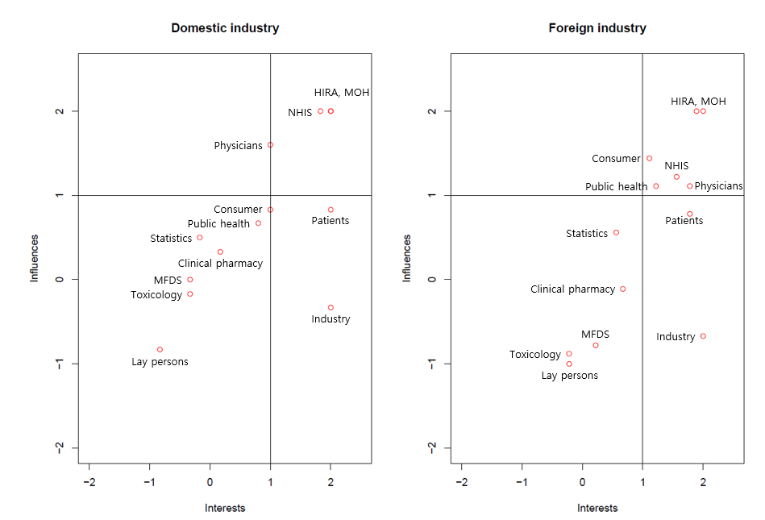
Appendix 2. Interests and influence of various stakeholder in making reimbursement decisions
Note) MFDS: Ministry of Food and Drug Safety; HIRA: Health Insurance Review and Assessment Service; NHIS: National Health Insurance Service; MOH: Ministry of Health and Welfare

