# Appendix

Table SA - Cost parameters

|  |  |  |
| --- | --- | --- |
| Parameter | Cost per unit GBP  (EUR) | Source |
| CT imaging study (CT of head without contrast) | 90  (103) | NHS reference costs 2017-2018, IMAGOP |
| MRI imaging study (MRI of brain with post-contrast) | 165  (188) | NHS reference costs 2017-2018, IMAGOP |
| Liquid Biopsy Test | 50, 75, 100, 200  (57, 86, 114, 228) | Examined prices |

Table SA – Updated decision tree model parameters

|  |  |  |  |
| --- | --- | --- | --- |
| **Parameter** | **Value** | **Distribution for PSA, if applicable** | **Source** |
| Prevalence Primary Care | 0.01 (1%) | Beta (5,495) | Expert opinion (1) |
| Prevalence Secondary Care | 0.03 (3%) | Beta (22.5,750) | (2,3) |
| Hazard ratio for delay to diagnosis (per day) | 1.015 | Normal (1.015, 0.005) | (4), assumptions in (1) |
| Median survival without delay (weeks) | 46 |  | (4) |
| Time-to-diagnosis, standard referral (weeks) | 1 |  | (5) |
| Time-to-diagnosis, fast-track referral (weeks) | 4 |  | (5) |
| Time-to-diagnosis, no referral (weeks) | 8 |  | Assumption |
| Utility weight, Brain tumour | 0.89 |  | (6) |
| **Decision Tree Probabilities:** |  |  |  |
|  | **Probability** | **Distribution for PSA, if applicable** | **Source** |
| **Probabilities for cancer cases:** |  |  |  |
| Liquid Biopsy Test positive result (test sensitivity) | 0·81 | Beta (54,13) | [Brennan et al, under review] |
| Standard MRI/CT positive result (reference test sensitivity) | 1 |  | Assumption |
| Fast-track MRI/CT positive result (reference test sensitivity) | 1 |  | Assumption |
| Referral decision if Liquid Biopsy Test negative result | Primary:0·5, Secondary: 1 |  | Expert opinion (1) |
| **Probabilities for non-cancer cases:** |  |
| Liquid Biopsy Test negative result (test specificity) | 0·8 | Beta (253,65) | [Brennan et al, under review] |
| Standard MRI/CT positive result (1 -reference test specificity) | 0 |  | Assumption |
| Fast-track MRI/CT positive result (1 - reference test specificity) | 0 |  | Assumption |
| Referral decision if Liquid Biopsy Test negative result | Primary:0·5, Secondary: 1 |  | Expert opinion (1) |

Table SA - Additional parameters for model extension.

|  |  |  |
| --- | --- | --- |
| Parameter | Value | Source |
| Proportion of patients that would receive surgery under standard care | 1 | Model assumption |
| Costs |  |  |
| Surgical excision/debulking | GBP 7931 (EUR 9045) | NHS reference costs 2017/18, average all AA52 and AA53 |
| biopsy, open | GBP 1888 (EUR 2153) | NHS reference costs 2017/18, AA54C |
| Full body CT | GBP 139 (EUR 159) | NHS reference costs 2017/18, IMAGOP |
| Probability of each cancer sub-type |  | Expert opinion - Clinical focus group |
| Glioblastoma | 0.9 |  |
| Primary Central Nervous System Lymphoma | 0.03 |  |
| Metastatic Cancer | 0.07 |  |
| Test accuracy for types |  | (7) |
| Glioblastoma sens. | 0.862 |  |
| Glioblastoma spec. | 0.843 |  |
| Lymphoma sens. | 0.74 |  |
| Lymphoma spec. | 0.64 |  |
| Metastatic sens. | 0.836 |  |
| Metastatic spec. | 0.942 |  |
| Other parameters |  |  |
| Probability identified PCNSL case will have primary surgery | 0 | (8) |
| Probability identified metastatic disease will have primary surgery | 0.1 | Expert opinion - Clinical focus group |
| Probability any identified brain tumour will have biopsy for possible PCNSL in current practice | 0.02 | Expert opinion - Clinical focus group |

Table SA Base case results using retrospective test data sensitivity and specificity parameters

|  |  |  |  |  |  |  |
| --- | --- | --- | --- | --- | --- | --- |
|  | Primary |  |  | Secondary |  |  |
| Serum spectroscopy cost (£) | ∆QALY | ∆Cost  GBP  (EUR) | ICER  GBP  (EUR) | ∆QALY | ∆Cost  GBP  (EUR) | ICER  GBP  (EUR) |
| 50 | 17.62 | -408687  (-466108) | -23194  (-26452)  (dominates) | 52.86 | 527646  (601780) | 9982  (11384) |
| 75 | 17.62 | -158687  (-180983) | -9006  (-10271)  (dominates) | 52.86 | 777646  (886905) | 14711  (16778) |
| 100 | 17.62 | 91313  (104143) | 5182  (5910) | 52.86 | 1027646  (1172030) | 19441  (22172) |
| 200 | 17.62 | 1091313  (1244642) | 61936  (70638) | 52.86 | 2027646  (2312530) | 38358  (43747) |

**One-way sensitivity analysis (OWSA)**

OWSA results are displayed on a cost-effectiveness plane. Multiple options for test cost are displayed in the base case and two of these GBP 50 (EUR 57) and GBP 100 (EUR 114) were used in the OWSA. Two series of data points are displayed, representing results using GBP 50 (EUR 57) or GBP 100 (EUR 114) test cost at specified values of prevalence and HR for delay to diagnosis. A reference line is displayed showing points equivalent to an ICER of GBP 20,000 (EUR 22,810).

Figure SA – OWSA Prevalence

Figure SA - OWSA HR for delay to diagnosis

Figure SA 3 - Probabilistic Sensitivity Analysis - Cost-effectiveness Plane

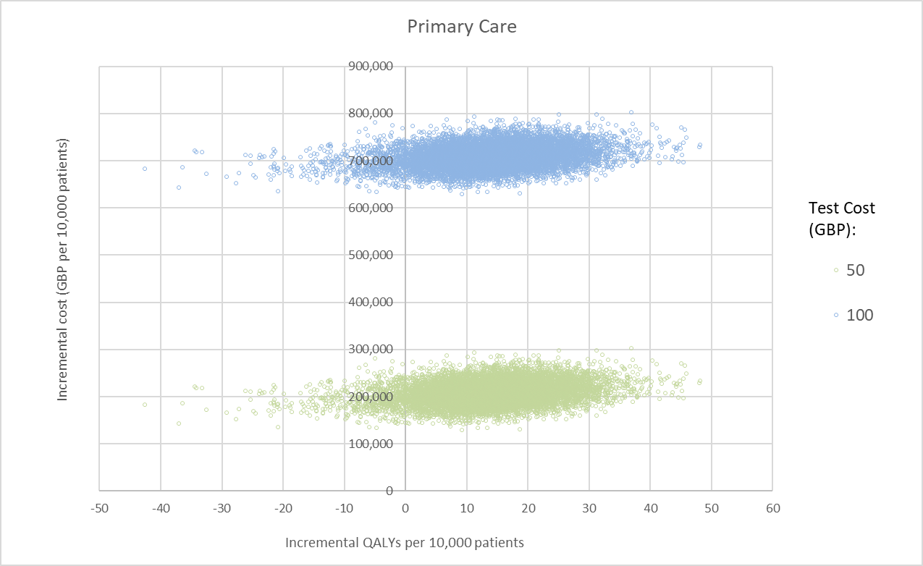

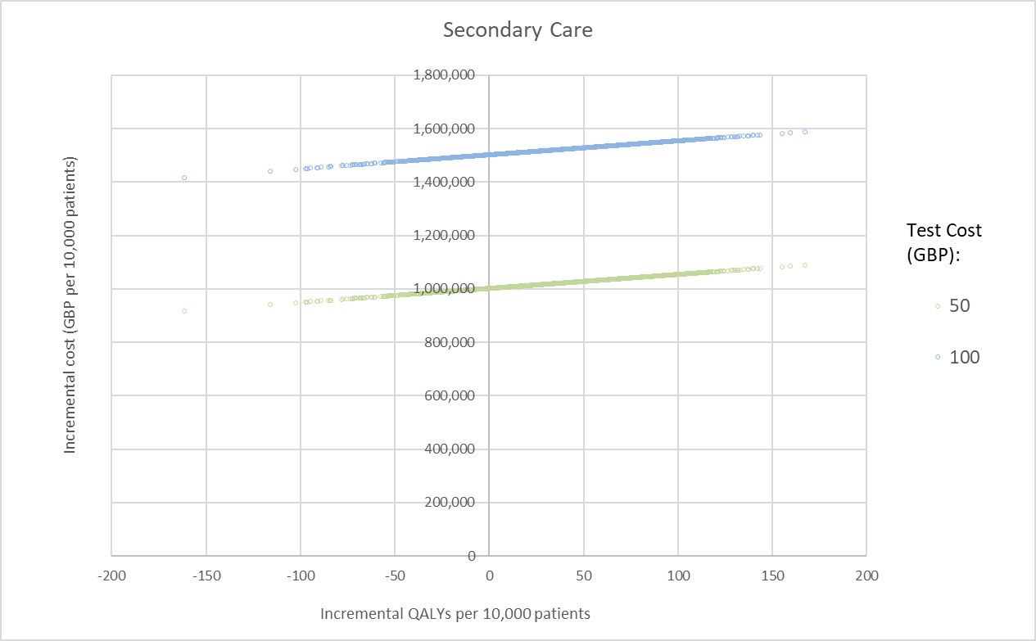

Note: Relative lack of variation in costs in the secondary care scenario occurs because all patients receive imaging regardless of liquid biopsy test result. Fast-track and standard referral imaging have the same unit cost.

Figure SA - OWSA tumour type prevalence among cases, cost-consequences analysis

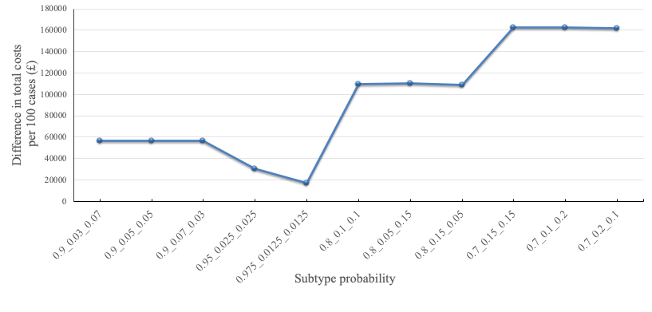

Tumour type probability: Probability of Glioblastoma, Primary Central Nervous System Lymphoma and Metastatic Cancer, ordered from high to low on probability of Glioblastoma vs others

# References

1. Gray E, Butler HJ, Board R, Brennan PM, Chalmers AJ, Dawson T, et al. Health economic evaluation of a serum-based blood test for brain tumour diagnosis: Exploration of two clinical scenarios. BMJ Open. 2018 May 1;8(5).

2. Clarke CE, Edwards J, Nicholl DJ, Sivaguru A. Imaging results in a consecutive series of 530 new patients in the Birmingham Headache Service. J Neurol. 2010;

3. Sempere AP, Porta-Etessama J, Medrano V, Garcia-Morales I, Concepcións L, Ramos A, et al. Neuroimaging in the evaluation of patients with non-acute headache. Cephalalgia. 2005;

4. Do V, Gebski V, Barton MB. The effect of waiting for radiotherapy for grade III/IV gliomas. Radiother Oncol. 2000;57(2):131–6.

5. Aggarwal A, Herz N, Campbell P, Arkush L, Short S, Rees J. Diagnostic delay and survival in high-grade gliomas - Evidence of the “waiting time paradox”? Br J Neurosurg. 2015;29(4):520–3.

6. Garside R, Pitt M, Anderson R, Dyer G, Mealing S, Somerville M, et al. The effectiveness and cost-effectiveness of carmustine implants and temozolomide for the treatment of newly diagnosed high-grade glioma: A systematic review and economic evaluation. Health Technology Assessment. 2007.

7. Cameron JM, Butler HJ, Smith BR, Hegarty MG, Jenkinson MD, Syed K, et al. Developing infrared spectroscopic detection for stratifying brain tumour patients: Glioblastoma multiforme: Vs. lymphoma. Analyst. 2019;144(22):6736–50.

8. Haldorsen IS, Aarseth JH, Hollender A, Larsen JL, Espeland A, Mella O. Incidence, clinical features, treatment and outcome of primary central nervous system lymphoma in Norway: A ten-year national survey. Acta Oncol (Madr). 2004;43(6):520–9.