Supplementary material

Supplementary Fig. 1: Modelled survival curves

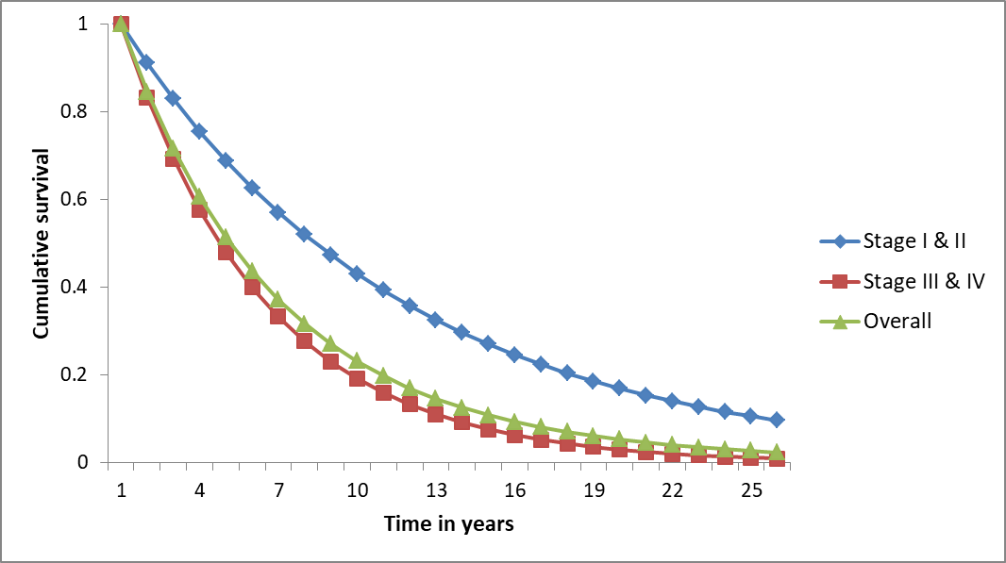

Supplementary Fig. 2: Cost effectiveness acceptability curves

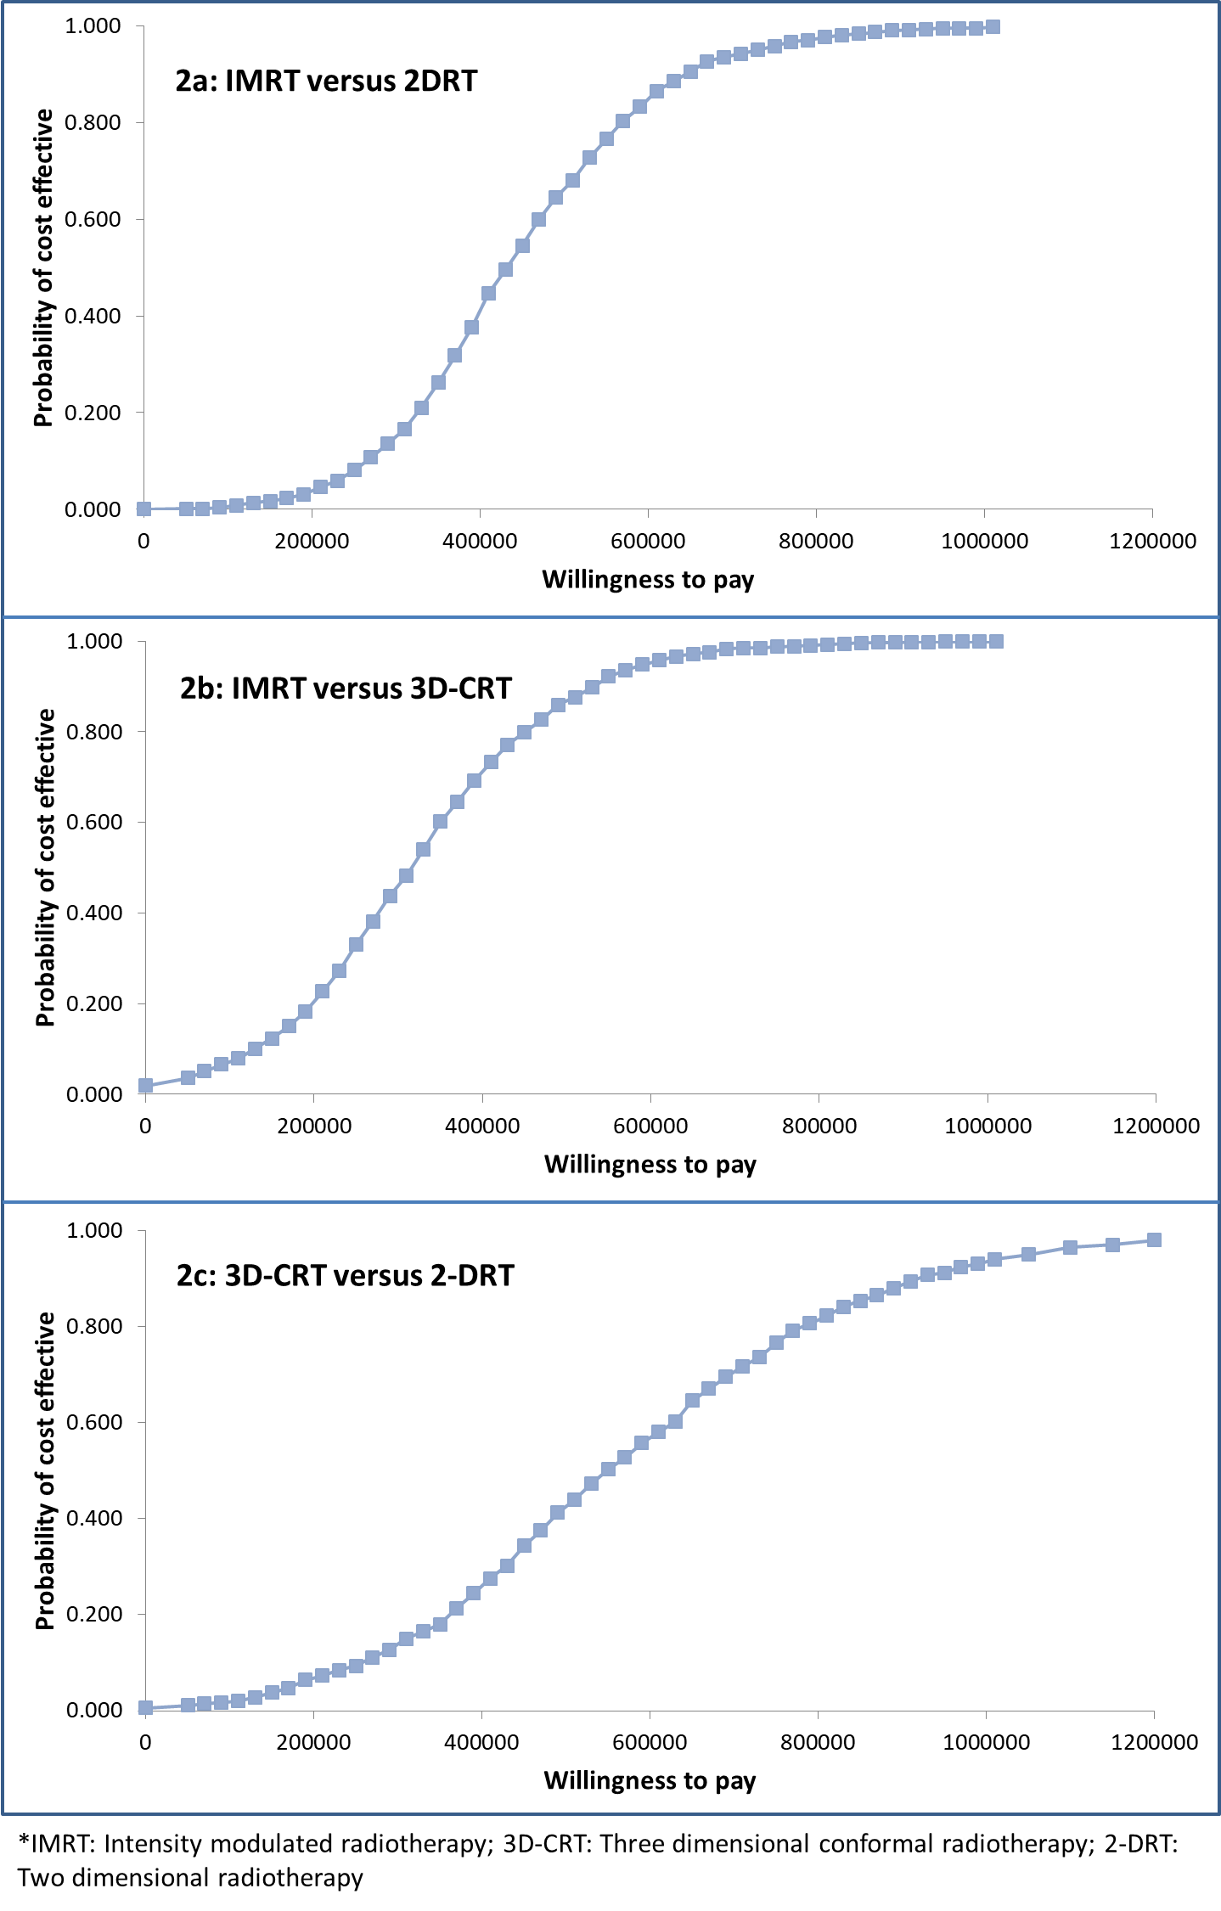
Supplementary Fig. 3: Tornado diagram showing sensitivity of ICER to various input parameter values used in model comparing IMRT versus 2-DRT

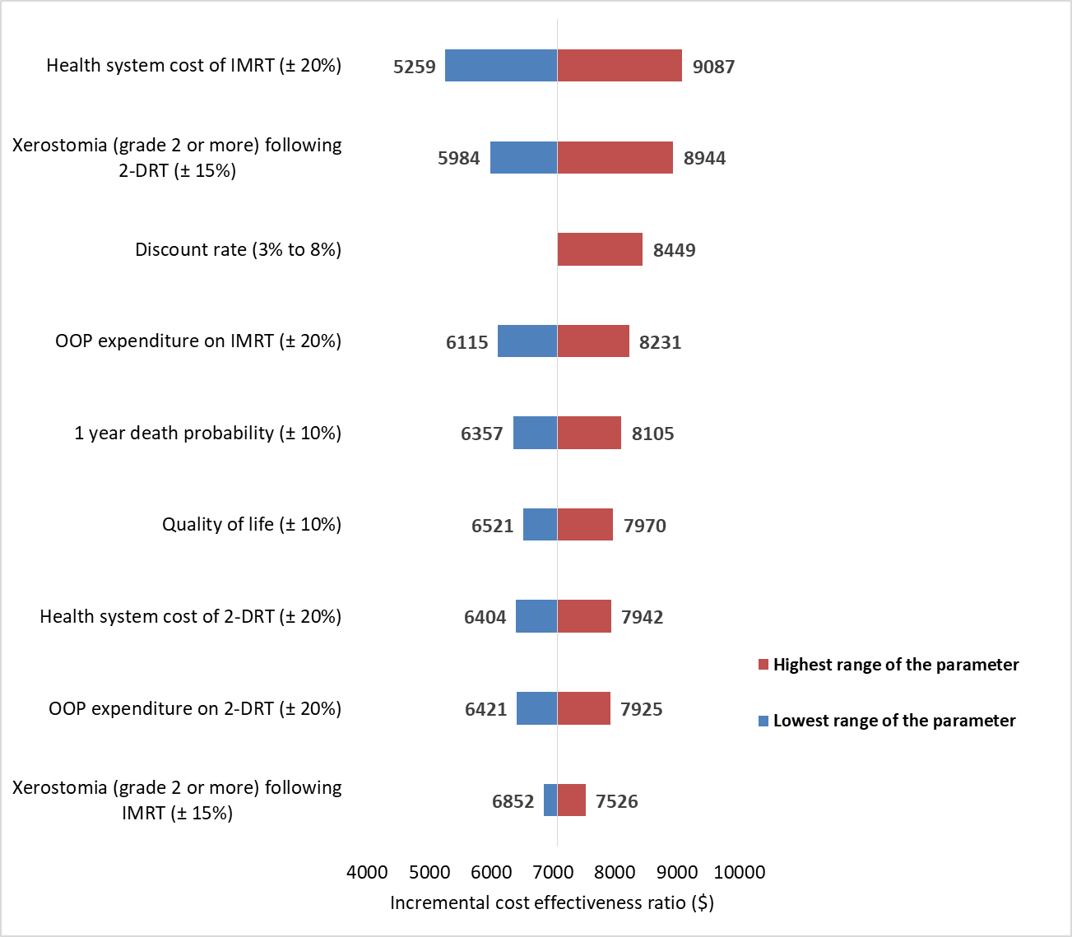
*Values in parenthesis shows the range by which input parameter was varied; IMRT: Intensity modulated radiotherapy; 2-DRT: 2 dimensional radiotherapy; OOP: Out of pocket expenditure; ICER: Incremental cost effectiveness ratio

Supplementary Fig. 4: Tornado diagram showing sensitivity of ICER to various input parameter values used in model comparing 3D-CRT versus 2-DRT

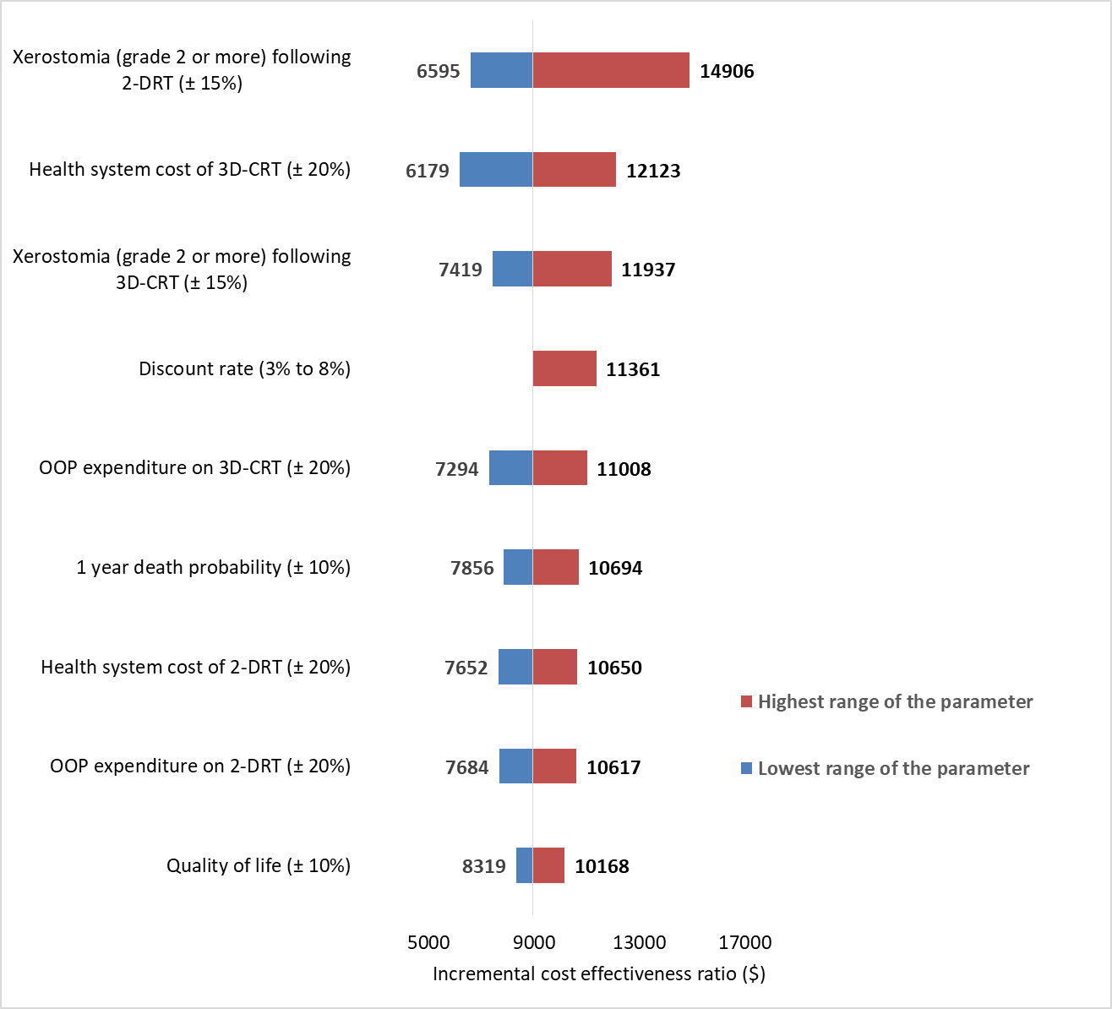
* Values in parenthesis shows the range by which input parameter was varied; 3D-CRT: Three dimensional conformal radiotherapy; 2-DRT: 2 dimensional radiotherapy; OOP: Out of pocket expenditure; ICER: Incremental cost effectiveness ratio

Supplementary Fig. 5: Tornado diagram showing sensitivity of ICER to various input parameter values used in model comparing IMRT versus 3D-CRT
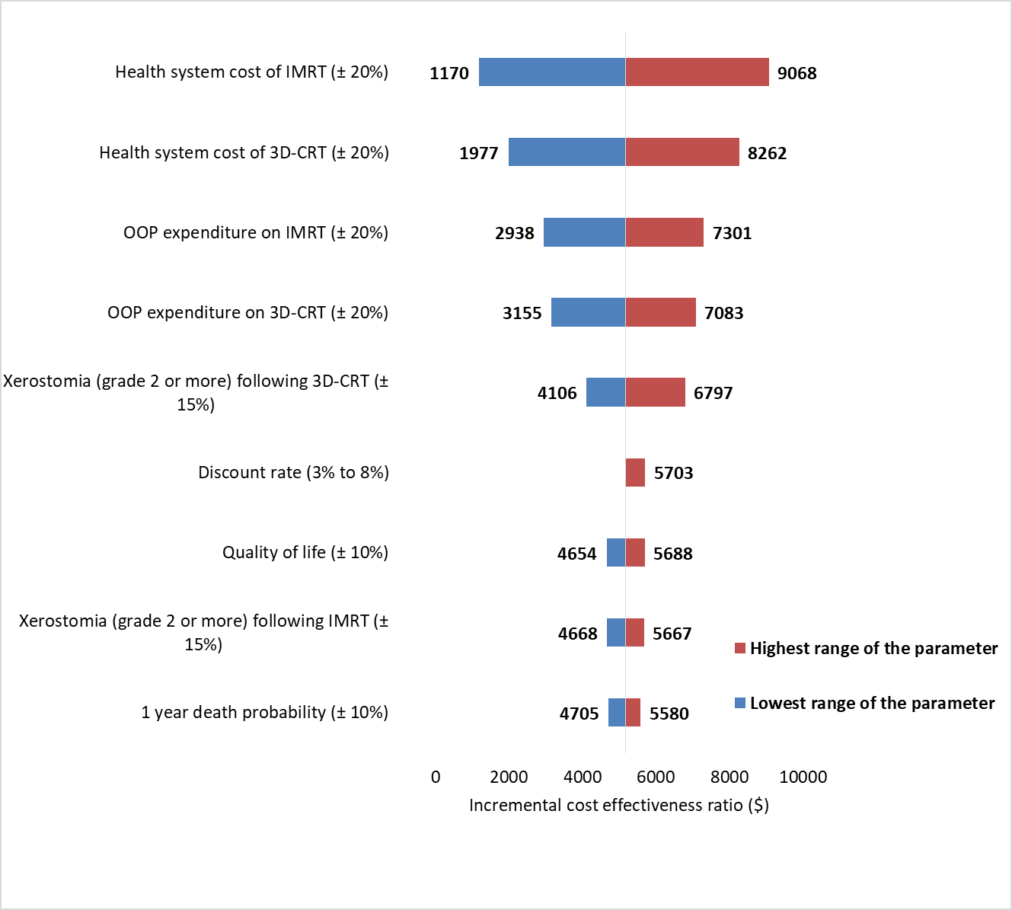

* Values in parenthesis shows the range by which input parameter was varied; 3D-CRT: Three dimensional conformal radiotherapy; IMRT: Intensity modulated radiotherapy; OOP: Out of pocket expenditure; ICER: Incremental cost effectiveness ratio

