APPENDIX
Focus groups’ selection strategy 2
Screening questionnaire 2
Data analysis 4
Codes 4
First order themes 6
Second order themes 15

Focus groups’ selection strategy

Screening questionnaire

SCREENING QUESTIONNAIRE
Interviewer: My name is “----” and I am calling to follow-up on a consent form we received indicating that you would like to be considered for a focus group on Health Technology Assessment. You will take part in a research study that is looking at how the public is involved in Health Technology Assessment decisions that may affect them. First, I would like to thank you for your interest in the project and ask you if you have any questions so far. Please feel free to stop me at any time if you are unclear about something or would like to ask a question.

Interviewer: As explained in the information letter, we are trying to select people who represent (province of origin) living in or around the (province) region. This means that we need a mix of males and females, and people from different age groups, income levels, educational backgrounds, and professions. We also need people who are unlikely to voice their views otherwise. Your answers to the questions that I will be asking you will help to make sure that we get things right! Please be aware that you do not have to answer any questions that you do not want to and you may stop the interview at any time. If it’s alright with you, I would like to begin now.

Questions | Answer
1. First of all, are you still willing and able to take part in the focus group, which will take place on (date, time, and local)? | If yes, proceed to question 2. If no, stop the interview.
2. Please state your postal code

3. How long have you lived at your current address?

4. Are you male or female?

5. Please tell me which one of the following age categories you fall into? Check off one of the boxes | 18 – 24 25 – 34 35 – 44  45 – 54 55 – 64 65 – 74  > 75
6. What do you consider to be your ethnic background (e.g., Asian, First Nations, etc.)?

7. What is the highest level of education you have completed? (check off one of the following boxes) | Less than high school  High school  Post-secondary diploma  University degree  Graduate degree  Other. Please specify:
8. Are you currently working for pay or for profit? Yes / No | If yes, go to question 10. If no, skip to question 13.
9. Which of the following best describes your work status? (check off one or more of the boxes) | Full-time Part-time  Seasonal Self-employed  On contract In a salaried position
10. To which of the following household income categories do you belong, before taxes and deductions: (check off one of the boxes) | < $20,000  $20,000 to $40,000  $40,000 to $60,000  $60,000 to $80,000  > $80,000
11. Is your current paid employment in the health care system (e.g., health care professional, administrator, support staff, etc.)? | Yes / No
12. Does any immediate member of your family work in health care? | Yes / No
13. Have you ever been associated with or a member of any patient group or society? | Yes / No
14. Do you work for a medical product or health care company? | Yes / No
Thank you for taking the time to answer these questions. When we have finished all of our interviews and selected the 10 participants, we will send you a letter stating whether or not we were able to include you. We plan to have these letters sent out within the next two weeks. In the meantime, if you have any questions or concerns, please feel free to contact me [insert telephone number].

Data analysis

Codes

Access 4 72
Accountability 3 28
Advertising 4 9
Advocacy 4 9
Agenda 4 37
Audit 4 17
Autonomy 3 6
Awareness 4 38
Background 4 26
Balance 4 50
Bias 4 48
Bureaucrats 4 24
Canada 2 9
Careful 4 108
Change 4 48
Check and balance 4 15
Choice 4 49
Civic duty 2 3
Committees or boards 4 41
Communication 4 40
Community 4 104
Complex 4 33
Conflict of interest 4 30
Connection 3 20
Consensus 3 8
Contentious 4 25
Context 4 170
Control 4 20
Convincing 2 3
Corruption 4 9
Costs 4 59
Courts - Justice 3 22
Criteria 4 30
Death 3 3
Decision making 4 118
Demand 2 2
Democracy 3 10
Demographics 4 8
Different regions 3 10
Difficult - Easy 4 93
Disagreement 4 25
Discrimination 3 7
Discussion 4 38
Diseases - conditions 4 35
Distortion 4 65
Diversity 4 39
Doubts 4 113
Education 4 47
Effort 4 63
Emotions 4 30
Engagement 4 83
Ethics 3 6
Evaluation 4 19
Experience 4 67
Experts 4 39
Feedback 4 95
Flexibility 4 30
Focus 4 13
Fundraising 1 1
Government 4 54
Group mentality 2 8
Health 4 39
Health industry 4 19
Health services 3 27
Healthcare professionals 4 30
Healthcare system 4 46
HTA process 3 33
Humanitarian 3 3
Important 4 104
Improvement 4 84
Inclusion - exclusion 4 75
Independent 4 27
Individuals 4 72
Influence 4 68
Information 4 128
Innovation 4 13
Input 4 132
Intention 4 49
Interests 4 92
Internet 4 19
Knowledge 4 78
Leadership 3 8
Learning process 4 16
Limits 4 30
Listened or not listened to 4 23
Lobby group 3 12
Media 3 8
Medical devices 4 18
Medicines 4 29
Middle ground 3 7
Missing something 4 31
Money 4 70
Monitoring 2 9
Objective - subjective 4 62
Older people 4 10
Opportunity 4 64
Other countries 4 20
Other stakeholders 0 0
Patient involvement 4 13
Patient organizations 1 2
Patients 4 32
Perceptions 4 110
Policies 2 8
Politics 3 19
Priorities 4 92
Private health insurance 1 2
Privatization 2 3
Proactive - reactive 4 10
Problematic 4 118
Processes 4 122
Professional 4 17
Promotion 4 19
Provinces 4 15
Public 4 166
Public involvement 4 156
Quality of life 3 12
Question 4 72
Random 3 13
Red tape 3 10
Relationships 2 3
Religion 2 3
Report 4 12
Representation 4 32
Research issues 4 54
Researchers 4 17
Responsibility 4 37
Results - outcomes 4 31
Rights 4 17
Saving lives 4 9
Security 2 3
Seriousness 2 5
Skills 4 8
Slowdown 3 5
Small versus large 4 24
Social media 3 5
Stages 2 12
Statistics 3 9
Strategy 4 83
Taxes 4 8
Technology 3 11
Third party 3 4
Time 4 40
Timelines 4 13
Transparency 4 8
Treatment (medical) 4 34
Trust 4 42
Uncertainty 4 85
Understand 4 102
Utilitarianism 3 9
Values 4 83
Variation 4 135
Volunteer 4 5
Waste 4 16
Work 4 13
Young people 3 7

First order themes
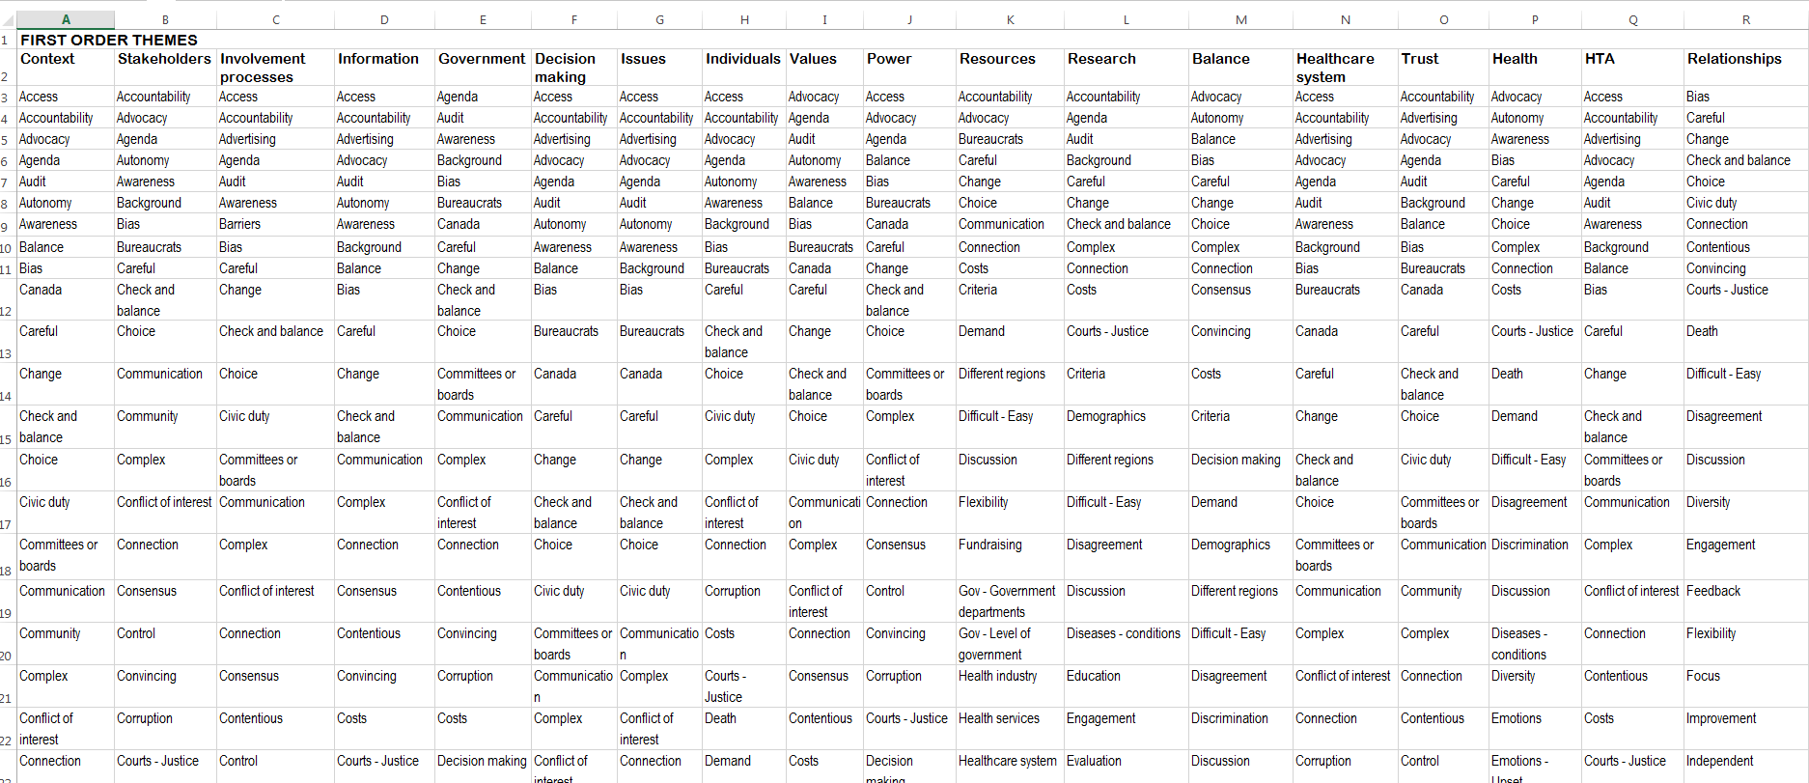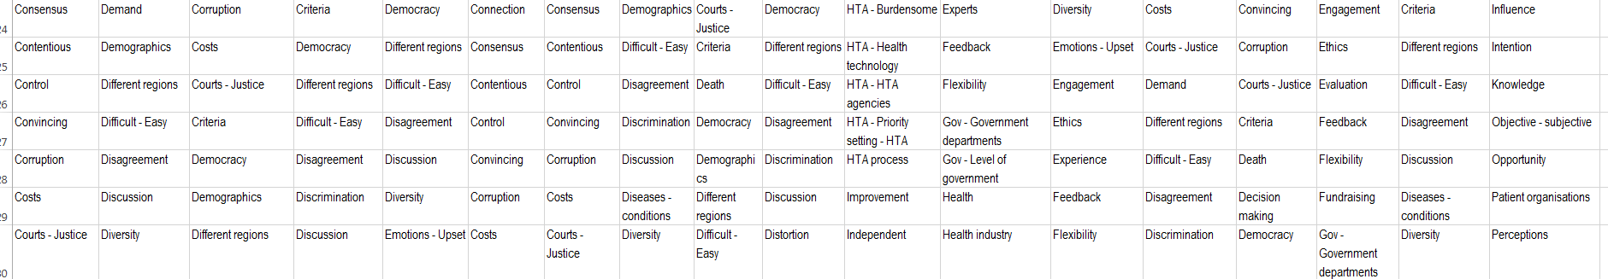

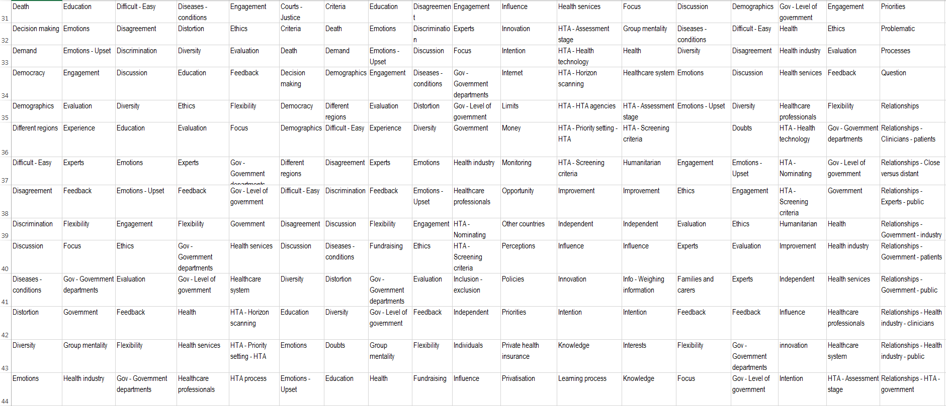
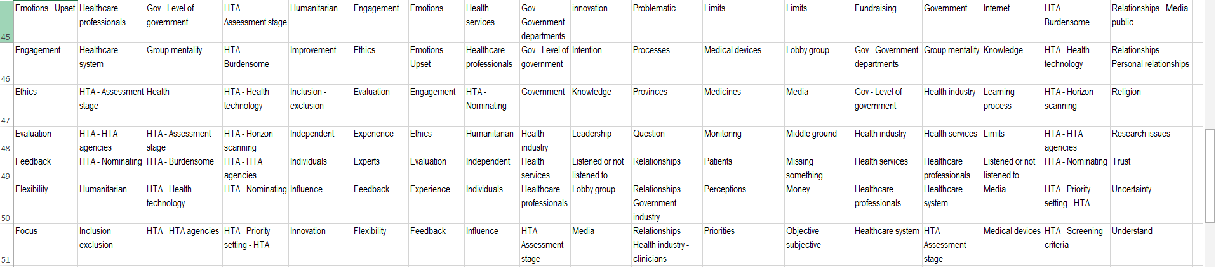
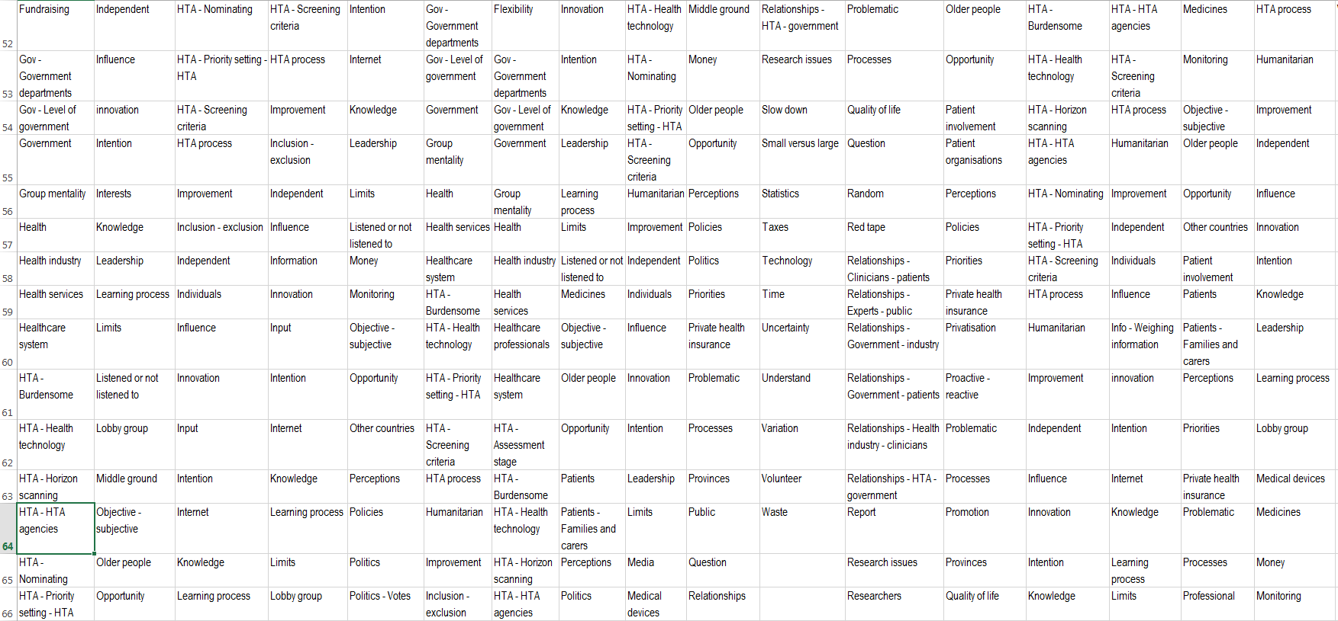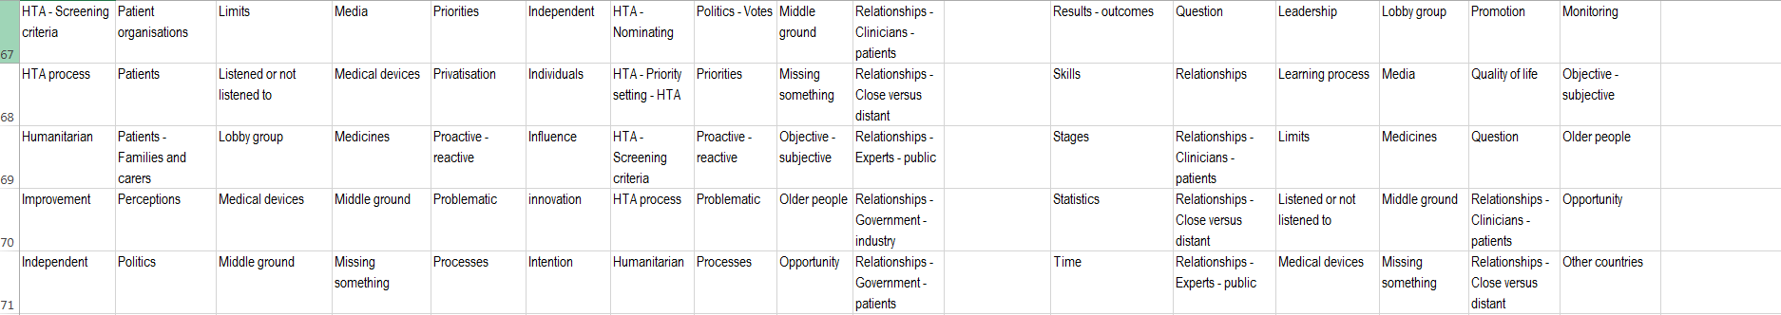

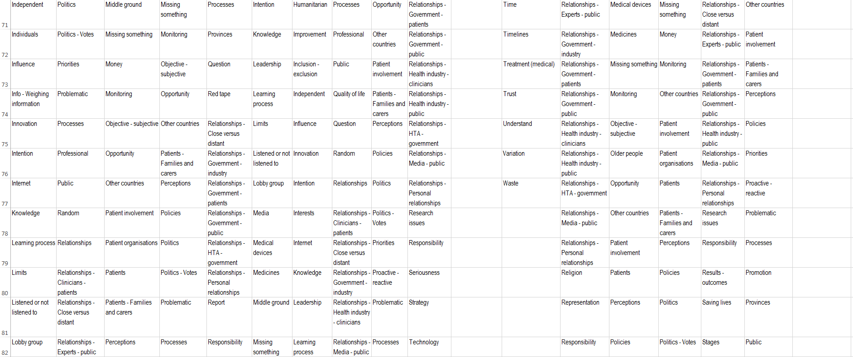
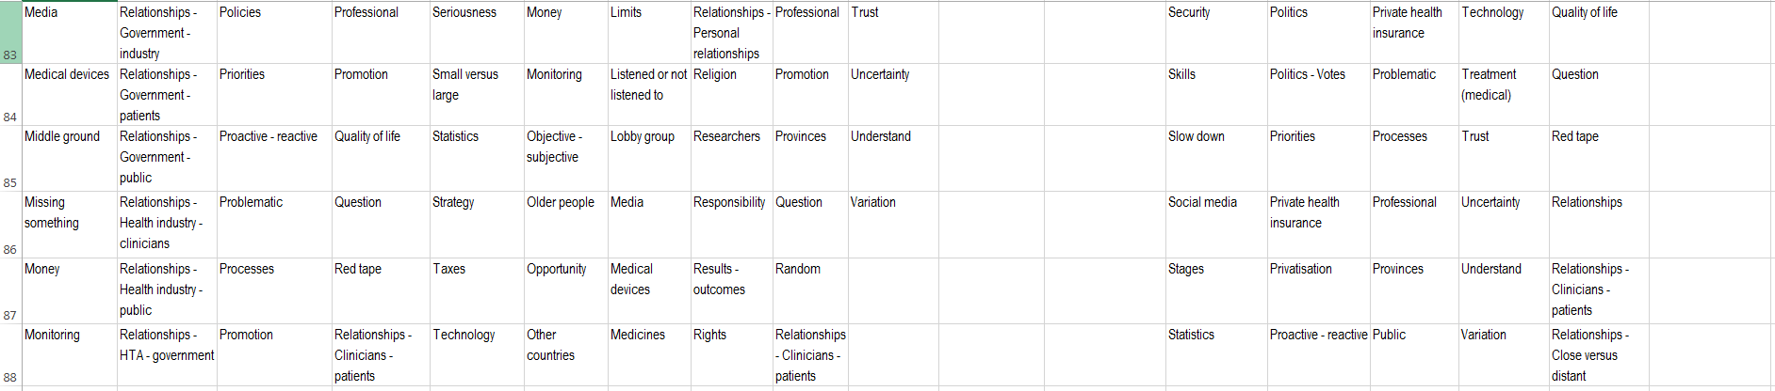

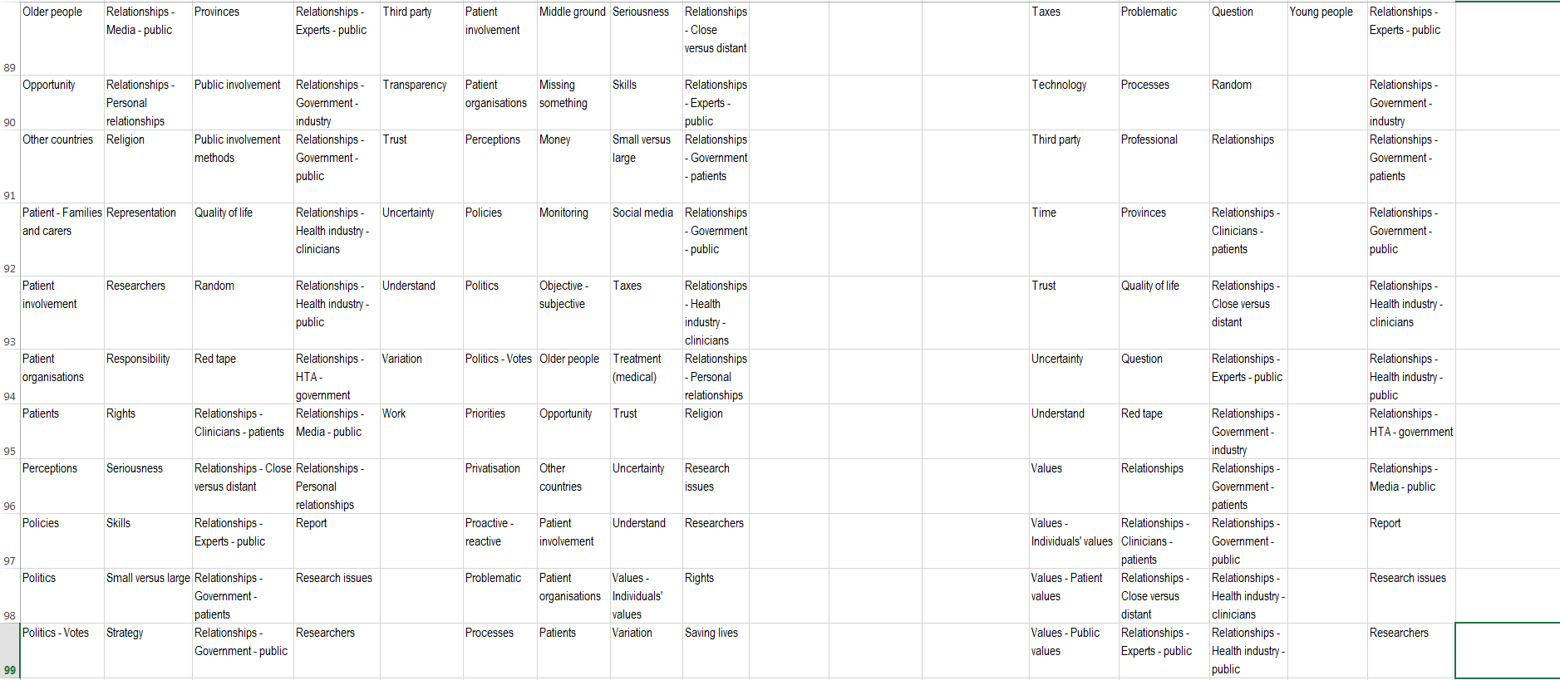
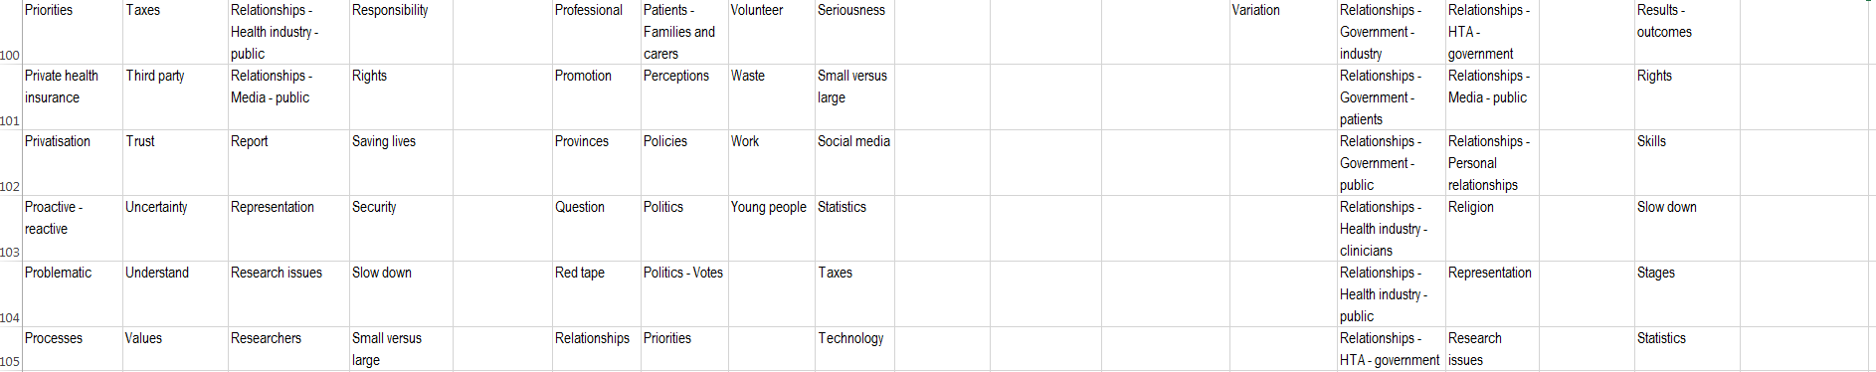

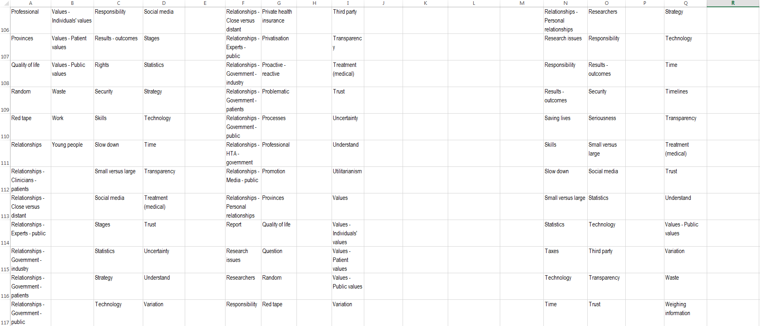
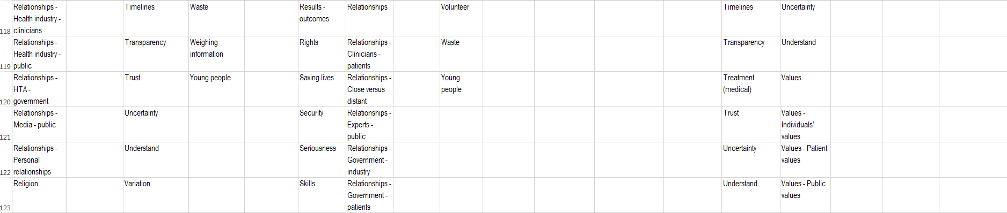

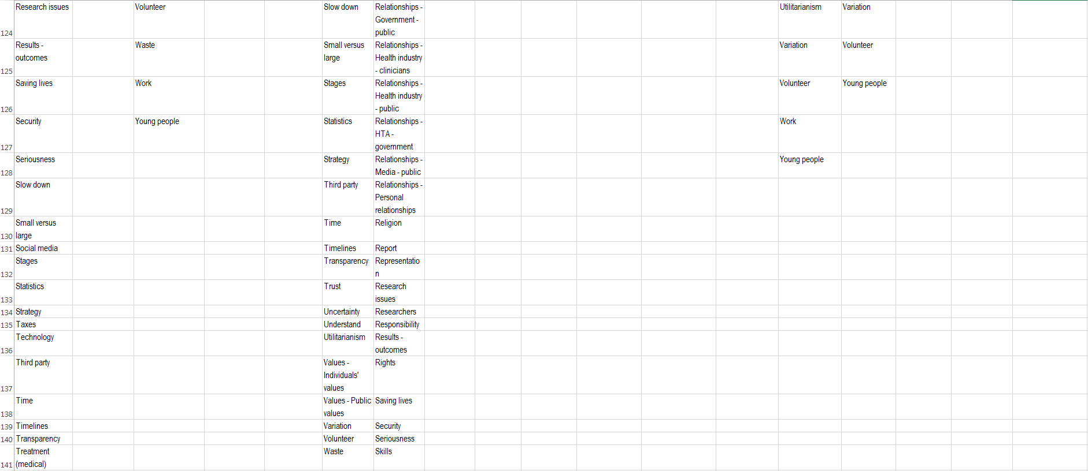
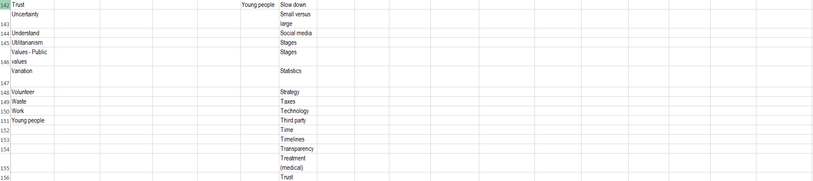

Second order themes
