**Projecting effectiveness after ending a randomized controlled trial: A two-state Markov micro-simulation model**

F. Yuan et al.

Supplementary Appendix

Supplementary Figures 3

Figure S1: Demonstration of nine subjects’ in-trial experience prior to the post-trial projection 3

Figure S2: Illustration of results of projection from 200 simulations 4

Figure S3: The post-trial projection of a participant in a simulation 5

5

Figure S4: Scenario C: with post-trial study medication and in-trial events: Distribution of projected life-year-gained from 200 simulations for 16 sub-experiments 6

Figure S5: Projected life-year-gained and 95% confidence interval (over 200 simulations) in sixteen sub-experiments under three scenarios: A) No post-trial study medications and in-trial events; B) No post-trial study medications but with in-trial events; C) With both post-trial study medications and in-trial events. 7

Figure S6: Projection of life expectancy on all-cause mortality by factors 9

Figure S7: Scenario C: with both in-trial events and post-trial study medication: ANOVA analysis (Life-year-gained (in days) ~ age correction +Cycle + background probability): check assumptions 10

Supplementary Tables 11

Table S1: A $2×4×2$ three-factor factorial design table with sub-experiments in “ascending order” 11

Table S2: Scenario C: with post-trial study medication and in-trial events: Descriptive statistics of distributions of projected life-year-gained in days from 200 simulations for 16 sub-experiments 12

Table S3: Projected life-expectancy (averaged over 200 simulations) in sixteen sub-experiments under three scenarios: A) No post-trial study medications and in-trial events; B) No post-trial study medications but with in-trial events; and C) With post-trial study medications and in-trial events 13

Table S4: Project life-year-gained and 95% confidence interval (over 200 simulations) in sixteen sub-experiments under three scenarios 14

Table S5: Input parameters of the Markov model 16

Table S6: Outline of steps of the analysis 18

Table S7: The comparison of times consumed by 15-year post-trial projection1 with various simulated cohorts and cycle lengths (in minutes) in our computing environment2 19

# **Supplementary** Figures

## ***Figure S***1: Demonstration of nine subjects’ in-trial experience prior to the post-trial projection

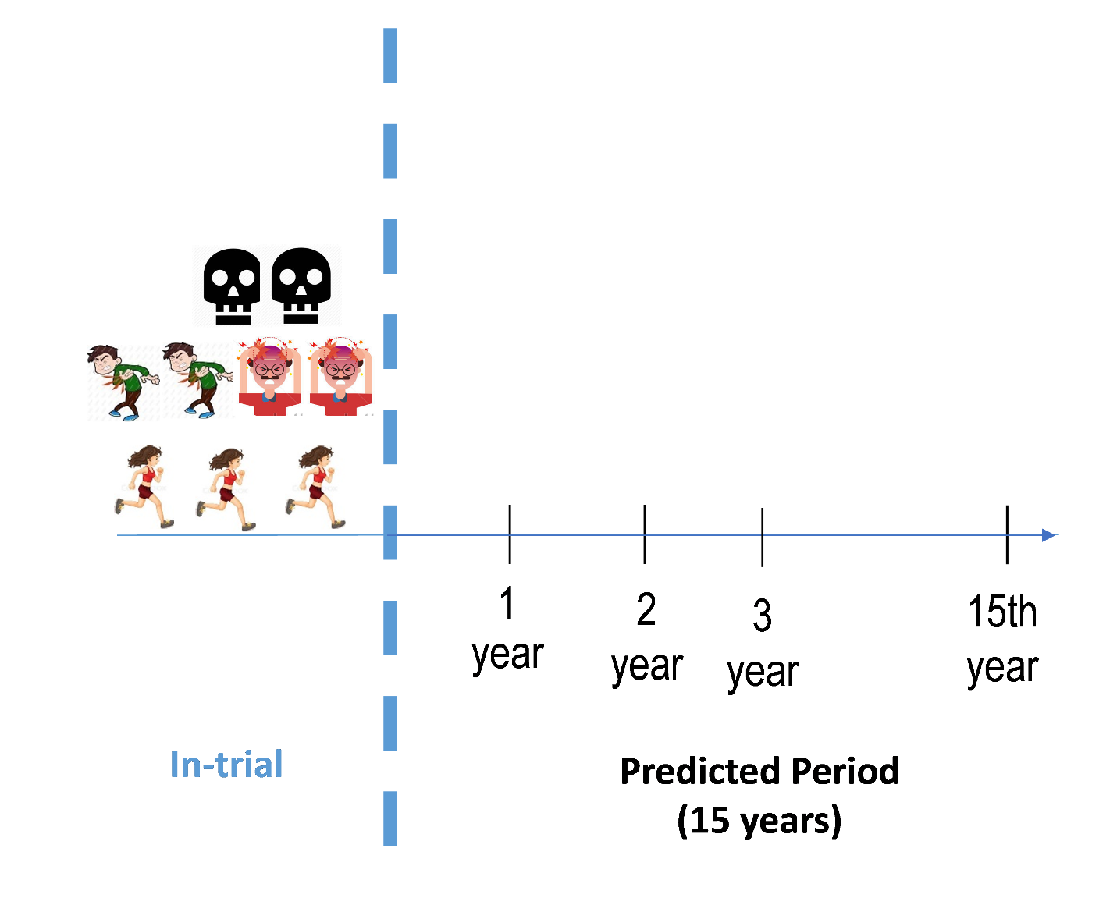

Icons for various diseases are obtained from online pictures.

: symbolizes a death, : symbolizes a myocardial infarction (MI), : symbolizes a stroke, : symbolizes an event-free participant

## ***Figure S2***: Illustration of results of projection from 200 simulations



Note: Icons for various diseases are obtained from online pictures.

## ***Figure S3: The post-trial projection of a participant in a simulation***

In-trial Myocardial Infarction (MI)?

Yes

Yes

No

No

No

## 

Yes

Adjust background probabilities by the effect of MI

Yes

Adjust background probabilities by the effect of Riva+ASA

Yes

Adjust background probabilities by the effect of major bleeding

In-trial stroke?

Yes

Adjust background probabilities by the effect of stroke

No

In-trial major bleed?

In-trial Riva + ASA ?

Survived after a cycle of projection?

Projection reaches 15 year

No, projected for next cycle

No

## Figure S4: Scenario C: with post-trial study medication and in-trial events: Distribution of projected life-year-gained from 200 simulations for 16 sub-experiments



M = Monthly, Q = Quarterly, S = Semi-annually, A = Annually, U = age-uncorrected, C = age-corrected. The indexes of sub-experiments follow the Table S1. For a distribution of RMSTs, the white dots are median. The thick black bars and thin lines are interquartile ranges and the rest of the distribution. On either side of a bar, there is a kernel density estimation that shows the shape of the data.

## Figure S5: Projected life-year-gained and 95% confidence interval (over 200 simulations) in sixteen sub-experiments under three scenarios: A) No post-trial study medications and in-trial events; B) No post-trial study medications but with in-trial events; C) With both post-trial study medications and in-trial events.



There are 16 sub-experiments: 1) Life table, monthly, age-uncorrected, 2) Life table, monthly, age-corrected, 3) Life table, quarterly, age-uncorrected, 4) Life table, quarterly, age-corrected, 5) Life table, semi-annually, age-uncorrected, 6) Life table, semi-annually, age-corrected, 7) Life table, annually, age-uncorrected, 8) Life table, annually, age-corrected, 9) REACH 20-mo, monthly, age-uncorrected, 10) REACH 20-mo, monthly, age-corrected, 11) REACH 20-mo, quarterly, age-uncorrected, 12) REACH 20-mo, quarterly, age-corrected, 13) REACH 20-mo, semi-annually, age-uncorrected, 14) REACH 20-mo, semi-annually, age-corrected, 15) REACH 20-mo, annually, age-uncorrected, 16) REACH 20-mo, annually, age-corrected.

## Figure S6: Projection of life expectancy on all-cause mortality by factors



REACH 20-mo risk: probabilities of death based on REACH 20-month risk; R + A: the intervention group of rivaroxaban 2.5 twice daily plus aspirin 100mg once daily; ASA: the control group of aspirin 100mg once daily. This graph considers the impact of post-trial medication or that of in-trial events (non-fatal MI, ischemic stroke, and ISH major bleeding). Projections using the USA Life Table as underlying death probability had higher projections than using the REACH-based-probabilities. Without the half-a-cycle age correction, projections did not vary much with cycle length. Annual cycle was much higher than the other cycles.

## Figure S7: Scenario C: with both in-trial events and post-trial study medication: ANOVA analysis (Life-year-gained (in days) ~ age correction +Cycle + background probability): check assumptions



## Supplementary Tables

## Table S1: A $2×4×2$ three-factor factorial design table with sub-experiments in “ascending order”

|  |  |  |  |
| --- | --- | --- | --- |
| Sub-experiments | Background probability of death:  (0: a 2013 USA life table, 1: modified REACH Registry 20-month risks based probabilities) | Four lengths of cycle:  (0: monthly,  1: quarterly,  2: semi-annually,  3: annually) | Half-a-cycle correction on age:  (0: without correction,  1: with correction) |
| 1 | 0 | 0 | 0 |
| 2 | 0 | 0 | 1 |
| 3 | 0 | 1 | 0 |
| 4 | 0 | 1 | 1 |
| 5 | 0 | 2 | 0 |
| 6 | 0 | 2 | 1 |
| 7 | 0 | 3 | 0 |
| 8 | 0 | 3 | 1 |
| 9 | 1 | 0 | 0 |
| 10 | 1 | 0 | 1 |
| 11 | 1 | 1 | 0 |
| 12 | 1 | 1 | 1 |
| 13 | 1 | 2 | 0 |
| 14 | 1 | 2 | 1 |
| 15 | 1 | 3 | 0 |
| 16 | 1 | 3 | 1 |

## Table S2: Scenario C: with post-trial study medication and in-trial events: Descriptive statistics of distributions of projected life-year-gained in days from 200 simulations for 16 sub-experiments

|  |  |  |  |  |  |  |  |  |  |
| --- | --- | --- | --- | --- | --- | --- | --- | --- | --- |
|  | Mean | SD | Min | Max | 25%  Percentile | Median | 75%  Percentile | Skewness | Kurtosis |
| 1) Life table, monthly, age-uncorrected | 234.5 | 22.3 | 169.9 | 295.3 | 218.5 | 236.1 | 248.3 | -0.14 | -0.14 |
| 2) Life table, monthly, age corrected | 230.5 | 23.4 | 167.7 | 292.4 | 214.2 | 230.4 | 246.9 | -0.07 | -0.2 |
| 3) Life table, quarterly, age-uncorrected | 233.8 | 25.1 | 169.1 | 302.9 | 215.1 | 232.7 | 250.8 | 0.2 | -0.21 |
| 4) Life table, quarterly, age-corrected | 230.1 | 19.2 | 183.4 | 274.9 | 217.6 | 229.9 | 244.2 | -0.12 | -0.38 |
| 5) Life table, semi-annually, age-uncorrected | 232.8 | 20.4 | 180.1 | 281.7 | 217.9 | 232.5 | 246 | 0.03 | -0.45 |
| 6) Life table, semi-annually, age-corrected | 225.4 | 22.1 | 149.8 | 294.7 | 210.8 | 225 | 240.3 | -0.08 | 0.49 |
| 7) Life table, annually, age-uncorrected | 224.7 | 21.5 | 165.2 | 281 | 210 | 226.6 | 240.9 | -0.18 | -0.47 |
| 8) Life table, annually, age-corrected | 211.1 | 19.2 | 160.8 | 265.1 | 197.9 | 210.3 | 224 | 0.13 | -0.06 |
| 9) REACH 20-mo, monthly, age-uncorrected | 273.2 | 25.4 | 182.3 | 338.4 | 256.9 | 273.8 | 291.4 | -0.25 | -0.06 |
| 10) REACH 20-mo, monthly, age-corrected | 270.7 | 26.6 | 204.6 | 353.2 | 255.2 | 268 | 289.6 | 0.19 | -0.01 |
| 11) REACH 20-mo, quarterly, age-uncorrected | 273.4 | 23.9 | 191.7 | 334.1 | 259.2 | 274.8 | 286.6 | -0.19 | 0.38 |
| 12) REACH 20-mo, quarterly, age-corrected | 269.8 | 23.8 | 205.9 | 335.3 | 253.6 | 271.3 | 284.6 | 0.05 | -0.06 |
| 13) REACH 20-mo, semi-annually, age-uncorrected | 271 | 23.5 | 216.6 | 333.8 | 255.8 | 267.9 | 288.4 | 0.16 | -0.51 |
| 14) REACH 20-mo, semi-annually, age-corrected | 267.2 | 24 | 192.8 | 328.6 | 254.1 | 267.1 | 284.1 | -0.15 | 0.09 |
| 15) REACH 20-mo, annually, age-uncorrected | 268.1 | 22.8 | 201.4 | 331.5 | 252.5 | 267.5 | 284.6 | -0.14 | -0.18 |
| 16) REACH 20-mo, annually, age-corrected | 259.5 | 21.3 | 184.2 | 320 | 247.2 | 257.2 | 272.3 | 0.13 | 0.64 |

## Table S3: Projected life-expectancy (averaged over 200 simulations) in sixteen sub-experiments under three scenarios: A) No post-trial study medications and in-trial events; B) No post-trial study medications but with in-trial events; and C) With post-trial study medications and in-trial events

|  |  |  |  |  |  |  |
| --- | --- | --- | --- | --- | --- | --- |
| Scenarios  Projected  life-expectancy  (RMST) in days  Sub-experiments | A) No post-trial study medications and in-trial events | | B) No post-trial study medications but with in-trial events | | C) With both post-trial study medications and in-trial events | |
| Intervention versus  standard care | | Intervention  versus  standard care | | Intervention versus  standard care | |
|  | Riva + ASA | ASA | Riva + ASA | ASA | Riva + ASA | ASA |
| 1) Life table, monthly, age-uncorrected | 4867.4 | 4814 | 4833.9 | 4773 | 5007.4 | 4772.9 |
| 2) Life table, monthly, age corrected | 4879.7 | 4830.5 | 4848 | 4787.3 | 5019.6 | 4789.1 |
| 3) Life table, quarterly, age-uncorrected | 4888.6 | 4835.5 | 4854.9 | 4796 | 5028.6 | 4794.8 |
| 4) Life table, quarterly, age-corrected | 4929.5 | 4877.2 | 4897.9 | 4838.5 | 5066.4 | 4836.2 |
| 5) Life table, semi-annually, age-uncorrected | 4918 | 4865.4 | 4885.5 | 4825.2 | 5058.1 | 4825.3 |
| 6) Life table, semi-annually, age-corrected | 5002 | 4949.6 | 4970.9 | 4908.2 | 5133.5 | 4908.1 |
| 7) Life table, annually, age-uncorrected | 4979.6 | 4925.9 | 4947.9 | 4887 | 511.7 | 4887 |
| 8) Life table, annually, age-corrected | 5138.6 | 5082.5 | 5106.4 | 5046.7 | 5256.1 | 5045.1 |
| 9) REACH 20-mo, monthly, age-uncorrected | 4453.9 | 4407.7 | 4416.8 | 4362.4 | 4634.4 | 4361.2 |
| 10) REACH 20-mo, monthly, age-corrected | 4463.2 | 4415.9 | 4428.6 | 4370.1 | 4642.5 | 4371.8 |
| 11) REACH 20-mo, quarterly, age-uncorrected | 4467 | 4421 | 4430.1 | 4373.7 | 4647.2 | 4373.8 |
| 12) REACH 20-mo, quarterly, age-corrected | 4493 | 4444.5 | 4456.1 | 4398.8 | 4668.3 | 4398.5 |
| 13) REACH 20-mo, semi-annually, age-uncorrected | 4485.3 | 4437.3 | 4449.9 | 4393.9 | 4663.6 | 4392.6 |
| 14) REACH 20-mo, semi-annually, age-corrected | 4534.6 | 4486.5 | 4500 | 4443 | 4709.3 | 4442 |
| 15) REACH 20-mo, annually, age-uncorrected | 4520.9 | 4473.8 | 4484.8 | 4428.9 | 4696.9 | 4428.8 |
| 16) REACH 20-mo, annually, age-corrected | 4624.5 | 4573 | 4586.7 | 4527.9 | 4789.4 | 4529.9 |

## Table S4: Project life-year-gained and 95% confidence interval (over 200 simulations) in sixteen sub-experiments under three scenarios

|  |  |  |  |
| --- | --- | --- | --- |
| Scenarios Projected  life-year-gained  (in days)  Sub-experiments | A) No post-trial study medications and in-trial events | B) No post-trial study medications but with in-trial events | C) With both post-trial study medications and in-trial events |
| 1) Life table, monthly, age-uncorrected | 53.4 (9.6, 97.2) | 60.9 (18.1, 103.8) | 234.5 (190.8, 278.2) |
| 2) Life table, monthly, age corrected | 49.4 (6.6, 92.3) | 60.7 (14.4, 106.9) | 230.5 (184.5, 276.4) |
| 3) Life table, quarterly, age-uncorrected | 53.1 (11.9, 94.3) | 58.9 (12.7, 105.2) | 233.9 (184.7, 283.0) |
| 4) Life table, quarterly, age-corrected | 52.3 (8.0, 96.7) | 59.4 (16.1, 102.7) | 230.1 (192.5, 267.7) |
| 5) Life table, semi-annually, age-uncorrected | 52.6 (10.3, 94.9) | 60.3 (22.2, 98.3) | 232.8(192.8, 272.8) |
| 6) Life table, semi-annually, age-corrected | 52.4 (13.6, 91.1) | 62.7 (22.8, 102.6) | 225.4 (182.0, 268.9) |
| 7) Life table, annually, age-uncorrected | 53.7 (12.9, 94.5) | 60.9 (17.1, 104.7) | 224.7 (182.6, 266.8) |
| 8) Life table, annually, age-corrected | 56.1 (20.0, 92.2) | 59.7(21.8, 97.6) | 211.1 (173.4, 248.8) |
| 9) REACH 20-mo, monthly, age-uncorrected | 46.2(-2.6, 95.1 ) | 54.3 (3.7, 105.0) | 273.2 (223.4 ,323.0) |
| 10) REACH 20-mo, monthly, age-corrected | 47.3 (-3.5, 98.1) | 58.5 (10.7, 106.2) | 270.7 (218.6, 322.8) |
| 11) REACH 20-mo, quarterly, age-uncorrected | 46.1(-1, 93.1) | 56.4 (9.8, 102.9) | 273.4 (226.5, 320.3) |
| 12) REACH 20-mo, quarterly, age-corrected | 48.5 (3.7, 93.2) | 57.3 (10.9, 103.7) | 269.9 (223.2, 316.5) |
| 13) REACH 20-mo, semi-annually, age-uncorrected | 48.0 (-5.8, 101.7) | 56.0 (10.9, 101) | 271.0 (225.0, 317.1) |
| 14) REACH 20-mo, semi-annually, age-corrected | 48.1 (-0.3, 96.6) | 57.1 (12.3, 101.8) | 267.2 (220.2 ,314.2) |
| 15) REACH 20-mo, annually, age-uncorrected | 47.1 (4.2, 90.1) | 55.9 (14.4, 97.4) | 268.1 (223.4, 312.8) |
| 16) REACH 20-mo, annually, age-corrected | 51.5 (5.5, 97.6) | 58.7 (10.4, 107.1) | 259.5 (217.7, 301.3) |

An estimate of life-year-gained was the average of results from 200 simulations. The 95% confidence intervals of life-year-gained are calculated using mean and standard deviance.

## Table S5: Input parameters of the Markov model

|  |  |  |
| --- | --- | --- |
| Parameters | Explanation | Sources |
| Population | 18,278 patients | COMPASS trial (Eikelboom JW (2017)) |
| Comparison | * Rivaroxaban + aspirin group (The treatment under investigation in the COMPASS trial) * Aspirin group (the standard treatment in the COMPASS trial): | 9,152 COMPASS participants  9,126 COMPASS participants |
| Health states | Two states   * Death * Alive |  |
| Mean time horizon of projection | Totally 17 years   * In-trial :   rivaroxaban + ASA group: 1.95 years  ASA group: 1.94 years   * Post-trial :15 years |  |
| Transition probabilities1 | * USA 2013 life table4 (Age- and sex-related) | Arias E et al (2017) |
| * REACH-20 month risk (Age-, sex- and baseline cardiovascular risk related) | Wilson PW et al (2012) |
| Cycle length2 | * Monthly * Quarterly * Semi-annually * Annually | They are generated in the Markov models and are compatible with the transition probabilities. |
| Age-correction3 | * With half-a-cycle correction * Without half-a-cycle correction | They are generated in the Markov models. |
| Effect of investigated treatment versus standard treatment | The hazard ratio and its 95% confidence interval: 0.76 (0.66-0.86) | COMPASS trial (Eikelboom JW (2017)) |
| Compliance during the post-trial projection | Assume a same compliance as that in the in-trial period. | COMPASS trial (Eikelboom JW (2017)) |
| Sensitivity analyses | Three scenarios:   * No adjustment * Without post-trial study medication but with in-trial events * With both post-trial study medication and in-trial events |  |

1,2 and 3 The various levels of the three items form the sixteen sub-experiments given in the Table S1. 4The 2013 USA life table was used because the COMPASS trial recruited patients from 2013 to 2016. Moreover, the manuscript started in 2017 when only 2013 USA life table was available. By comparing the 2017 versus 2013 USA life tables, males’ mortality probabilities in 2017 are less than 0.1% lower than those in 2013 for 90-year-old or older. Otherwise, both life tables are very similar to each other. Therefore, we do not expect difference occurring in our conclusion by replacing the 2013 USA life table with the 2017 one.

## Table S6: Outline of steps of the analysis

|  |  |  |
| --- | --- | --- |
| Steps | Software, packages and functions | Purpose |
| 1. Participant-wise micro simulation  (Multiple times of simulations) | SAS 9.4 | First determine how the model should run in terms of background probability, cycle length and correct-age-or not, number of years of post-trial projection. The projection can refer to Figure S3. Results of projection can be output into SAS data sets. |
| 2. Calculation of restricted mean survival time (RMST) | R 3.5.1, “survRM2” package,  and its function rmst2() | * Read the SAS data sets output from the step 1 into R 3.5.1. * For a simulation, we calculated average survival times and incremental survival of rivaroxaban plus aspirin versus aspirin groups for combined in-trial and post-trial years. The final incremental survivals were calculated on the average of simulations. * An example of R code:   library(survival)  library(survRM2)  # Get life-expectancy and life-year gained by estimating RMST for a scenario  rmst1<-rmst2(var.survtime, var.event.ind, dat$treatment)  est.arm1<-c(rmst1$RMST.arm1$result[1,1])  est.arm0<-c(rmst1$RMST.arm0$result[1,1])  arm1.arm0.diff<- est.arm1 - est.arm0 |
| 3. Analyze the effect of three factors on incremental survival | R 3.5.1 and its function “aov” | Investigate three factors (background probabilities, cycle lengths and correct-age-or-not) through a three-way ANOVA analysis. Assumptions are checked for the ANOVA models through a QQ plot, a residual plot and a predicted-values-versus-residual plot. |

## Table S7: The comparison of times consumed by 15-year post-trial projection1 with various simulated cohorts and cycle lengths (in minutes) in our computing environment2

|  |  |  |  |  |
| --- | --- | --- | --- | --- |
| Projection (with half-a-cycle  correction)  Required  Time (in minutes)  Simulated  Cohorts  (Number of participants) | Cycle lengths | | | |
| Monthly | Quarterly | Semi-Annual | Annual |
| 5000 | 3.3 | 1.7 | 1.2 | 1.0 |
| 10, 000 | 6.5 | 3.4 | 2.4 | 1.9 |
| 18,278 – COMPASS original data size | 12.1 | 6 | 4.5 | 3.6 |
| 50,000 – 3 times of the COMPASS original data size | 37.7 | 20.2 | 15.4 | 13.2 |
| 200,000– 11 times of the COMASS original data sets | 142.4 | 74.7 | 56.6 | 49.2 |

1 Projection with a half-a-cycle-age-correction, US life table, three scenarios. 2 Hardware: Dell R730 with a CPU of 32 processors, a 32GB memory, a 550GB local hard disk and 4300GB Network disk. Software: CentOS version 6.10 and SAS 9.4.