Supplementary Material

Supplementary Table 1. Decision data by country (sources)
Country | Institution/Database | Data source
England | NICE | HTA decisions from the NICE website
Scotland | SMC | HTA decisions from the SMC website
Sweden | TLV / NLT | HTA decisions from the TLV/NLT website. Validation from the TLV team.
Belgium | RIZIV INAMI | HTA decisions from the INAMI database (online). Validation of the data and information on Managed Entry Agreement (MEA) from the INAMI team.
Portugal | INFARMED | HTA decisions from INFARMED database (online). Information on the MEA from the INFARMED team.
Poland | AHTAPol | Database created by AHTAPol.
Spain | BOTPLUS | Database created by EASP and UCLM from BOTPLUS. Validation of data by GENESIS.
Germany | G-BA | HTA decisions from the G-BA website. Only decisions from 2011 onwards (AMNOG)
France | HAS/MoH | Database created by the UPEC.

NICE -National Institute for Health and Care Excellence; SMC - Scottish Medicine Consortium; TLV - The Dental and Pharmaceutical Benefits Agency, NLT - New pharmaceutical product therapies, RIZIV-INAMI - Belgium Health Insurance Agency; INFARMED - National Authority of Medicines and Health Products, IP; AHTAPol - Agency for Health Technology Assessment in Poland; EASP - Andalusian School of Public Health; UCLM - University of Castilla la Mancha; GENESIS - Spanish Society of Hospital Pharmacy; G-BA - Federal Joint Committee; AMNOG - Pharmaceuticals Market Reorganisation Act; HAS - French National Authority for Health; UPEC - University Paris-Est Créteil. Source: created by the author

Supplementary Table 2. Subgroup: percentage of agreement for 80 cancer drug-indications (2002-2014) – assessed by NICE and SMC

Agreement in HTA decisions (assessed drugs) | Spain | Germany | France | Sweden | Scotland | Portugal | Poland | England | Belgium
France | 89.83% (59) ¹ | 90% (10) |  | 73.33% (30) | 29.87% (77) | 88% (25) | 19.64% (56) | 41.56% (77) | 58.82% (68)
Germany | 77.78% (9) |  |  | 60% (10) | 54.55% (11) | 100% (4) | 0% (8) | 54.55% (11) | 62.50% (8)
Spain |  |  |  | 76.92% (26) | 22.95% (61) | 81.82% (22) | 19.15% (47) | 32.79% (61) | 60.38% (53)
Belgium |  |  |  | 74.07% (27) | 39.13% (69) | 66.67% (24) | 32.69% (52) | 42.03% (69)
England |  |  |  | 40% (30) | 63.75% (80) | 44% (25) | 44.64% (56)
Poland |  |  |  | 16% (25) | 42.86% (56) | 33.33% (24)
Portugal |  |  |  | 72.22% (18) | 36% (25)
Scotland |  |  |  | 36.67% (30)
Sweden
Notes: ¹ percentage of agreed decisions and in brackets, the total number of common assessed decisions in both countries.
>=75% | High Congruence | >=50% & <75% | Medium Congruence | <50% | Low Congruence

Supplementary Table 3. Subgroup: Kappa Score for 80 cancer drug-indications (2002-2014) – assessed by NICE and SMC

KAPPA SCORE | Spain | Germany | France | Sweden | Scotland | Portugal | Poland | England | Belgium
France | 0.2934*** | 0.0000 |  | -0.1009 | 0.0253 | 0.3644*** | 0.0210 | 0.0020 | 0.0211
Germany | 0.0000 |  |  | 0.0000 | 0.0000 | N.A. | 0.0000 | 0.0000 | 0.0000
Spain |  |  |  | 0.0311 | -0.0365 | 0.1619* | 0.0078 | -0.0606 | -0.0520
Belgium |  |  |  | 0.3483*** | 0.1127* | 0.2700** | 0.0319 | 0.0858
England |  |  |  | -0.0093 | 0.4661*** | 0.0331 | 0.2022***
Poland |  |  |  | -0.0214 | 0.0904 | 0.1616**
Portugal |  |  |  | -0.1111 | 0.0521
Scotland |  |  |  | -0.0270
Sweden
Notes: significance levels: *** p<0.01, ** p<0.05, * p<0.1

McHugh Threshold | Cohen Threshold | Kappa coefficient
No Agreement | No Agreement | ≤ 0.0
 | None to Slight | 0.01-0.20
Minimal Agreement | Fair Agreement | 0.21 - 0.39
Weak Agreement | Moderate Agreement | 0.4 - 0.59
Moderate Agreement | Substantial Agreement | 0.6 - 0.79
Strong Agreement | Almost Perfect Agreement | 0.8 – 0.9
Almost perfect Agreement | Almost Perfect Agreement | > 0.9

Supplementary Figure 1. Acceptance, restriction and rejection rate (2002-2014)

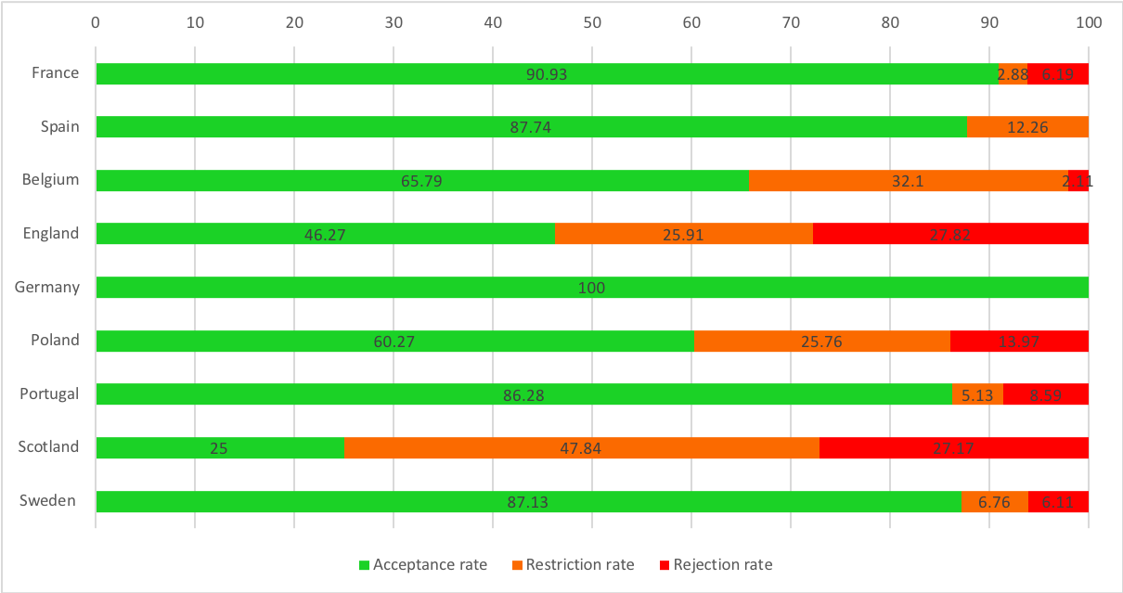
Source: ADVANCE-HTA dataset, created by the author

