SUPPLEMENTARY FILE 3
Supplementary Table and Figures

Supplementary Table 1. One-way deterministic sensitivity analysis result.
Parameter | Base Case ICER (QALY): $12,843 |  | Lower to Base Case ICER Range | Upper to Base Case ICER Range | Lower to Upper ICER Range
 | Lower ICER (QALY) | Upper ICER (QALY)
Angiotensin II 28-day survival rate | $5,027 | $282,946 | –$7,817 | $270,102 | $277,919
Benefit discount rate | $9,708 | $16,970 | –$3,136 | $4,126 | $7,262
ICU and hospital ward daily cost | $11,366 | $14,321 | –$6,985 | $241,361 | $2,956
Postsurvival mortality relative risk | $11,966 | $14,820 | –$878 | $1,977 | $2,855
Angiotensin II drug cost (vial) | $11,934 | $13,752 | –$909 | $909 | $1,818
Adverse event cost | $12,590 | $13,097 | –$254 | $254 | $507
48-hour background vasopressor cost* | $12,772 | $12,915 | –$72 | $72 | $144
Nonsurvivor resource inflation factor | $12,824 | $12,863 | –$19 | $19 | $39
QOL measurement: EQ-5D (22) | $10,100 |  | –%2,743
QOL measurement: QWB (21) |  | $13,145 |  | $302
*Baseline vasopressors included norepinephrine, epinephrine, dopamine, phenylephrine, and vasopressin. All vasopressor prices were obtained from Micromedex Redbook at 2018 WAC price and weighted by market sales from January–May 2018.
ICER, incremental cost-effectiveness ratio; ICU, intensive care unit; QALY, quality-adjusted life years; QOL, quality of life; QWB, Quality of Well-Being scale.
Supplementary Figure 1. Model setting. LYG, life years gained; QALY, quality-adjusted life years.
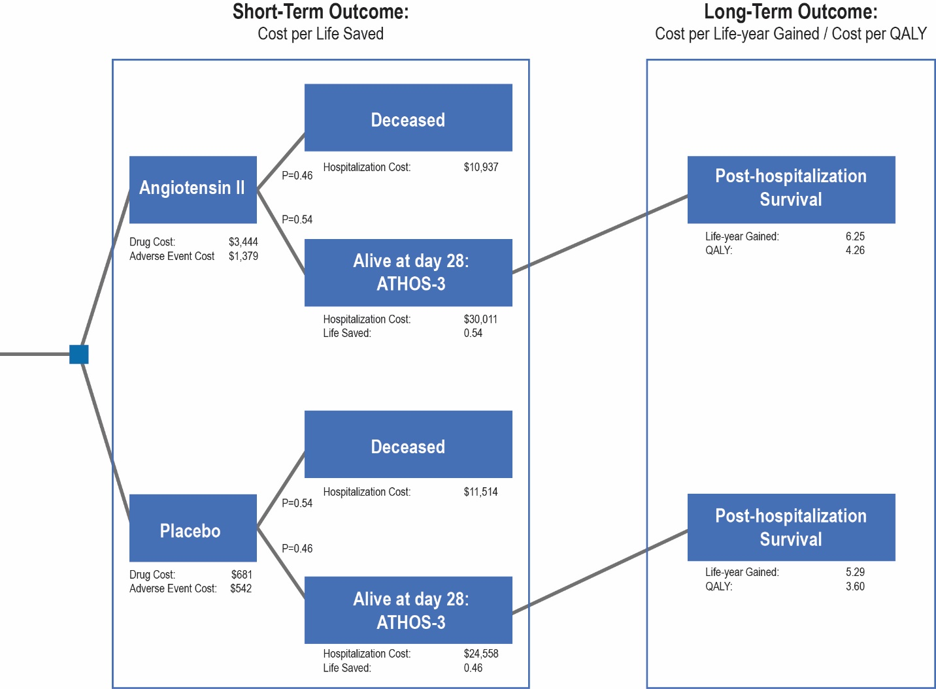

Supplementary Figure 2. Threshold analysis, angiotensin II survival rate vs incremental cost-effectiveness ratio (QALY). QALY, quality-adjusted life years; WTP, willingness to pay. Survival rates in ATHOS-3 trial for angiotensin II arm and placebo arm were 54% and 46%, respectively.

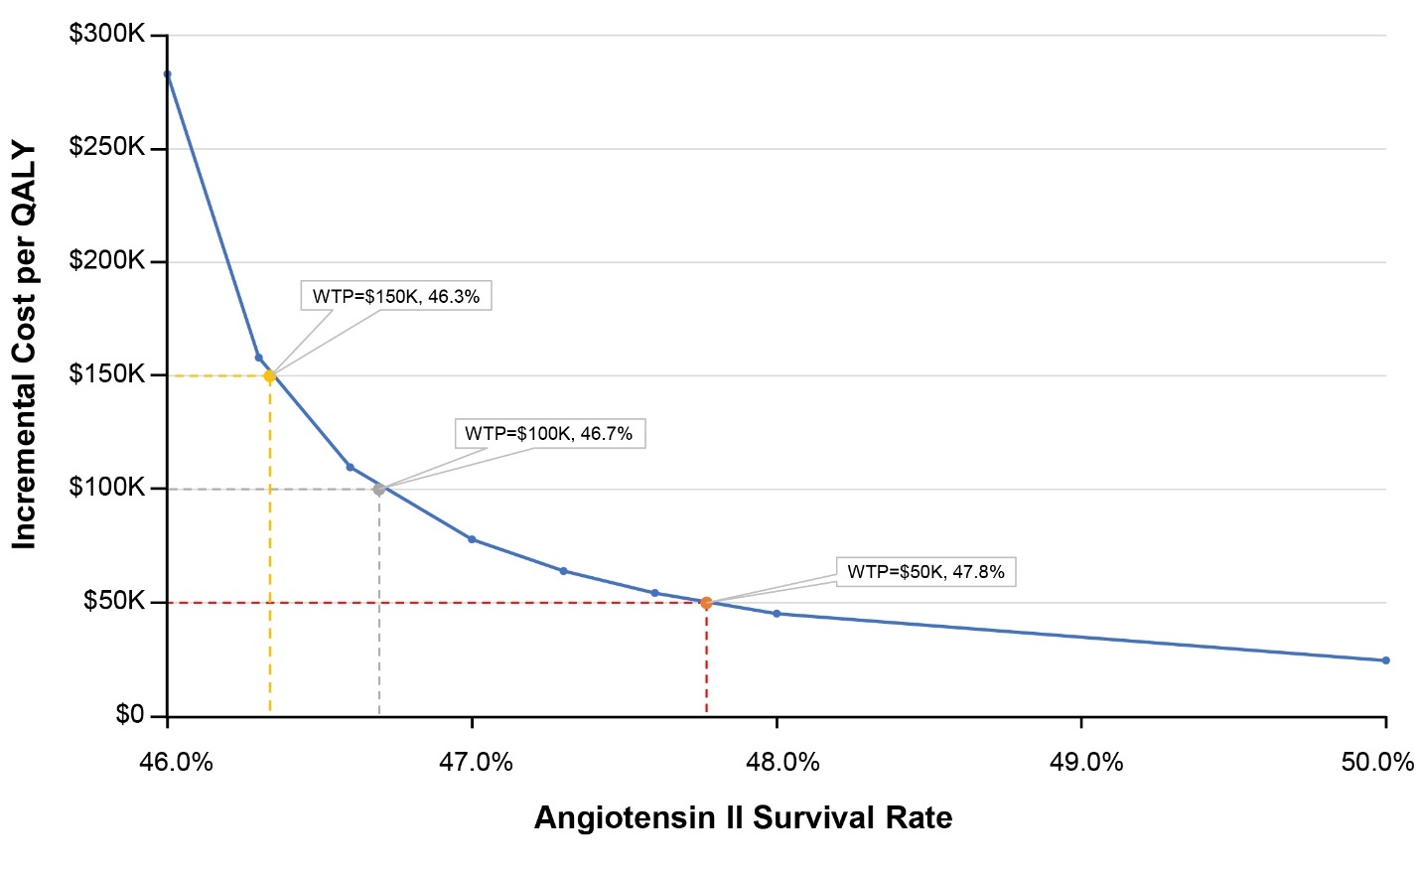

Supplementary Figure 3. Willingness-to-pay threshold analysis, angiotensin II price per vial vs ICER (QALY).* ICER, incremental cost-effectiveness ratio; QALY, quality-adjusted life years; WTP, willingness to pay. *Current angiotensin II cost per vial (wholesale acquisition cost, 2018 USD): $1,500.

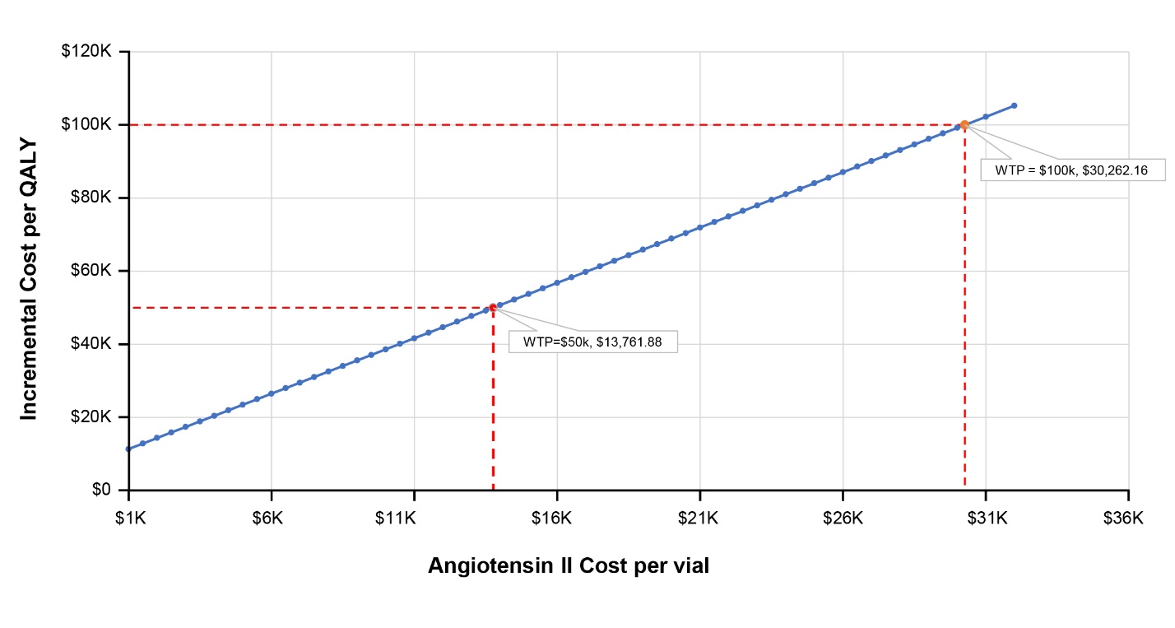

Supplementary Figure 4. Cost-effectiveness acceptability curve with net monetary benefit. CE, cost-effectiveness; Prob., probability; QALY, quality-adjusted life years; WTP, willingness to pay.