Supplementary Table 1: 10-year risk of EOC without surgery
Current age (years) | BRCA1 (%) | BRCA2 (%)
30–39 | 5 | 5
40–44 | 10 | 5
45–49 | 10 | 10
50–54 | 15 | 10
55–59 | 10 | 10
60–64 | 10 | 5
65–69 | 10 | 5
70–79 | 10 | 5
Abbreviations: EOC, epithelial ovarian cancer.
Source: [1]
Supplementary Table 2: 10-year risk of BC without surgery
Current age (years) | BRCA1 (%) | BRCA2 (%)
20–25 | 5 | 1
26–30 | 5 | 2
31–35 | 5 | 5
36–40 | 10 | 2
41–45 | 10 | 10
46–50 | 15 | 10
51–55 | 15 | 10
56–60 | 10 | 10
61–65 | 10 | 15
66–70 | 10 | 15
Abbreviations: BC, breast cancer.
Source: [1]
Supplementary Table 3: Risk reductions following RRS
EOC | BRCA1 HR | BRCA2 HR
RRBSO | 0.16 | 0.12
RRM | 1.00 | 1.00
RRM+RRBSO | 0.16 | 0.12
BC | BRCA1 HR | BRCA2 HR
RRBSO | 0.51 | 0.39
RRM | 0.10 | 0.09
RRM+RRBSO | 0.05 | 0.05
Abbreviations: BC, breast cancer; EOC, epithelial ovarian cancer; HR, hazard ratio; RRBSO, risk-reducing bilateral salpingo-oophorectomy; RRM, risk-reducing mastectomy; RRS, risk-reducing surgery.
Sources: [2-9]
Supplementary Table 4: 5-year net survival with EOC and BC
Age range (years) | EOC (%) | BC (%)
<45 | 76.5 | 88.1
45–54 | 59.1 | 90.6
55–64 | 49.5 | 90.1
65–74 | 38.7 | 91.4
75+ | 20.9 | 87.1
Abbreviations: BC, breast cancer; EOC, epithelial ovarian cancer.
Source: [10]
Supplementary Table 5: Summary of costs in the model
Component | Cost | Source
Testing and counselling
BRCA test | CAD 675  (USD478) | Estimate
Genetic counselling | CAD 306  (USD287) | Estimate
RRS
RRBSO | CAD4,835  (USD3,421) | Kwon J et al.[11] Inflated to 2016.
RRM | CAD6,711  (USD4,749) | Pataky R et al.[13]
Cancer treatment
EOC, with surgery (first year cost) | CAD40,420  (USD28,603) | Estimate for ovarian cancer. Cost of surgery from Ontario Case Costing Initiative [14]
EOC, without surgery (cost in subsequent years until death) | CAD34,412  (USD24,352) | Estimate [15]
BC, with surgery (one-off cost) | CAD29,629  (USD20,967) | Pataky et al [16], inflated to 2016 costs [17]
BC, without surgery (one-off cost if prior RRM had been performed) | CAD23,796  (USD16,840) | Assumed to be cost of BC minus RRM [16, 17]
Palliative care
EOC | CAD14,687  (USD11K) | Hollander et al [18], inflated to 2016 costs [17]
BC | CAD29,993  (USD22K) | Pataky et al [16], inflated to 2016 costs [17]
All-cause mortality | CAD14,687  (USD11K) | Hollander et al [18], inflated to 2016 costs [17]
Abbreviations: BC, breast cancer; EOC, epithelial ovarian cancer; RRBSO, risk-reducing bilateral salpingo-oophorectomy; RRM, risk-reducing mastectomy, RRS, risk-reducing surgery.

Supplementary Table 6: Summary of utility values in the model
Utility by age for females
Age (years) | Utility for females, mean (95% CI)
<30 | 0.87 (0.86, 0.89)
30–39 | 0.87 (0.87, 0.88)
40–49 | 0.84 (0.83, 0.86)
50–59 | 0.83 (0.81, 0.84)
60–69 | 0.82 (0.81, 0.84)
70–79 | 0.81 (0.80, 0.83)
>79 | 0.81 (0.78, 0.84)
Cancer-related utilities
Time from diagnosis | EOC | BC
Year 1 | 0.50 | 0.71
Year 2 | 0.65 | 0.72
Year 3 | 0.67 | 0.73
Year 4 | 0.69 | 0.74
Year 5 | 0.70 | 0.76
Year 6+ | 0.72 | 0.77
Health state utilities
Health state | Utility in controls, mean (SD)
Perfect health | 1.00
RRBSO | 0.90 (0.14)
RRM | 0.88 (0.17)
RRBSO and RRM | 0.79 (0.21)
Abbreviations: BC, breast cancer; CI, confidence interval; EOC, epithelial ovarian cancer; RRBSO, risk-reducing bilateral salpingo-oophorectomy; RRM, risk-reducing mastectomy; SD, standard deviation.
Sources: [19-21]
Supplementary Table 7: Inputs for probabilistic sensitivity analysis
Parameter | Base | SE | Distribution
Model setup
Discount rate (costs) | 1.5% | 0.004 | Beta
Discount rate (utilities) | 1.5% | 0.004 | Beta
Time horizon (years) | 50 | – | None
EOC risk
10-year risk BRCA1: Age 30–39 | 5% | 0.01 | Beta
10-year risk BRCA1: Age 40–44 | 10% | 0.01 | Beta
10-year risk BRCA1: Age 45–49 | 10% | 0.01 | Beta
10-year risk BRCA1: Age 50–54 | 15% | 0.02 | Beta
10-year risk BRCA1: Age 55–59 | 10% | 0.01 | Beta
10-year risk BRCA1: Age 60–64 | 10% | 0.01 | Beta
10-year risk BRCA1: Age 65–69 | 10% | 0.01 | Beta
10-year risk BRCA1: Age 70–79 | 10% | 0.01 | Beta
10-year risk BRCA2: Age 30–39 | 5% | 0.01 | Beta
10-year risk BRCA2: Age 40–44 | 5% | 0.01 | Beta
10-year risk BRCA2: Age 45–49 | 10% | 0.01 | Beta
10-year risk BRCA2: Age 50–54 | 10% | 0.01 | Beta
10-year risk BRCA2: Age 55–59 | 10% | 0.01 | Beta
10-year risk BRCA2: Age 60–64 | 5% | 0.01 | Beta
10-year risk BRCA2: Age 65–69 | 5% | 0.01 | Beta
10-year risk BRCA2: Age 70–79 | 5% | 0.01 | Beta
BC risk
5-year risk BRCA1: Age 20–25 | 5% | 0.01 | Beta
5-year risk BRCA1: Age 26–30 | 5% | 0.01 | Beta
5-year risk BRCA1: Age 31–35 | 5% | 0.01 | Beta
5-year risk BRCA1: Age 36–40 | 10% | 0.01 | Beta
5-year risk BRCA1: Age 41–45 | 10% | 0.01 | Beta
5-year risk BRCA1: Age 46–50 | 15% | 0.02 | Beta
5-year risk BRCA1: Age 51–55 | 15% | 0.02 | Beta
5-year risk BRCA1: Age 56–60 | 10% | 0.01 | Beta
5-year risk BRCA1: Age 61–65 | 10% | 0.01 | Beta
5-year risk BRCA1: Age 66–70 | 10% | 0.01 | Beta
5-year risk BRCA2: Age 20–25 | 1% | 0.00 | Beta
5-year risk BRCA2: Age 26–30 | 2% | 0.00 | Beta
5-year risk BRCA2: Age 31–35 | 5% | 0.01 | Beta
5-year risk BRCA2: Age 36–40 | 2% | 0.00 | Beta
5-year risk BRCA2: Age 41–45 | 10% | 0.01 | Beta
5-year risk BRCA2: Age 46–50 | 10% | 0.01 | Beta
5-year risk BRCA2: Age 51–55 | 10% | 0.01 | Beta
5-year risk BRCA2: Age 56–60 | 10% | 0.01 | Beta
5-year risk BRCA2: Age 61–65 | 15% | 0.02 | Beta
5-year risk BRCA2: Age 66–70 | 15% | 0.02 | Beta
RRBSO
BRCA1: Estimated age of surgery | 54 | 5.74 | Normal
BRCA1: Uptake rate ≥ estimated age | 44% | 0.06 | Beta
BRCA2: Estimated age of surgery | 54 | 5.74 | Normal
BRCA2: Uptake rate ≥ estimated age | 44% | 0.06 | Beta
BRCA1: EOC HR | 0.16 | 0.27 | Log-normal
BRCA1: BC HR | 0.51 | 0.13 | Log-normal
BRCA2: EOC HR | 0.12 | 0.34 | Log-normal
BRCA2: BC HR | 0.39 | 0.16 | Log-normal
RRM
BRCA1: Estimated age of surgery | 44 | 5.61 | Normal
BRCA1: Uptake rate ≥ estimated age | 21.1% | 0.06 | Beta
BRCA2: Estimated age of surgery | 44 | 5.61 | Normal
BRCA2: Uptake rate ≥ estimated age | 21.1% | 0.06 | Beta
BRCA1: BC HR | 0.10 | 0.60 | Log-normal
BRCA2: BC HR | 0.09 | 0.60 | Log-normal
RRBSO + RRM
EOC HR: BRCA1 | 0.16 | 0.27 | Log-normal
BC HR: BRCA1 | 0.05 | 0.79 | Log-normal
EOC HR: BRCA2 | 0.12 | 0.34 | Log-normal
BC HR: BRCA2 | 0.05 | 0.79 | Log-normal
Cumulative survival probability
Males: Age 0–101 | – | – | Beta
Females: Age 0–101 | – | – | Beta
Ovarian cancer: 5-year survival rate
Age range <45 | 76.5% | 0.10 | Beta
Age range 45–54 | 59.1% | 0.08 | Beta
Age range 55–64 | 49.5% | 0.06 | Beta
Age range 65–74 | 38.7% | 0.05 | Beta
Age range 75+ | 20.9% | 0.03 | Beta
Breast cancer: 5-year survival rate
Age range <45 | 88.1% | 0.09 | Beta
Age range 45–54 | 90.6% | 0.08 | Beta
Age range 55–64 | 90.1% | 0.08 | Beta
Age range 65-74 | 91.4% | 0.08 | Beta
Age range 75+ | 87.1% | 0.09 | Beta
Costs
BRCA test – index case | CAD 675  (USD478) | CAD 86.10  (USD60.93) | Gamma
Tumour testing – index case | CAD 306  (USD287) | CAD 39.03  (USD36.59) | Gamma
Genetic counselling – index case | CAD 300  (USD212) | CAD 38.27  (USD27.08) | Gamma
BRCA test – family members | CAD 675  (USD478) | CAD 86.10  (USD60.93) | Gamma
Tumour testing – family members | CAD 108  (USD101) | CAD 13.78  (USD12.91) | Gamma
Genetic counselling – family members | CAD 300  (USD212) | CAD 38.27  (USD27.08) | Gamma
RRBSO total cost | CAD4,835  (USD3,421) | CAD616.68  (USD436.40) | Gamma
RRM total cost | CAD6,711  (USD4,749) | CAD 855.95  (USD605.71) | Gamma
EOC – cost with surgery | CAD40,420  (USD28,603) | CAD5,155.69  (USD3648) | Gamma
BC – cost with surgery | CAD29,629  (USD20,967) | CAD3,779.32  (USD2674) | Gamma
EOC – cost without surgery | CAD34,412  (USD24,352) | CAD4,389.35  (USD3106) | Gamma
BC – cost without surgery | CAD23,796  (USD16,840) | CAD3,035.31  (USD2147) | Gamma
Palliative care – EOC | CAD14,687  (USD11K) | CAD1,873.38  (USD1414) | Gamma
Palliative care – BC | CAD29,993  (USD22K) | CAD3,825.70  (USD2887) | Gamma
Palliative care – all-cause | CAD14,687  (USD11K) | CAD1,873.38  (USD1414) | Gamma
Utilities
Perfect health – controls | 1.00 |  | None
RRBSO – controls | 0.90 | 0.08 | Beta
RRM – controls | 0.88 | 0.09 | Beta
RRM & RRBSO – controls | 0.79 | 0.10 | Beta
BRCA mut positive test result – controls | 1.00 | 0.06 | Beta
RRBSO – BRCA mut positive | 0.95 | 0.07 | Beta
RRM – BRCA mut positive | 0.88 | 0.09 | Beta
RRM & RRBSO – BRCA mut positive | 0.84 | 0.09 | Beta
BRCA mut positive test result – BRCA mut positive | 1.00 | 0.06 | Beta
Age-related utilities: Males age 1–101 | – | – | Beta
Age-related utilities: Females age 1–101 | – | – | Beta
EOC: Year 1 | 0.50 | 0.06 | Beta
EOC: Year 2 | 0.65 | 0.08 | Beta
EOC: Year 3 | 0.67 | 0.09 | Beta
EOC: Year 4 | 0.69 | 0.09 | Beta
EOC: Year 5 | 0.70 | 0.09 | Beta
EOC: Year 5+ | 0.72 | 0.09 | Beta
BC: Year 1 | 0.71 | 0.09 | Beta
BC: Year 2 | 0.72 | 0.09 | Beta
BC: Year 3 | 0.73 | 0.09 | Beta
BC: Year 4 | 0.74 | 0.09 | Beta
BC: Year 5 | 0.76 | 0.10 | Beta
BC: Year 5+ | 0.77 | 0.10 | Beta
Duration of disutility
Duration of effect (yrs): Perfect health | – | – | None
Duration of effect (yrs): RRBSO | 1.00 | 0.06 | Log-normal
Duration of effect (yrs): RRM | 1.00 | 0.06 | Log-normal
Duration of effect (yrs): RRM & RRBSO | 1.00 | 0.06 | Log-normal
Duration of effect (yrs): BRCA mut positive test result | 1.00 | 0.06 | Log-normal
Duration of effect (yrs): Death | – | – | None
Population generation
Number of index cases | 2,786 | – | None
Index population: Mean age | 50 | 6.38 | Normal
Index population: Age SD | 5.00 | – | None
Index population: Probability germline BRCA mut positive | 12% | 0.02 | Beta
Index population: % BRCA1 | 62% | 0.08 | Beta
First-degree: Probability of BRCA mutation if index case is BRCA mutation positive | 50% | 0.06 | Beta
Mother: Mean age (relative to index) | 30 | 3.83 | Normal
Mother: Age SD | 5 |  | None
Father: Mean age (relative to index) | 32 | 4.12 | Normal
Father: Age SD | 5 |  | None
Siblings: Mean number | 0.61 | 0.13 | Log
Siblings: Number SD | 0.5 |  | None
Siblings: Mean age (relative to index) | 0 |  | None
Siblings: Age SD | 5 |  | None
Siblings: Gender (probability female) | 50.41% | 0.06 | Beta
Children: Mean number | 1.91 |  | None
Children: Number SD | 1 |  | None
Children: Mean age (relative to index) | –30 | 3.83 | Normal
Children: Age SD | 5 |  | None
Children: Gender (probability female) | 50.41% | 0.06 | Beta
Second-degree: Probability of BRCA mutation if index case is BRCA mutation positive | 25% | 0.03 | Beta
Abbreviations: BC, breast cancer; EOC, epithelial ovarian cancer; HR, hazard ratio; mut, mutation; RRBSO, risk-reducing bilateral salpingo-oophorectomy; RRM, risk-reducing mastectomy; SD, standard deviation; SE, standard error; yrs, years.
Supplementary Table 8: Budget impact for testing vs no testing over 5 years
 | Year 1 | Year 2 | Year 3 | Year 4 | Year 5
Testing costs | CAD24,495K | CAD 0 | CAD 0 | CAD 0 | CAD 0
 | USD17,334K | USD 0 | USD 0 | USD 0 | USD 0
Counselling costs | CAD3,662K | CAD 0 | CAD 0 | CAD 0 | CAD 0
 | USD2,591K | USD 0 | USD 0 | USD 0 | USD 0
RRS costs | CAD3,553K | CAD 241,445 | CAD 192,305 | CAD 179,677 | CAD 232,066
 | USD2,514K | USD170,859 | USD136,085 | USD127,148 | USD164,221
OC costs | -CAD 80,840 | -CAD230,503 | -CAD287,311 | -CAD327,731 | -CAD321,723
 | -USD57,206 | -USD163,116 | -USD203,316 | -USD231,919 | -USD227,667
BC costs | -CAD 59,259 | -CAD118,517 | -CAD48,147 | -CAD118,517 | -CAD177,776
 | -USD41,934 | -USD83,869 | -USD104,836 | -USD83,869 | -USD125,803
Palliative costs | CAD0 | -CAD29,993 | CAD45,299 | -CAD29,374 | -CAD44,680
 | USD0 | -USD22,640 | USD34,193 | -USD22,172 | -USD33,726
Total costs | CAD31,571K | -CAD137,569 | -CAD197,854 | -CAD295,945 | -CAD312,113
 | USD22,341K | -USD98,766 | -USD137,874 | -USD210,812 | -USD222,975

Supplementary Figure 1: Cost-effectiveness plane for the base-case analysis
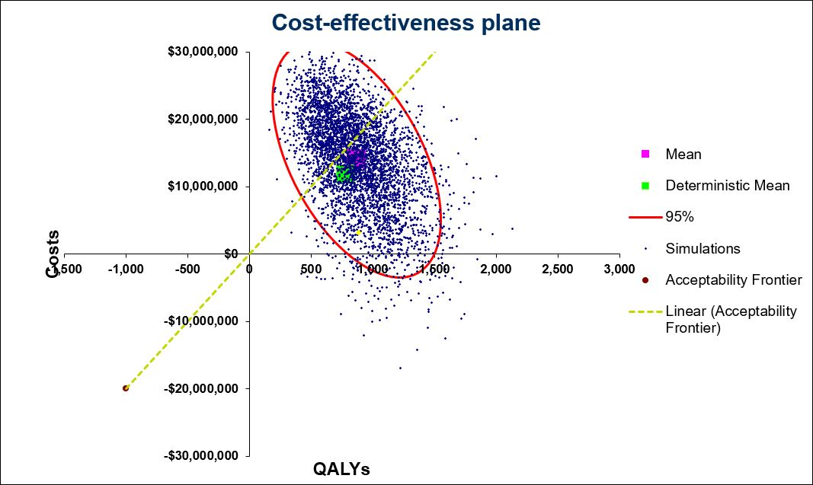Abbreviations: QALYs, quality adjusted life years.
Supplementary Figure 2: Cost-effectiveness acceptability curve for the base-case analysis
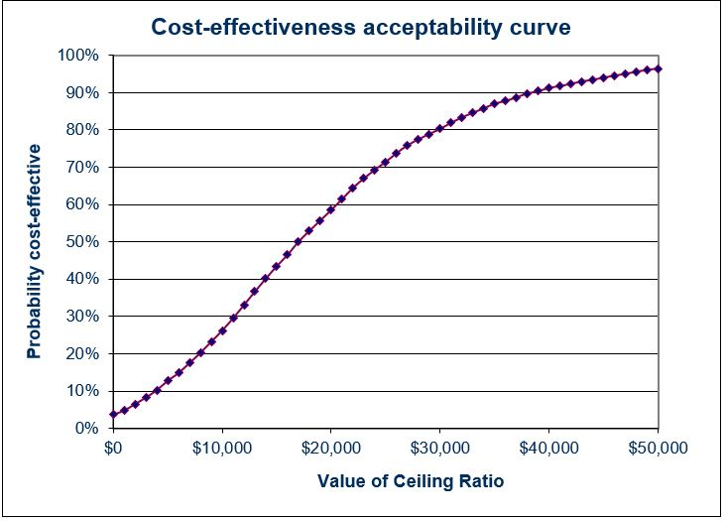

References
1. The Institute of Cancer Research, Protocol 3: BRCA mutation carrier guidelines. 2015.
2. Domchek, S.M., et al., Mortality after bilateral salpingo-oophorectomy in BRCA1 and BRCA2 mutation carriers: a prospective cohort study. Lancet Oncol, 2006. 7(3): p. 223-9.
3. Domchek, S.M., et al., Association of Risk-Reducing Surgery in BRCA1 or BRCA2 Mutation Carriers with Cancer Risk and Mortality. JAMA : the journal of the American Medical Association, 2010. 304(9): p. 967-975.
4. Finch, A., et al., Salpingo-oophorectomy and the risk of ovarian, fallopian tube, and peritoneal cancers in women with a BRCA1 or BRCA2 Mutation. Jama, 2006. 296(2): p. 185-92.
5. Kauff, N.D., et al., Risk-reducing salpingo-oophorectomy for the prevention of BRCA1- and BRCA2-associated breast and gynecologic cancer: a multicenter, prospective study. J Clin Oncol, 2008. 26(8): p. 1331-7.
6. Kauff, N.D., et al., Risk-reducing salpingo-oophorectomy in women with a BRCA1 or BRCA2 mutation. N Engl J Med, 2002. 346(21): p. 1609-15.
7. Meijers-Heijboer, H., et al., Breast cancer after prophylactic bilateral mastectomy in women with a BRCA1 or BRCA2 mutation. N Engl J Med, 2001. 345(3): p. 159-64.
8. Rebbeck, T.R., et al., Bilateral prophylactic mastectomy reduces breast cancer risk in BRCA1 and BRCA2 mutation carriers: the PROSE Study Group. J Clin Oncol, 2004. 22(6): p. 1055-62.
9. Rebbeck, T.R., et al., Prophylactic oophorectomy in carriers of BRCA1 or BRCA2 mutations. N Engl J Med, 2002. 346(21): p. 1616-22.
10. National Cancer Institute, SEER Cancer Statistics Review 1975-2014.
11. Kwon, J.S., et al., Costs and benefits of opportunistic salpingectomy as an ovarian cancer prevention strategy. Obstet Gynecol, 2015. 125(2): p. 338-45.
12. Ontario Case Costing Initiative, 2015/16 costs. Procedure: 1YM89LA.
13. Pataky, R.E. and C.R. Baliski, Reoperation costs in attempted breast-conserving surgery: a decision analysis. Curr Oncol, 2016. 23(5): p. 314-321.
14. Ontario Case Costing Initiative, 2015/16 costs. Procedure: 1RB87DA, 1RB87LA, 1RB87RA, 1RB89DA, 1RB89LA.
15. Duong, M., et al., The cost-effectiveness of bevacizumab for the treatment of advanced ovarian cancer in Canada. Curr Oncol, 2016. 23(5): p. e461-e467.
16. Pataky, R., et al., Cost-effectiveness of MRI for breast cancer screening in BRCA1/2 mutation carriers. BMC Cancer, 2013. 13: p. 339.
17. Statistics Canada, Consumer Price Index, health and personal care, by province (Canada). 2017.
18. Hollander, M.J., Costs of end-of-life care: findings from the province of Saskatchewan. Healthc Q, 2009. 12(3): p. 50-8.
19. National Institute for Health and Care Excellence, Clinical Guideline 164 - Familial Breast Cancer - Cost-effectiveness evidence review. 2013.
20. Health Quality Council of Alberta, EQ-5D-5L Index Norms for Alberta Population. 2016.
21. Grann, V.R., et al., Comparative effectiveness of screening and prevention strategies among BRCA1/2-affected mutation carriers. Breast Cancer Res Treat, 2011. 125(3): p. 837-47.

