Supplemental Materials for

Jen et al, “Hurdle Poisson Regression Model for Identifying Factors Related to Non-compliance and Waiting Time for Confirmatory Diagnosis in Colorectal Cancer Screening”

The Likelihood Function for Estimation of Parameters
After aggregating data by relevant covariates, we assume there are G subsets and define confirmation with colonoscopy as a binary outcome,$y_{ij}$, which represents whether the j-th screenee of subset i had underwent colonoscopy or not so that $y_{i}=\sum_{j}{y_{ij}}$ is the number of screenees had underwent colonoscopy in subset i and $N_{i}$ is the total number of screenee in subset i ϵ {1,…,G}. $t_{ij}$ is time to undergo colonoscopy of the j-th screenee in subset i so that $t_{i}=\sum_{j}{t_{ij}}$ represents total waiting time in subset i. $p_{i}$ is the probability of refusing to undergo colonoscopy (non-complier), and $λ_{i}$ is the mean arrival rate of receiving colonoscopy. To easily express the likelihood function for the hurdle model, we divided each subset i into two groups by non-compliance or compliance, symbolizing i₁ and i₂ so that i* = {1₁,1₂} $∪$…$∪${G₁,G₂}.
The hurdle is crossed if a count is greater than zero. Therefore, the process generates a binary response (whether the number of screenees undergoing colonoscopy takes on the value zero or a positive value), and the probability mass function (p.m.f) is
$P\left(Y_{i^{*}}=y_{i^{*}}\right)=\left\{\begin{aligned} {p_{i^{*}}}^{N_{i^{*}}-y_{i^{*}}} , y_{i^{*}}=0 (i^{*}ϵi_{1}) \\ {\left(1-p_{i^{*}}\right)}^{y_{i^{*}}},y_{i^{*}}>0 (i^{*}ϵi_{2})\end{aligned}\right.$
(1)
Because $Y_{i^{*}}$ is a count data, which follows Poisson distribution, the probability of zero counts is
$P\left(Y_{i^{*}}=0\right)=\frac{e^{-λ_{i^{*}}t_{i^{*}}}{\left(λ_{i^{*}}t_{i^{*}}\right)}^{y_{i^{*}}}}{y_{i^{*}}!}=e^{-λ_{i^{*}}t_{i^{*}}}$
(2)
and the probability of no zero counts equals $1-e^{-λ_{i^{*}}t_{i^{*}}}$. As result, we can obtain the p.m.f of truncated Poisson process (given the count greater than one)
$P\left(Y_{i^{*}}=y_{i^{*}} | Y_{i^{*}}>0\right)=\frac{e^{-λ_{i^{*}}t_{i^{*}}}{\left(λ_{i^{*}}t_{i^{*}}\right)}^{y_{i^{*}}}}{y_{i^{*}}!\left(1-e^{-λ_{i^{*}}t_{i^{*}}}\right)}$
(3)
Thus, the p.m.f of hurdle model can be expressed as
$P\left(Y_{i^{*}}=y_{i^{*}}\right)=\left\{ \begin{aligned} {{ p}_{i^{*}}}^{N_{i^{*}} } , for y_{i^{*}}=0 \\ {\left(1-p_{i^{*}}\right)}^{y_{i^{*}}}\frac{e^{-λ_{i^{*}}t_{i^{*}}}{\left(λ_{i^{*}}t_{i^{*}}\right)}^{y_{i^{*}}}}{y_{i^{*}}!\left(1-e^{-λ_{i^{*}}t_{i^{*}}}\right)} , for y_{i^{*}}>0 \end{aligned}\right.$
(4)
where $0≤p_{i^{*}}≤1 ;λ_{i^{*}},t_{i^{*}}>0 ;N_{i^{*}},y_{i^{*}}≥0$.
The general form of the likelihood function for the hurdle model is
$L=\prod_{i^{*}ϵi_{1}}{{p_{i^{*}}}^{N_{i^{*}}}}\prod_{i^{*}ϵi_{2}}{{\left(1-p_{i^{*}}\right)}^{y_{i^{*}}}\frac{e^{-λ_{i^{*}}t_{i^{*}}}{\left(λ_{i^{*}}t_{i^{*}}\right)}^{y_{i^{*}}}}{y_{i^{*}}!\left(1-e^{-λ_{i^{*}}t_{i^{*}}}\right)}}$
(5)
To identify the effect of relevant covariates ($x_{i^{*}}$), we model $p_{i^{*}}$ using the logistic regression model
$logit\left(p_{i^{*}}\right)=x_{i^{*}}γ$
(6)
and $λ_{i^{*}}$ using the Poisson regression model
$\log\left(λ_{i^{*}}\right)=x_{i^{*}}β$
(7)
Thus, the log-likelihood can be written
$$lnL=\ln\left\{\prod_{i^{*}ϵi_{0}}{{\left(\frac{e^{x_{i^{*}}γ}}{1+e^{x_{i^{*}}γ}}\right)}^{N_{i^{*}}}}\prod_{i^{*}ϵi_{1}}{{\left(1-\frac{e^{x_{i^{*}}γ}}{1+e^{x_{i^{*}}γ}}\right)}^{y_{i^{*}}}\frac{e^{-e^{x_{i^{*}}β}t_{i^{*}}}{\left(e^{x_{i^{*}}β}t_{i^{*}}\right)}^{y_{i^{*}}}}{y_{i^{*}}!\left(1-e^{-e^{x_{i^{*}}β}t_{i^{*}}}\right)}}\right\}$$
$$=\left\{\sum_{i^{*}ϵi_{0}}{N_{i^{*}}\left[x_{i^{*}}γ-ln\left(1+e^{x_{i^{*}}γ}\right)\right]}-\sum_{i^{*}ϵi_{1}}{y_{i^{*}}\ln\left(1+e^{x_{i^{*}}γ}\right)}\right\}$$
$$+\left\{\sum_{i^{*}ϵi_{1}}{y_{i^{*}}\left[x_{i^{*}}β+ln\left(t_{i^{*}}\right)\right]}-\sum_{i^{*}ϵi_{1}}{e^{x_{i^{*}}β}t_{i^{*}}}-\sum_{i^{*}ϵi_{1}}{\ln\left(1-e^{-e^{x_{i^{*}}β}t_{i^{*}}}\right)}-\sum_{i^{*}ϵi_{1}}{\ln\left(y_{i^{*}}!\right)}\right\}$$
$=ln\left\{L_{1}\left(γ\right)\right\}+ln\left\{L_{2}\left(β\right)\right\}$
(8)
Supplementary Table 1. Multivariate analysis of hurdle part on factors affecting non-compliance for colonoscopy and non-hurdle part on factors affecting waiting time for undergoing colonoscopy by screening periods

Characteristics | Hurdle part |  | Non-hurdle part
 | Coefficient | Risk Score | Coefficient | Risk Score
Gender
male | -2.3532ª | 0 | 0.0076 | 8
female | 0.0283 | 28 | -4.0401 ª | 0
Age
50-54 | -2.3532 ª | 0 | 0.0308 | 31
55-59 | 0.1023 | 102 | 0.0235 | 24
60-64 | 0.1290 | 129 | 0.0252 | 25
65-69 | 0.2309 | 231 | -4.0401 ª | 0
Screening round
Prevalent | 0.4809 | 481 | -4.0401 ª | 0
Subsequent | -2.3532 ª | 0 | 0.0430 | 43
Level of urbanization
Metropolitan | -2.3532 ª | 0 | - | -
Sub-metropolitan | 0.0636 | 64 | - | -
Non-metropolitan | 0.1946 | 195 | - | -
Period
2004-2009
Geographic area
Northern | -2.3532 ª | 0 | 0.0566 | 57
Central | 0.0989 | 99 | 0.1530 | 153
Southern | 0.0862 | 86 | 0.1021 | 102
Eastern/offshore islands | 0.2103 | 210 | -4.2421 ^{b} | 0
Level of urbanization
Metropolitan | - | - | -4.2421 ^{b} | 56
Sub-metropolitan | - | - | -0.0412 | 15
Non-metropolitan | - | - | -0.0560 | 0
Type of screening units
Hospital | 1.1320 | 1132 | 0.2298 | 230
Public health centers | -2.3532 ª | 0 | 0.6531 | 653
Local clinic | 0.8772 | 877 | -4.2421 ^{b} | 0
2010-2013
Geographic area
Northern | -1.2174 ^{b} | 0 | 0.1052 | 106
Central | 0.1238 | 124 | 0.1263 | 127
Southern | 0.0137 | 14 | -0.0011 | 0
Eastern/offshore islands | 0.0164 | 16 | -4.0401 ª | 1
Level of urbanization
Metropolitan | - | - | -4.0401 ª | 0
Sub-metropolitan | - | - | 0.0964 | 96
Non-metropolitan | - | - | 0.0333 | 33
Type of screening units
Hospital | -0.0400 | 0 | 0.1210 | 121
Public health centers | -1.2174^{b} | 40 | 0.0742 | 74
Local clinic | 0.6256 | 666 | -4.0401 ª | 0
ª represents intercept term.
^{b} represents intercept term plus period effect.

Supplementary Figure 1. Study framework of hurdle model for referral to confirmatory diagnosis in Taiwanese nationwide colorectal cancer screening program
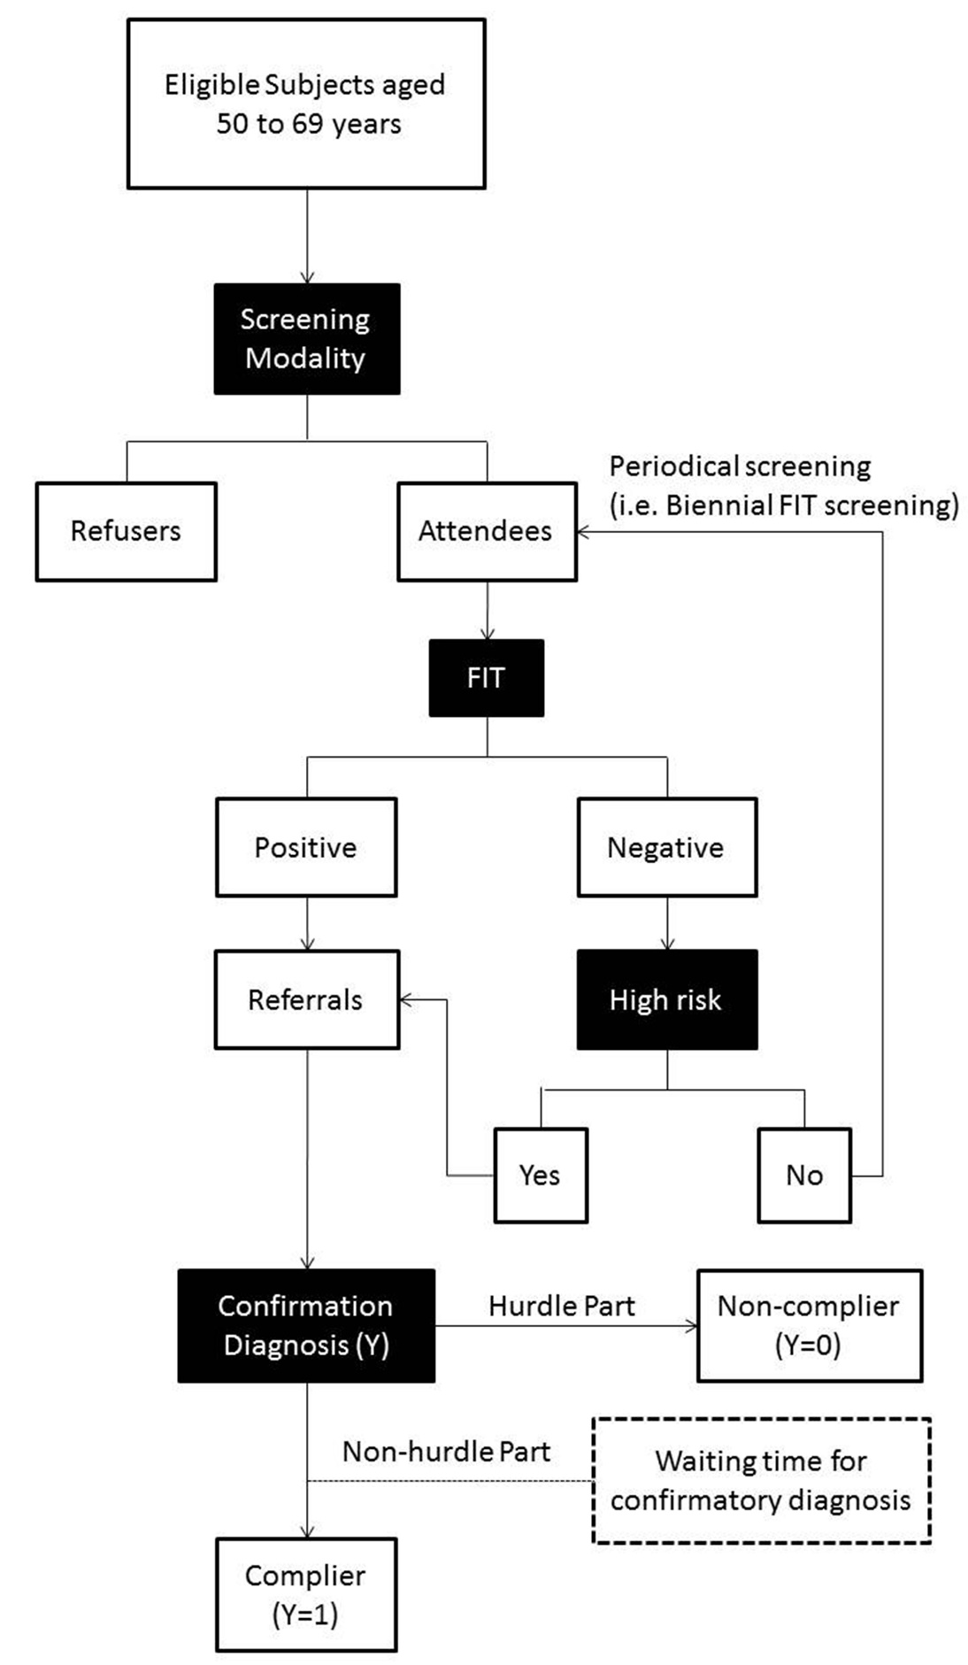
Supplementary Figure 2. Illustration of two type of zero on the waiting time (WT) for confirmatory examination
