Supplementary Figure 1. Model structure of the Decision tree
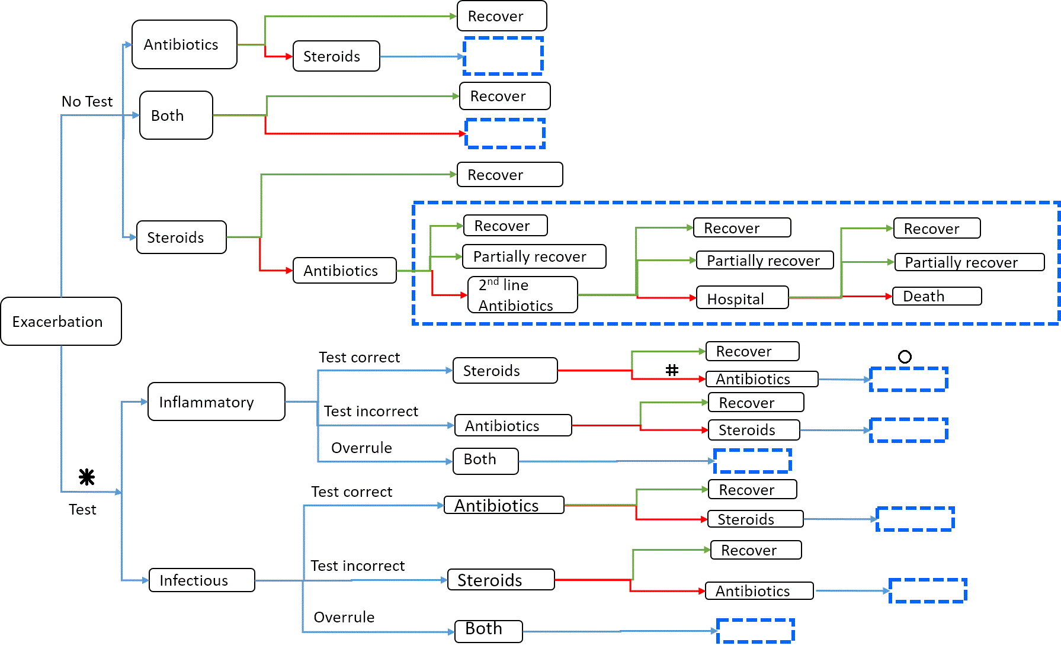
Subset of the tree with the box is repeated.
*, #, and ○ symbols indicate the location of first, second and third patient contact during an exacerbation, described in more detail in Table 1.

