Supplementary Figure 2. Markov model structure
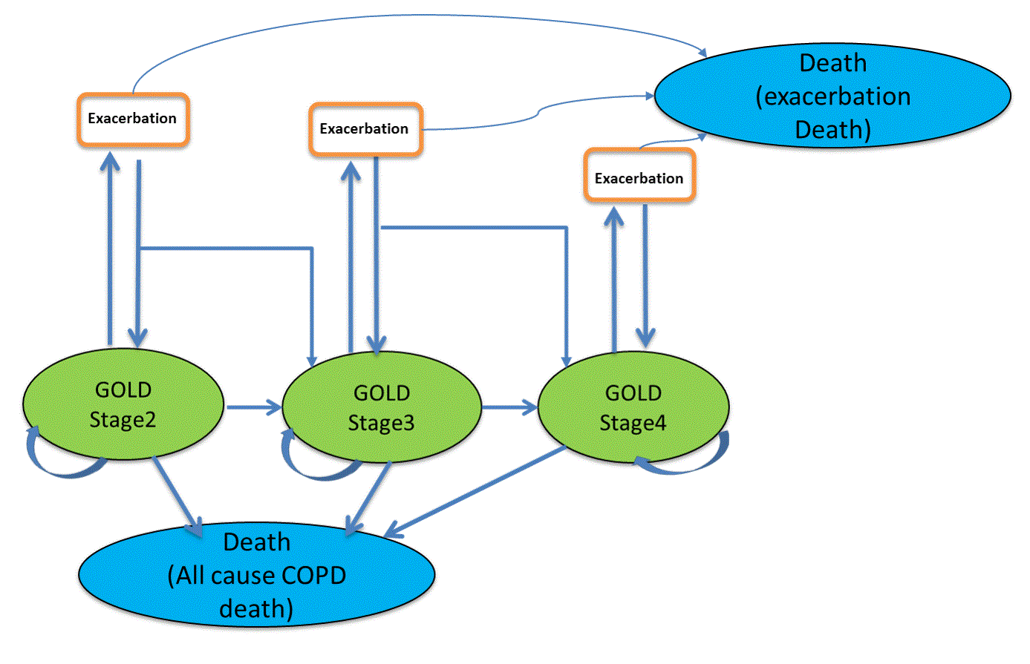
GOLD: Global Initiative for Obstructive Lung Disease Stage; COPD: Chronic obstructive pulmonary disease. The costs and utilities of exacerbation states in the Markov model were calculated as expected values from the decision tree based on the proportion of mild, moderate and severe exacerbations.

