Supplementary Table 1. Sensitivity Analyses of the Effect of Key Input Parameters on ICER
Scenario | Total cost ($) | Incr. cost($) | Total QALYs | Incr. QALYs | Incr. cost per QALYs gained
Base case
Ivabradine+SoC  SoC alone | 5,212  3,005 | 2,206 | 3.71  3.30 | 0.41 | 5,437
Sensitivity analyses
- Price of Ivabradine decreased 20%
Ivabradine+SoC  SoC alone | 4,793  3,005 | 1,788 | 3.71  3.30 | 0.41 | 4,361
- Price of Ivabradine increased 20%
Ivabradine+SoC  SoC alone | 5,631  3,005 | 2,626 | 3.71  3.30 | 0.41 | 6,405
- Reduced time horizon (5 years)
Ivabradine+SoC  SoC alone | 3,560  2,069 | 1,491 | 2.35  2.15 | 0.20 | 7,455*
- Increased time horizon (15 years)
Ivabradine+SoC  SoC alone | 6,017  3,428 | 2,589 | 4.47  3.91 | 0.56 | 4,623
- Increased time horizon (20 years)
Ivabradine+SoC  SoC alone | 6,415  3,617 | 2,798 | 4.91  4.24 | 0.67 | 4,176
- Ivabradine mortality HR Increased 20%
Ivabradine+SoC  SoC alone | 4,951  3,005 | 1,946 | 3.52  3.30 | 0.22 | 8,845*
- Ivabradine mortality HR decreased 20%
Ivabradine+SoC  SoC alone | 5,496  3,005 | 2,491 | 3.92  3.30 | 0.62 | 4,018
- No discounting
Ivabradine+SoC  SoC alone | 6,922  4,013 | 2,909 | 4.56  4.04 | 0.52 | 5,594
- The same initial distribution
Ivabradine+SoC  SoC alone | 5,265  3,085 | 2,180 | 3.71  3.30 | 0.41 | 5,317

ICER: incremental cost-effectiveness ratio; Incr. cost($): incremental cost; QALYs: quality-adjusted life years; SoC: standard of care; Ivabradine mortality HR: Ivabradine mortality hazard ratio

Supplementary Table 2. Deterministic cost - effectiveness results of Base Case Analysis
 | Ivabradine+SoC | SoC alone | incremental
Costs (2017 USD)
Total costs | 5,212 | 3,005 | 2,207
Drug acquisition cost | 2800 | 672 | 2,128
Medical care cost | 1104 | 583 | 521
hospitalization cost | 701 | 947 | -246
HF management cost | 529 | 714 | -185
QALYs | 3.71 | 3.30 | 0.41
ICER |  |  | 5,437
HF: heart failure; ICER: incremental cost-effectiveness ratio; LY: life year; QALYs: quality-adjusted life years

Supplementary Figure 1. Results for one-way sensitivity analysis, effect of parameter variation on the incremental cost (USD) per QALYs
HR_IVB_mort: Ivabradine mortality hazard ratio, IVB_Price: the price for ivabridine, IVB_i_Coeff: Ivabradine improvement coefficient, d_r_util: utility discount rate, d_r_cost: cost discount rate, u_NYHA_II: utility applied for NYHA II, RR_IVB_hosp: releative risk of hospitalization with ivabradine, u_NYHA_I: utility applied for NYHA I, IVB_w_Coeff: Ivabradine worsening coefficient, c_HF_Management: cost of hart failure management, c_CCU: cost of a day in cardiac care unit, u_NYHA_III: utility applied for NYHA III, u_NYHA_IV: utility applied for NYHA IV, c_ICU: cost of a day in intensive care unit, c_postCCU: cost of post CCU management, c_death: associated cost of death, SoC_Price: associated cost of standard of care, c_Specialist: cost of specialist visit, LoS: length of stay in hospital

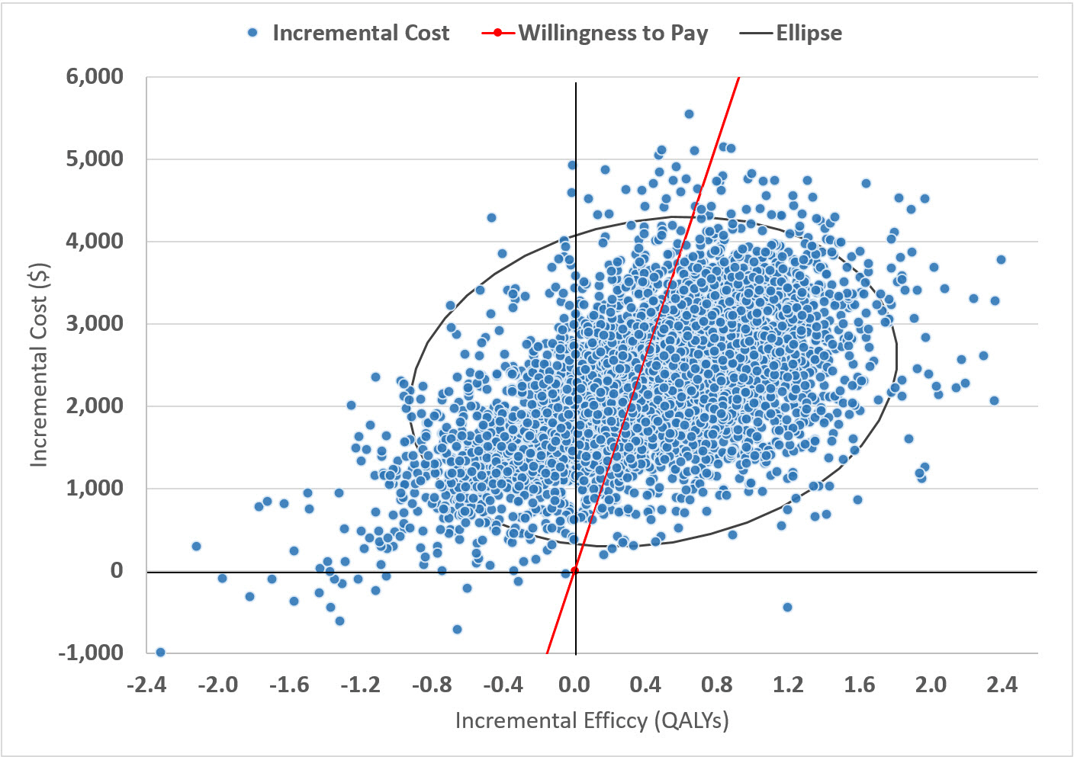

Supplementary Figure 2. Incremental cost-effectiveness scatter plot for Ivabradine vs. SoC with a willingness-to-pay line at 1 GDP per capita per QALY

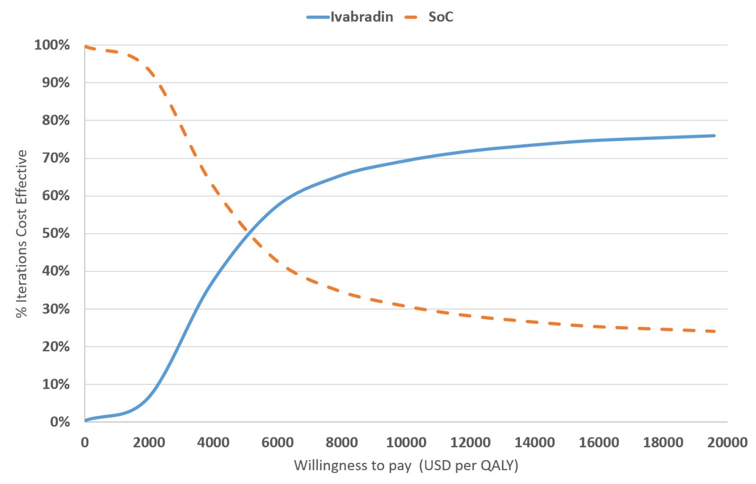
Supplementary Figure 3. Cost-effectiveness acceptability curve

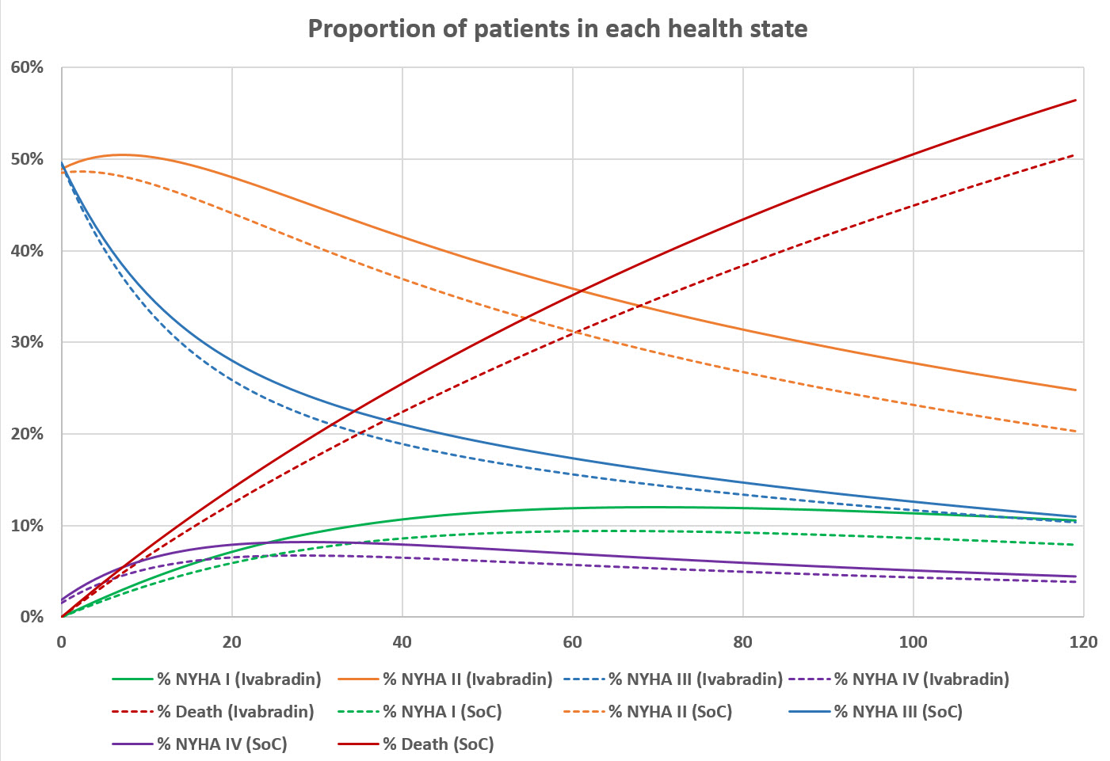

Supplementary Figure 4. Cumulative proportion of patients in each health state over 120 month (10-year) time horizon.

