Figure 1: Sensitivity analysis

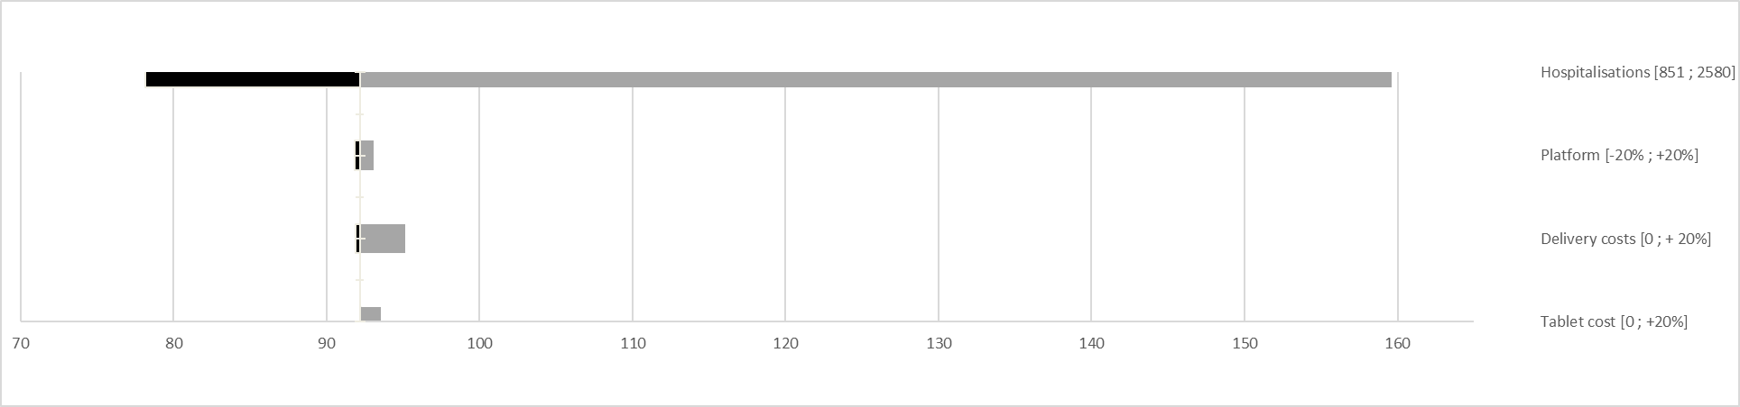
92€
ICER

