ONLINE SUPPLEMENTARY APPENDIX

Supplementary Table 1. Sensitivity analysis of the key variables in the Markov model
Parameter | Ranges for 1- way SA | Probability distribution
Number of all bleeding episodes per year, on- demand | 8.0-27.0 | ̴̴ Poisson (17)
Number of all bleeding episodes per year, primary prophylaxis | 0.0-9.0 | ̴̴ Poisson (3)
Average cost plasma derived Factor VIII | $90- $1350 | Not applied
Average cost recombinant Factor VIII | $145- $2175 | Not applied
Utility of being alive without arthopathy, primary prophylaxys or on demand | 0.500- 0.942 | Beta̴ β ̴ (4.426, 0.298)
Utility of being alive with arthopathy, primary prophylaxys or on demand | 0.500- 0.883 | Beta̴ β ̴ (3.011, 1.334)
Discount rate for costs | 0- 5% | Not applied
Discount rate for effects | 0- 5% | Not applied
Probability of having an articular bleeding | 0.5- 1.0 | Beta̴ β ̴ (80, 20)
Probability of developing arthropathy, on demand | 0.0725- 0.2175 | Beta̴ β ̴ (4.205, 24.795)
Probability of developing arthropathy, primary prophylaxis | 0.0094- 0.0282 | Beta̴ β ̴ (0.508, 26.492)
Probability of dying from bleeding | 0,0026- 0.0079 | Beta̴ β ̴ (5.618, 1064.383)

Supplementary Figure 1. Tornado diagram (ICER)

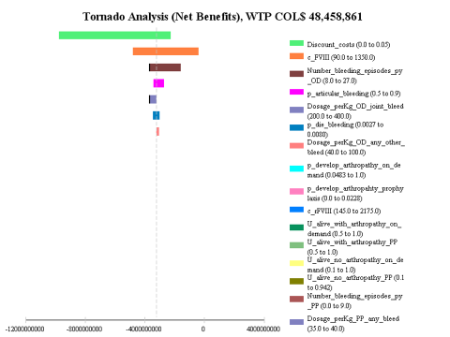
2013 COP per additional QALY

Supplementary Figure 2. Probabilistic Sensitivity Analysis. PP vs. OD ICER scatterplot (WTP 48,458,861 COP)

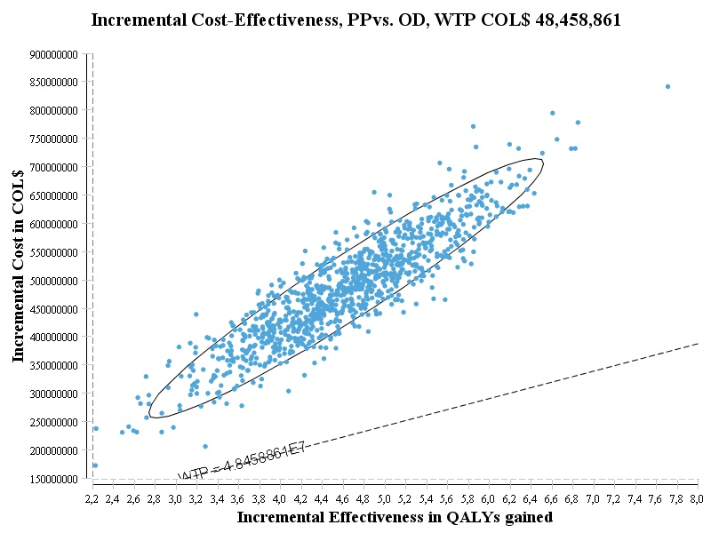

Supplementary Figure 3. Cost-effectiveness acceptability curve

