eFigure 1. Proportion of drugs that accounted for a category of “other considerations”, by category

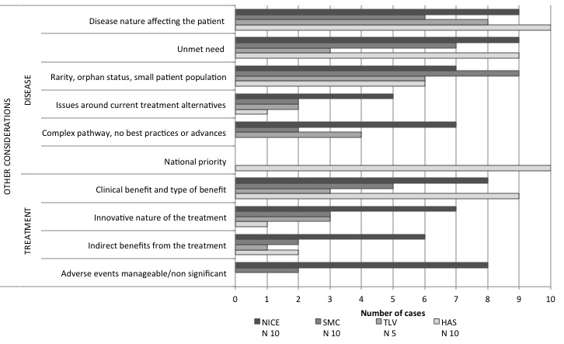

eFigure 1 illustrates the number of cases where “other considerations” were considered, by category of “other considerations”. In total, 125 individual “other considerations” were identified and grouped into ten categories, clustered by whether the pertained to treatment or disease characteristics.

