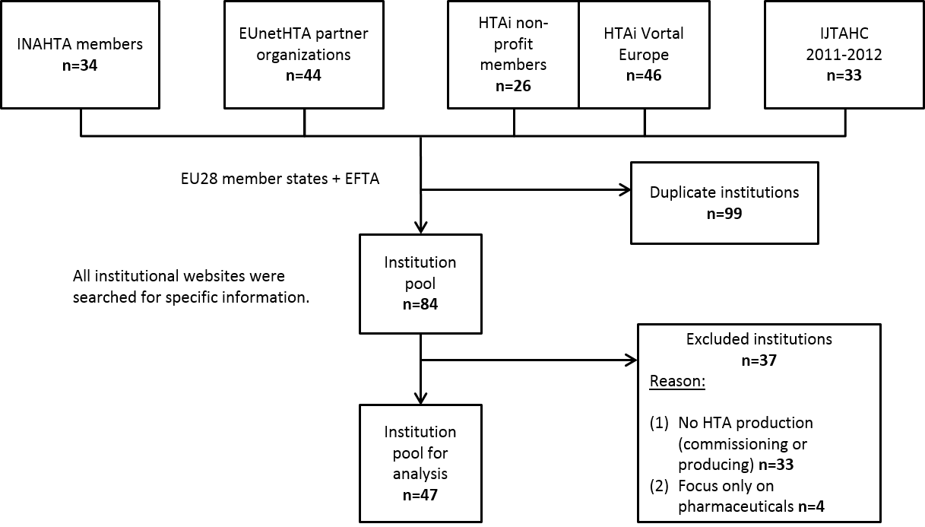
Supplementary Figure 1: Sampling of European institutions
Notes: INAHTA= International Network of Agencies for Health Technology Assessment; EUnetHTA= European network for Health Technology Assessment; HTAi= Health Technology Assessment international; IJTAHC= International Journal of Technology Assessment in Health Care

