## Supplementary Figure 1.

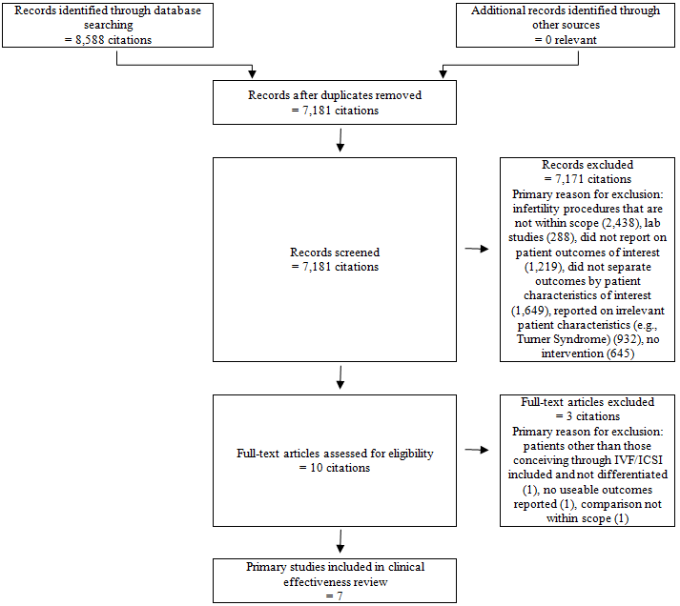

PRISMA flowchart of literature search results and study selection for clinical effectiveness review: additional primary studies.