**Supplementary Figure 1 – Probabilistic sensitivity analysis: probabilities of cost-effectiveness for alternative follow-up schedules and adherence rates, by QALY threshold value, for the 50-69 and 70-79 year old cohorts, in each prognostic subgroup**

a: Excellent group 50-69 years b: Excellent group 70-79 years



c: Good group 50-69 years d: Good group 70-79 years



e: Moderate group 50-69 years f: Moderate group 70-79 years

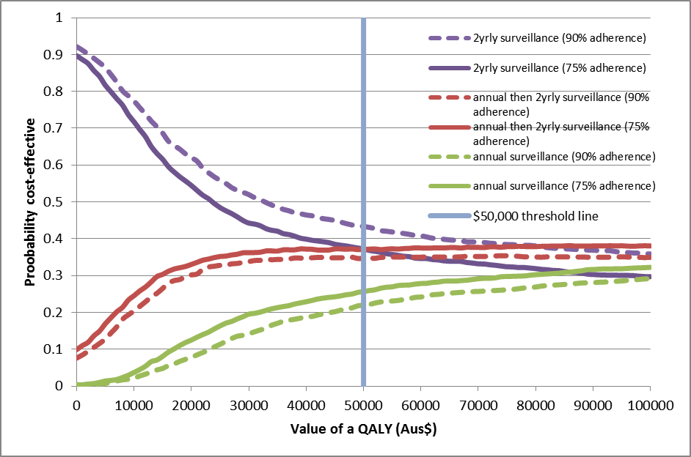

g: Poor group 50-69 years h: Poor group 70-79 years

