Figure 4
Variations of savings for all cancer patients in the province by the intervention
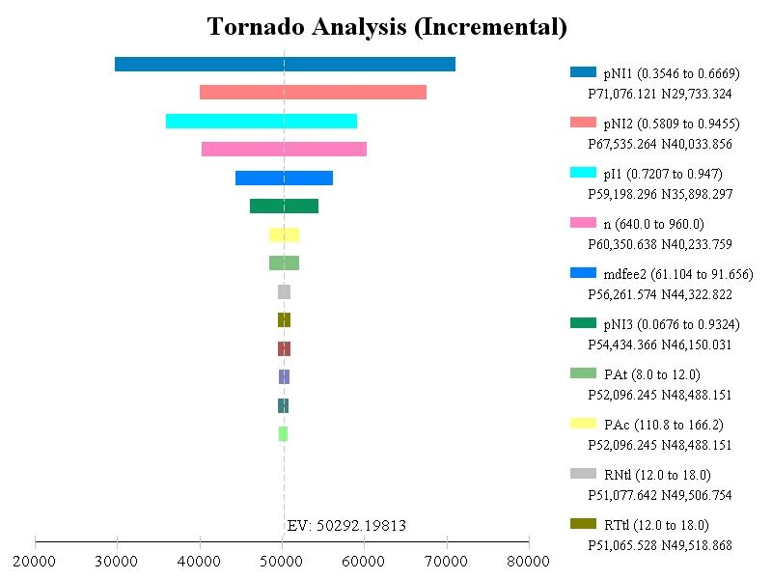
Legend for figure 6
pNI1: Probability of diagnosis at 1st location if no ROSE
pNI2: Probability of diagnosis at 2nd locations among those who have more than 1 location if no ROSE
pI1: Probability of being diagnosed at the 1st location with simulated ROSE
n: number of patients in the province
mdfee2: Cost for MD per additional location or per extra tests
pNI3: Probability of diagnosis at 3rd locations among those who have more than 2 locations if no ROSE
PAt: Time (minutes) the Pathologist spent on 1 location (read 3 slides)
PAc: Cost (Rate) of the pathologist per hour
RNtl: Time (minutes) the registered nurse spent on 1 location (3 passes)
RTtl: Time (minutes) the Respiratory Therapist/MD assistant spent on 1 location (3 passes)

