Figure 3
Variations of savings per sarcoidosis patient by the intervention
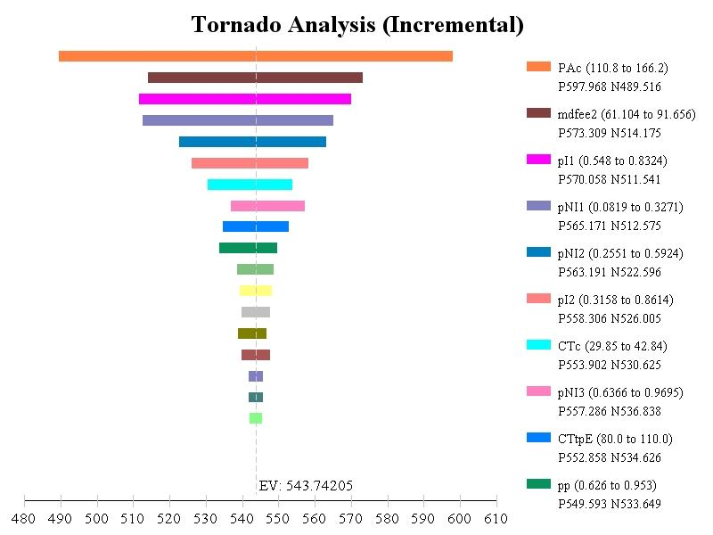
Legend for Figure 5
PAc: Cost (Rate) of the pathologist per hour
mdfee2: Cost for MD per additional location or per extra tests
pI1: Probability of being diagnosed at the 1st location with simulated ROSE
pNI1: Probability of diagnosis at 1st location if no ROSE
pNI2: Probability of diagnosis at 2nd locations among those who have more than 1 location if no ROSE
pI2: Probability of being diagnosed at the 2nd location among those who is not diagnosed at the 1st location with simulated ROSE
CTc: Cost (Rate) of the cytotechnologist per hour
pNI3: Probability of diagnosis at 3rd locations among those who have more than 2 locations if no ROSE
CTtpE: Time (minutes) the CT (20’) and other technician (60’-90’) spent on 1 patient for the extra tests (prepare 8-14 slides/test)
pp: Probability of positive results at the 3rd location with simulated ROSE (without extra tests)

